Treasure Trove of Hadith

Abu Kab Anisur Rahman
First Edition: 2013

published on abukab.weebly.com
29 Rabi Awwal 1435 AH
31-01-2016 CE

Open Order: Anybody can publish, print, and photocopy the book Treasure Trove of Hadith. However a copy of published book may be sent to the author.
Translation into different languages is also welcomed.

The Prophet (pbuh) said: He who does not follow my sunnah, is not from me." (Bukhari, Muslim, Nasai)
Imam Suyuti (Rah) said: “It must be acknowledged that whoever rejects any hadith of the Prophet (pbuh), be it deed or word, which fulfills condition of authenticity (sihhah) as evidence of shariah, he will become disbeliever and be out of the fold of Islam. His Resurrection will be with Jews or Christians or any other disbelieving groups as Allah wishes. (Miftahul Jannah, Suyuti)

Content

 | page
Introduction | 4
Faith in Allah | 7
Faith in Hereafter | 14
Faith in Prophethood | 16
Predestination (Fate) | 28
Purity | 29
Knowledge | 30
Cleanliness | 38
Wudu and bath | 46
The Quran | 54
Salaah (Prayer) | 66
Zakat (Purification of wealth) | 120
Hajj and Sacrifice | 125
Reality of the world | 130
Food and Drink | 134
Disease, Death and Medicine | 137
Marriage and Family Life | 141
Human rights | 147
Dignity of Sahabi | 149
Antidefamation Guideline | 151
Musical Instruments and Sports | 157
Graves, Images and Idols | 159
Governance and Judgment | 161
Hijab | 166
Friendship and separation | 170
Dua and Zikr | 172
Miscellaneous | 180
Narrators of hadith | 185
Index | 191

In the name of Allah
Introduction
The first duty of every Muslim is to know the Quran, then Hadith, the tradition of the Prophet (pbuh). In post-Muhammad Islam, Islam is unthinkable witout the Quran. Hadith is the explanation of the Quran. If hadith is not learnt, Quran may be misinterpreted. Rituals will be performed inaccurately in absence of Hadith.
How will we perform our salaah, how to ruku, how to sujud?
How will we know which incomes are usurary.
How much will we pay zakaat?

It is the Quran in which the sunnah or hadith of the prophet (pbuh) has been prescribed to be followed. Say [O Prophet]: 'If you love God, follow me, God will love you and forgive you your sins; for God is much-forgiving, a dispenser of grace.' (Quran 3:31)
'That which the messenger gives you, take it, and that which he withholds from you, leave it'. (Q. 59:7)
Obey Allah, and obey the Messenger, (5 times in Quran 4:59, 5:92, 24:54, 47:33, 64:12)
Obey Allah, and the Messenger, (2 times in Quran 3:32, 3:132)
Obey Allah, and his Messenger, (4 times in Quran 8:1, 8:20, 8:46, 58:13)
In only one place. Allah says, O ye who believe! Obey Allah, and obey the Messenger, and those charged with authority among you. If ye differ in anything among yourselves, refer it to Allah and His Messenger, if ye do believe in Allah and the Last Day: That is best, and most suitable for final determination. (Q. 4:59)
those charged with authority include parents, teachers, administrators and religious leaders.
To obey those charged with authority is under certain condition that is if they differ in anything refer it to Allah and His Messenger.

But nay, by thy lord, they will not believe (in truth) until they make you judge of what is in dispute between them and find within themselves no dislike of that which you decide, and submit with full submission. (Q. 4:65)
And let those who conspire to evade orders beware lest grief or painful punishment befall them.” (Q. 24:63)
Bukhari narrated from Salama bin Akwa: I heard the Prophet (pbuh) saying, "Whoever ascribes to me what I have not said then (surely) let him occupy his seat in Hell-fire.”
Imam Awzaee (Rah) said: When any hadith is reached from the Prophet (pbuh) refrain yourself from saying anything other than the hadith. (Bayhaqi)
Imam Suyuti (Rah) said: It must be acknowledged that whoever rejects any hadith of the Prophet (pbuh), be it deed or word, which fulfills condition of authenticity (sihhah) as evidence of shariah, he will become disbeliever and be out of the fold of Islam. His Resurrection will be with Jews or Christians or any other disbelieving groups as Allah wishes. (Miftahul Jannah, Suyuti)

I wished to compile a collection of hadith for myself, my wife, my children, and also for those Muslims who have not read greater collections of hadith.

I named it Zakhiratul Hadith. Zakhira means treasure.

I advice the readers that they should not end up after reding this small booklet. They must keep reading on. They may read “Book of Sunnah”, Riyadhus Saleheen by Muhiyuddin and “Bulugul Maram” by Ibn Hazar Asqalani. They may also read Amalul Yawmi wal Lailah by Nasai and Fazail Amal by Zia Maqdisi.

If anybody find difference between two saheeh hadiths or between a Quranic verse and a hadith, then it will be required to follow the both instruction, because both instructions have been proved with equal authenticity. So long as it is possible for follow both the instruction if will not be permissible to turn away from one of the two.
Shaikh Abdul Aziz Nuristani said: In hadith both narrations on recitation of Bismillah loudly and silently have been found authentic. So both the styles should be kept in practice. (Kitab Sallu kama Ra-aitumuni usalli)
Nazir Husain Dehlawi said, hadith of both hand raising and not raising are available. (Fatwa Naziriyyah)
- - --
- - --

I have tried to keep sahih and hasan hadith. These two types of hadith are acceptable (maqbool) to muhaddithoon. In few places daif hadith have been taken to present support for a ruling based on sahih or hasan hadith.
I generally relied on Bukhari, Muslim, Tirmiji, Abu Dawud, Ibn Hajar for verifying authenticity of hadith. However in some cases Tahqeeq of recent scholars like Suaib Arnaut, Zubair Ali Zai and Ahmad Shaker have been consulted.

There is possibilty of errors. Errors may be of tahqeeq, reference, spelling, translation etc. When a reader finds any error he must avoid the error and act on the right.

Abu Kab Anisur Rahman

Faith in Allah
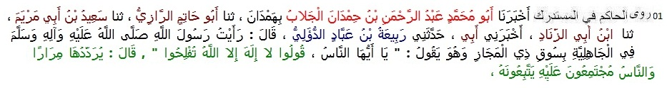
1 Hakim narrated .......... from Rabiah bin Abbad Dailee; He said: I saw the Prophet (peace be upon him) while he was in Zul-Majaz market and said to people, O people, Say: There is no god but One God, You will be successful. (also narrated by Ibn Hibban, Daraqutni; Ibn Hibban, Hakim, Dhahabi, Suyuti and many other muhaddithun classed this narration as authentic or sahih.)
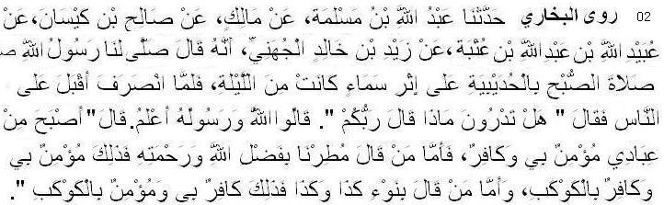
2 Bukhari narrated .................. from Zaid bin Khalid Juhani: Allah's Messenger (pbuh) led us in the Fajr prayer at Hudaibiyah after a rainy night. On completion of the prayer, he faced the people and said, "Do you know what your Lord has said?" The people replied, "Allah and His Messenger know better." He said, "Allah has said, 'In this morning, some of my slaves remained as true believers and some became disbelievers; whoever said that the rain was due to the blessings and the mercy of Allah is the one who believes in Me and he disbelieves in the star, and whoever said that it rained because of a particular star, is a disbeliever in Me and believer in the star.' "(also Muslim, Nasai)
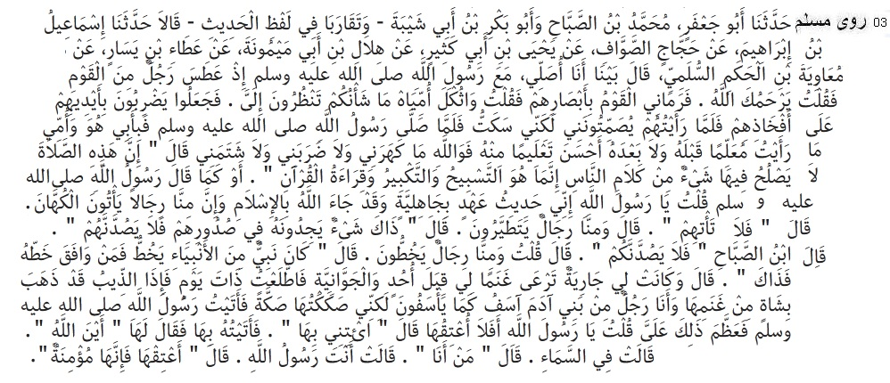
3 Muslim narrated . . . . . . Muawiya b. Hakam said: While I was praying with the Messenger of Allah, a man in the company sneezed. I said: Allah have mercy on you! The people stared at me with disapproving looks, so I said: Woe be upon me, why is it that you stare at me? They began to strike their hands on their thighs, and when I saw them urging me to observe silence but I said nothing. When the Messenger of Allah had said the prayer and I declare that neither before him nor after him have I seen a leader who gave better instruction than he for whom I would give my father and mother as ransom. I swear that he did not scold, beat or revile me but said: Talking to persons is not fitting during the prayer, for it consists of glorifying Allah, declaring his Greatness and recitation of the Quran or words to that effect. I said: Messenger of Allah. I was till recently a pagan, but Allah has brought Islam to us; among us there are men who have recourse to fortune-tellers. He said, Do not have recourse to them. I said. There are men who take omens. That is something which they find in their breasts, but let it not turn their way. I said: Among us there are men who draw lines. He said: There was a prophet who drew lines, so if they do it as they did, that is allowable. I had a maid-servant who tended goats by the side of Uhud and Jawwaniya. One day I happened to pass that way and found that a wolf had carried a goat from her flock. I am after all a man from the posterity of Adam. I felt sorry as they feel sorry. So I slapped her. I came to the Messenger of Allah and felt as something grievous I said: Messenger of Allah, should I not grant her freedom? He said: Bring her to me. So I brought her to him. He said to her: Where is Allah? She said: He is in the heaven. He said: Who am I? She said: Thou art the Messenger of Allah. He said: Grant her freedom, she is a believing woman. (also recorded in Risalah of Shafii, Muwatta of Malik, Sunan of Nasai, Sunan of Abu Dawud)
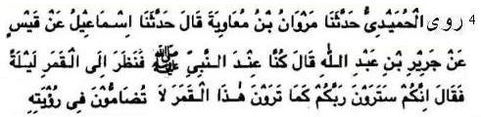
4 Humaidi narrated ................. from Jarir bin Abdullah: We were with the Prophet (pbuh) on a full moon night. He looked at the moon and said, "You will certainly see your Lord as you see this moon, and there will be no trouble in seeing Him. (also Bukhari)
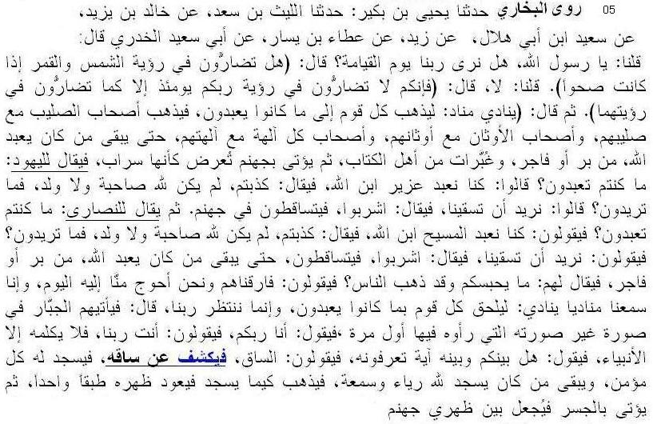
5 Bukhari narrated ......................... from Abu Said Khudri: We said, "O Allah's Messenger! Shall we see our Lord on the Day of Resurrection?" He said, "Do you have any difficulty in seeing the sun and the moon when the sky is clear?" We said, "No." He said, "So you will have no difficulty in seeing your Lord on that Day as you have no difficulty in seeing the sun and the moon." The Prophet (pbuh) then said, "Somebody will then announce, 'Let every nation follow what they used to worship.' So the companions of the Cross will go with their cross, and the idolators will go with their idols, and the companions of every false deities will go with their gods, till there remain those who used to worship Allah, both the obedient ones and the mischievous ones, and some of the people of the Scripture. Then Hell will be presented to them as if it were a mirage. Then it will be said to the Jews, 'What did you use to worship?' They will reply, 'We used to worship Ezra, the son of Allah.' It will be said to them, 'You are liars, for Allah has neither a wife nor a son. What do you want (now)?' They will reply, 'We want You to provide us with water.' Then it will be said to them 'Drink,' and they will fall down in Hell. Then it will be said to the Christians, 'What did you use to worship?' They will reply, 'We used to worship Messiah, the son of Allah.' It will be said, 'You are liars, for Allah has neither a wife nor a son. What: do you want (now)?' They will say, 'We want You to provide us with water.' It will be said to them, 'Drink,' and they will fall down in Hell. When there remain only those who used to worship Allah (Alone), both the obedient ones and the mischievous ones, it will be said to them, 'What keeps you here when all the people have gone?' They will say, 'We parted with them (in the world) when we were in greater need of them than we are today, we heard the call of one proclaiming, 'Let every nation follow what they used to worship,' and now we are waiting for our Lord.' Then the Almighty will come to them in a shape other than the one which they saw the first time, and He will say, 'I am your Lord,' and they will say, 'You are not our Lord.' And none will speak to Him then but the Prophets, and then it will be said to them, 'Do you know any sign by which you can recognize Him?' They will say. 'The Shin,' and so Allah will then uncover His Shin whereupon every believer will prostrate before Him and there will remain those who used to prostrate before Him just for showing off and for gaining good reputation. These people will try to prostrate but their backs will be rigid like one piece of a wood.
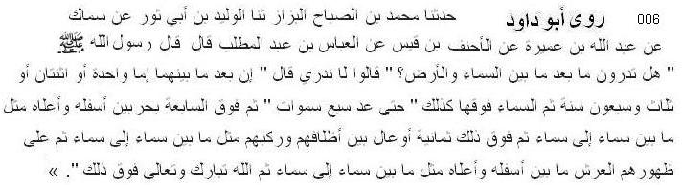
6 Abu Dawud narrated ............... from Abbas: Allah's Messenger (pbuh) said: "Do you know how much the distance between earth and heaven is?" They said, "We dont know." Then he said, "The distance between them is 500 years, and the distance between one heaven to the next is 500 years, and the dimension of each heaven will take 500 years to travel, and there is a sea between the seventh heaven and the Throne which has between its lowest and highest ends the distance like that between the heavens and the earth (i.e. 500 years). And Allah the Most Exalted is above that and nothing is secret from Him of the deeds of children of Adam." (Abu Dawud 4723, 4724, 4725.) Sanad is zaif. But there are several sanads which strengthen one another. Hence most scholars accepted this hadith. )
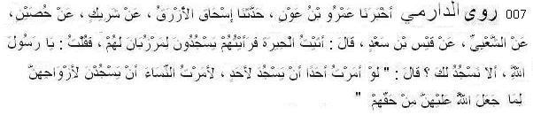
7 Daremi narrated .................. from Anas bin Malik: Qais bin Sa’d said: I visited Al-Hirah, and saw that its inhabitants would prostrate to their nobles. I said (to myself), ‘Allah’s Messenger has more right that (people) prostrate to him.’ So I returned to the prophet & said, ‘I visited Hirah, and saw that its inhabitants would prostrate to their nobles. And you, O Allah’s Messenger, have more right that we prostrate to you.’ He replied, “Were I to command any person to prostrate to another, I would have commanded the women to prostrate to their husbands, due to the rights that Allah has given them over their wives.”
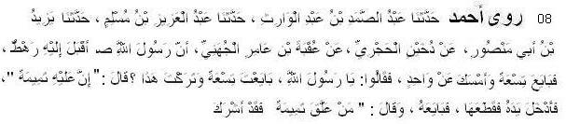
8 Ahmad narrated ........................ from Uqba bin Amer: A group of people came to the Prophet (pbuh) to take oath (baiah). The Prophet (pbuh) took baiah from nine persons and abstained fron one. .. . . . . . . . . . . . Prophet (pbuh) said: "He has a talisman. The man tore the talisman The Prophet (pbuh) took baiah from him and said: "Whoever wears a talisman has committed shirk (polytheism)." (Ahmad 17091, Hakim ; Sahih)
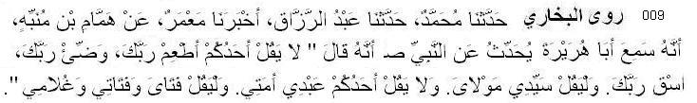
9 Bukhari narrated ........................ from Abu Huraira: The Prophet (pbuh) said, "You should not say, 'Feed your lord (rabbak), help your lord in performing ablution, or give water to your lord, but should say, my master (saiyidi), or my guardian (maulai), and one should not say, my slave (abdi), or my girl-slave (amati), but should say, my lad (fatai), my lass (fatati), and my boy (ghulami). (also Muslim)
Faith in Hereafter
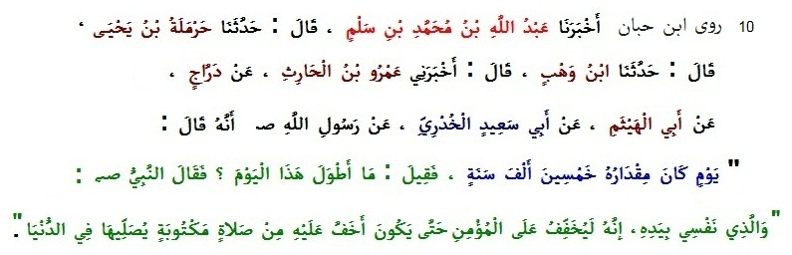
10 Ibn Hibban narrated ................ from Abu Sa’id Khudri: The Prophet (pbuh) said, "The Day of Resurrection will be as long as 50000 years. It was said: How long the day is! Prophet said, “It will be light for the believing folk, even easier then performing a obligatory prayer.” (sahih; also Ahmad with weak chain)
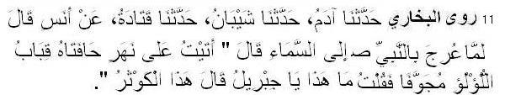
11 Bukhari narrated ................... from Anas: When the Prophet (pbuh) was made to ascend to the Heavens, he said (after his return), "I came upon a river the banks of which were made of tents of hollow pearls. I asked Gabriel, 'What is this (river)?' He replied, 'This is the Kauthar.'
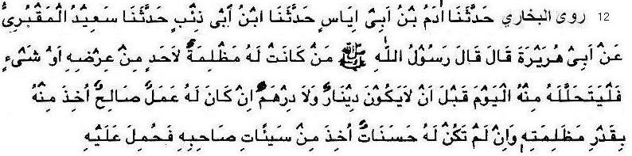
12 Bukhari narrated ........................ from Abu Hurairah narrated that the Prophet (pbuh) said: "Whoever has wronged his brother, should ask for his pardon (before his death), as (in the Hereafter) there will be neither a Dinar nor a Dirham. He should secure pardon in this life before some of his good deeds are taken and paid to his brother, or, if he has done no good deeds, some of the bad deeds of his brother are taken to be loaded on him."
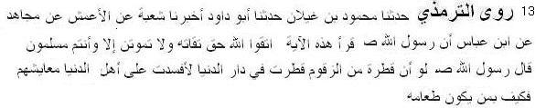
13 Tirmiji narrated ........................ from Ibn Abbas: The Prophet (pbuh) said: If a small portion of Zaqqum tree falls on earth it will destroy the livelihood of dwelers of the world. Then what will be his state whose food is Zaqqum? (, Nasai, Ibn Hibban; sahih)
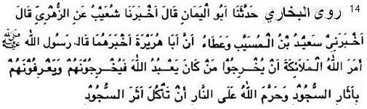
14 Bukhari narrated ........................ from Abu Hurairah: The Prophet (pbuh) said: The angels will recognize them (sinful believers) in the Fire by the marks of prostration, for the Fire will eat up all the human body except the mark caused by prostration as Allah has forbidden the Fire to eat the mark of prostration.
Faith in Prophethood
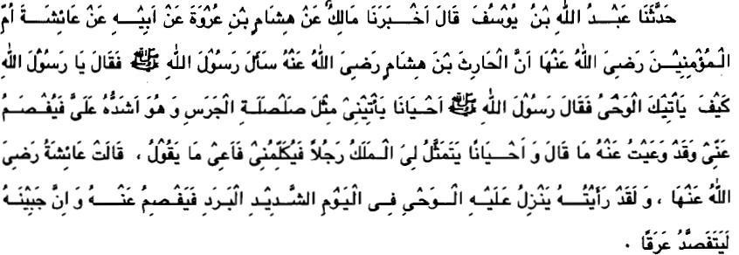
15 Bukhari narrated ................... from Aisha: Al-Harith bin Hisham asked Allah's Messenger(pbuh), "O Allah's Messenger! How is the Divine Inspiration revealed to you?" Allah's Messenger replied, "Sometimes it is like the ringing of a bell, this form of Inspiration is the hardest of all and then this state passes' off after I have grasped what is inspired. Sometimes the Angel comes in the form of a man and talks to me and I grasp whatever he says."
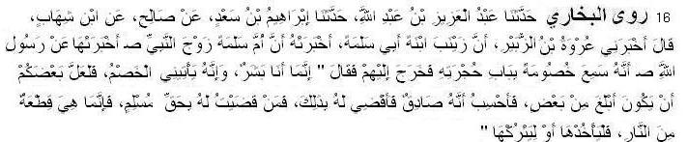
16 Bukhari narrated ............ from Umm Salama: the Messenger of Allah (pbuh) heard some people quarreling at the door of his dwelling, so he went out to them and said, "I am only a human being, and litigants with cases of dispute come to me, and someone of you may happen to be more eloquent (in presenting his case) than the other, whereby I may consider that he is truthful and pass a judgment in his favor. If ever I pass a judgment in favor of somebody whereby he takes a Muslim's right unjustly, then whatever he takes is nothing but a piece of Fire, and it is up to him to take or leave." (also Muslim, Nasai, Abu Dawud)
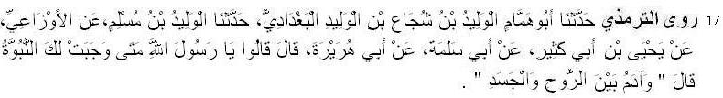
17 Tirmiji narrated ............ from Abu Hurairah: They (the companions) said: O Messenger of Allah! When was the prophethood established for you? The Prophet (pbuh) said: “When Adam was between his soul and body.”(sahih)
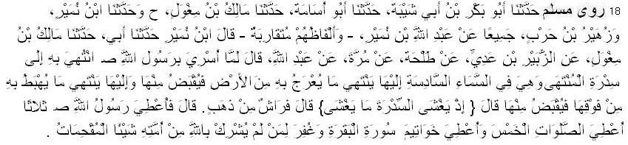
18 Muslim narrated ............ from Abdullah ibn Mas'ud: When the Messenger of Allah (pbuh) was taken for the Night Journey, he was taken to Sidrat al-Muntaha, which is situated on the sixth heaven, where terminates everything that ascends from the earth and is held there, and where terminates everything that descends from above it and is held there. (It is with reference to this that) Allah said: "When that which covers covered the lote tree" (Quran, 53:16). He (the narrator) said: The Messenger of Allah (pbuh) was given three (things): he was given five prayers, he was given the concluding verses of Surat al-Baqarah, and remission of serious sins for those among his Ummah who associate not anything with Allah. (also Ahmad, Nasai, Tirmiji)
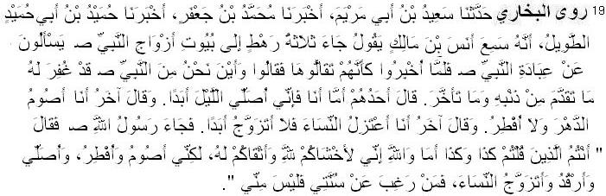
19 Bukhari narrated ............ from Anas: A group of three men came to the houses of the wives of the Prophet (pbuh). They asked how the Prophet (pbuh) worshipped. When they were informed about that, they considered their worship insufficient and said, "Where are we from the Prophet (pbuh) as his past and future sins have been forgiven." Then one of them said, "I will offer the prayer throughout the night forever." The other said, "I will fast throughout the year and will not break my fast." The third said, "I will keep away from the women and will not marry forever." Allah's Messenger came to them and said, "Are you the same people who said so-and-so? By Allah, I am more submissive to Allah and more afraid of Him than you; yet I fast and break my fast, I do sleep and I also marry women. So he who does not follow my sunnah, is not from me (not one of my followers)." (also Muslim, Nasai)
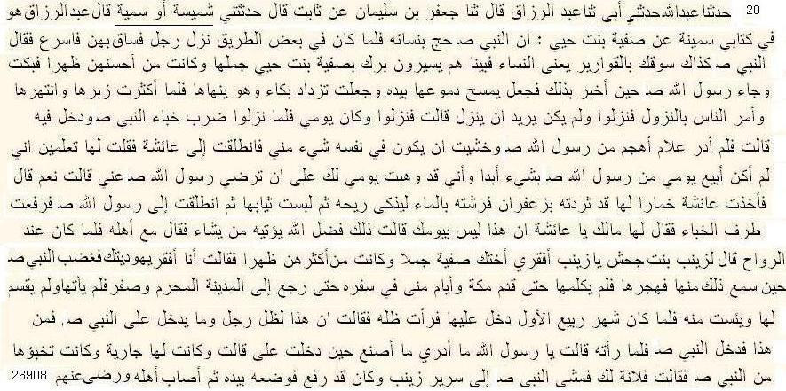
20 Ahmad narrated .................. from Safiyyah bint Huyyai: Once the Prophet (pbuh) was in a journey for Hajj accompanied by some of his wives. The Prophet requested Zaynab to borrow a camel for Safiyyah. Zaynab called Safiyyah bint Huyyai ‘a jewess’. So the Prophet became dissatisfied with Zaynab. This dissatisfaction remained for two months or more. Zaynab said: I was dissappointed about the Prophet’s appearance. He went to her in the month of Rabi Awal Zaynab could see the shadow of the Prophet. She said: It must be the shadow of Prophet (pbuh).” (also Ibn Majah, Abu Dawud; hasan. All narrators are narrators of Sahih Muslim except Sumaiyyah who is acceptable narrator according to Ibn Hazar.)
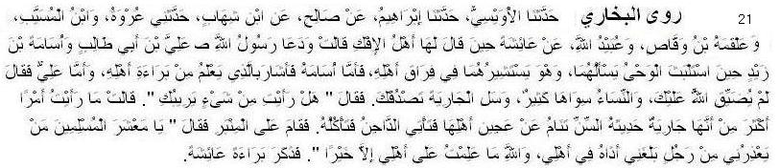
21 Bukhari narrated ............... from Aisha: After the slanderers had given a forged statement against her, Allah's Messenger called 'Ali bin Abu Talib and Usama bin Zaid when the Divine Inspiration was delayed. He wanted to ask them and consult them about the question of divorcing me. Usama gave his evidence that was based on what he knew about my innocence, but 'Ali said, "Allah has not put restrictions on you and there are many women other than her. Furthermore you may ask the slave girl who will tell you the truth." So the Prophet asked Barira (my slave girl), "Have you seen anything that may arouse your suspicion?" She replied, "I have not seen anything more than that she is a little girl who sleeps, leaving the dough of her family (unguarded) that the domestic goats come and eat it." Then the Prophet stood on the pulpit and said, "O Muslims! Who will help me against the man who has harmed me by slandering my wife? By Allah, I know nothing about my family except good." The narrator added: Then the Prophet mentioned the innocence of Aisha.
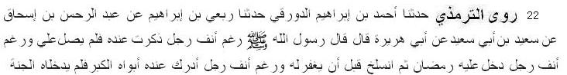
22 Tirmiji narrated .................. from Abu Hurairah Allah's Messenger (pbuh) said: “May his nose be sticked in the dust (i.e. may he be degraded) who do not pray for me when my name is mentioned before him. May his nose be sticked in the dust who gets Ramadan but fails to have his sins forgiven. May his nose be sticked in the dust who has old parents yet he fails to enter Jannah by serving them” (Tirmiji 3545; sahih)
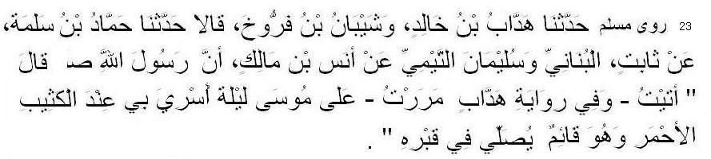
23 Muslim narrated .................. from Anas ibn Malik: Allah's Messenger (pbuh) said: I happened to pass by Moses on the occasion of the Night Journey near the red mound (and found him) saying his prayer in his grave. (Muslim 6306, also Nasai)
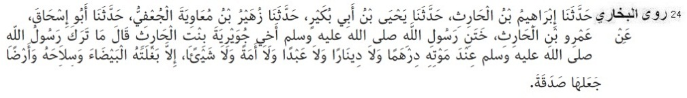
24 Bukhari narrated .................. from Amr bin Harith, the brother of Juwairiyah, the Mother of believers reported: (When he died) Messenger of Allah (ﷺ) left neither a dinar nor a dirham nor a male slave except a mule, his weapons and his land which he had given in charity to wayfarers.
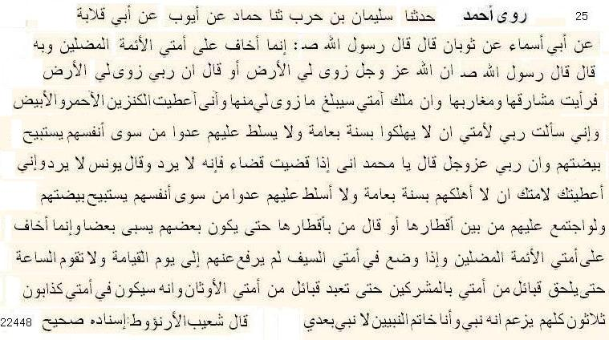
25 Ahmad ibn Hanbal narrated ................ from Thawban that the Messenger of Allah (pbuh) said; "I fear deviant leaders in my Ummah .... There will be thirty liars among my Ummah. Each one will claim that he is a prophet; but I am the last of the Prophets and there will be no Prophet after me."
Shuaib Arnaut said: The hadith is sahih.
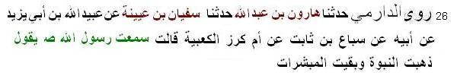

26 Daremi narrated ................ from Umm Kurj Ka’biah, the Messenger of Allah (pbuh) said, Nubuwwah (prophethood) stand terminated after me; mubashshirat is left.” (also Ibn Majah; sahih)
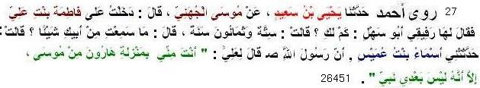
27 Ahmad narrated ........... from Asma bint Umais: The Messenger of Allah (pbuh) said to 'Ali, "Will you not be pleased from this that you are to me like Aaron was to Moses? But there is no prophet after me"
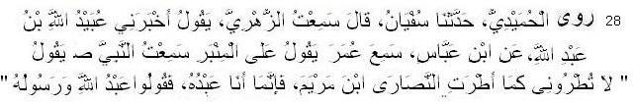
28 Humaidi narrated ............... from Umar bin al-Khattab: The Messenger of Allah (pbuh) said: "Do not exaggerate in praise of me just as the Christians exaggerated in the praise of Jesus, son of Mary. I am but a slave, so call me Allah's slave and His Messenger." (also Bukhari and Muslim)
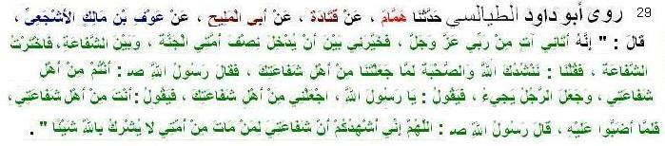
29 Abu Dawud Tayalisi narrated .................. from Awf ibn Malik: The Messenger of Allah (pbuh) said, "One came to me from my Lord and gave me a choice between half of my people entering Paradise and intercession, and I chose intercession. It will apply to those who have died and have associated nothing with Allah." (also Tirmizi, Ibn Hibban, Ibn Majah; sahih)
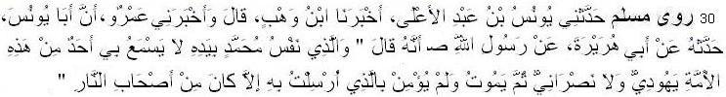
30 Muslim narrated ................. from Abu Hurayrah: The Messenger of Allah (pbuh) said: By Him in Whose hand is the life of Muhammad, he who amongst the community of Jews or Christians hears about me, but does not affirm his belief in that with which I have been sent and dies in this state (of disbelief), he shall be but one of the denizens of Hell-Fire. (also Ahmad)
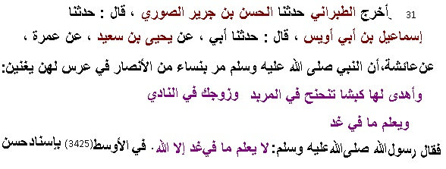
31 Tabarani narrated ......... from Aishah: The Prophet (pbuh) went to one of Ansar women.
There girls were singing: ........... he knows what will happen tomorrow." The Prophet (pbuh) said,"None but Allah knows what will happen tomorrow."
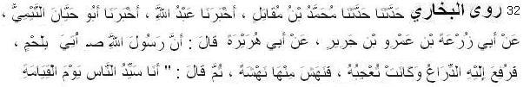
32 Bukhari narrated ................ from Abu Hurairah narrated that Allah's Messenger (pbuh) said: I will be the leader of mankind on the Day of Resurrection.” (also Tirmiji, Ibn Mazah)
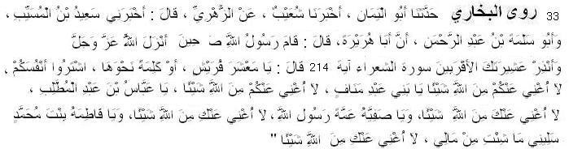
33 Bukhari narrated .................. from Abu Hurairah: Allah's Messenger (pbuh) stood up when it was revealed to him:"And warn your tribe of near kindred." (26:214) and he said, "O people of Quraish" - or words similar to that -" sell your own souls. I will not be of any help to you before Allah; O Abbas bin Abdul-Muttalib, I will not be of any help to you before Allah; O Safiyah, aunt of Allah's Messenger, I will not be of any help to you before Allah; O Fatimah, daughter of Muhammad, ask of my wealth what you wish, I will be of no avail to you before Allah." (also Muslim)

Predestination
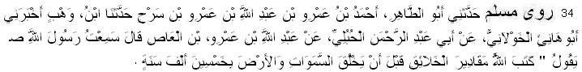
34 Muslim narrated .............. from Abdullah bin 'Amr ibnul 'As: He said: I heard Allah's Messenger (pbuh) as saying: Allah ordained the measures (of quality) of the creation fifty thousand years before He created the heavens and the earth.” (also Tirmiji)
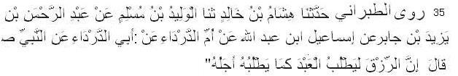
35 Tabarani narrated .................. from Abud Darda: Allah's Messenger (pbuh) said: “Rizq searches a man in the same way as death searches its time.”(Muzam kabeer; also Baihaqi in Shuabul Iman; hasan hadith)
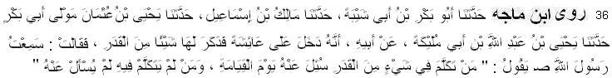
36 Ibn Majah narrated .................. from Aishah: The Messenger of Allah (pbuh) said: “He who discusses any aspect of taqdeer will be questioned about it on the Day of Judgement but he who does not discuss it will not be questioned about it.” (Sunan Ibn Majah)
Keep your religion pure
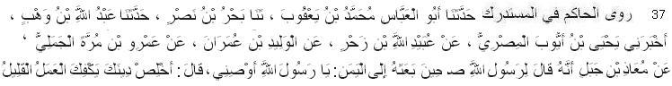
37 Hakim narrated .................. from Muaz bin Jabal: The Messenger of Allah (pbuh) said, "Keep your religion pure, then small-scale good deeds will be sufficient for you. (also Ibn Abu Hatim in his Tafsir, Baihaqi in Shuabul Iman. sahih)
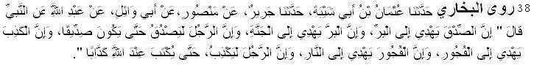
38 Bukhari narrated .................. from Abdullah ibn Masud: The Messenger of Allah (pbuh) said, "Truthfulness leads to righteousness, and righteousness leads to Paradise. And a man keeps on telling the truth until he becomes a truthful person. Falsehood leads to evil-doing and evil-doing leads to the (Hell) Fire, and a man may keep on telling lies till he is written before Allah, a liar." (also Muslim)
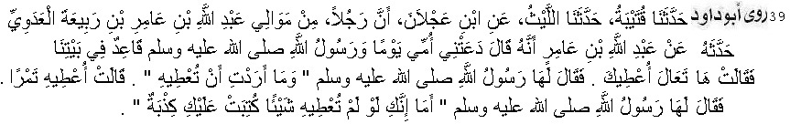
39 Abu Dawud narrated ........ from Abdullah ibn Amir: My mother called me one day when the Messenger of Allah (pbuh) was sitting in our house. She said: Come here and I shall give you something. The Messenger of Allah (pbuh) asked her: What did you intend to give him? She replied: I intended to give him some dates. The Messenger of Allah (pbuh) said: If you were not to give him anything, a lie would be recorded against you. (also Ahmad; the hadith is hasan)
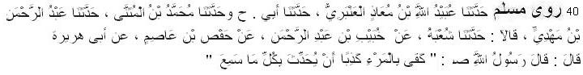
40 Muslim narrated .................. from Abu Hurairah: Messenger of Allah (pbuh) said: “It is sufficient for a person to be a liar that he narrates whatever he hears (without verification).
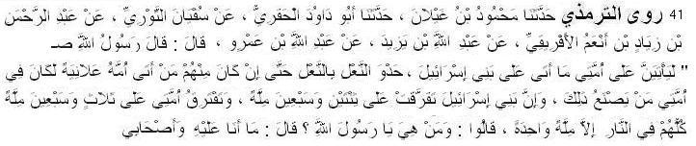
41 Tirmiji narrated .................. from Abdullah ibn Amr, Messenger of Allah said: My Ummah will be fragmented into seventy-three sects. All will go to hell except one. They said: Who are they? Whereupon he said: It is one to which I and my companions belong. (sahih)
Knowledge
42 Ibn Majah narrated .................. from Anas, Messenger of Allah (pbuh) said: “Acquiring Knowledge is obligatory for every Muslim.” (sahih)
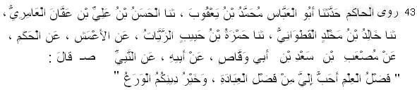
43 Hakim narrated .................. from Sad bin Abu Waqqas: The Messenger of Allah (pbuh) said: “Knowledge is more fruitful than worship.” (also Tabarani in Muzam Awsat and Muzam Kabir, Khatib Bagdadi in Tarikh Bagdad, Ibn Abdul Barr in Jami Bayan al-Ilm; Suyuti graded it as hasan hadith.)
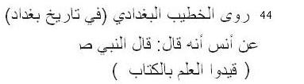
44 Khatib Baghdadi narrated (in Tarikh Baghdad) ............. from Anas: Allah's Messenger (pbuh) said: “Captivate knowledge by books.” (sahih)
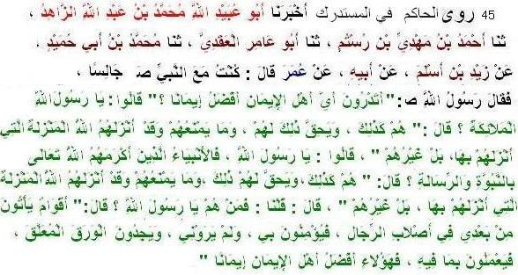
45 Hakim narrated ........... from Umar: the Prophet (pbuh) said, “Honorable believers are those who believe in me without seeing me. They will read papers and act accordingly.”
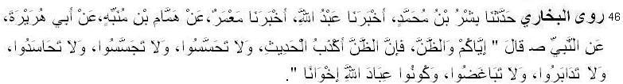
46 Bukhari narrated ........... from Abu Huraira: The Prophet (pbuh) said, "Beware of supposition, for supposition is the worst of false tales; and do not look for the others' faults and do not spy, and do not be jealous of one another, and do not cut your relation with one another, and do not hate one another; and O Allah's worshipers! Be brothers.
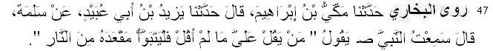
47 Bukhari narrated ......... from Salama bin Akwa: I heard the Prophet (pbuh) saying, "Whoever ascribes to me what I have not said then let him occupy his seat in Hell-fire."
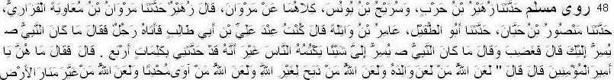
48 Muslim narrated .............. from Abu Tufail Amir bin Withila. He said: I was in the company of Ali b. Abu Talib, when a person came to him, and said: What was it that Allah's Messenger (pbuh) told you in secret? Thereupon he was enraged and said: Allah's Messenger did not tell me anything in secret that he hid from people, except that he told me four things. He said: Commader of Faithful, what are these? He said: Allah cursed him who cursed his father; Allah cursed him who sacrificed for anyone besides Allah; Allah cursed him who accommodates an innovator (in religion); and Allah cursed him who changed the boundary lines of the land.
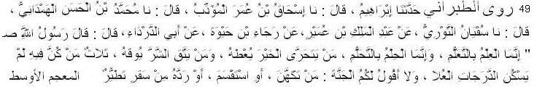
49 Tabarani narrated ........... from Abud Darda: The Messenger of Allah (pbuh) said: “Certainly learning is through study.” (Muzam Awsat, also narrated by Khatib Bagdadi in Tarikh)
50 Ahmad narrated ........... from Zayd bin Thabit: The Messenger of Allah (pbuh) said: “Do you know Syriac language? I receive letters written in this language.” I replied no. The Prophet said, “Learn it.” (also Tirmiji, Ibn Hibban, Hakim, Ibn Abu Shaibah, Tabarani in Muzam Kabeer)

Rejection of Personal Opinion and Accepance of Hadith
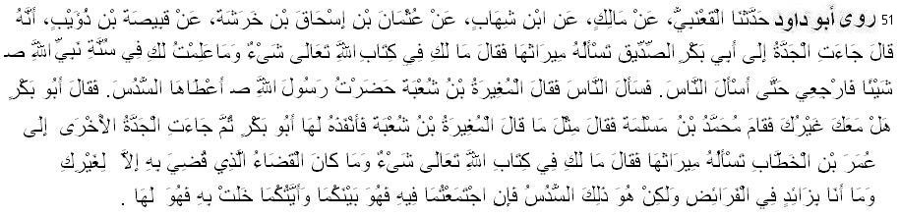
51 Abu Dawud narrated ........... from Qabisah ibn Dhuwayb: A grandmother came to Abu Bakr asking him for her share of inheritance. He said: There is nothing prescribed for you in Allah's Book, nor do I know anything for you in the Sunnah of the Prophet of Allah. Go home till I question the people. He then questioned the people, and al-Mughirah ibn Shu'bah said: I had been present with the Messenger of Allah when he gave grandmother a sixth. Abu Bakr said: Is there anyone with you? Muhammad ibn Maslamah stood and said the same as al-Mughirah ibn Shu'bah had said. So Abu Bakr made it apply to her. Another grandmother came to Umar asking him for her share of inheritance. He said: Nothing has been prescribed for you in Allah's Book. The decision made before you was made for a grandmother other than you. I am not going to add in the shares of inheritance; but it is that sixth. If there are two of you, it is shared between you, but whichever of you is the only one left gets it all. (also Tirmiji 2047; hasan)
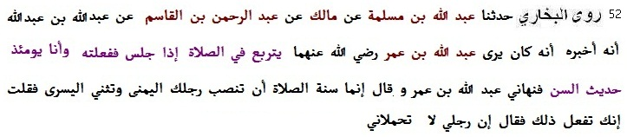
52 Bukhari narrated ........ from Abdullah bin Abdullah; He said: I saw Abdullah bin Umar crossing his legs while sitting in the prayer and I, a mere youngster in those days, did the same. Ibn 'Umar forbade me to do so, and said, "The sunnah is to keep the right foot propped up and bend the left in the prayer." I said questioningly, "But you are doing so (crossing the legs)." He said, "My feet cannot bear my weight."
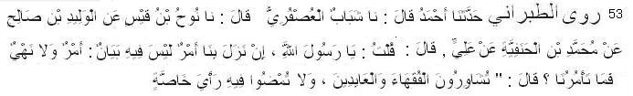
53 Tabarani narrated ........... from Ali: He said: I said to Messenger of Allah (pbuh): If there is any issue at our disposal for which we find no order or prohibition then what is your instruction concerning such issue? The Messenger of Allah (pbuh) said: “Consult the learned and virtuous people, but you shall not give preference to any selected person.” (Tabarani in Muzam Awsat 1647, Khalifa bin Khayat in his Musnad 46; Suyuti in Miftahul Jannah marked its chain as sahih)
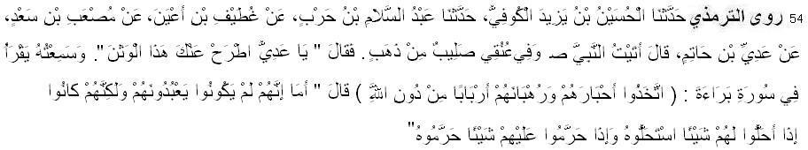
54 Tirmiji narrated ........... from Adi bin Hatim: "I came to the Prophet (pbuh) while I had a cross of gold around my neck. He said: 'O Adi! Remove this idol from yourself!' And I heard him reciting from Surah Bara'ah: They took their rabbis and monks as lords besides Allah (Quran 9:31). He said: 'As for them, they did not worship them, but when they made something lawful for them, they considered it lawful, and when they made something unlawful for them,
they considered it unlawful.'" (also Baihaqi in Sunan Kubra, Tabarani in Muzam Kabir, Ibn S’ad in Tabaqat Kubra)
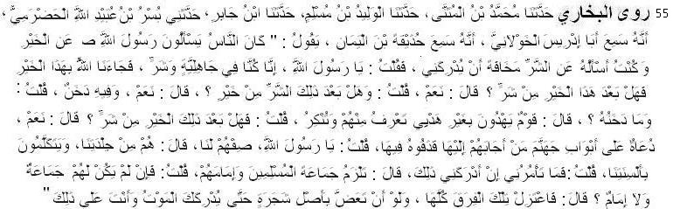
55 Bukhari narrated ........... from Huzaifah ibn al-Yaman: People used to ask the Messenger of Allah (pbuh) about the good times, but I used to ask him about the bad times fearing lest they should overtake me. I said: Messenger of Allah, we were in the mid of ignorance and evil, and then Allah brought us this good. Is there any bad time after this good one? He said: Yes. I asked: Will there be a good time again after that bad time? He said: Yes, but in it will be a hidden evil. I asked: What will be the evil hidden therein? He said: That time will witness the rise of the people who will adopt ways other than mine and seek guidance other than mine. You will know good points as well as bad points. I asked: Will there be a bad time after this good one? He said: Yes. A time will come when there will be people standing and inviting at the gates of Hell. Whoever responds to their call will be thrown into the fire. I said: Messenger of Allah, describe them to us. He said: All right. They will be a people having the same complexion as ours and speaking our language. I said: Messenger of Allah, what do you suggest if I happen to live at that time? He said: You should stay with the Jama’ah of the Muslims and their leader. I said: If they have no (such thing as the) Jamah and have no leader? He said: Separate yourself from all these factions, though you may have to eat the roots of trees (in a jungle) until death comes to you when you are in this state. (also Muslim )
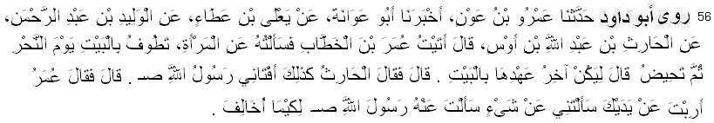
56 Abu Dawud narrated ........... from Al-Harith ibn Abdullah ibn Aws; He said: I came to Umar and asked him about a woman who has performed the (obligatory) tawwaf on the day of sacrifice, and then she menstruates. He said: She must perform the last tawwaf of the House (the Kabah). Al-Harith said: The Messenger of Allah (pbuh) told me the same thing. Umar said: May your hands fall down! You asked me about a thing that you had asked the Messenger of Allah (pbuh) so that I might oppose him.
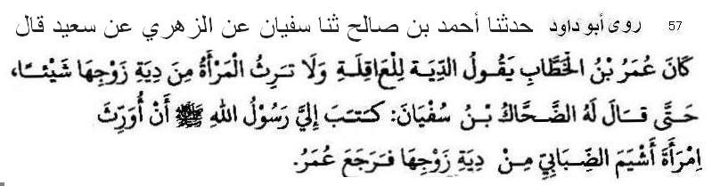
57 Abu Dawud narrated ........... from Sa’eed ibn Musayyib reported that Umar used to say that diyat (blood-money) is payable by Aaqilah (tribe or the people nearest to murderer in relation) and a woman has no share in it (inheritance from diyat) till Dahhak ibn Sufyan Kilabi told him that Allah’s Messenger (pbuh) had written to him, “Give share of inheritance to the wife of Ashyam Dababi from his diyat.” [Abu Dawud 2927, Ibn Majah 2642, Ahmed 15736, Nasaii, Tirmiji 2057; good chain]
PURIFICATION
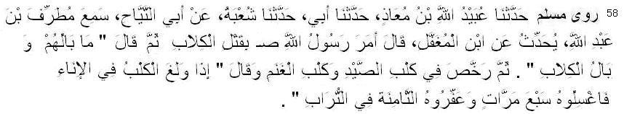
58 Muslim narrated ........... from Ibn Mughaffal: The Messenger of Allah (pbuh) ordered killing of the dogs, and then said: What about them, i.e. about other dogs? And then granted concession (to keep) the dog for hunting and the dog for (the security) of the herd, and said: “When the dog licks the utensil, wash it seven times, and rub it with earth the eighth time.” (Muslim 551)
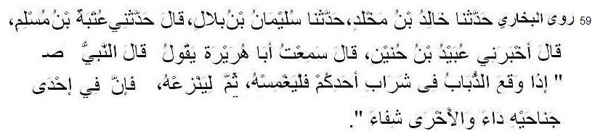
59 Bukhari narrated .............. from Abu Huraira: The Prophet (pbuh) said, "If a house fly falls in the drink of anyone of you, he should dip it (in the drink), for one of its wings has a disease
and the other has the cure for the disease." (Bukhari, Abu Dawud)
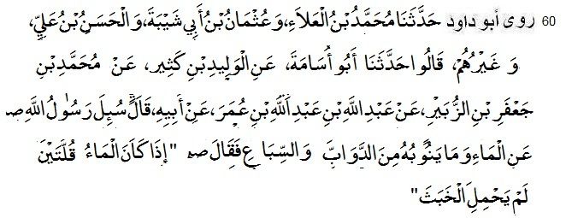
60 Abu Dawud narrated .............. from Ibn Umar: The Prophet (pbuh), was asked about water (in desert country) and what is frequented by animals and wild beasts. He replied: When there is enough water to fill two pitchers, (kulla), it does not become impure.” (Ahmad, Abu Dawud 63, Tirmiji 67, Nasai 52, Ibn Mazah 517, Ibn Hibban 1249, Ibn Khuzaimah 92, Hakim; sahih)
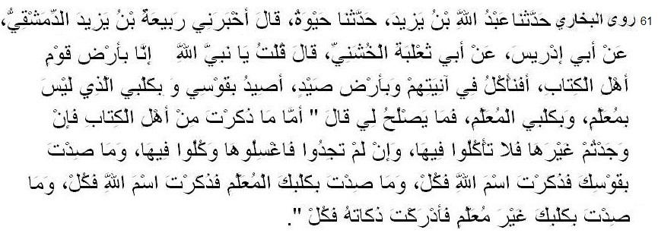
61 Bukhari narrated .............. from Abu Tha`laba Al-Khushani: I said, "O Allah's Prophet! We are living in a land ruled by the people of the Scripture; Can we take our meals in their utensils? In that land there is plenty of game and I hunt the game with my bow and with my hound that is not trained and with my trained hound. Then what is lawful for me to eat?" He said, "As for what you have mentioned about the people of the Scripture, if you can get utensils other than theirs, do not eat out of theirs, but if you cannot get other than theirs, wash their utensils and eat out of it. If you hunt an animal with your bow after mentioning Allah's Name, eat of it. and if you hunt something with your trained hound after mentioning Allah's Name, eat of it, and if you hunt something with your untrained hound (and get it before it dies) and slaughter it, eat of it." (also Muslim)
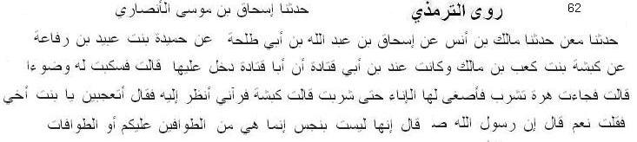
62 Tirmizi narrated ............... from Kabshah bint Ka'b bin Malik - she was (married) with son of Abu Qatadah - narrated "Abu Qatadah visited her, [so she said:] 'So I poured water for him to use for Wudu.' She said: 'A cat came to drink, so he lowered he container until it drank.' Kabshah said: 'So he saw me looking at it and said, "O my niece! Are you surprised at that?" So I said yes.He said: "Indeed Allah's Messenger (pbuh) said 'It is not impure, it is only one of those roam around among you.'" (also Nasai 68, Ibn Mazah)
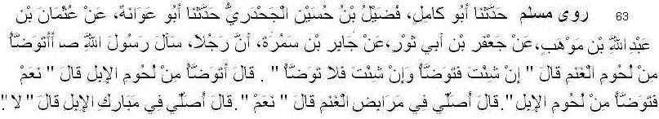
63 Muslim narrated ............... from Jabir b. Samura: A man asked the Messenger of Allah (pbuh) whether he should perform ablution after (eating) mutton. He (the Messenger of Allah) said: Perform ablution it you so desire, and if you do not wish, do not perform it. He (again) asked: Should I perform ablution (after eating) camel's flesh? He said: Yes, perform ablution (after eating) camel's flesh. He (again) said: May I say prayer in the sheepfolds? He (the Messenger of Allah) said: Yes. He (the narrator) again said: May I say prayer where camels lie down? He (the Prophet) said: No.
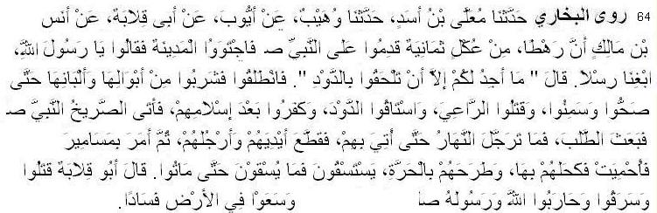
64 Bukhari narrated ............... from Anas bin Malik: A group of eight men from the tribe of 'Ukil came to the Prophet and then they found the climate of Madina unsuitable for them. So, they said, "O Allah's Messenger! Provide us with some milk." Allah's Messenger said, "I recommend that you should join the herd of camels." So they went and drank the urine and the milk of the camels (as a medicine) till they became healthy and fat. Then they killed the shepherd and drove away the camels, and they became unbelievers after whey were Muslims. When the Prophet was informed by a shouter for help, he sent some men in their pursuit, and before the sun rose high, they were brought, and he had their hands and feet cut off. Then he ordered for nails which were heated and passed over their eyes, and whey were left in the Harra (i.e. rocky land in Medina). They asked for water, and nobody provided them with water till they died. Abu Qilaba said, "They committed murder and theft and fought against Allah and His Messenger, and spread evil in the land." (also Tirmiji)
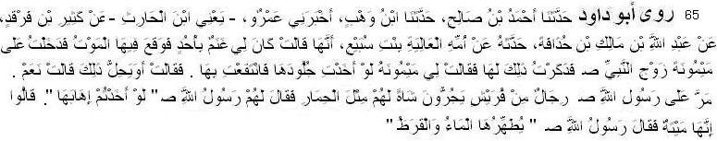
65. Abu Dawud narrated . . . .from Al-Aliyah bint Subay', said: I had some sheep at Uhud, and they began to die. I then entered upon Maymunah, wife of the Prophet (pbuh), and mentioned it to her. Maymunah said to me: If you took their skins and made use of them, (that would be better for you). She asked: Is that lawful? She replied, Yes. Some people of the Quraysh passed by the Messenger of Allah (pbuh) dragging a sheep of theirs as big as an ass. The Messenger of Allah (pbuh) said to them: Would that you took its skin. They said: It died a natural death. The Messenger of Allah (pbuh) said: Water and leaves of the mimosa flava purify it. [also Nasa'i; sahih]
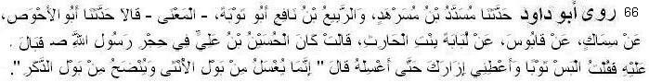
66 Abu Dawud narrated ........... from Ummul Fadl Lubabah bintul Harith: Al-Husayn ibn Ali was (sitting) in the lap of the Messenger of Allah (pbuh). He passed water on him. I said: Put on (another) clothe, and give me your wrapper to wash. He said: “The urine of a female child should be washed (thoroughly) and the urine of a male child should be sprinkled over.” (also Ahmad)
PURIFICATION FROM EXCREMENT
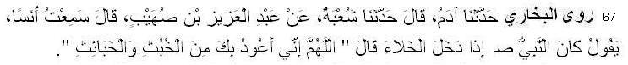
67 Bukhari narrated . . . .from Anas: Whenever the Prophet went to answer the call of nature, he used to say, "Allahumma inni a`uzu bika minal khubuthi wal khaba'ith i.e. O Allah, I seek Refuge with You from evil deeds and evil spirits.” (also Muslim, Nasai)
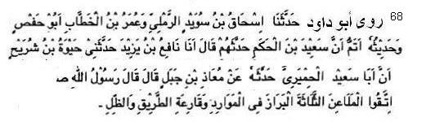
68 Abu Dawud narrated . . . .from Muaz: Allah's Messenger (pbuh) said: “Protect yourselves from three cursed acts – to defecate on places of watersource, walk-way of people and sheds for people.”
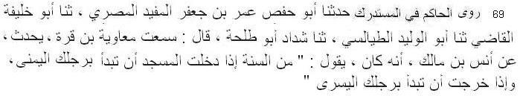
69 Hakim narrated ........... from Anas: He said: It is from sunnah that you enter into a masjid with your right leg, and leave with your left leg.
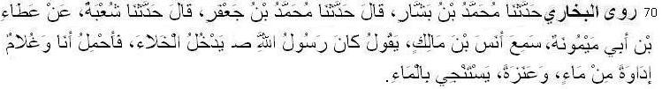
70 Bukhari narrated ........... from Anas bin Malik: Whenever the Messenger of Allah went to answer the call of nature, I along with another boy used to carry a container full of water and a short spear (or stick). He attained purity by water" (also Muslim, Nasai)
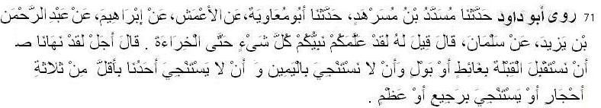
71 Abu Dawud narrated ......... from Salman al-Farsi: It was said to him (by polytheists): Your Prophet teaches you everything, even about excrement. He replied: Yes. He has forbidden us to face the qiblah at the time of easing or urinating, and cleansing with right hand, and cleansing with less than three stones, or cleansing with dung or bone. (Nasai 49, Ibn Majah 316; sahih)
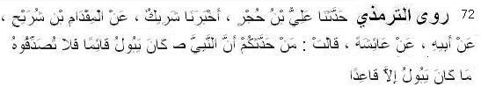
72 Tirmiji narrated ........... from Aishah: Do not believe him who say that the Messenger of Allah (pbuh) urinated standing. He never urinated except sitting. (also Ahmad sahih)

Wudu (ablution)
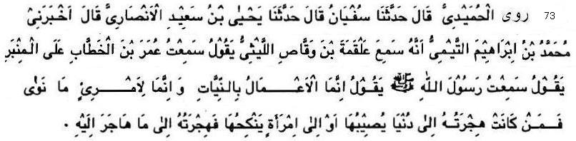
73 Humaidi narrated .............. from Umar ibnul Khattab: I heard the Messenger of Allah (pbuh) saying, "The reward of deeds depends upon the intentions and every person will get the reward according to what he has intended. So whoever emigrated for worldly benefits or for a woman to marry, his emigration was for what he emigrated for." (also Bukhari 001, Muslim 4904)
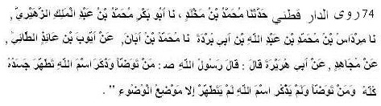
74 Daraqutni narrated ............... from Abu Hurairah: The Messenger of Allah (pbuh) said: “He who makes wudu and mentions Allah’ name it makes all his body pure. He who makes wudu and does not mention Allah’ name it makes his body- parts of wudu pure” (Daraqutni h.n. 200)
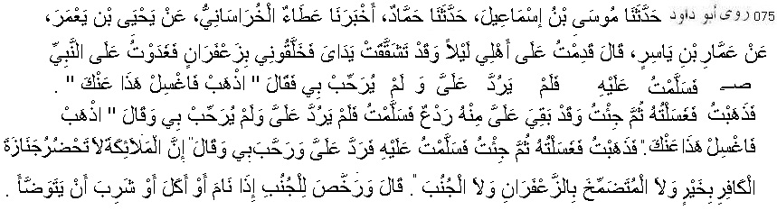
75 Abu Dawud narrated ......... from Ammar ibn Yasir: I came to my family at night (after a journey) with my hands chapped and they perfumed me with saffron. In the morning I went to the Prophet (pbuh) and gave him a greeting, but he did not respond to me nor did he welcome me. He said: Go away and wash this off yourself. I then went away and washed it off me. I came to him but there remained a spot of it on me. I give him a greeting, but he did not respond to me nor did he welcome me. He said: Go away and wash it off yourself. I then went away and washed it off me. I then came and gave him a greeting. He responded to me and welcomed me, saying: The angels do not attend the funeral of an unbeliever bringing good to it, nor a man who smears himself with saffron, nor a man who is requies obligatory bath. He said: He permitted the man who was sexually defiled to perform ablution when he slept, ate or drank. (Abu Dawud 4128; hasan)
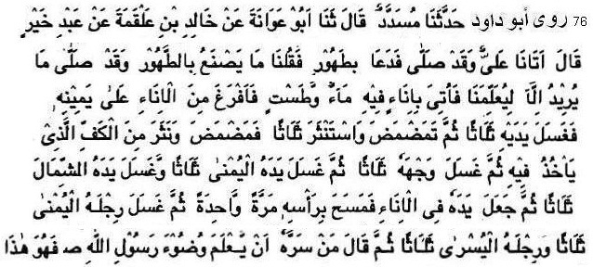
76 Abu Dawud narated .......... from Abdu Khayr: He said: Ali came upon us and he had already offered prayer. He called for water. We asked: What will he do with water when he has already offered prayer? - Perhaps to teach us. Utensil containing water and a wash-basin were brought
(to him). He poured water from the utensil on his right hand and washed both his hands three times, rinsed the mouth, snuffed up water and cleansed the nose three times. He then rinsed the mouth and snuffed up water with the same hand by which he took water. He then washed his face three times, and washed his right hand three times and washed his left hand three times. He then put his hand in water and wiped his head once. He then washed his right foot thrice and left foot thrice, then said: If one is pleased to know the method of performing ablution of the Messenger of Allah, this is how he did it. (also Nasai)
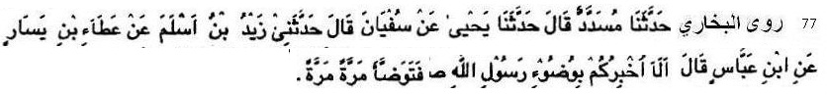
77 Bukhari narated .......... from Ibn Abbas: He said, "Shall I not inform you about wudu of Messenger of Allah (pbuh)? He used to make wudu (washing each part) once." (Sahih)
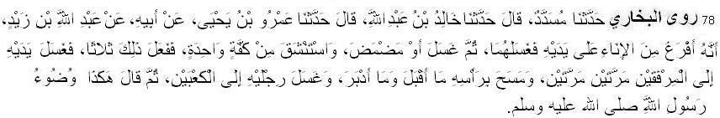
78 Bukhari narrated ................ from Abdullah Bin Zaid: “He (Allah's Messenger) poured water on his hands from a utensil containing water and washed them and then with one handful of water he rinsed his mouth and cleaned his nose by putting water in it and then blowing it out. He repeated it thrice. He, then, washed his hands and forearms up to the elbows twice and passed wet hands over his head, both forwards and backwards, and washed his feet up to the ankles and said, "This is the ablution of Allah's Messenger."
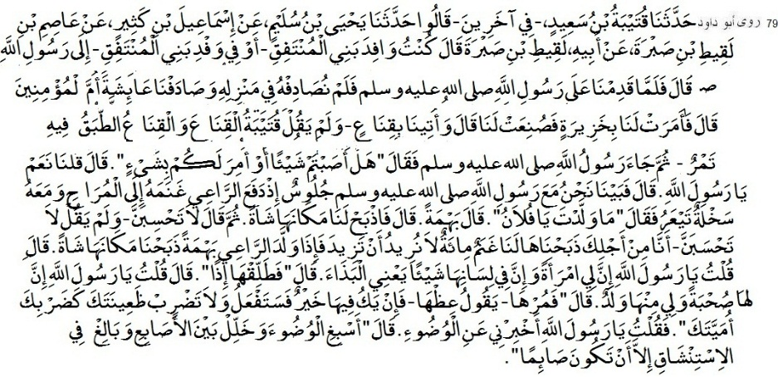
79 Abu Dawud narrated ............ ... from Laqit ibn Sabirah: I was the leader of the delegation of Banu Muntafiq or (the narrator doubted) I was among the delegation of Banu Muntafiq that came to the Messenger of Allah (pbuh). I (the narrator Laqit) then said: Messenger of Allah, I have a wife who has something (wrong) in her tongue, i.e. she is insolent. He said: Then divorce her. I said: Messenger of Allah, she had company with me and I have children from her. He said: Then ask her (to obey you). If there is something good in her, she will do so (obey); and do not beat your wife as you beat your slave-girl. I said: O Messenger of Allah, tell me about wudu. He said: Perform ablution in full and make the fingers go through the beard and snuff with water well except when you are fasting. (Abu Dawud 142, Nasai 87)
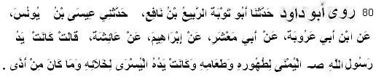
80 Abu Dawud narrated ................ from Aisha: The Prophet (pbuh) used to use his right hand for getting water for wudu (ablution) and taking food, and his left hand for his evacuation and for anything repugnant. (Ab Dawud 33)
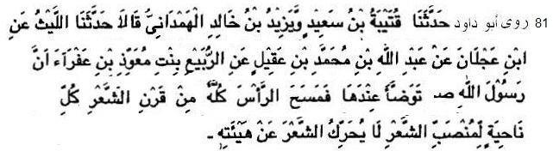
81 Abu Dawud narrated ............ from Rubayyi' daughter of Mu'awwidh bin 'Afra: The Messenger of Allah (pbuh) performed wudu in her presence. He wiped the whole of his head from its upper to the lower part moving every side. He did not move the hair from their original position. (also Ahmad; Hasan hadith)
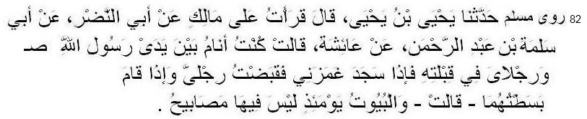
82 narrated ............... from A'isha: I was sleeping in front of the Messenger of Allah (pbuh) with my legs between him and the Qibla. When he prostrated himself he pinched me and I drew up my legs, and when be stood up, I stretched them out. She said: At that time there were no lamps in the houses. (Bukhari, Muslim)
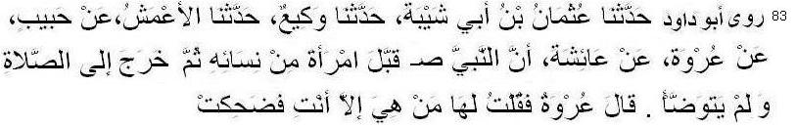
83 Abu Dawud narrated ............... from Aishah: The Prophet (pbuh) kissed one of his wives and went out for saying prayer. He did not perform ablution. Urwah said: I said to her: Who is she
except you! (Abu Dawud 179, also Ahmad, Bazzar)
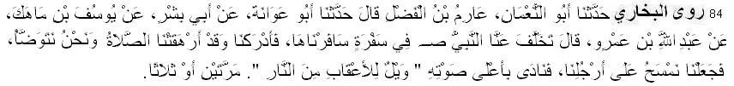
84 Bukhari narrated ............... from Abdullah bin Amr: Once the Prophet remained behind us in a journey. He joined us while we were performing ablution for the prayer which was over-due. We were just passing wet hands over our feet (and not washing them properly) so the Prophet addressed us in a loud voice and said twice or thrice: "Save your heels from the fire.". (Bukhari 60, also Muslim 242)

Bath (Gusl)
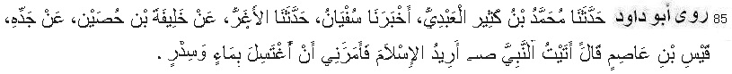
85 Abu Dawud narrated ......from Qays. He said, I came to the Prophet (pbuh) with the intention of embracing Islam. He commanded me to take a bath with water (boiled with) the leaves of the lote-tree. (also Tirmizi; sahih)
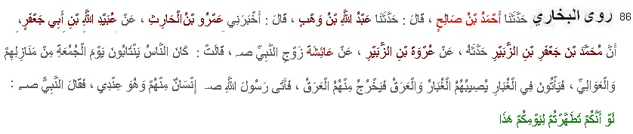
86 Bukhari narrated ...... from Aisha, the wife of the Messenger of Allah (pbuh); The people used to come from their abodes and from Al-`Awali (i.e. outskirts of Medina). They used to pass through dust and used to be drenched with sweat and covered with dust; so sweat used to trickle from them. One of them came to Allah's Messenger (pbuh) who was in my house. The Prophet (pbuh) said to him, "I wish that you keep yourself clean on this day of yours (i.e. take a bath)."
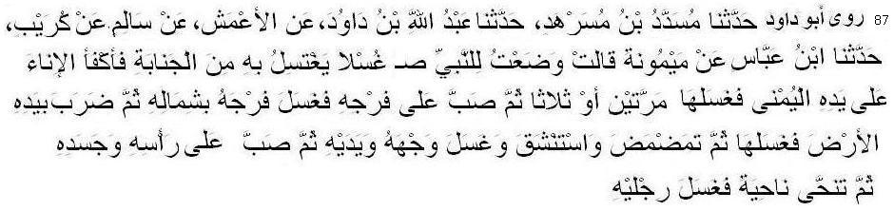
87 Abu Dawud narrated ............ from Maimunah reported: I placed (the vessel of) water for the Messenger of Allah (pbuh) to wash himself because of major impurity. He lowered down the vessel and poured water on his right hand. He then washed it twice or thrice. He then poured water over his private parts and washed them with his left hand. Then he put it on the ground and wiped it. He then rinsed his mouth and snuffed up water, and washed his face and hands. He then poured water over his head and body. Then he moved aside and washed his feet.

The Quran
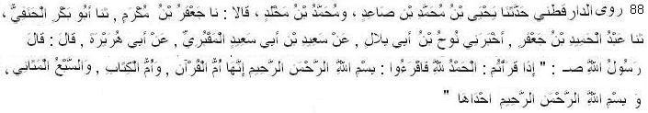
88 Daraqutni narrated ............ from Abu Hurairah: The Messenger of Allah (pbuh) said: When you recite Alhamdulillah you should also recite <<Bismillahir Rahmanir Raheem>>.
Certainly that is Ummul Quran, Ummul Kitab and the Seven oft-repeated Verses. and <<Bismillahir Rahmanir Raheem>> is one of it.
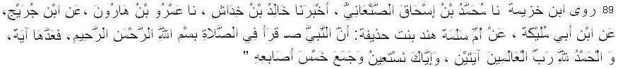
89 Ibn Khuzaimah narrated ............ from Umm Salama Hind: The Messenger of Allah (pbuh) recited Bismillahir-Rahmanir-Raheem in salaah and counted it a verse (with his finger) then he recited . <<Al hamdu lillahi Rabbil Alameen>> and counted it as the second.
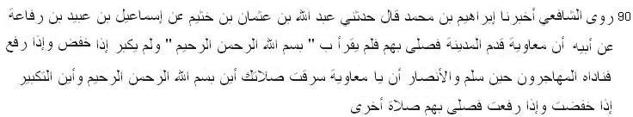
90 Shafei narrated ............ from Anas: Muawiyah once came to Madinah and led led the prayers in Madinah and did not recite Bismillah. The Muhajir and Ansar companions (who were present at that prayer) called him and said: Have you forget where Bismillah is in the Opening of the Quran? When Mu`awiyah led the following prayer, he recited the Bismillah aloud. (alsoHakim, Bayhaqi)
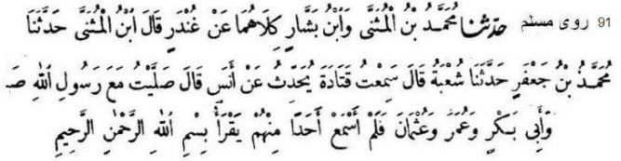
91 Muslim narrated ............... from Anas: I prayed once behind the Messenger of Allah (pbuh), Abu Bakr, Umar and Uthman and I never heard any of them reciting Bismillahir-Rahmanir-Raheem loudly. (also Nasai)
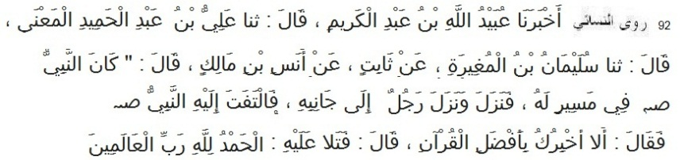
92 Nasai narrated (in sunan Kubra) ............. from Anas: Once I was behind the Messenger of Allah (pbuh) in a journey. A man came. The Messenger of Allah (pbuh) said to him, “Shall I not inform you the Best surah in the Quran?” He said: Yes. The Messenger of Allah (pbuh) said,
“Al hamdu lillahi Rabbil Alameen.” (Sunan kubra 7695, also Ibn Hibban 781 Hakim 1991; sahih)
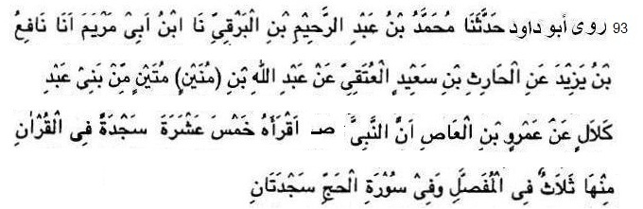
93 Abu Dawud narrated ................... from Amr ibnul 'As: The Prophet (pbuh) taught me fifteen prostrations while reciting the Qur'an, including three in al-Mufassal and two in Surah al-Hajj. (also Ibn Mazah; sahih)
Virtue of the Quran
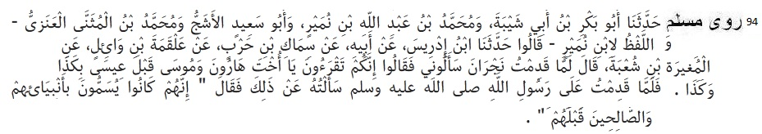
94 Muslim narrated ............ Mughira b. Shu'ba reported: When I came to Najran, they (the Christians of Najran) asked me: You read" O sister of Harun" (i. e. Maryam) in the Quran, whereas Moses was born much before Jesus. When I came back to Allah's Messenger (pbuh) I asked him about that, whereupon he said: The (people of the old age) used to give names (to their persons) after the names of Apostles and pious persons who had gone before them.
95 Tirmiji narrated ................... from Ibn Mas’ud: The Prophet (pbuh) said: Whoever reads reads a letter of the Book of Allah will be credited with a good deed, and a good deed gets a tenfold reward. I do not say that ALM is one harf. Rather A is one harf. L is one harf. M is one harf. (Tirmizi 2910)
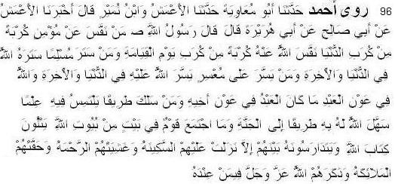
96 Ahmad narrated ............... from Abu Hurayra: The Messenger of Allah (pbuh) said, .......... ........... No people gather in a house of the houses of Allah reciting the Book of Allah and studying it among themselves except that serenity descends upon them, mercy envelops
them, the angels surround them, and Allah makes mention of them to those with Him. (Ahmad 7118; also Muslim)
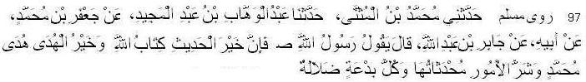
97 Muslim narrated ............... from Jabir: The Prophet (pbuh) said: The best speech is Book of Allah, and the best guidance is the guidance of Muhammad, and the worst matters are the innovations and and every innovation is asrtay. (also Tirmiji)
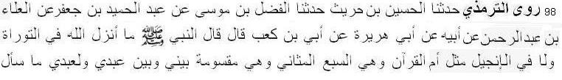
98 Nasai narrated ....................... from Ubayy bin Kaab: The Prophet (pbuh) said: No surah, like surah Fatiha had been sent down in Torah, Inzil, Zabur and even in the Quran. This is the oft-repeated Seven. (Nasai 914; also Ahmad, Tirmiji)
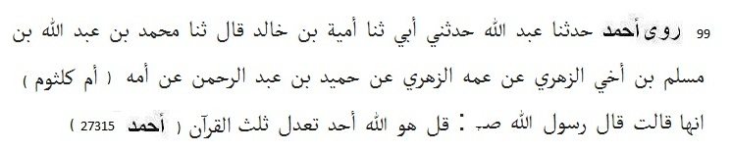
99 Ahmad narrated ................. from Umm Kulthum bint Uqba: The Prophet (pbuh) said: Qul huwaAllahu Ahad (surah Ikhlas) is equal to one-third of the Quran. (sahih)
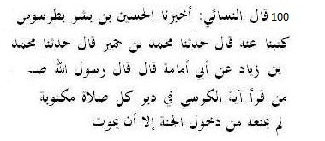
100 Nasa'i narrated (in Amalul yawmi wal lailah) ................. from Abu Umamah Al-Bahili: The Messenger of Allah (pbuh) said: “Whoever recites Ayat al-Kursi immediately after each prescribed prayer, there will be nothing standing between him and his entering Paradise except death.” [Amalul yawmi wal lailah 100, Ibn Hibban, Tabarani, ibn Hibban; Sahih]
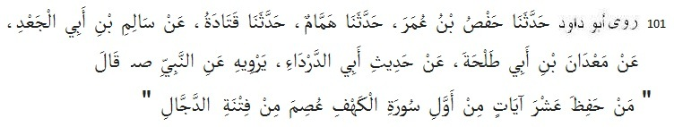
101 Abu Dawud narrated .......... from Abud Darda: The Prophet (pbuh) said: He who memorises the first ten verses of Kahf (18), will be kept safe from (test of) Dajjal. [also Ahmad]
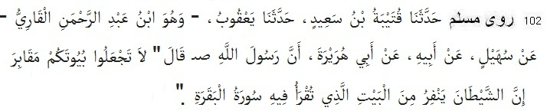
102 Muslim narrated ............. from Abu Hurairah: The Prophet (pbuh) said: Do not make your houses graves. Certainly Satan flees from the house in which surah Baqarah is recited.
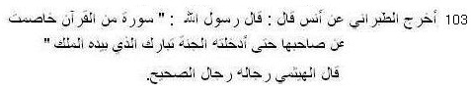
103 Tabarani narrated ............. from Anas ibn Malik: The Messenger of Allah (pbuh) said, “There is a Surah which will plead for its reciter till it causes him to enter paradise. That is Tabarakallazi biyadihil Mulk.” [Tabarani in Muzam Sagir; Haithami said: all narrators are reliable]
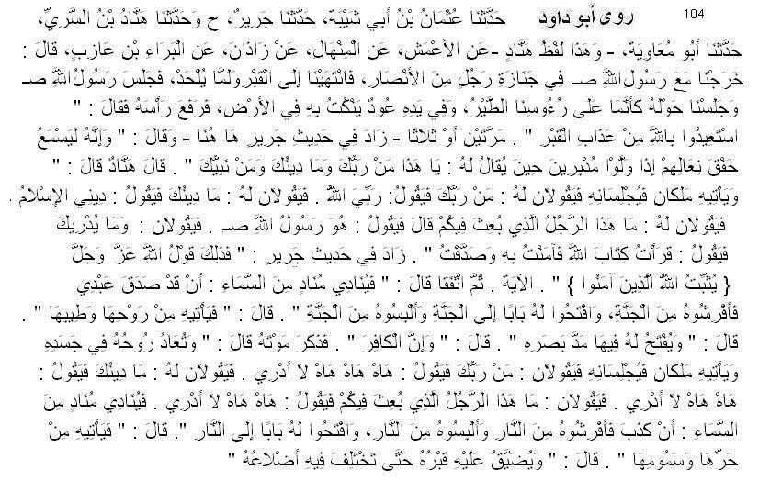
104 Abu Dawud narrated ......... from Bara' bin 'Azib: We went out with the Messenger of Allah (pbuh) accompanying the bier of a man of the Ansar. When we reached his grave, it was not yet dug. So the Messenger of Allah (pbuh) sat down and we also sat down around him as if birds were over our heads. He had in his hand a stick with which he was scratching the ground. He then raised his head and said: Seek refuge with Allah from the punishment in the grave. He said it twice or thrice.
The version of Jabir adds here: He hears the beat of their sandals when they go back, and at that moment he is asked: O so and so! Who is your Lord, what is your religion, and who is your Prophet? Hannad's version says: Two angels will come to him, make him sit up and ask him: Who is your Lord? He will reply: My Lord is Allah. They will ask him: What is your religion?
He will reply: My religion is Islam. They will ask him: What is your opinion about the man who was sent on a mission among you? He will reply: He is the Messenger of Allah (pbuh). They will ask: Who made you aware of this? He will reply: I read Allah's Book, believed in it, and considered it true; which is verified by Allah's words: "Allah's Book, believed in it, and considered it true, which is verified by Allah's words: "Allah establishes those who believe with the word that stands firm in this world and the next."
The agreed version reads: Then a crier will call from Heaven: My servant has spoken the truth, so spread a bed for him from Paradise, clothe him from Paradise, and open a door for him into Paradise. So some of its air and perfume will come to him, and a space will be made for him as far as the eye can see. He also mentioned the death of the infidel, saying: His spirit will be restored to his body, two angels will come to him, make him sit up and ask him: Who is your Lord? He will reply: Alas, alas! I do not know. They will ask him: What is your religion? He will reply: Alas, alas! I do not know. They will ask: Who was the man who was sent on a mission among you? He will reply: Alas, alas! I do not know. Then a crier will call from Heaven: He has lied, so spread a bed for him from Hell, clothe him from Hell, and open for him a door into Hell. Then some of its heat and pestilential wind will come to him, and his grave will be compressed, so that his ribs will be crushed together. [Ahmad from Anas, Bara and Jabir, Abu Dawud from Bara' bin 'Azib, Tirmiji 989 from Abu Hurairah, Bukhari from Bara and Anas, Muslim from Anas Abd bin Humaid from Anas; hadith is sahih]
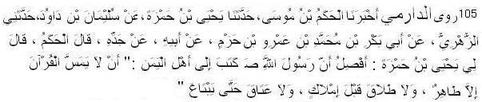
105 Daremi narrated ............from Abu Bakr bin Muhammad bin Amr: The Messenger of Allah (pbuh) gave a letter to people of Yemen. In this letter it was written, No person shall touch the Quran except the purified. No divorce before marriage and no emancipation before buying the slave. (sahih; Malik mentions only touching Quran, Ibn Mazah and Ibn abu Shaibah mentions divorce and emancipation)
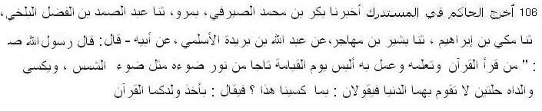
106 Narrated Hakim (in Mustadrak) . . .. from Buraidah: The Messenger of Allah (pbuh) said, Who recites the Quran and acts according to it will be coronated by a crown of Light. His parents will be adorned by sets of dress - world cannot assess its cost. They will say: Why have they been adorned? It will be said: Because your child had grasped the Quran.
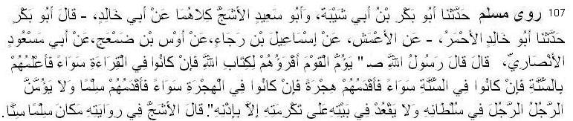
107 Muslim narrated ............... from Abu Mas'ud Ansari: The Messenger of Allah (pbuh) said: “The one who is most versed in Allah's Book should act as Imam for the people, but If they are equally versed in reciting it, then the one who has most knowledge regarding Sunnah. If they are equal regarding the Sunnah, then the earliest one to emigrate; it they emigrated at the same time, then the earliest one to embrace Islam. No man must lead another in prayer where (the latter) has authority, or sit in his place of honour in his house, without his permission.” Ashajj in his narration used the word," age" in place of" Islam". (also Nasai)
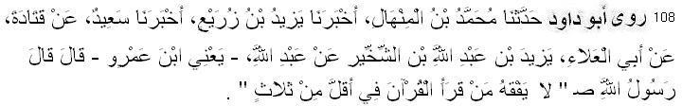
108 Abu Dawud narrated .......... from Abdullah bin Amr: The Prophet (pbuh) said, "He who recites the (entire) Quran in a period less than three days does not understand it.” (also Tirmiji, Ibn Mazah)
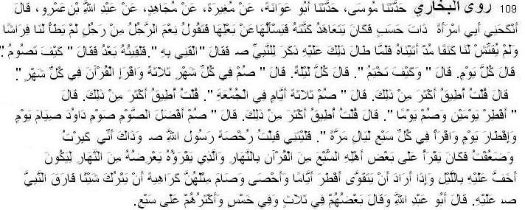
109 Bukhari narrated .......... from Abdullah bin Amr: "My father got me married to a lady of a noble family, and often used to ask my wife about me, and she used to reply, "What a wonderful man he is! He never comes to my bed, nor has he approached me since he married me." When this state continued for a long period, my father told the story to the Prophet who said to my father, "Let me meet him." Then I met him and he asked me, "How do you fast?" I replied, "I fast daily," He asked, "How long does it take you to finish the recitation of the whole Qur'an?" I replied, "I finish it every night." On that he said, "Fast for three days every month and recite the Qur'an (and finish it) in one month." I said, "But I have power to do more than that." He said, "Then fast for three days per week." I said, "I have the power to do more than that." He said, "Therefore, fast the most superior type of fasting, the fasting of David who used to fast every alternate day; and finish the recitation of the whole Qur'an In seven days." I wish I had accepted the permission of Allah's Messenger as I have become a weak old man. It is said that `Abdullah used to recite one-seventh of the Qur'an during the day-time to some of his family members, for he used to check his memorization of what he would recite at night during the daytime so that it would be easier for him to read at night. And whenever he wanted to gain some strength, he used to give up fasting for some days and count those days to fast for a similar period, for he disliked to leave those things which he used to do during the lifetime of the Prophet.
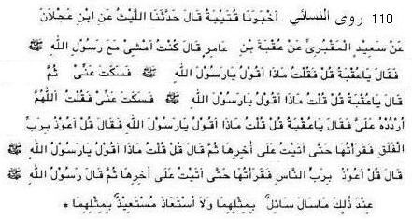
110 Nasai narrated .......... from Uqbah bin Amer, The Prophet (pbuh) said, “Say Qul Auzu bi Rabbil falaq.” I recited. He said, Say Qul Auzu bi Rabbin Naas. I recited. He said, A suppicant cannot supplicate like this one and a refugee cannot seek refuge in a better way than through these two surahs. (Nasai 5438)
Virtue of Salaah
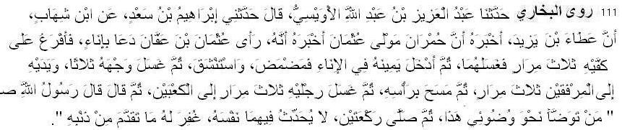
111 Bukhari narrated ............ from Humran: I saw Uthman bin Affan asking for a water container. (When it was brought) He poured water over his hands and washed them thrice and then
put his right hand in the water container and rinsed his mouth, washed his nose by putting water in it and then blowing it out. then he washed his face and forearrlns up to the elbows thrice, passed his wet hands over his head and washed his feet up to the ankles thrice. Then he said, "Allah's Messenger (pbuh) said 'If anyone Performs ablution like that of mine and offers a two-rak'at prayer during which he does not think of anything else (not related to the present prayer) then his past sins will be forgiven.' "After performing the ablution Uthman said, "I am going to tell you a Hadith which I would not have told you, had I not been compelled by a certain Holy Verse (the sub narrator Urwa said: This verse is: "Verily, those who conceal the clear signs and the guidance which we have sent down...)" (2:159). I heard the Prophet (pbuh) saying, 'If a man performs ablution perfectly and then offers the compulsory congregational prayer, Allah will forgive his sins committed between that (prayer) and the (next) prayer till he offers it." (also Muslim)
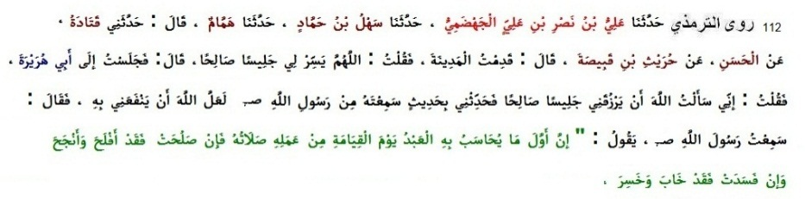
112 Tirmiji narrated .......... from Abu Hurairah: The Prophet (pbuh) said, "The first action a person is held accountable for on the Day of Recompense is Salah. If it is complete, his entire actions shall be complete, however it is incomplete, his entire action shall be incomplete." [Tabarani in Muzam Awsat; sahih]
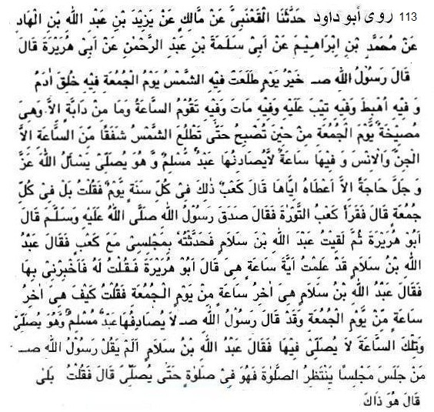
113 Abu Dawud narrated .......................... from Abu Hurayrah: The Messenger of Allah (pbuh) said: The best day on which the sun has risen is Friday; on it Adam was created, on it he was expelled (from Paradise), on it his contrition was accepted, on it he died, and on it the Last
Hour will take place. On Friday every beast is on the lookout from dawn to sunrise in fear of the Last Hour, but not jinn and men, and it contains a time at which no Muslim prays and asks anything from Allah but He will give it to him. Ka'b said: That is one day every year. So I said: It is on every Friday. Ka'b read the Torah and said: The Messenger of Allah (pbuh) has spoken the truth. AbuHurayrah said: I met Abdullah ibn Salam and told him of my meeting with Ka'b. Abdullah ibn Salam said: I know what time it is. Abu Hurayrah said: I asked him to tell me about it. Abdullah ibn Salam said: It is at the very end of Friday. I asked: How can it be when the Messenger of Allah (pbuh) has said: "No Muslim finds it while he is praying...." and this is the moment when no prayer is offered. Abdullah ibn Salam said: Has the Messenger of Allah (pbuh) not said: "If anyone is seated waiting for the prayer, he is engaged in the prayer until he observes it." I said: Yes, it is so. (Abu Dawud 1046, Ahmad, Ibn Mazah 1139, Nasai 1430)
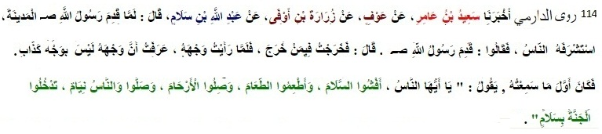
114 Daremi narrated ............ from Abdullah ibn Salam: The first words I heard the Prophet (pbuh) say were: 'O people! Spread peace. Share food. Keep good relations with your kith and kin.
Pray during the night while people sleep. Then you will enter Paradise in peace. Abu Isa Tirmiji said this hadith is sahih. (also Ahmad, Ibn Majah, Tirmiji; Sahih. In Tirmiji’s narration “Keep good relations with your kith and kin” is missing.)
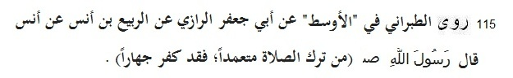
115 Tabarani narrated ............ from Anas: The Prophet (pbuh) said, “He who neglects salaah deliberately comits evident Kufr.” (Muzam Awsat; some say this hadith is weak as Abu Jafar is Zaif. but Suyuti says it is sahih as Abu Jafar is saduq or truthful.)
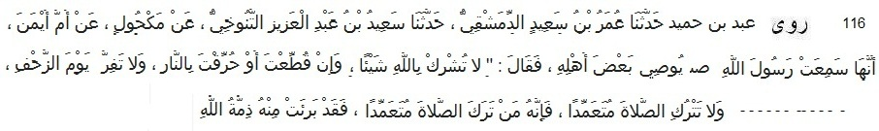
116 Abd bin Humaid narrated ............ from Umm Ayman Barakah, the baby-sitter of the Prophet: The Prophet (pbuh) said, “Do not associate anyone beside Allah even if you are chopped into pieces or burnt. - - - - - - - - Do not give up (mandatory) prayer. Allah and his Messenger are free from him who neglects salaah deliberately.” (also Ibn Asakir and Bayhaqi; chain is hasan or good.)
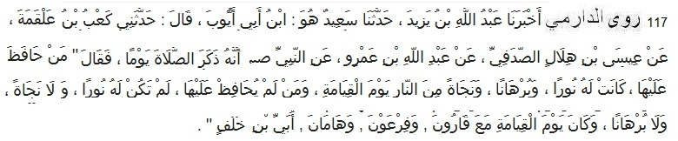
117 Daremi narrated ............ from Abdullah ibn Amr: The Prophet (pbuh) said, “He who cares for salaah, it will be light, evidence and way of salvation for him on the day of Resurrection. And He who does not care for salaah, it will not be light, evidence, and way of salvation for him. And he will be brought with Korah, Pharaoh, Haman and Ubayy bin Khalaf on the day of Resurrection. (also Ahmad, Abd bin Humaid, Ibn Hibban; hadith is sahih or at least hasan)
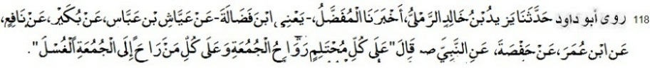
118 Abu Dawud narrated ............ from Hafsa bint Umar: The Prophet (pbuh) said, It is necessary for every adult (person) to go for (saying) Friday (prayer), and for everyone who goes for Friday (prayer) washing is necessary.” (also Nasai)
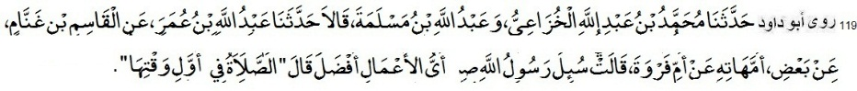
119 Abu Dawud narrated ............ from Umm Farwah (sister of Abu Bakr): The Messenger of Allah (pbuh) was asked: Which of the actions is best? He replied: Observing prayer early in its period. (also Ahmad, Tirmiji; sahih)
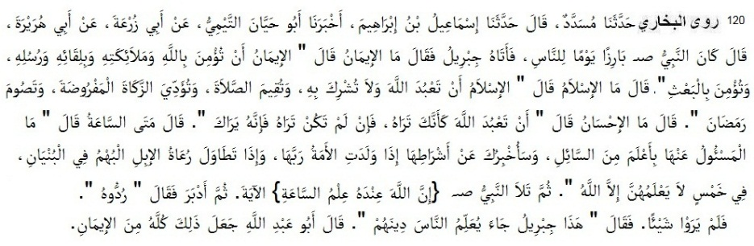
120 Bukhari narrated ............ from Abu Huraira: One day while the Prophet was sitting in the company of some people, (The angel) Gabriel came and asked, "What is faith?" Allah's Messenger replied, 'Faith is to believe in Allah, His angels, (the) meeting with Him, His Messengers, and to believe in Resurrection." Then he further asked, "What is Islam?" Allah's Messenger replied, "To worship Allah Alone and none else, to offer prayers perfectly to pay the compulsory charity (Zakat) and to observe fasts during the month of Ramadan."
Then he further asked, "What is Ihsan (perfection)?" Allah's Messenger replied, "To worship Allah as if you see Him, and if you cannot achieve this state of devotion then you must consider that He is looking at you." Then he further asked, "When will the Hour be established?" Allah's Messenger replied, "The answerer has no better knowledge than the questioner. But I will inform you about its portents.
1. When a slave (lady) gives birth to her master. 2. When the shepherds of black camels start boasting and competing with others in the construction of higher buildings. And the Hour is one of five things which nobody knows except Allah.
The Prophet (pbuh) then recited: "Verily, with Allah (Alone) is the knowledge of the Hour--." (31. 34) Then that man (Gabriel) left and the Prophet asked his companions to call him back, but they could not see him. Then the Prophet said, "That was Gabriel who came to teach the people their religion."

Entering a Masjid
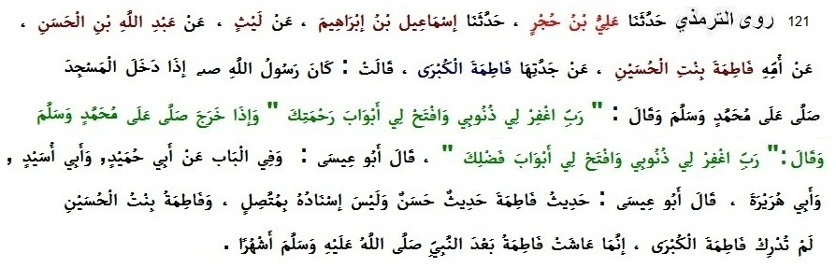
121 Tirmiji narrated ............ from Fatimah, daughter of Husain from her grandmother Fatimah the Great (daughter of the Prophet): "When Allah's Messenger (pbuh) entered the Masjid he said Salat and Salam upon Muhammad and then said: (Rabbighfirli junubi, waftahli abwaba rahmatik) 'O pardon my sins, and open the gates of Your mercy for me.' And when he exited he said Salat and Salam upon Muhammad, and then said: (Rabbighfirli junubi, waftahli abwaba rakmatik) 'O Lord pardon my sins, and open the gates of Your blessings for me.'" Similar hadith is from Abu Hurairah. Tirmiji said: This hadith of Fatimah is hasan although sanad is not muttasil. Because Fatimah bint Husain did not meet Fatimah the Great who survived upto several month after death of the Prophet. (also Ahmad, Ibn Abu Shaibah, Daremi, Ibn Mazah. Notice the missing link between Faitmah the Great and Fatimah Junior may be Husain or any other family member. All other narrators trustworthy. Hence the hadith is acceptable to Tirmiji and many others.)
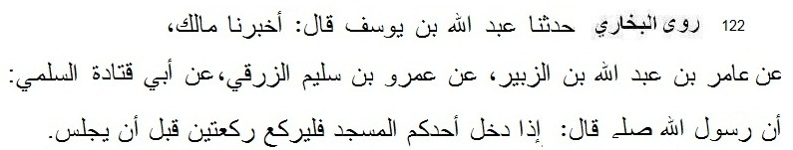
122 Bukhari narrated ............ from Abu Qatada: The Messenger of Allah (pbuh) said, "If one of you enters the mosque, do not sit until you pray two rakats (of prayer)." [also Muslim]

Prayer Time
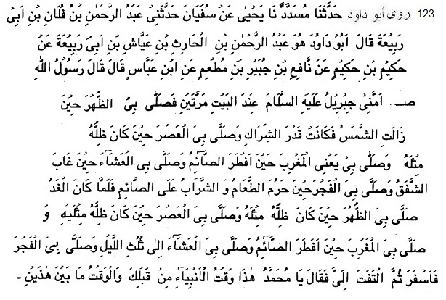
123 Abu Dawud narrated ............ from Ibn Abbas: The Messenger of Allah (pbuh) said: Gabriel led me in prayer at the House (i.e. the Ka'bah). He prayed the noon prayer with me when the sun had passed the meridian to the extent of the thong of a sandal; He prayed the afternoon prayer with me when the shadow of everything was as long as itself; He prayed the evening prayer with me when one who is fasting breaks the fast; He prayed the night prayer with me when the twilight had ended; And he prayed the dawn prayer with me when food and drink become forbidden to one who is keeping the fast. On the following day he prayed the noon prayer with me when his shadow was as long as himself; He prayed the afternoon prayer with me when his shadow was twice as long as himself; He prayed the evening prayer at the time when one who is fasting breaks the fast; He prayed the night prayer with me when about one-third of the night had passed; And he prayed the dawn prayer with me when there was a fair amount of light. Then turning to me he said: Muhammad, this is the time observed by the prophets before you, and the time is anywhere between two times. (Abu Dawud: Hadith No. 393, Tirmiji 149, Ahmad, daraqutni, Abdul Qadir Jilani in Guniatu Talibeen; sahih)
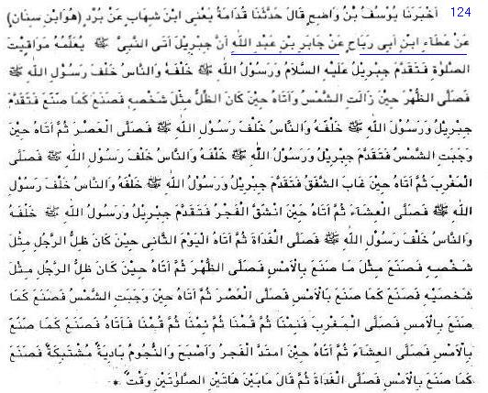
124 Nasai narrated ..... ...... from Jabir b. Abdullah: Gabriel came to teach the Messenger of Allah (pbuh) prayer times. Gabriel stood in front, the prophet stood behind him and people stood behind him. He prayed the noon prayer when the sun had passed the meridian. When the shadow of
everything was as long as itself; Gabriel came again, he stood in front, the prophet stood behind him and people stood behind him. He prayed the afternoon prayer. After the sunset Gabriel came, he stood in front, the prophet stood behind him and people stood behind him. He prayed the evening prayer. When the the twilight had ended, Gabriel came again; he stood in front, the prophet stood behind him and people stood behind him. He prayed the night prayer. At the beginning of Fazr, Gabriel came; he stood in front, the prophet stood behind him and people stood behind him. He prayed the Fazr prayer. On the next day Gabriel came when the shadow of everything was as long as itself; and he prayed the noon prayer. He came again when shadow of everything was twice as long as itself; and he prayed the afternoon prayer.
Gabriel prayed the evening prayer after the sunset. We slept; thn we rose and again slept and rose. Then Gabriel came and prayed the night prayer. Gabriel came; at Fazr, and the stars were visble (in the sky) he prayed the Fazr prayer. He said: the prayer times are prescribed between the times of two days. (Nasai 513, Abu Dawud 418; sahih)
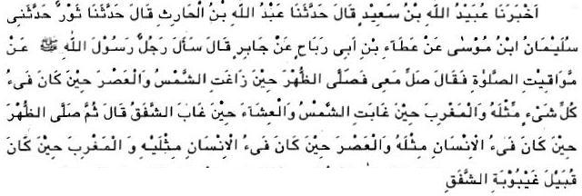
125 Nasai narrated ................. from Jabir b. Abdullah: A man asked the Prophet (pbuh) about times of prayer. He said: Pray with us. He prayed the noon prayer when when the sun had passed the meridian. He prayed the afternoon prayer when the shadow of everything was as long as itself; He prayed the evening prayer after the sunset. The next day he prayed the noon prayer when the shadow of everything was as long as itself; and and he prayed the afternoon prayer when shadow of everything was twice as long as itself.He prayed the evening prayer before the disappearance of the twilight. (Nasai 504, sahih)
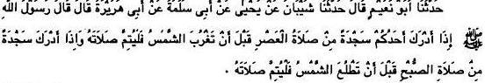
126 Muslim narrated ............. from Abu Haurairah and Aishah: The Prophet (pbuh) said, When anyone of you gets one sijdah of the 'Asr prayer before sunset, he should complete the
prayer. When he gets one sijdah of the Fazr prayer before sunrise, he should complete the prayer. (Muslim)
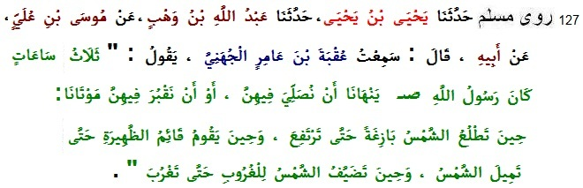
127 Muslim narrated ......... from Uqbah bin Amir: “There are three times that Messenger of Allah (pbuh) prohibited us from performing salaah or burying our dead: When the sun’s rising appears until it has risen up; when the sun is at the zenith until it passes; and when the sun begins its setting until it has set.” (also Nasa’i 2015, Tirmidhi 1030, Ibn Majah 1519)
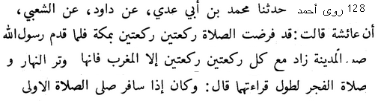
128 Ahmad narrated ......... Aishah said: "The salah was made fard in Makkah in sets of two rak'at. When the Prophet, pbuh, came to Madinah, two rak'at were added to each salah except the maghrib salah because it is the witr of the daytime, and the dawn prayer due to its lengthy Quranic recital. But if one travels, he performs the original prayer [i.e., only two rak'at]." (also Baihaqi, Ibn Mazah, and Ibn Khuzaimah)
Call (Azan) and Second Call (Iqamah)
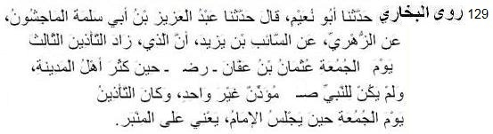
129 Bukhari narrated ......... from Saib bin Yazid: The person who increased the number of Azans for the Jumua prayers to three was Uthman bin Affan and it was when the number of the people of Medina had increased. In the lifetime of the Prophet (pbuh) there was only one Muazzin and the azan used to be pronounced only after the imam had taken his seat.
Azan and Iqamah can be given in two ways. First method is as Abdullah bin Zaid taught by the Prophet (pbuh).
And second method of azan is as Abu Mahzura taught by the Prophet (pbuh).
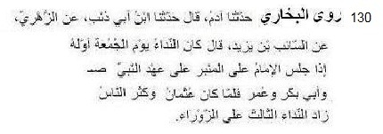
130 Bukhari narrated .............. from As-Saib bin Yazid: In the lifetime of the Prophet (pbuh), Abu Bakr and Umar, the azan for the Jumuah prayer used to be pronounced when the Imam sat on the pulpit. But during the Caliphate of Uthman, when the Muslims increased in number, a third azan at Zaura was added."
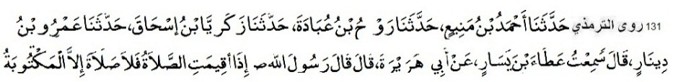
131 Tirmiji narrated .............. from Abu Hurairah: The Prophet (pbuh) said, 'When the Iqamah for prayer is said, there is no prayer except the obligatory prayer. (also Abu Dawud, Nasai)
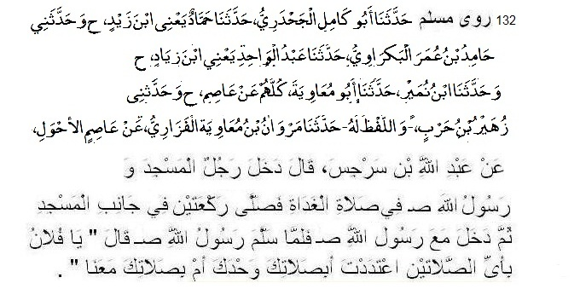
132 Muslim narrated .............. from Abdullah bin Sarzis: A person entered the mosque, while the Messenger of Allah (pbuh) was leading the dawn prayer. He observed two rak'ahs in a corner of the mosque, and then joined the Messenger of Allah (pbuh) in prayer. When the Messenger of Allah (pbuh) had pronounced salutations (he had concluded the prayer), he said: O, so and so, which one out of these two prayers did you count (as your Fard prayer), the one that you observed alone or the prayer that you observed with us? (also Nasai)

Jamaah (Congregation) and Saff of Salaah
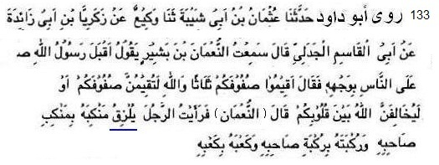
133 Abu Dawud narrated .................. from Numan bin Bashir: The Prophet (pbuh) came to people and said: Straighten your rows, (three times) by Allah! You must make your rows straight; or Allah will make conflict among you.” He (Numan) said: I saw every one have attached his shoulder with the shoulder of his companion and his foot with the foot and heel with heel. (Abu Dawud 662)
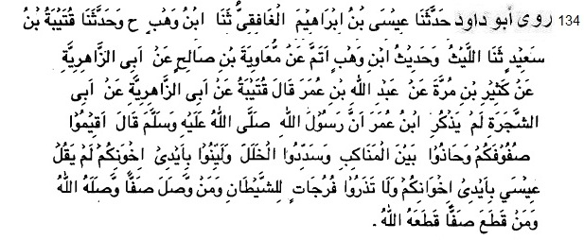
134 Abu Dawud narrated ................ from Abdullah ibn Umar: The Prophet (pbuh) said: Set the rows in order, stand shoulder to shoulder, close the gaps, be pliant in the hands of your
brethren, and do not leave openings for Saten. If anyone joins up a row, Allah will join him up, but if anyone breaks a row, Allah will cut him off. (Ahmad, Abu Dawud 666)
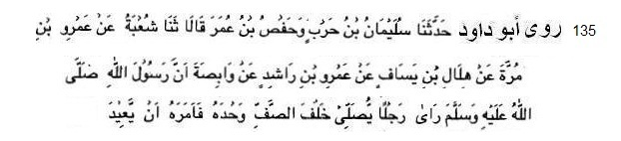
135 Abu Dawud narrated ................ from Wabisah bin Mabad: The Messenger of Allah (pbuh) saw a man praying alone behind the row. He ordered him to repeat. (Ahmad, Abu Dawud 682, Ibn Majah; the hadith is sahih according to Ibn Hibban and hasan according to Tirmiji)
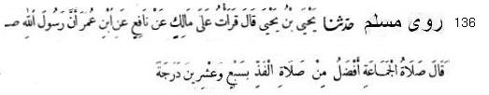
136 Narrated Ibn Umar: The Prophet (pbuh) said: “Prayer in congregation is superior to prayer alone by twenty seven degrees.” (Nasai 837, Ahmad, Bukhari, Muslim)
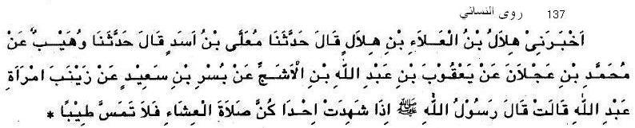
137 Nasai narrated ............ from Jainab bint Abu Muawiyah: The Prophet (pbuh) said to us: When any one of you comes to the mosque, .she must not use perfume. (Muslim)
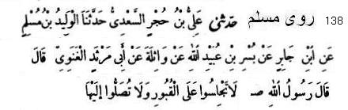
138 Muslim narrated from ............ Abu Marsad Ganawi: The Prophet (pbuh) said: “Do not sit on graves and do not perform Salat facing them.”
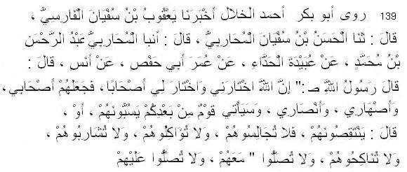
139 Abu Bakr Ahmad al-Khallal narrated ............ from Anas: The Prophet (pbuh) said: “Allah has selected me and picked out my companions. He also granted me friends, brothers and relatives by marriage. There will be another generation thereafter who will revile and disparage them. Therefore, you should not interact with them in food, drink marriage, prayer over them or prayer with them." [also in Hakim, Daraqutni, Shafei partially]
Acts in salaah
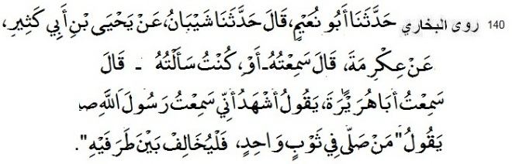
140 Bukhari narrated ............ from Abu Hurairah: The Prophet (pbuh) said, “When somebody prays in a single garment he should cross its ends (to cover armpit).”
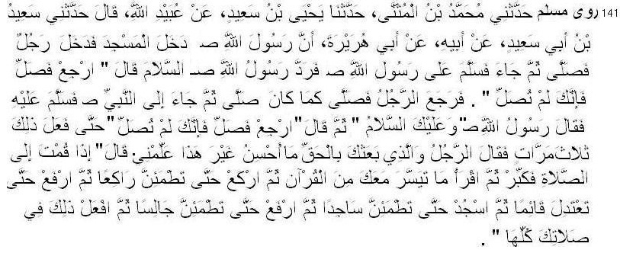
141 Muslim narrated .................. from Abu Huraira: The Messenger of Allah (pbuh) entered the mosque and a person also entered therein and offered prayer, and then came and paid salutation to the Messenger of Allah (pbuh). The Messenger of Allah (pbuh) returned his salutation and said: Go back and pray, for you have not offered the prayer. He again prayed as he had prayed before, and came to the Messenger of Allah (pbuh) and saluted him.The Messenger of Allah (pbuh) returned the salutation and said: Go back and say prayer, for you have not offered the prayer.
This (act of repeating the prayer) was done three times. Upon this the person said: By Him Who has sent you with truth, whatever better I can do than this, please teach me. He said: When you get up to pray, recite takbir, and then recite whatever you conveniently can from the Qur'an, then bow down and remain quietly in that position, then raise yourself and stand erect; then prostrate yourself and remain quietly in that attitude; then raise yourself and sit quietly; and do that throughout all your prayers. (also Bukhari, Nasai)
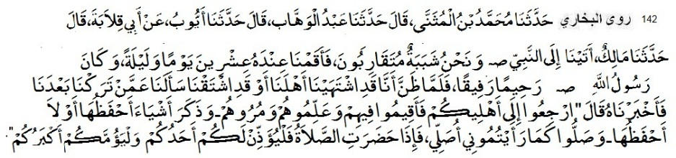
142 Bukhari narrated ............ from Malik bin Huwairith: We came to the Prophet (pbuh) and stayed with him for twenty days and nights. We were all young and of about the same age. The Prophet (pbuh) was very kind and merciful. When he realized our longing for our families, he asked about our homes and the people there and we told him.
Then he asked us to go back to our families and stay with them and teach them (the religion) and to order them to do good things. He also mentioned some other things which I have remembered or forgotten (some portion). The Prophet (pbuh) then added, "Pray as you have seen me praying and when it is the time for the prayer one of you should pronounce the azan and the oldest of you should lead the prayer. (Bukhari, Muslim)
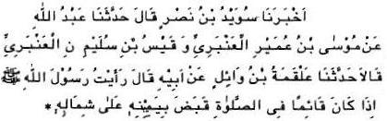
143 Nasai narrated .... ... from Wail bin Hujr; He said, ‘I saw the Prophet (pbuh) that he used to place his right hand over his left while he had been standing in salaah. (sahih)
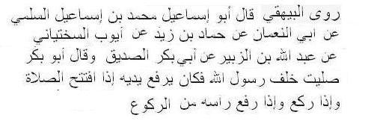
144 Bayhaqi narrated ............. from Abu Bakr. Abu Bakr says, “I prayed with the Prophet (pbuh). He used to raise his hands at the beginning of prayer, and when he bowed he did the same; and he did the same when lifted his head from bowing.” (Bayhaqi, Zuj Raful yadain by Bukhari; sahih)
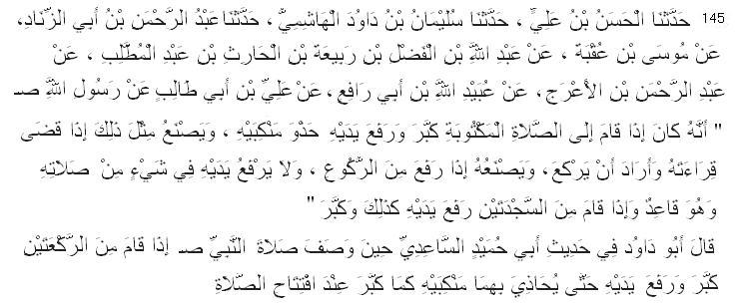
145 Abu Dawud narrated ............. from Ali ibn Abu Talib: When the Messenger of Allah (pbuh) stood for offering the obligatory prayer, he uttered the takbir and raised his hands opposite to his shoulders; and he did like that when he finished recitation and was about to bow; and he did like that when he rose after bowing; and he did not raise his hands in his prayer while he was in his sitting position. When he stood up from his prostrations he raised his hands likewise and uttered the takbir. Abu Dawud said: In hadith of Abu Humaid Saeedi it is mentioned : When he stood up from (end of) two rak'ahs, he raised his hands likewise and uttered the takbir and raised his hands so as to bring them up to his shoulders, as he uttered the takbir in the beginning of the prayer. (Abu Dawud, Ahmad, Ibn Mazah; Ahmad said: hadith is sahih)
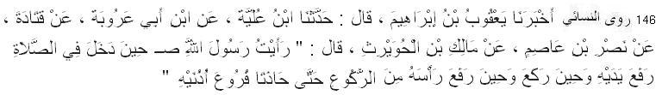
146 Nasai narrated ............. from Malik ibnul Huwairith: “I saw the Messenger of Allah (pbuh) raise his hands until they reached the highest part of his ears, when he entered inro salaah, when he bowed and when he raised his head from bowing.” (Sahih)
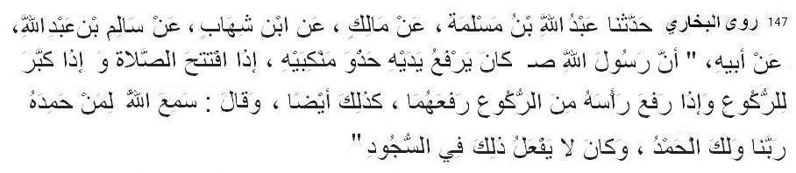
147 Bukhari narrated .... ....... from ibn Umar: I saw Allah’s Messenger (pbuh) opening the prayer with the Takbir and raising his hands to the level of his shoulders at the time of saying the Takbir, and on saying the Takbir for bowing he did the same; and when he said, “Samiallahu liman hamidah”, he did the same and then said, “Rabbana wa lakal hamd.” But he did not do the same on prostrating and on lifting the head from it.” (Bukhari 696, also Muslim 591, Tirmiji, Abu Dawud, Nasai)
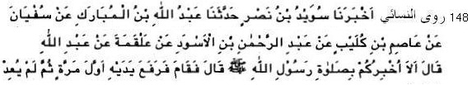
148 Nasai narrated .... ....... from Alqamah: Abdullah ibn Mas'ud said: Should I not pray in the way the Messenger of Allah (pbuh) had performed it? He said: He prayed, raising his hands only once. (Nasai 1026, Abu Dawud 748, Ahmad, Tirmiji; Ibn Hazm said: hadith is sahih; Tirmiji said: hadith is hasan; and Abu Dawud said: hadith is not sahih)
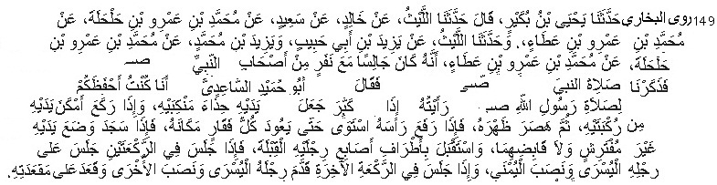
149 Bukhari narrated ..... from Muhammad bin Amr bin Ata; He said, I was sitting with some of the companions of Messenger of Allah (pbuh) and we were discussing about the way of praying of the Prophet. Abu Humaid As-Sa`idi said, "I remember the prayer of Allah's Messenger (pbuh) better than any one of you. I saw him raising both his hands up to the level of the shoulders on saying the Takbir; and on bowing he placed his hands on both knees and bent his back straight, then he stood up straight from bowing till all the vertebrate took their normal positions. In prostrations, he placed both his hands on the ground with the forearms away from the ground and away from his body, and his toes were facing the Qibla. On sitting in the second rak`a he sat on his left foot and propped up the right one; and in the last rak`a he pushed his left foot forward and kept the other foot propped up and sat over the buttocks." (also Daremi)

Supplications to be recited in salaah
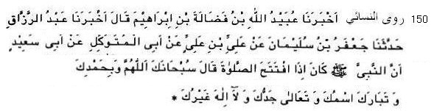
150 Nasai narrated .... ....... fromAbu Saeed Khudri: When Messenger of Allah (pbuh) started prayer, he used to say these words: Subhanaka Allahumma wa bihamdika wa tabaraka-smuka
wa ta’ala jadduka wa la ilaha ghairuk.
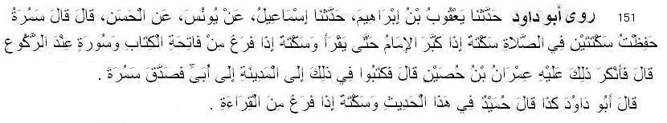
151 Abu Dawud narrated from Yaqub from Ismail from Yunus from Hasan Basri: Samurah ibn Jundub said: I remember two pauses in prayer, one when the imam said the takbir; and one when he finished reciting the Fatihah and another surah when he was about to bow. But Imran ibn Husayn took it as something strange. So they wrote about it to Ubayy (ibn Ka'b) in Madinah. He verified the statement of Samurah. Abu Dawud said: Humaid also narrated in this tradition the words "and one pause when he finished the recitation (of the Quran)"
[Abu Dawud 777; with sahih chain all narrators are thiqah or reliable. Some (Al Uthaimin) say that sanad (chain of narrators) of this hadith is weak. They argue that “Hasan Basri narrated the hadith from Samurah but he did not hear from Samurah. So the narrator between Hasan and Samurah is unknown and missing. So this hadith is not authentic.” This argumant is not valid. Because according to Bukhari, Tirmiji and Ibnul Madini Hasan Basri heard hadiths from Samurah directly. According to Nasai, Bayhaqi and Dar„qutni Hasan Basri heard only one hadith on aqeeqah from Samurah directly. According to Yahya bin Maeen and Ibn Hibban Hasan Basri did not hear from Samurah ]
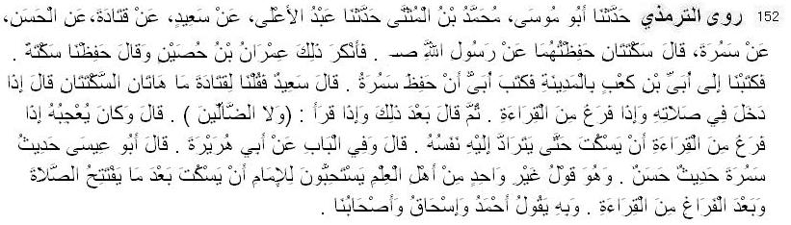
152 Tirmiji narrated from Abu Musa from Abdul A’la from Saeed from Qatadah from Hasan Basri from Samurah ibn Jundub, He said: "There are two pauses that I preserved from Messenger of Allah (pbuh)." But Imran bin Husain rejected that and said: "We preserved one pause." "So we wrote to Ubayy bin Ka'b in Madinah. Ubayy wrote that Samurah was correct." Sa'eed said: "We said to Qatadah: 'What are those two pauses?' He said: 'When he entered into his Salat, and when he finished his recitation.' Then he (Qatadah) said after that: 'And when he recited (Nor those who went astray.)' And he said: 'He liked to pause when he finished the recitation until he caught his breath.'" Abu Eisa Tirmiji said: This hadith is hasan. (Tirmiji 251, Abu Dawud 779, 780, Ahmad; Ahmad Shakir said; hadith is sahih, Zubair Ali Zai said this hadith is hasan. This hadith is also zaif according to some scholars (Albani, Al Uthaimin) on objection of miising narrator between Hasan Basri and Samurah. ]
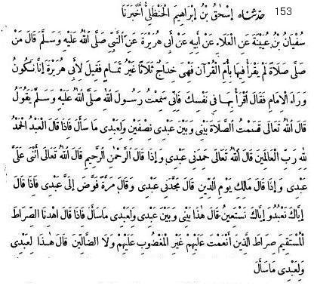
153 Muslim narrated ................ from Abu Huraira: The Messenger of Allah (pbuh) said: If anyone observes prayer in which he does not recite Surah Fatihah, It is deficient [he said this three times] and not complete. It was said to Abu Huraira: At times we are behind the Imam. He said: Recite it inwardly, for he had heard the Messenger of Allah (pbuh) declare that Allah the Exalted had said: I have divided the prayer into two halves between Me and My servant, and My servant will receive what he asks.When the servant says: Praise be to Allah, the Lord of worlds, Allah the Most High says: My servant has praised Me. And when he says: The Most Compassionate, the Merciful, Allah the Most High says: My servant has lauded Me. And when he says: Master of the Day of Judgment, He remarks: My servant has glorified Me. and sometimes He would say: My servant entrusted (his affairs) to Me. And when he says: You alone we worship and You alone we ask help, He says: This is between Me and My servant, and My servant will receive what he asks for. Then, when he says: Guide us to the straight path, the path of those upon whom You have bestowed favor, not of those who incurred Your anger, nor of those who are astray, He says: This is for My servant and My servant will receive what he asks for. (Muslim 774, Ahmad, Nasai 909, Muatta, Ibn Mazah and Bukhari in his Khairul Kalam fi qira-at khalfal imam)
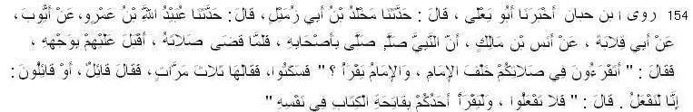
154 Ibn Hibban narrated ........... from Anas: The Messenger of Allah (pbuh) prayed prayer with his companions. When turned (after finishing) he said: 'You are reciting behind your Imam?'" He said: "We said: 'Yes’, Messenger of Allah said: “Do not recite when imam recites. But every one of you must recite the Opening of the Book silently. (also Daraqutni 1118, Bayhaqi 2686 from Harith bin Rabi’; sahih)
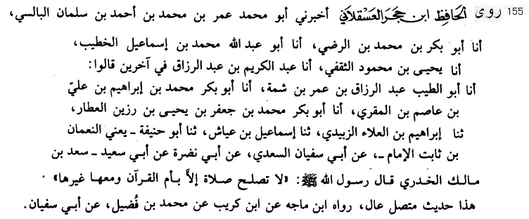
155 Ibn Hajar Asqalani narrated ........... from Abu Saeed Sa’d bin Malik Khudri: "The Messenger of Allah (pbuh) said: Prayer will not be fine without recitation the Essence of the Quran (Fatihah) and some more (from the Quran) with it.” (Imta bil Arbaun of Asqalani. Asqalani said this hadith is muttasil, and also narrated by ibn Mazah. I say: Abu Dawud also narrated with different wording. Sufyan bin Uwainah said: This is for solitary devotee. )
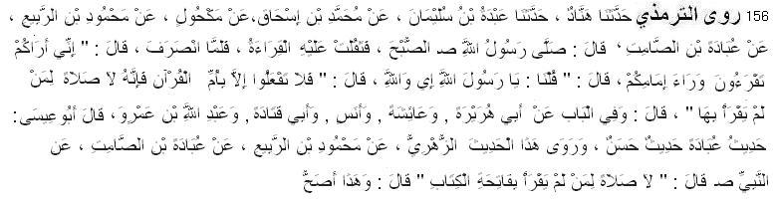
156 Tirmiji narrated ........... from Ubadah bin As-Samit: "The Messenger of Allah (pbuh) prayed the Subh (Fazr) prayer, and he had difficulty with the recitation. When turned (after finishing) he said: 'I think that you are reciting behind your Imam?'" He said: "We said: 'Yes, Messenger of Allah, by Allah!' He said: 'Do not do that, except for Mother of the Book (Surah Fatiha), for there is no Salat for one who does not recite it.' Abu Eisa Tirmiji says, “(This) Hadith of Ubadah is hasan. This hadith is narrated by Juhri from Mahmud from Ubadah in which the Messenger of Allah said: There is no Salat for one who does not recite Opening of the Book in it.' This is more authentic.” [Tirmiji 286 also Abu Dawud 823, Hakim 824, Ahmad – in all of their sanad there is Muhammad ibn Ishaq who is considered by Bayhaqi and Ahmad Shakir as thiqah (trustworthy) and by Ibn Hazar as saduq mudallis i.e. truthful but sometimes made tadlis. Imam Ibn as-Salah (d. 643H) said, “The ruling is that the only narration of a Mudallis that will be accepted is the one in which he clarifies who he heard it from.” (Muqaddimah Ibn as-Salah p.60). This Ibn Ishaq is famous writer of Siraat RasulAllah. Imam Bukhari took three hadiths from ibn Ishaq and Imam Muslim took three hadiths from ibn Ishaq.
Considering Hadith of Anas in Ibn Hibban and of Harith in Bayhaqi the event is certainly true. Wording of the hadith may be slightly distorted but meaning is right. There is no Salat for one who does not recite Opening of the Book in it is also narrated by Bukhari and Muslim.]
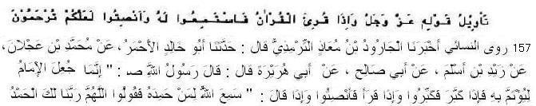
157 Nasai narrated ................... from Abu Hurairah: The Messenger of Allah (pbuh) said:. Imam is apponted for following. Recite the takbir when he recites it and when he recites remain silent. And when he says: SamiAllahu liman hamidah, you should say Rabbana lakal hamd. (Nasai 921, Ibn Majah; hadith is sahih) Muslim has narrated:
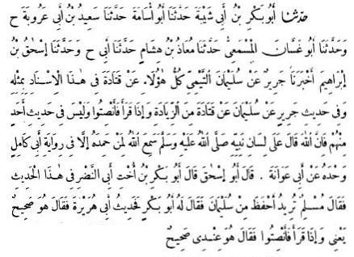
Qatada has narrated a hadith like this with another chain of transmitters. In the hadith transmitted by Jarir on the authority of Sulaiman, Qatida's further words are: When (the Quran) is recited (in prayer), you should observe silence, and (the following words are) not found in the hadith narrated by anyone except by Abu Kamil who heard it from Abu Awana (and the words are): Verily Allah vouchsafed through the tongue of the Messenger of Allah (pbuh) this: SamiAllahu liman hamidah. Abu Ishaq (a student of Imam Muslim) said: Abu Bakr the son of Abu Nadr's sister has (critically) discussed this hadith. Imam Muslim said: Whom can you find a more authentic transmitter of hadith than Sulaiman? Abu Bakr said to him (Imam Muslim): What about the hadith narrated by Abd Huraira, i. e. the hadith that when the Qur'in is recited (in pray er) observe silence? He (Abu Bakr again) said: Then, why. have you not included it (in your compilation)? He (Imam Muslim) said: I have not included in this every hadith which I deem authentic; I have recorded only such ahadith on which there is an agreement (amongst the Muhaddithun apart from their being authentic). (Muslim in his Sahih in “Tashsah.hud” H 801)
158 Bukhari narrated .......... from Talha bin Abdullah bin Auf: I offered the funeral prayer behind Ibn Abbas and he recited the Opening Chapter and said, “You should know that it (i.e. recitation of Surah Fatiha) is a sunnah. (Bukhari 419, Nasai)
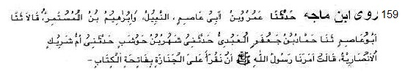
159 Ibn Mazah narrated ........... from Umm Shuraik Ansariyyah: the Messenger of Allah (pbuh) ordered us to recite the Opening Chapter in funeral prayer. (Ibn Mazah; sanad is weak but it has many corroborrator chains.)
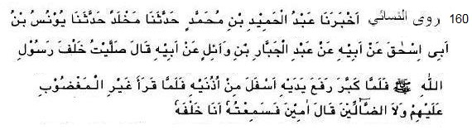
160 Nasai narrated ........... from Wa’il ibn Hujr narated that he prayed with Messenger of Allah (pbuh), he raised his voice while uttering Amin. (Nasai 932; hasan)
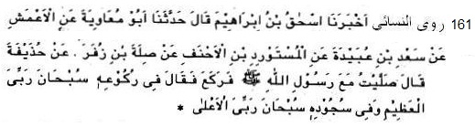
161 Nasai narrated ........... from Huzaifah: I prayed with the Prophet (pbuh). In ruku he said: Subhana Rabbial Azim and in sijdah he said: Subhana Rabbial Ala (Nasai, Muslim, and Tirmiji)
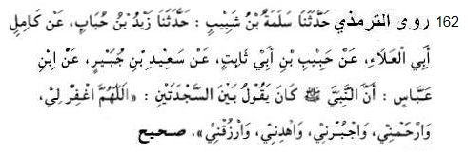
162 Tirmiji narrated ....... from Ibn Abbas: The Prophet (pbuh) used to say between two sijdahs Allahummagfirli warhamni wajburni wahdini warjuqni. (also Abu Dawud; sahih)
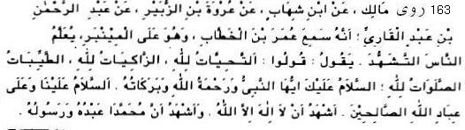
163 Malik narrated from Ibn Shihab from Urwa ibn az-Zubayr from Abdur Rahman ibn Abdul Qari that he heard Umar ibnul Khattab say, while he was teaching people the tashahhud from the mimbar, "Say, At-tahiyatu lillah, az-zakiyatu lillah, at-tayibatu was salawatu lillah. As-salamu alayka ayyuhan nabiyyu wa rahmatullahi wa barakatuhu. As-salamu alayna wa ala ibadillahis-salihin. Ash-hadu an la ilaha illallah wa ash-hadu anna Muhammadan abduhu wa rasuluh." (Malik in Muwatta, Bayhaqi; in sahih chain)
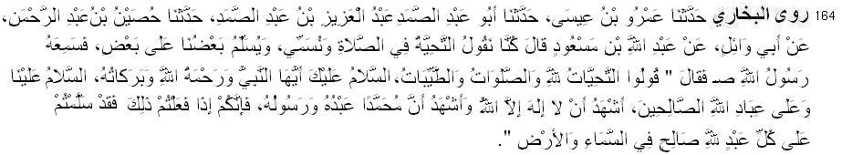
164 Bukhari narrated ....... from Ibn Mas`ud: We used to say the greeting, name and greet each other in the prayer. Allah's Messenger heard it and said:--"Say, 'at-tahiyyatu lil-lahi was-salawatu wat-taiyibat. Assalamu 'Alaika aiyuha-n-Nabiyu warahmatullahi wa barakatuh. Assalamu alaina wa-'ala 'ibadi-l-lahi as-salihin. Ashhadu an la ilaha illa-l-lah wa ashhadu anna Muhammadan `Abdu hu wa Rasuluh. So, when you have said this, then you have surely sent the greetings to every good (pious) worshipper of Allah, whether he be in the Heaven or on the Earth." (also Muslim)
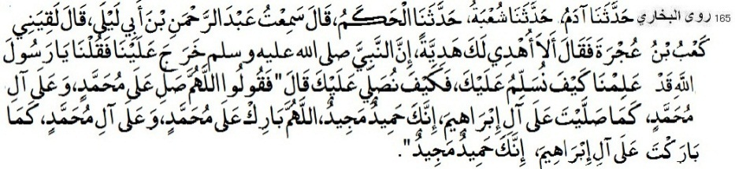
165 Bukhari narrated ........... from Ka'b bin Ujra: It was said, "O Messenger of Allah! We know how to convey you salam. But how to invoke Allah for you?" He (pbuh) said, "Say: Allahumma salli ala Muhammadin wa ala ali Muhammaddin kama sallaita ala ali Ibrahim. Innaka Hamidun Majid. Allahumma barik ala Muhammadin wa ala ali Muhammaddin kama
barakta ala ali Ibrahim. Innaka Hamidun Majid". (also Muslim)
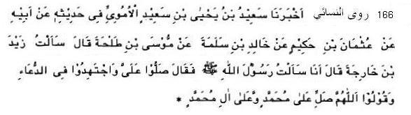
166 Nasai narrated ........... from Zaid bin Kharija: The Prophet (pbuh) said, "You should seek blessing for me and supplicate and say: Allahumma salli ala Muhammadin wa ala ali Muhammad. (Nasai 1293; sahih)
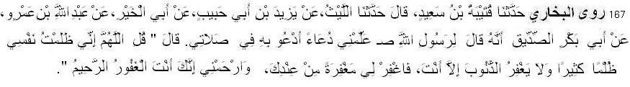
167 Bukhari narrated ........... from Abu Bakr Siddiq that he asked the Messenger of Allah (pbuh), Teach me an invocation so that I may invoke Allah with it in my prayer. He told me to say, "Allahumma inni zalumtu nafsi zulman kathiran. Wala yagfiruz zunuba illa anta fagfirli magfiratan min indika, warhamni. Innaka antal Gafurur Raheem." (also Muslim, Malik in Muwatta)
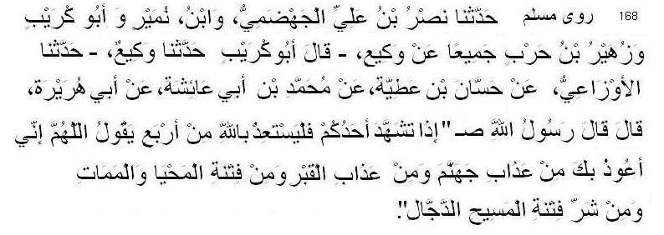
168 Muslim narrated ........... from Abu Huraira: The Messenger of Allah (pbuh) said: When any one of you utters tashahhud (in prayer) he must seek refuge with Allah from four (trials) and should thus say: Allahumma inni auzubika min azabi jahannama wa min azabil qabri wa min fitnatil mahya wal mamat wa min fitnatil Masihid Dajjal.”
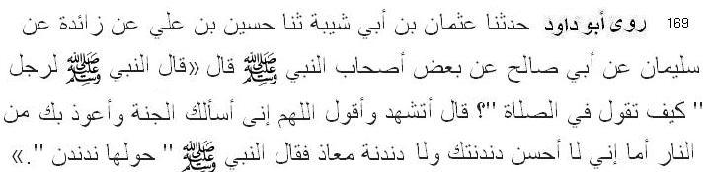
169 Abu Dawud narrated ............. from a sahabi: The Messenger of Allah (pbuh) asked a man: What do you say in salaah? He said: I say: Allahumma inni as-alukal jannata wa auzubika minan nar. The Messenger of Allah said: We also say something like this. (792, Ibn Mazah; sahih)
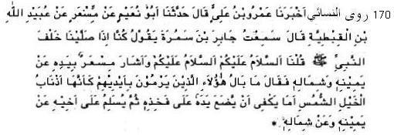
170 Nasai narrated . . . . . . ... . .. from Jabir b. Samura: Her said: When we said prayer with the Messenger of Allah (pbuh), we pronounced: Salamu alaikum wa rahmatullah, Salamu alaikum wa rahmatullah; and made gesture with the hand on both the sides. Upon this the Messenger of Allah (pbuh) said: What do you point out with your hands as if they are the tails of headstrong horses? This is enough for you that one should place one's hand on one's thigh and then pronounce salutation upon one's brother on the right side and then on the left. (also Muslim)
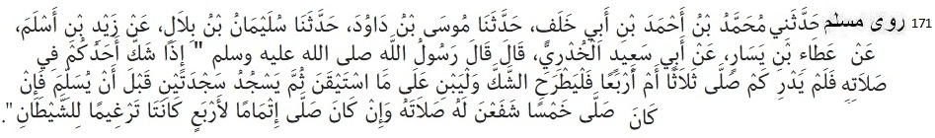
171 Muslim narrated ....... Abu Sa'eed Khudri: The Messenger of Allah (pbuh) said: When any one of you is in doubt about his prayer and he does Dot know how much he has prayed, three or four (rak'ahs). he should cast aside his doubt and base his prayer on what he is sure of. then perform two prostrations before giving salutations. If he has prayed five rak'ahs, they will make his prayer an even number for him, and if he has prayed exactly four, they will be humiliation for Satan. (also Abu Dawud)
Optional Night prayers (Taraweeh, Tahajjud, Witr)
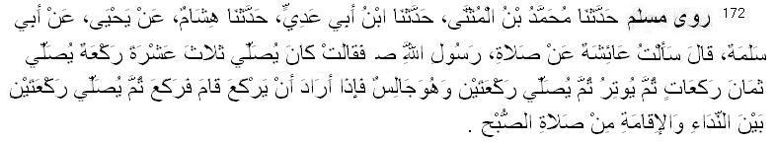
172 Muslim narrated . . . . . . ... from Abu Salama: She said: I asked Aishah about the night prayer of the Messenger of Allah (pbuh). She said: he used to pray thirteen rakat. First he prayed eight rakahs, and then he offered one rakat witr. Then he prayed two rakaat sitting. (In this prayer) When he wished to make ruku he stood and made ruku. He also prayed two rakaat between azan and iqamah of Fazr prayer.
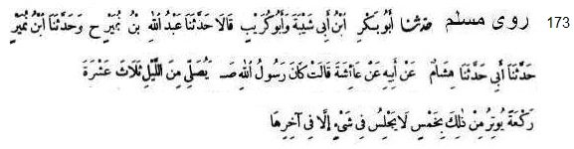
173 Muslim narrated ................from Aisha: The Messenger of Allah (pbuh) used to pray at night thirteen rakat. It included five rakat witr in which he gave salaam at the end (of fifth rakaat)
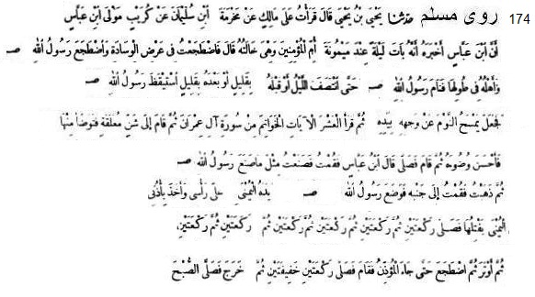
174 Muslim narrated .............. from Ibn Abbas: He said: I spent a night with Maimunah, sister of my mother. The Messenger of Allah (pbuh) got up during the night and relieved himself, then washed his face and hands and went to sleep. He then got up again, and came to the water skin and loosened its straps, then performed good ablution between the two extremes. He then stood up and observed prayer. I also stood up and stretched my body fearing that he might be under the impression that I was there to find out (what he did at night). So I also performed ablution and stood up to pray, but I stood on his left. He took hold of my hand and made me go round to his right side. The Messenger of Allah (pbuh) prayed two rakaat, then he prayed two rakaat, then he prayed two rakaat, then he prayed two rakaat, then he prayed two rakaat, then he prayed two rakaat. Then he prayed one rakaat. He then lay down and slept and snored. Then Bilal came and he informed him about the prayer. He then stood up for prayer and he prayed two rakaat and went out to pray Fazr. (Muslim 1671)
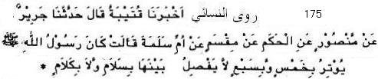
175 Nasai narrated ................from Umm Salamah: The Messenger of Allah (pbuh) used to pray witr with five or seven rakaat. He did not separete those rakaah with salaam or talking. (Nasai 1713, Ibn Mazah 1192 )
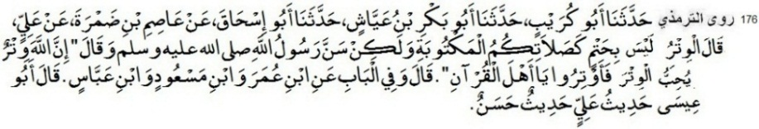
176 Tirmiji narrated ................ Ali said: "Al-Witr is not incumbent like your obligatory prayers, but it is a Sunnah of Allah's Messenger who said: "Indeed Allah is Witr (One), and He loves Al-Witr, so perform Al-Witr O people of the Qur'an." Tirmiji said this hadith of Ali is hasan. (also Ahmad, Nasai, Ibn Majah)
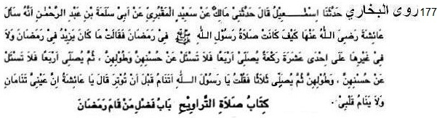
177 Bukhari narrated ................from Abu Salama bin Abdur Rahman: He asked Aisha, "How was the prayer of the Messenger of Allah (pbuh) in Ramadan?" She replied, "He did not pray more than eleven rakat in Ramadan or in any other month. He used to pray four rakat -- let alone their beauty and length - - and then he would pray four - - let alone their beauty and length - - and then he would pray three rakat (Witr)." She added, "I asked, 'O Messenger of Allah! Do you sleep before praying the Witr?' He replied, 'O Aisha! My eyes sleep but my heart does not sleep." [Bukhari in Sahih Bukhari {Book of Taraweeh, Bab: Praying at Night in Ramadan}]
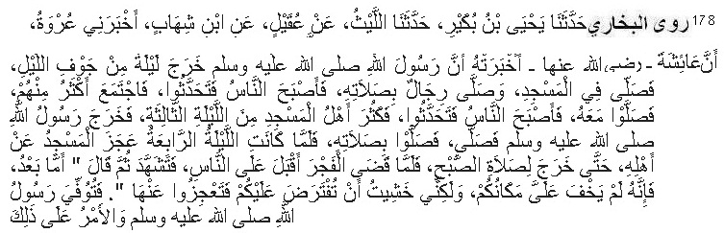
178 Bukhari narrated ................ from 'Urwa that he was informed by Aisha, "Allah's Messenger (pbuh) went out in the middle of the night and prayed in the mosque and some men prayed behind him. In the morning, the people spoke about it and then a large number of them gathered and prayed behind him (on the second night). In the next morning the people again talked about it and on the third night the mosque was full with a large number of people. Allah's Messenger (pbuh) came out and the people prayed behind him. On the fourth night the Mosque was overwhelmed with people and could not accommodate them, but the Prophet (pbuh) came out (only) for the morning prayer. When the morning prayer was finished he recited Tashah-hud and (addressing the people) said, "your presence was not hidden from me but I was afraid lest the night prayer (Qiyam) should be enjoined on you and you might not be able to carry it on." So, Allah's Apostle died and the situation remained like that (i.e. people prayed individually).
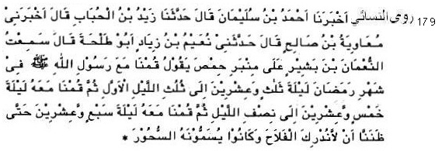
179 Nasai narrated ................from Numan bin Bashir: We prayed with the Messenger of Allah (pbuh) for one-third of night on 23rd Ramadan. We prayed for half of night on 25th Ramadan. We prayed on 27th Ramadan until we were afraid that we might miss the sahar. (Nasai; sahih)
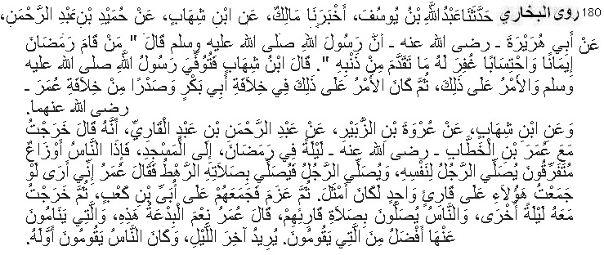
180 Bukhari narrated .........from Abu Huraira: Allah's Apostle said, "Whoever prayed at night the whole month of Ramadan out of sincere Faith and hoping for a reward from Allah, then all his previous sins will be forgiven." Ibn Shihab said, "Allah's Apostle died and the people continued observing that (i.e. offered individually, not in congregation), and it remained as it was during the Caliphate of Abu Bakr and in the early days of 'Umar's Caliphate." 'Abdur Rahman bin 'Abdul Qari said, "I went out in the company of 'Umar bin Khattab one night in Ramadan to the mosque and found the people praying in different groups. A man praying alone or a man praying with a little group behind him. So, 'Umar said, 'In my opinion I would better collect these (people) under the leadership of one Qari (Reciter)'. So, he made up his mind to congregate them behind Ubai bin Ka'b. Then on another night I went again in his company and the people were praying behind their reciter. On that, 'Umar remarked, 'What an excellent innovation this is; but the prayer which they do not perform, but sleep at its time is better than the one they are offering.' He meant the prayer in the last part of the night. (In those days) people used to pray in the early part of the night."

Muslim narrated from Jabir: The Messenger of Allah (pbuh) said: "Whoever dies not having associated anyone with Him (in worship), shall enter paradise; and whoever dies having committed shirk will enter the Hell-fire." Shirk means to associate others beside Allah
One of the prophets used to draw a certain type of lines. He is either Idris or Daniel (pbuh).
The Prophet (pbuh) asked two questions in order to know her faith. Being satisfied at her answer, he recommenderd to set her free. We learn from this hadith that Allah is separate from His creation. This hadith is explanation of the Quranic verse: Have ye taken security from Him Who is in the heaven that He will not cause the earth to swallow you when lo! it is convulsed? Or have ye taken security from Him Who is in the heaven that He will not let loose on you a hurricane? (67:16-17) The notorious Sufi Ibn Arabi Tayee (d. Damuscus 638 A.H.) said: "al-`abd-u rabb-un wa-r-rabb-u `abd-un" (The slave is the lord and the lord is the slave) (Futuhat Makkiyah, Ibn Arabi) He said, Allah worships me and I worship Him. The followers of Bid’ah and shrik regard Ibn Arabi as the greatest ustad (Shaykh-e-Akbar)
Allah says: The Day that the shin shall be laid bare and they shall be summoned to bow in adoration but they shall not be able (68:42) Allah will be visible for the believers on the day of Resurrection. I salah it sahould be thought that I can see Allah. But in worldly life Allah can not be seen by anybody even by any prophet. Shibli, says I saw a mad man being hurt with stones by a few boys. I threatened them, stopped them. They said, 'sir, he claims to have had meetings with Allah and that he sees HIM'. I came near him and asked him ' do you really claim to have direct meetings with Allah?' Being in this world, you claim to hear Allah, see Allah? He said ' listen, shouted and said Shibli, by Him, who has worsened my conditions in His love. If He would disappear from my sight even for a moment, I would come apart and die of this seclusion. He remains in my vision all the time.' Virtues of Amal, Virtues of Zikr, (Bangla), Tablighi Kutubkhana, 2009, p. 367 Eng Trans P 574) Prophet Moses (a.s.) could not see Allah yet these insane dervishes could see Him!
This is the explanation of the Quranic verse: “And He it is Who created the heavens and the earth in six Days and His Throne was upon the water” (11:7)
Tamima means those things which are used to get rid of dangers or illness e.g. talisman.
We should not say such statements which is absolute right of Allah. This idea is actually 'shirk'. How can a man be refuge in Here and hereafter? Likewise the attributes namely Dastogeer, Gareeb-newaz, Gawsul Azam, refuge in both the worlds are only befitting for Allah.
Zaqqum is the tree of Hell. According to the Quran it is the only food of the people of Hell. Its another name is Dhari.
Adam had been made of clay. Inspite of being made of clay, Mankind have been honored. Allah says: Verily We have honored the children of Adam. (17:70) Messenger of Allah was a man. Allah says: Say: I am only a mortal like you. My Lord inspires in me that your God is only One God. (18:110) Allah says: I say not unto you: "I have the treasures of Allah" nor "I have knowledge of the Unseen," nor say I: "Lo! I am an angel!" Nor say I unto those whom your eyes scorn that Allah will not give them good-Allah knows best what is their hearts -Lo! then indeed I should be of the wrong-doers. (11:31)
Imam Suyuti (Rah) said: “It must be acknowledged that whoever rejects any hadith of the Prophet, be it deed or word, which fulfills condition of authenticity (sihhah) as evidence of shariah, he will become disbeliever and be out of the fold of Islam. His Resurrection will be with Jews or Christians or any other disbelieving groups as Allah wishes. (Miftahul Jannah, Suyuti)
We learn from this hadith that the Prophet (pbuh) had shadow. This opposes the notion (of some people) that The Prophet (pbuh) was made of Light.
We learn from this hadith that the prophet had no knowledge of the unseen (ghayeb). If the prophet had knowledge of the unseen (ghayeb) he need not ask witness i.e. Ali, Usama and Barirah. Allah says: “Say: For myself I have no power to benefit, nor power to hurt, save that which Allah willeth. Had I knowledge of the Unseen, I should have abundance of wealth, and adversity would not touch me. I am but a warner, and a bearer of good tidings unto folk who believe. (7:188) Second point is that he took witness of a freed slave-girl.
The phrase There will be no Prophet after me has been declared by the prophet many times in many occassions. This has been narrated by Samurah bin Jundub, Jabir bin Samurah, Jabir bin Abdullah, Ibn Umar, Ali, Asma bint Umais and many others.
mubashshirat is dreams which become true.
There is a branch of Rafezi shiahs named Uluwiyah (Alawite) – who say that prophethood was for Ali. But Gabriel wronged.
Imam Nabawi explains, “Here Jews and Christians have been mentioned to warn others. Despite Jews and Christians have books they will not be spared for not following the Quran. As for those who have no books must also follow the Quran.” The prophet (pbuh) sent letter to Muqawqis (Cyrus), Patriarch of Alexandria, who administered Egypt on behalf of the Byzantine Empire. The prophet also sent letter to Negus king of Axum (Abyssinia)
Ali said: Taqdeer is a dark way. Do not take that way. It’s a deep sea. Dont swim in it. It is a mystery of Allah which is obscure to you. Do not try to discover it. (Mirkat)
The Prophet (pbuh) said, “Do not write anything from me except the Quran (Muslim) This hadith is sahih but abrogated by above-mentioned hadith.
Many fabricated hadith are in use. For example, “Patriotism is part of belief” , “Heart of a believer is Seat of Allah”, “He who knew himself knew Allah”, “To acquire knowledge go to China”, “Ink of a scholar is more sacred than blood of a myrter”, “Satan is mentor (shaikh) for him who do not adopt a shaikh”, “zikr for 2 milion virtue” , “to say Sadaqallah after reciting the Quran”, “To say Anis wahshati after the recitation of the complete Quran” – these all are fabricated.
(a) From this hadith it is evident that there is no secret (batin) knowledge in Islam. (b) Hasan Basri said, “Do not sit in majlis of a man of bidah lest you may be affected by his disease.” Imām Laith bin Said (Rh) said: “I shall not honor any follower of Bidah even I see him walking on water”. Imām Shafii (Rh) said: “I shall not honor any follower of Bidah even I see h im walking in air”. (Talbisu Iblis, Imām Ibn Jawzi, Cairo, p-24) This is because follower of Bidah can show miracles by Satan’s help. Fuzail bin Iyaz (Rh) [d. 187 H] said: “If you see any follower of Bidah to walk along any road, you should take another road.” (Talbisu Iblis, Imam Ibn Jawzi, Cairo, p-23)
Muhammad ibnul Hasan Hamadani in this chain is weak narrator. Hadith is hasan according to some muhaddithun. Ta-allum means study or learning. This learning may be self study or by taking lessons from teachers. Sufis and Shiahs believe in batin (sceret) knowledge. According to them batin (secret) knowledge is attained directly from Allah and transmitted from a shaykh to his follower. Abdul Qadir Jilani (d. 561 H/1166 CE) said: “It is safe and good to do according to zahiri (outward) meaning of the Quran and sunnah.” (Guniat Talibeen, Jilani) Zakaria Saharanpuri wrote: "One person asked Khidr that, "Have you ever seen any wali who is better than you?" Khidr replied, "Yes, I have. I once visited the masjid of the prophet. I saw Imam Abdur Razzaq muhaddith and he was teaching hadith. The crowd and I listened to the hadith from him. In one corner of the masjid there was a youngster sitting who had kept his head between his knees away from the crowd. I said, Do you not see that hadith of the prophet are being taught? Why don't you also attend the circle? He neither lifted his head nor did he look at me and said, "In that place are those who listen to hadith from the slave of Razzaq. But I'm the one who listen to hadith from the Razzaq, not from the Abdur Razzaq." (Fazail Hajj) Funny story. Bukhari, Muslim, Nasai could not hear from Allah. Can anybody listen voice of Allah in this world?
Hadith No. 51, 56 and 57 proves that companions might not know some hadith. Even Abu Bakr and Umar were unaware of some hadith. On hearing a hadith on a matter, they abandoned their opinion in favor of hadith without any hesitation. Umar did not say, “Oh! This Dahhak ibn Sufyan Kulabi is a man from Najd and has been with the Prophet for very short time. So I shall not accept his statement unless it is supported by any Ansari and Muhazir companion”. Even Umar abandoned his fatwa upon hearing explanation of the Quran from an ordinary woman. (See hadith no. 269). And We also see that Ali and Fatimah did not know the hadith: Messenger of Allah (pbuh) said, "Not even a single Dinar of my property should be distributed (after my death) to my inheritors, but whatever I leave excluding the provision for my wives and my servants, should be spent in charity." (See hadith no. 24) This hadith was known to Abu Bakr and Abu Hurairah. Ali and Fatimah came to take their share of in heritence in the Prophet’s property. When Ali and Fatimah learnt it, they went satisfied. Shia people say Abu Bakr deprived Ali and Fatimah of their inheritence. If that had been the case, Ali could take the inheritence which had been in state control when he became khalifah.
Scholars said: If a house flys became impure owing to their death, then it was not ordered to dip it in drink. They compared house flies with the insects which do nort have flowing blood and commented that these insects are pure (even if they are dead) such as mosquito, kockroach, louse
If impure things fall in water of volume less than two kulla thw water is impure even if color is not changed. If impure things fall in water of volume more than two kulla the water is pure even if color is changed. Two pitchers (kulla) = 270 litres (approx)
If utensils of people of the Scripture are not allowed certainly it is not permissible to use utensils of of Hindus and other polytheists. It is a matter of regeret that many Muslim eat with Hindus in one plate.
Scholars made ijtihad on these two hadiths and opined that pure are the dung and urine of those animals which are halal for eating. This means that if dung and urine of cow or goat is there on cloths there is no problem praying with these cloths put on. The faeces and urine of donkey, elephant, dog etc. are impure.
This ruling is for those children whose only food is mother’s milk.
We did not find any hadith concerning placing left foot into toilet. It seems that scholars made ijtihad based on this hadith and another hadith hadith no. 80 of this book.
Intention is an act of mind. So it should be performed by mind, not by mouth. Intention is mandatory for all works.
Kissing wife without temptation and touching her do not nullify wudu. Malik narrated from Hisham ibn Urwa from his father that Miswar ibn Makhrama told him that he had visited Umar ibn al Khattab on the night he was stabbed and had woken him up for the subh prayer and Umar had said, ''Yes. Whoever stops doing the prayer has no share in Islam," and he did the prayer with blood pouring from his wound. (Muwatta Malik; sahih) According to Shafii, Malik, Ahmad Ibn Hanbal bleeding from wound do not nullyfy wudu. According to Abu Hanifah, bleeding from wound nullyfies wudu which is based on narration from Daraqutni and Ibn Adi. However these narrations are not authentic. Reasons foe nullifying wudu are- defecate, pass water, pass air, semen, eating camel’s meat.
Wudu must be performed carefully. In some hadith it has been reported that the ears shall be wiped.
One must take bath on embracing Islam. This practice had been in existance in previous prophets traditions. For example In Christianity a similar prectice is called Baptism. To learn other causes of obligatory bath read Quran (5:6), Ahmad (8372), Muslim (689), Abu Dawud (200).
Aishah narrated the the prophet (pbuh) used to make wudu before bath.
Imam Ibnul Jawzi (d. 597) wrote: {Scholars differed whether Bismillahir-Rahmanir-Raheem would be recited loudly or not in salaah in which reading is loud. A section maintains that it is not sunnah to recite loudly on authority of Ahmad. This is opinion of Abu Bakr, Ali, Uthman, Ibn Masd’ud, Ammar bin Yasar, Ibn Mugaffal, Ibn Zubair, Ibn Abbas and also Hasan Basri, Shabi, Sayeed ibn Zubair, Ibraheem Nakhee, Qatadah, Umar bin abdul Aziz, A’mash, Sufian Thauri, Malik Abu hanifa, and Abu Ubaid. According to Shafii, it is sunnah to recite Bismillahir-Rahmanir-Raheem loudly in salaah in which reading is loud. He was with Muawiyah, Ata, Tawus and Mujahid in this issue.}
From this hadith and some other hadiths it seems that Bismillahir-Rahmanir-Raheem is not a verse of Surah Fatihah. But if we want to match this hadith with hadiths mentioned earlier we have to consider one of the two possibilities. a. Surah Fatihah had six verses initially; then Bismillahir-Rahmanir-Raheem was added. ( in such way that some other surahs revealed part by part); or the sahabi used to indicate surah Fatihah by saying “Al hamdu lillahi Rabbil Alameen.” Allah knows the best.
The addition “If anyone does not make two prostrations, he should not recite them” in Tirmiji is not sahih. (Bulugul Maram with Tahqiq) If it were sahih prostration of recitation would be wajib. Actually this sijadah is sunnah.
Bukhari and Muslim’s narration are brief. So here Abu Dawuds narrtion has been chosen. Some people among Muslims refute barzakh. This is not right.The.
. . .. . . . . . . . . Narrated Ibn Umar: The Prophet (pbuh) said, Junubi person and menstruating woman shall not touch the Quran. (Ahmad, Tirmiji; chain of narrators is good/weak) Ismail bin Aiash, a narrator in the chain is munkar/zaif.
Umar said, “Did your Prophet not say that Verily Allah raises people up by this book and cast down others by it?” (Muslim)
For him who neglects salaah deliberately – Muslims shall not maintain marital relation, Muslims shall not attend for his funeral prayer, he will not be given any share of inheritence and he will not be buried in Muslim graveyard. This is the opinion of Abdul Qadir Jilani and many other Muslim scholars. The opinion is based on several hadith such as Hadith 115, 116, 117 and others.
There is another similar narration from Abu Hurairah. (Nasai 502, chain is hasan) Narrated Abdullah bin Amr: The Prophet (pbuh) said, the noon prayer time is between (the time) when the sun had passed the meridian and when the shadow of everything was as long as itself until the afternoon prayer time afternoon prayer time remains upto tthe sun is yellow. The correct explanation of this hadith is : when the shadow of everything was as long as itself the noon prayer time is ended. When shadow of everything was twice as long as itself afternoon prayer time is ended. However if there is any problem afternoon prayer may be performed before the sunst. (see hadith no. 126)
... Abdullah ibn Zayd narrated: I saw a man in dream who had a horn in his hand. I said to him, Will you sell the horn to me? He said: For what use? I said: To call people for prayer. He said: Rather it is better that you say: Allahu akbar, Allahu akbar (twice), Ash-hadu an-la ilaha illallah (twice), Ash-hadu anna Muhammadan Rasulullah (twice), Hayya alas salat (twice), Hayya alal-falah (twice), Allahu akbar (twice) La ilaha illa-Allah. The man said: when you stand for salaah you shall say: Allahu akbar, Allahu akbar, Ash-hadu an-la ilaha illallah, Ash-hadu anna Muhammadan-Rasulullah, Hayya alas salat, Hayya alal-falah, Qad qamatis salaah (twice), Allahu akbar (twice), La ilaha illa-Allah. Next morning I came to the Messenger of Allah (pbuh) and informed him about it. He said: This is a true dream. Call Bilal and teach him, He has a voice louder than you. (Abu Dawud, 499)
... Abu Mahjura said: Messenger of Allah (pbuh) taught me azan in 19 sentences and iqamah in 17 sentences. Words of azan are: Allahu akbar, Allahu akbar (twice) Ash-hadu an-la ilaha illallah (twice), Ash-hadu anna Muhammadan-Rasulullah (twice), Hayya alas salat (twice), Hayya ala 'l-falah (twice), Allahu akbar (twice), La ilaha illallah. Words of iqamah are: Allahu akbar, Allahu akbar, Ash-hadu an-la ilaha illallah, Ash-hadu anna Muhammadan-Rasulullah, Hayya alas salat, Hayya alal-falah, Qad qamatis salaah (twice), Allahu akbar (twice), La ilaha illa-Allah (Abu Dawud, 502)
In this hadith the azan is called first azan, iqamah is called second azan and the azan introduced at market of Madinah is called the third azan. Zaura' is a place in the market of Madinah.
The term yuljiq means attach, affix, fasten, glue. Narrated Anas bin Malik: The Prophet (pbuh) said, “Straighten your rows for I see you from behind my back.” Anas added, “Every one of us used to join his shoulder with the shoulder of his companion and his foot with the foot.” (Bukhari) In this narration, Anas used the verb tarassas which means condense like melted . . . .. .
It is advised that one should not pray behind an imam who reviles sahabis. So, one should not pray behind a Shiah, Nasebi or Kharizi imam. Likewise it is disliked (makruh) to pray behind those who have major deviation in belief. Ibn Mubarak said: If you pray behind Abu Yusuf (a Jahmiyyah) think well whether your salaah remains valid or not. (Kitabuz Zuafa, Uqaili) Ismail Safavi (1501 CE) Shah of Iran enforced the ritual and compulsory cursing of the Abu Bakr, Umar, and Uthman as usurpers, from all mosques. He destroyed Sunni mosques. This was even noted by Tomé Pires, the Portuguese ambassador to China who visited Iran in 1511–12, who when referring to Ismail noted: "He (i.e. Ismail) reforms our churches, destroys the houses of all Moors who follow (the Sunnah of) Muhammad…" In 2010 a TV series (Mokhtarnamah) was produced in Iran about Mohkhtar Thaqafi who set up a movement in 686 AD in the town of Kufa to avenge the death of Imam Hussein. On the TV series they called sahabi Ibn zubair, a hypocrite and a shaytan.
. . . . . . .
Narated by Tawus: The Messenger of Allah (pbuh) used to place his right hand on his left hand, and then he folded them strictly on his chest in prayer. (Abu Dawud 758) Wail bin Hujr says, ‘I prayed with the Prophet and he placed his right hand over his left on his chest.(Ibn Khuzaimah 479) Wail ibn Hujr narrates, “I was present with the Prophet. He rose, went towards the masjid and entered the mihraab. He raised his hands with takbeer and then placed his right hand over his left upon his chest.”[Bayhaqi 2335]
The narrators of this hadith namely Ata bin Abu Rabah (Imam Abu Hanifa’s teacher), Ayub Sakhtiani, . . . .. . . . . . . also practised it. We also find similar narration from Ali, Malik ibnul Huwairith, Wail ibn Hujr, Abu Humaid Saidi, Abdullah ibn Umar et.al. So there is no excuse to say that this amal is repealed (mansukh). Imam Bukhari has written Zuj Raful yadain and Shah Ismail bin Shah . . . . . .. has written Tanwirul Aynain fi Isbati Raful yadain on this subject. They have collected numerous hadith and athar.
Hadiths of Raf-ul Yadain (raising both hands) befror ruku and after ruku have been narrated by Abu Bakr, Umar, Ali, Ibn Umar, Malik ibnul Huwairith and many other sahabis.
It has also been narrated that Abdullah ibn Mas'ud used to raise his hands at the beginning of prayer, and when he bowed he did the same; and he did the same when lifted his head from bowing.” (Bayhaqi) So it is permissible to raise hands only once. It is sunnah to raise hand on every rising and bowing. Salaah shown by Abdullah ibn Mas'ud is not the only way. More examples: the tashahhud narrated by Abdullah ibn Mas'ud is not the only tashahhud.
Meaning of this thana: “Glory to You, 0 Allah, and Your is the Praise, and Blessed is Your Name and Exalted is Your Majesty and there is no other object of worship beside You.” There are several other thana which the Messenger of Allah (pbuh) used to recite. All such thana found in authentic chain can be recited. For example Allahumma baeed baini, inni wajjahtu etc.
The imam of prayer should remain silent after the end of recitation. This period is called saktah or periods of silence. In this period following prayees may recite the Opening Chapter. If the imam do not observe the periods of silence (saktah) following prayees should recite the Opening Chapter during imam’s recitation. Maqhul (the Tabeyee) said: The following prayees should recite the Opening Chapter silently whether imam observes the saktah or not – either before imam or after imam. (Abu Dawud) Shaikh Abdul Qadir Jilani also advised imams to observe two periods of silence. (Guniatu Talibeen)
There is dispute over the location of the second pause. I am convinced that the previous hadith (Abu Dawud 777) is sahih and the hadith (Tirmiji 251, Abu Dawud 779, 780) is hasan. Both hadith mentions the same event. All narrations of the event are through Samurah, Hasan Basri and then by Humaid, Qatadah, Mansur, Yunus and Ash’ath, all from Hasan Basri. Most narrations say that the second pause will be when imam finishes the full recitation.
Some imams neglected saktah even during age of companions of the Prophet (due to lack of knowledge or inability to understand its importance). So Abu Hurairah said: Recite the Opening Chapter when imam recites, rather recite before imam’s recitation. (Bukhari in his Khairul Kalam fi qira-at khalfal imam; sanad is good (hasan) or sahih. Ali, Ibn Masud and Ibn Mugaffal used to recite surah Fatiha behind imam, (Bukhari’s Khairul Kalam fi qira-at khalfal imam rewayat no. 54, 55 and 61) Imam Trimiji said: Imam Malik, Ibn Mubarak, Shafii, Ahmad b. Hanbal, Ishaq b. Rahwaih ordered to recite Fatiha behind imam. Urwa bin Zubair said to his son, “My son! When imam observes silence recite and when imam recites loudly remain silent. (Bukhari in his Khairul Kalam fi qira-at khalfal imam, Bayhaqi) Imam Ibnul Jawzi said: “Some devotees recite takbir, thana and auzubillah just before the imam goes to ruku. Then he attends ruku with imam. To recite thana and auzubillah is sunnah whereas To recite Opening Chapter is mandatory according to congregation of Scholars. (Talbisu Iblis, p 144)
It should be noticed that the prohibition of recitation behind the imam is a general order and the order to recite Fatihah is a special order. . . .. . . .. To eat dead animal is haram this order is a general order while to eat dead fish or sea animal is halal this order is a special order. Ibn Umar, Abud Darda and Jabir said: Imam’s recitation is sufficient for muqtadees (sanad is sahih/hasan). We see this statement as a general order which does not include recitation of surah fatihah. However those who say that to recite behind imam is not permissible takes this hadith as their proof. Yazid ibn Sharik asked Umar “ Should I read behind Imam, and he said, Yes. Yazid ibn Sharik said: O commander of the Faithful, when you are imam. He said: , ....................... ...................................)
Abu Dawud narrated Wa’il ibn Hujr narated that he prayed with Messenger of Allah (pbuh), he raised his voice while uttering Amin
There are other narrations - - - - - - - -
Meaning: Greetings belong to Allah. Pure actions belong to Allah. Good words and prayers belong to Allah. Peace on you, Prophet, and the mercy of Allah and His blessings. Peace be upon us and on the slaves of Allah who are salihun. I testify that there is no god except Allah. And I testify that Muhammad is His slave and His messenger." Tashah-hud has been narrated in several ways. Any one found through sahih chain may be recited.
Meaning: All the compliments are for Allah and all the prayers and all the good things (are for Allah). Peace be on you, O Prophet, and Allah's mercy and blessings (are on you). And peace be on us and on the good (pious) worshipers of Allah. I testify that none has the right to be worshipped but Allah and that Muhammad is His slave and messenger.
Meaning: O Allah: Bless Muhammad and his family as You blessed the family of Ibrahim. Verily You are Praiseworthy and Glorious. O Allah, favor Muhammad and his family as You favored the family of Ibrahim. Verily You are Praiseworthy and Glorious."
Meaning: O Allah! I have done great injustice to myself and none except You forgives sins, so please forgive me and be Merciful to me as You are the Forgiver, the Merciful.
Meaning: O Allah! I seek refuge with Thee from the torment of the Hell, from the torment of the grave, from the trial of life and death and from the evil of the trial of Masih al-Dajjal (Antichrist).
সালাতের মধ্যে ভুল বুঝতে পারলে সালাম ফেরার আগেই সহু সেজদা দিতে হবে। কিন্তু যদি সালাম ফিরানোর পরে মনে পড়ে তবে বাকী রাকাত পড়ে দোনো সালামসহ শেষ করে দুটি ছিজদা দিয়ে আবার সালাম দিতে হবে। আবূ হুরায়রা (রা.) বলেন, রসুলুল্লাহ (স.) আমাদেরকে নিয়ে যুহর অথবা আসরের সালাত পড়লেন এবং দু-রাকআত পড়েই সালাম ফিরালেন। যাদের তাড়াতাড়ি করে যাওয়ার ছিল তাঁরা এই বলে চলে গেল যে, সালাত কমে গিয়াছে। তখন যুল-ইয়াদায়ন নামক ব্যক্তি দাঁড়ালেন এবং বললেন, হে রসুলাল্লাহ! সালাত কমে গিয়েছে, না আপনি ভূলে গেছেন? নবী (স.) ডানে ও বামে তাকিয়ে বললেন, যুল-ইয়াদাইন বলে কি? লোকেরা বলল, সে সত্য বলেছে; আপনি দু-রাকআতই পড়েছেন। তখন তিনি (আরো) দুই রাকআত পড়লেন এবং সালাম ফিরালেন। তারপর তাকবীর বললেন ও ছিজদা (সাহু) করলেন। এরপর তাকবীর বললেন ও মাথা উঠালেন। আবার তাকবীর বললেন ও ছিজদা করলেন। এরপর আবার তাকবীর বললেন ও মাথা উঠালেন। ইবনু সীরীন (রহ.) বলেন, ইমরান ইবনু হুসায়ন (রা.) থেকে বর্ণিত যে, তিনি বলেছেন, "এবং সালাম ফিরালেন।" (মুসলিম, আবু দাউদ)
Nasai and Abu Dawud narrated - - - - - - - - -- - - -- -
Ahl Quran does not mean that they should reject hadith. - - - - - - - - - - - - -- .
From this hadith it is understood that taraweeh and tahajjud are the same prayer.
Malik narrated (in Muwatta) from Muhammad ibn Yusuf that Sa'ib ibn Yazid said, "Umar ibnul Khattab ordered Ubayy ibn Ka’b and Tamim Dari to watch the night in prayer with the people for eleven rakahs. The reciter (imam) would recite the Mi'in (a group of medium-sized surahs) until we would be leaning on our staffs from having stood so long. And we would not leave until the approach of dawn." (also Ibn Khuzaima, Ibn Abu Shaibah, Bayhaqi, Mishkat) Some people reject this narration. This narration is undoubtedly authentic. Sa'ib ibn Yazid is a sahabi. Muhammad ibn Yusuf is his nephew. He is Imam Malik’s ustad and a thiqah thabit (confirmed trustworthy) narrator. The Prophet (pbuh) prayed 20 rakahs (taraweeh) prayer [Bayhaqi, Abd bin Humaid, Tabarani]. This narration is fabricated because Abu Shaibah a narrator in the chain is zaif and also because it goes against sahih hadith. Malik narrated (in Muwatta): Yazid bin Ruman said: During Umar’s period people used to say 20 rakahs (taraweeh) prayer in night. (Baihaqi said: Yazid bin Ruman is a man who did not get Umar’s period. So this statement cannot be relied upon.) Abu Dawud narrated a narration from Hasan Basri who said, Umar convened the people under Ubai ibn Ka’b who led them in prayer for 20 nights. (Abu Dawud 1429; The report is not authentic.) Those who conceal sahih hadith and propagate fabricated hadith should fear Allah.

