Shortening of prayer in journey
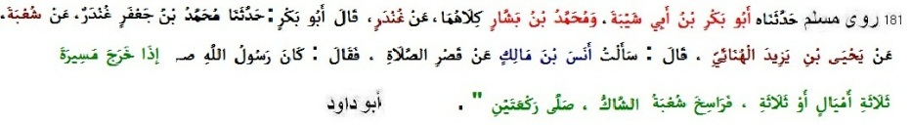
181 Muslim narrated .........from Shu’ba from Yahya b. Yazid al-Huna'i: He said: I asked Anas b. Malik about shortening of prayer. He said: The Messenger of' Allah (pbuh) observed two rak'ahs when had covered a distance of three miles or three farsakh. (Shu'ba had doubt whether Yahya Huna'i said miles or farsakh) (also Abu Dawud 1017, Ahmad, Ibn Abu Shaibah, Abu Awana)
Fasting
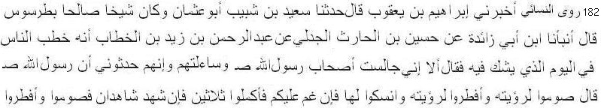
182 Nasai narrated ............ from Husain bin Harith: Abdur-Rahman bin Zaid (junior sahabi) addressed the people on the day concerning which there was doubt (as to whether the month had begun) and said: "I sat with the companions of the Messenger of Allah (pbuh) and asked them, and they a narrated that the Messenger of Allah said: 'Fast when you see it and stop fasting when you see it, and perform the rites on that basis. If it is obscured, then complete thirty days, and if two witnesses testify then fast and stop fasting. (sahih according to Zubair Ali Zai)
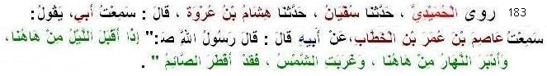
183 Humaidi narrated .............. from Umar: The Messenger of Allah (pbuh) said: When night comes from there and day exits from there the fasting person shall break his fast. (also Ahmad, Daremi, Bukhari 1954, Muslim 2553, Abu Dawud, Tirmiji)
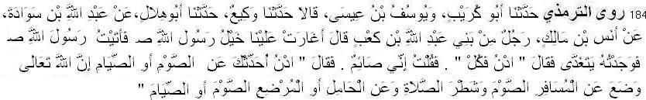
184 Tirmiji narrated ............. from Anas: A man from Banu Abdullah bin Ka'b said: "Some cavalry man of the Messenger of Allah came galloping upon us, so I came to the Messenger of Allah and found him having lunch. He said: "Come and eat." I said: 'I am fasting.' So he said: 'Come and I will narrate to you about the fast or fasting. Indeed Allah Most High lifted (the fast and) half of the Salat from the traveler, and (He lifted) the fast or fasting - from the pregnant person, or the breast-feeding". [also Nasa'i, Ibn Majah, Abu Dawud; hasan/sahih]
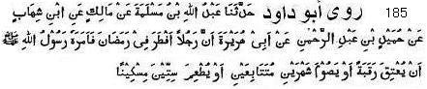
185 Abu Dawud narrated .............. from Abu Hurairah: A man had broken fast in Ramadan; so the Messenger of Allah (pbuh) ordered him to set free a slave or to fast two consecutive months or to feed sixty poor people. (also Ahmad, Bukhari, Muslim)
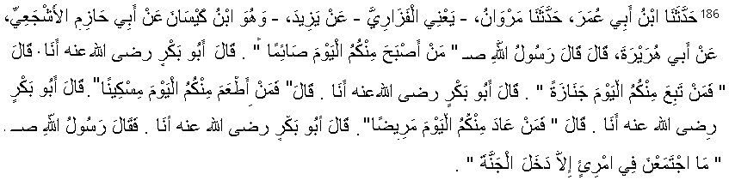
186 Muslim narrated ........... from Abu Hurairah: so the Messenger of Allah (pbuh) said: “Who has observed is fast among you today?” Abu Bakr said: It is I. He said: Who has followed a funeral procession among you today? Abu Bakr said: It is I. He said: Who among you has fed the needy today? Abu Bakr said: It is I. He said: Who among you has today visited the sick? Abu Bakr said: It is I. Then the Messenger of Allah (pbuh) said: “Anyone in whom (these good deeds) are combined will certainly, enter paradise.”[Sahih]
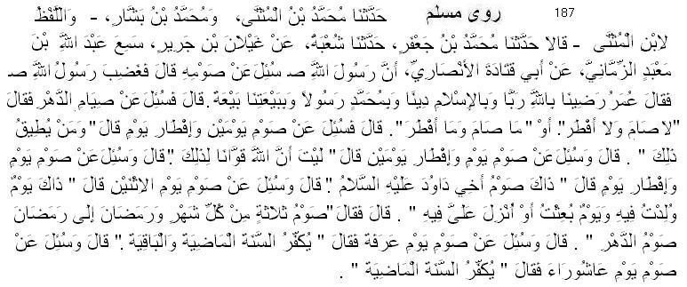
187 Muslim narrated ............. from Abu Qatada: The Messenger of Allah (pbuh) was asked about his fasting. The Messenger of Allah (pbuh) felt annoyed. Umar said: We are pleased with Allah as the Lord, with Islam as our Code of Life, with Muhammad as the Messenger and with our pledge as a commitment. He was then asked about perpetual fasting, whereupon he said: He neither fasted nor did he break it, or he did not fast and he did not break it. He was then asked about fasting for two days and breaking one day. He (pbuh) said: And who has strength enough to do it? He was asked about fasting for a day and breaking for two days, whereupon he said: May Allah bestow upon us strength to do it. He was then asked about fasting for a day and breaking on the other, whereupon he said: That is the fasting of my brother David (pbuh). He was then asked about fasting on Monday, whereupon he said: It was the day on which I was born. on which I was appointed as prophet or revelation was sent to me, (and he further) said: Three days' fasting every month and of the whole of Ramadan every year is a perpetual fast. He was asked about fasting on the day of 'Arafah (9th of Dhu'l-Hijja), whereupon he said: It expiates the sins of the preceding year and the coming year. He was asked about fasting on the day of 'Ashura (10th of Muharram), whereupon he said: It expiates the sins of the preceding year.
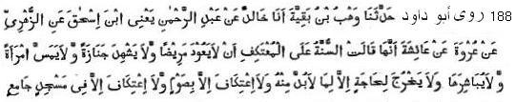
188 Abu Dawud narrated ............. from Aisha: She said: The sunnah for one who is observing i'tikaf (in a mosque) is not to visit a patient, or to attend a funeral, or touch or embrace one's wife, or go out for anything but necessary purposes. There is no i'tikaf without fasting, and there is no i'tikaf except in a congregational mosque.
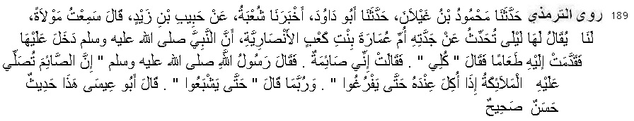
189 Tirmiji narrated from ..... Habib bin Zaid; he said: "I heard a freed slave of ours called Laila narrated from Umm Amarah bint Ka'b Ansari (Nusaybah), that the Prophet entered upon her and some food was brought to him. He said: 'Eat.' She said: 'I am fasting.' So the Messenger of Allah said: 'Indeed the angels send Salat upon the fasting person when others eat in his presence, until they finish.' And perhaps he said: 'Until they have eaten their fill.'" (also: Ahmad, Daremi, Ibn Mazah, Ibn Khuzaimah)

Zakat and Donation
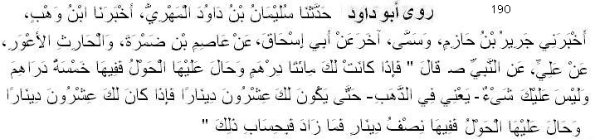
190 Abu Dawud narrated ............. from Ali: The Prophet (pbuh) said: "When you possess two hundred dirhams and one year passes on them; five dirhams are payable. Nothing is incumbent on you, that is, on gold, till it reaches twenty dinars. When you possess twenty dinars and one year passes on them; half a dinar is payable.” (hadith is hasan)

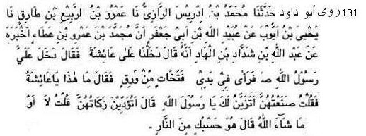
191 Abu Dawud narrated ......... from Aishah: The Messenger of Allah (pbuh) entered into my room and noticed ornaments in my hand. He said to me: What is this? I said: This is to enhance my beuty before you. He said to me: Do you pay zakat on them? I said: “No” or what Allah willed. He then said: These are sufficient to take you to hell-fire. (sahih)
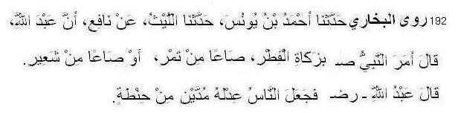
192 Bukhari narrated ............................ from Abdullah bin Umar: The Prophet (pbuh) ordered to give one Sa' of dates or one Sa' of barley as Zakat-ul-Fitr. The people rewarded two mudds of wheat as equal to that. (also Nasai)
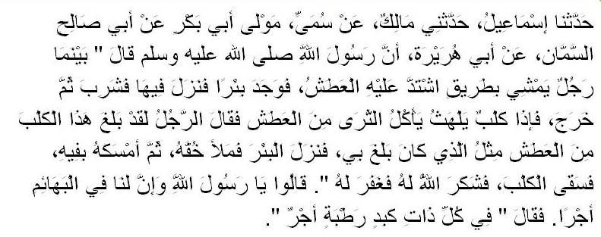
193 Bukhari narrated .......... from Abu Huraira: The Messenger of Allah (pbuh) said, "While a man was walking on a road. He became very thirsty. Then he came across a well, got down into it, drank (of its water) and then came out. Meanwhile he saw a dog panting and licking mud because of excessive thirst. The man said to himself "This dog is suffering from the same state of thirst as I did." So he went down the well (again) and filled his shoe (with water) and held it in his mouth and watered the dog. Allah thanked him for that deed and forgave him." The people asked, "O Allah's Messenger! Is there a reward for us in serving the animals?" He said, "There is a reward for serving any animate (living being)."

Hajj and Sacrifice (of animals)
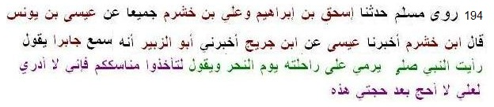
194 Muslim narrated .............. from Jabir: The Messenger of Allah (pbuh) said, "Take your rituals ( of Hajj and umrah), for I do not know whether I will perform Hajj after this one. (in Nasai from me is added.)
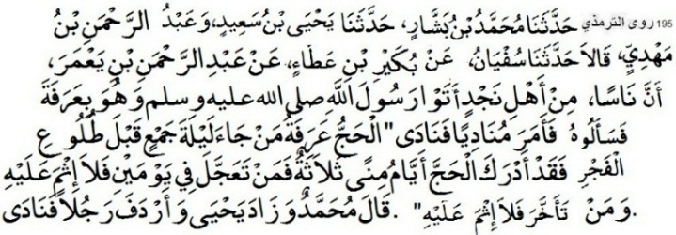
195 Tirmiji narrated . . . . from Abdur-Rahman bin Ya'mar that: Some people among the residents of Najd came to the Messenger of Allah while he was at Arafat. They were questioning him, so he ordered a caller to proclaim: "The Hajj is Arafah. Whoever came to during the night of Jam, before the time of Fajr, then he has attended the Hajj. The days of Mina are three, so whoever hastens (leaving after) two days, then there is no sin upon him, and whoever delays, then
there is no sin upon him." (also narrated by Nasai, Ahmad)
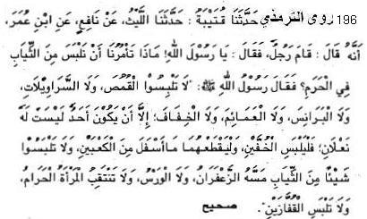
196 Tirmiji narrated ............. from Ibn Umar: The Prophet (pbuh) said, "The man who is in ihram must not wear shirt, pyjama, cap and turban. The woman who is in ihram must not cover her face and wear gloves.” (also Bukhari 1838)
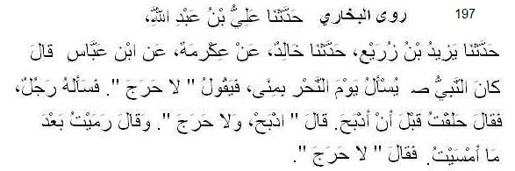
197 Bukhari narrated in his Sahih in Book of Hajj rituals: . . . Ibn Abbas narrated: The Prophet (pbuh) was asked (as regards the ceremonies of Hajj) at Mina on the Day of Nahr and he replied that there was no harm. Then a man said to him, "I got my head shaved before slaughtering." He replied, "Slaughter (now) and there is no harm in it." (Another) man said, "I did the Rami (of the Jimar) after midday." The Prophet replied, "There was no harm in it."
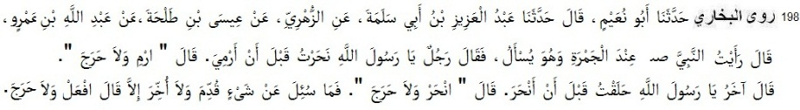
198 Bukhari narrated in his Sahih in Book of Knowledge: . . . Abdullah bin Amr said: I saw the Prophet (pbuh) near the Jamra and the people were asking him questions (about religious problems). A man asked, "O Allah's Messenger! I have slaughtered the Hadi (animal) before doing the Rami." The Prophet (pbuh) replied, "Do the Rami (now) and there is no harm." Another person asked, "O Allah's Messenger! I got my head shaved before slaughtering the animal."
The Prophet (pbuh) replied, "Do the slaughtering (now) and there is no harm." On that day, when the Prophet (pbuh) was asked about anything as regards the ceremonies of Hajj performed before or after its due time his reply was, "Do it (now) and there is no harm."
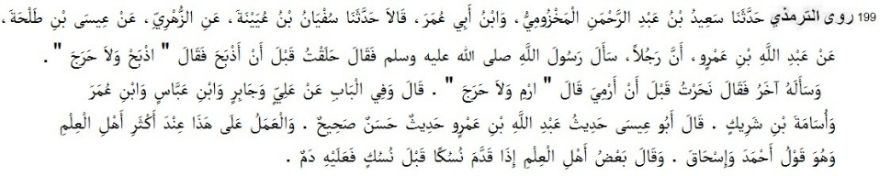
199 Tirmiji narrated . . . . .. from Abdullah bin Amr: A man said to the Prophet (pbuh), "I got my head shaved before slaughtering." He replied, "Slaughter (now) and there is no harm in it." Another man said, "I slaughter before the Rami (of the Jimar)." The Prophet replied, “Do the Rami (now) and there is no harm in it."
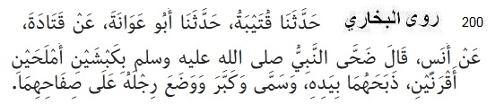
200 Bukhari narrated ....... Anas said, The Prophet (pbuh) offered, as sacrifices, two horned rams, black and white in color. He slaughtered them with his own hands and mentioned Allah's Name over them and said Takbir and put his foot on their sides.
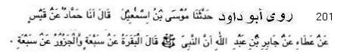
201 Narrated Abu Dawud . . . . . . .. from Jabir ibn Abdullah: The Prophet (pbuh) said: A cow serves for seven, and a camel serves for seven.

Reality of the World
202 Muslim narrated ........ from Abu Huraira: The Messenger of Allah (pbuh) said, “The world is a prison for the believer and a paradise for the disbeliever” (also Ahmad, Tirmiji).
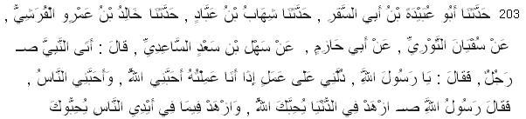
203 Ibn Majah narrated ....... from Sahl bin Sa’d: A man came to the prophet (pbuh) and said: “O Messenger of Allah, direct me to an act which, if I do it, [will cause] Allah to love me and people to love me.” He said: “Renounce the world and Allah will love you, and renounce what people possess and people will love you.” (also Tabarani; Zainuddin Iraqi said: hasan, Hakim said: sahih)
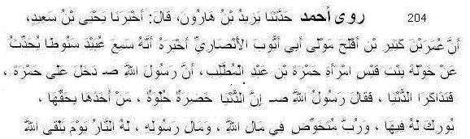
204 Ahmad narrated ..... from Khawlah bint Qais: The Messenger of Allah (pbuh) said, “The world is green and sweet. Who takes it in approved ways Allah gives prosperity. .........
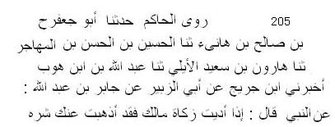
205 Hakim narrated .. . . from Jabir: Messenger of Allah (pbuh) said: When you pay zakat the danger of your wealth goes away. (Hakim in Mustadrak 1439; hasan; also Ibn Khuzaimah, Bayhaqi in Sunan Kabir)
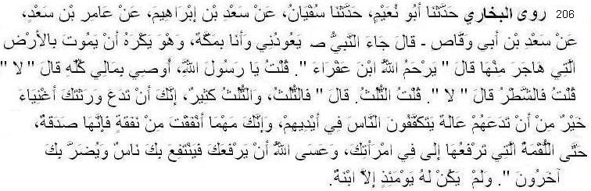
206 Bukhari narrated .. .... from Sa`d bin Abu Waqqas: The Prophet (pbuh) came visiting me while I was (sick) in Makkah, (Amir the sub-narrator said, and he disliked to die in the land, whence he had already migrated). He (i.e. the Prophet) said, "May Allah bestow His Mercy on Ibn Afra (Sa`d bin Khaula)." I said, "O Allah's Messenger! May I will all my property (in charity)?" He said, "No." I said, "Then may I will half of it?" He said, "No". I said, "One third?" He said: "Yes, one third, yet even one third is too much. It is better for you to leave your inheritors wealthy than to leave them poor begging others, and whatever you spend for Allah's sake will be considered as a charitable deed even the handful of food you put in your wife's mouth. Allah may lengthen your age so that some people may benefit by you, and some others be harmed by you." At that time Sa`d had only one daughter.
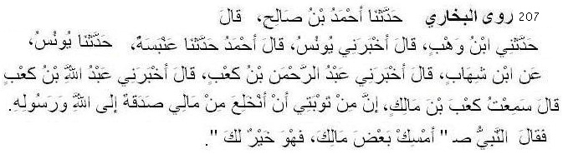
207 Bukhari narrated ............. from Abdullah bin Ka`b: I heard Ka`b bin Malik talking about the verse:- 'And to the three (He also forgave) who remained behind.' (9.118) saying in the last portion of his talk, "(I said), 'As a part (sign) of my repentance, I would like to give up all my property in the cause of Allah and His Messenger.' The Prophet (pbuh) said to me, 'Keep some of your wealth as it is good for you."
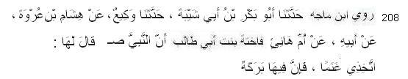
208 Ibn Mazah narrated ................. from Umm Hani Fakhitah bint Abu Talib: The Prophet (pbuh) said to me, 'Keep goats because it has prosperity.” (also Ahmad)
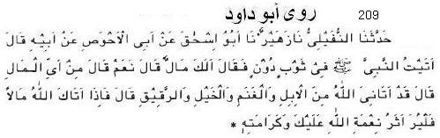
209 Abu Dawud narated ................. from Abu al-Ahwas Awf ibn Malik: I came to the Prophet (pbuh) wearing a poor garment and he said (to me): Have you any property? He replied: Yes. He asked: What kind is it? He said: Allah has given me camels. Sheep, horses and slaves. He then said: When Allah gives you property, let the mark of Allah's favour and honour to you be seen. (also Ahmad, Nasai)

Food and Drink
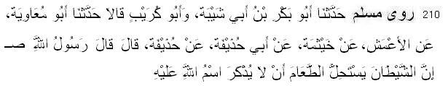
210 Muslim narrated ..................... from Hudhaifa: Allah's Messenger (pbuh): Satan considers that food lawful on which Allah's name is not mentioned. (also Abu Dawud)
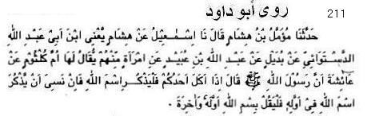
211 Abu Dawud narated ................ from 'Aisha: The Messenger of Allah (pbuh) said: When one of you eats, he should mention the name of Allah; if he forgets to mention the name of Allah name at the beginning, he should say: "In the name of Allah at the beginning and at the end of it." (also Tirmiji; sahih)
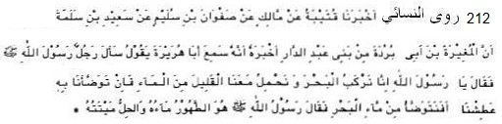
212 Nasai narrated .....................from Mughirah bin Abu Burdah, who was from the tribe of Banu 'Abdud Dar, he said that he heard Abu Hurairah say: A man came to the Messenger of Allah (pbuh) and said, "O Messenger of Allah, we travel by sea and carry a small amount of water with us. If we use it for ablution, we will become thirsty. Can we perform ablution with seawater?" The Messenger of Allah (pbuh) said, "Its water is a means of purification, and its dead meat is permissible." (Hadith is sahih; also Malik in Muwatta, Abu Dawud 73, Ibn Mazah 386, Ibn Khuzaimah)
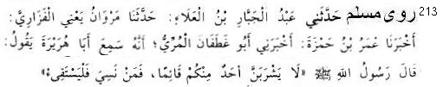
213 Muslim narrated .................... Abu Huraira reported Allah's Messenger (pbuh) as saying: None of you should drink while standing; and if anyone forgets, he must vomit.
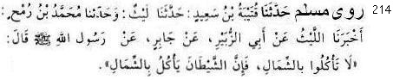
214 Muslim narrated ..... from Jabir: Allah's Messenger (pbuh) said: Do not eat with his left hand, for the Satan eats with left hand.
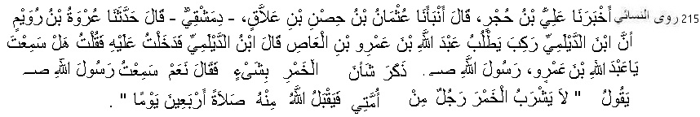
215 Nasaai narrated ............... from Urwah bin Ruwaim, He narrated that: Ibn Ad-Dailami rode looking for Abdullah bin 'Amr. Ibn Ad-Dailami said: "I entered upon him and said: 'O Abdullah bin 'Amr, did you hear the Messenger of Allah [pbuh] say anything concerning Khamr?' He said: 'Yes, I heard the Messenger of Allah say: If a man among my Ummah drinks Khamr, Allah will not accept his Salah for forty days.'" (also Ahmad)
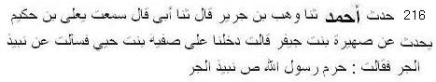
216 Ahmad narrated .............. from Safiyyah bint Huyyai: She said, Allah's Messenger (pbuh) made nabeez made of moistened date-fruits haram. (Ahmad 26904; Shuaib Arnaut said: The Hadith is Sahih li-ghairih and this sanad is weak because Suhairah bint Jayfar is unknown.)

Disease, Death and Medicine
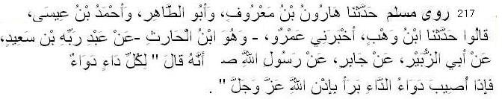
217 Muslim narrated .. ......... from Jabir: Allah's Messenger (pbuh) said: There is a remedy for every malady, and when the remedy is applied to the disease it is cured with the permission of Allah, the Exalted and Glorious.
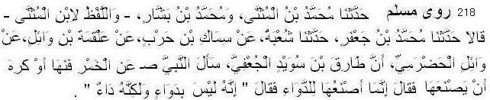
218 Muslim narrated .. .......... from Wa'il al-Hadrami that Tariq b. Suwaid Ju'fi asked Allah's Messenger (pbuh) about liquor. He forbade (its use) and he expressed hatred that it should be prepared. He (Tariq) said: I prepare it as a medicine, whereupon he (the Prophet) said: It is no medicine, but it is a disease. (also Tirmiji, Ibn Mazah)
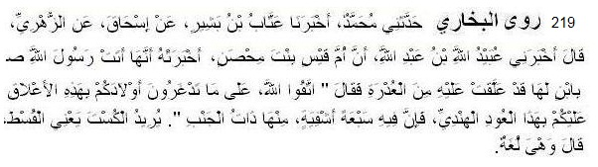
219 Bukhari narrated ............... from Um Qais bint Mihsan: she narrated that she took to Messenger of Allah (pbuh) one of her sons whose palate and tonsils she had pressed to treat a throat trouble. The Prophet (pbuh) said, "Be afraid of Allah! Why do you pain your children by having their tonsils pressed like that?
Use the Ud Hindi for it cures seven diseases, one of which is pleurisy."
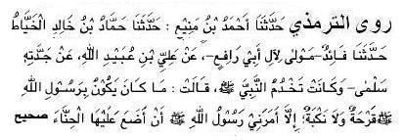
220 Tirmiji relates .................. from Umm Rafi, servant of Safiyyah; She said, If ever the Prophet (pbuh) was affected by ulceration or thorns, he would apply henna to them. (also Ibn Mazah)

Dignity of Parents
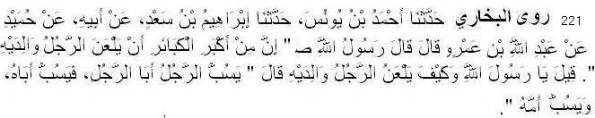
221 Bukhari narrated .......................... from Abdullah bin 'Amr: Allah's Messenger said. "It is one of the greatest sins that a man should curse his parents." It was asked (by the people), "O Allah's Messenger! How does a man curse his parents?" The Prophet said, "'The man abuses the father of another man and the latter abuses the father of the former and abuses his mother."
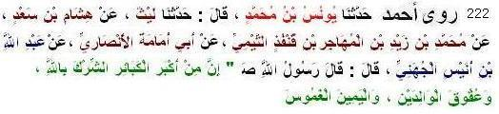
222 Ahmad narrated ........................ from Abdullah bin Unais Juhani; The Prophet (pbuh) said, "Major sins are Worshipping others with Allah, disobedience to parents and false oath to devour wealth of others." (also Tirmiji, Ibn Hibban)
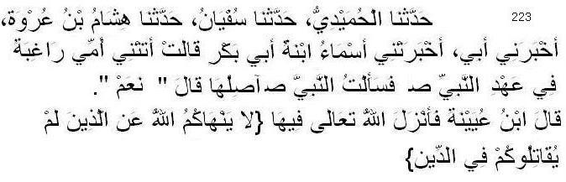
223 Humaidi narrated ......................... from Asma' bint Abu Bakr: My mother came to me, hoping (for my favor) during the lifetime of the Prophet (pbuh). I asked the Prophet, "May I treat her kindly?" He replied, "Yes." Ibn 'Uyaina said, "Then Allah revealed: 'Allah forbids you not with regards to those who fought not against you because of religion, and drove you not out from your homes, that you should show them kindness and deal justly with them.'....... (60.8) (also Bukhari, Nasai)
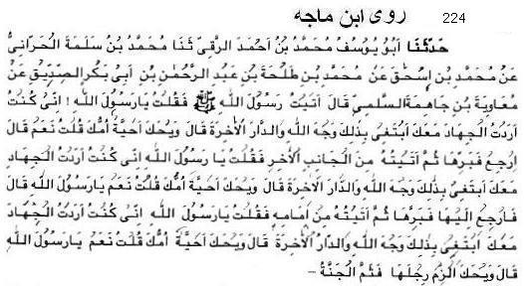
224 Ibn Majah narrated ................... from Muawiyah bin Zahimah Sulami; the Prophet (pbuh) said: Be at your Mother's feet and there is the Paradise.” (IM 2771, Nasai 3108)

Marriage and Family Life
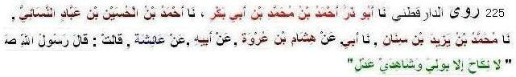
225 Daraaqutni narrated ......................... from Aishah; the Prophet (pbuh) said: No Nikah is valid except with a guardian and two impartial witnesses.” (also Tabarani)
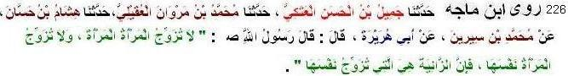
226 Ibn Majah narrated ......................... from Abu Hurairah: the Prophet (pbuh) said: “No woman may conduct the marriage contract of another woman, and no woman can conduct the marriage contract on behalf of her own self, because the zaaniyah (fornicatress, adulteress) is the one who arranges things on her own behalf. (also Daraqutni; sahih)
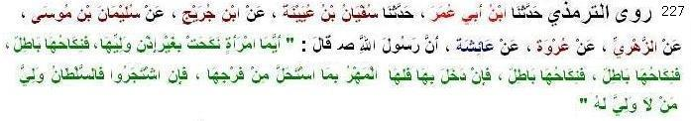
227 Tirmiji narrated ............... from ‘Aishah: The Messenger of Allah (pbuh) said: Any woman who gets married without the permission of her guardian, her marriage is invalid, her marriage is invalid, her marriage is invalid. But if the marriage is consummated then the mahr is hers because she has allowed him to be intimate with her. If they dispute, then the ruler is the guardian of the one who has no guardian. (Tirmiji said the hadith is hasan- actually it is sahih; also Abu Dawud, Ibn Hibban)
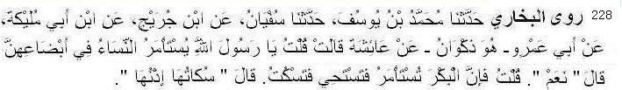
228 Bukhari narrated ............. from Aisha: I asked the Prophet (pbuh), "O Allah's Messenger! Should the women be asked for their consent to their marriage?" He said, "Yes." I said, "A virgin, if asked, feels shy and keeps quiet." He said, "Her silence means her consent."
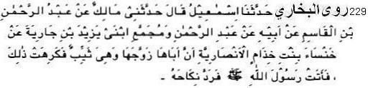
229 Bukhari narrated ..................... from Khansa bint Khidam Al-Ansariya: that her father gave her in marriage when she was a matron and she disliked that marriage. So she went to Allah's Messenger (pbuh) and he declared that marriage invalid. (also Nasai)
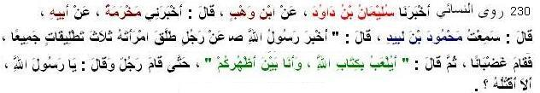
230 Nasai narrated ..................... from Mahmud bin Labid: Allah's Messenger (pbuh) was told about a man who pronounced three divorces on his wife at one time, so the Prophet stood up while angry and said: «أَيُلْعَبُ بِكِتَابِ اللهِ وَأَنَا بَيْنَ أَظْهُرِكُم» The Book of Allah is being made the subject of jest while I am still amongst you. A man then stood up and said, "Should I kill that man, O Messenger of Allah?'' (sahih according to Ahmad)
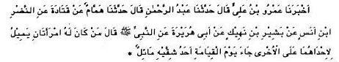
231 Tirmiji narrated ............. from Abu Hurairah: The Messenger of Allah (pbuh) said: “A man who has two wives and he does not deal justly with them will be resurrected on the Day of Judgment with half
his body paralysed. (sahih)
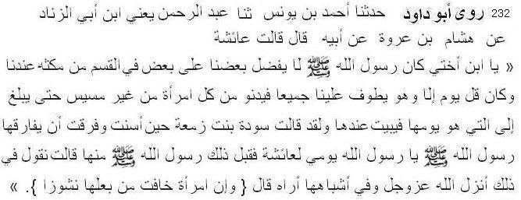
232 Abu Dawud narrated ..................... from Aishah: The Prophet (pbuh) did not give preference of one of us over other in dividing his time between us. He used to meet all of us on a day (to have a chat) but he did not touch anyone until he went to the wife whose hospitality was due on that day.
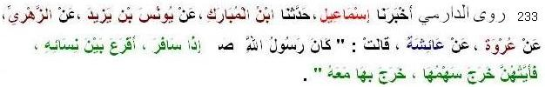
233 Daremi narrated ............................... from Aishah said: Whenever the Messenger of Allah (pbuh) intended to set out on a journey he cast lots among his wives and he took one with him in whose favour the lot was cast. (also Bukhari, Muslim)
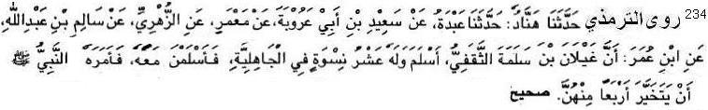
234 Trimiji narrated ............................... from Ibn Umar: Ghaylan ibn Salamah Saqafi accepted Islam and that he had ten wives in the pre-Islamic period who accepted Islam along with him; so the Prophet (pbuh) told him to keep four (and separate from the rest of them) (also Ahmad, Ibn Majah)
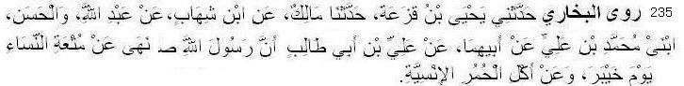
235 Bukhari narrated .............. from Ali bin abu Talib: On the day of khaibar, the Messenger of Allah (pbuh) forbade the mut'a (i.e. temporary marriage) and the eating of donkey-meat
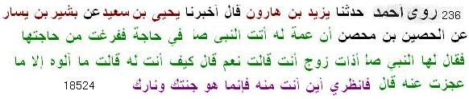
236 Ahmad narrated ........................ from Husain bin Mihsan from his aunt Asma: The Messenger of Allah (pbuh) said: Do you have husband? She said: Yes. He said: How are you to him? She said: I serve him well. However I get less from him. He said: How Wait and see where you will reach through him. He is your paradise and your hell.

Human Rights
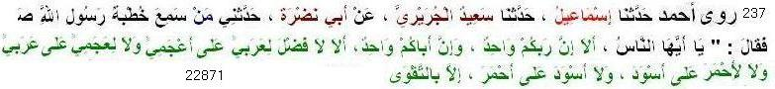
237 Ahmad narrated ........................ from Abu Nadrah. He said a man who witnessed lecture of the Messenger of Allah (pbuh) narrated to me that He (pbuh) said, “Beware your Lord is One and your father is one. Beware there is no excellance of Arabs over Non-Arabs and there is no excellance of Non-Arabs over Arabs and there is no excellance of Reds over Blacks and there is no excellance of Blacks over Reds except due to God-consciousness.
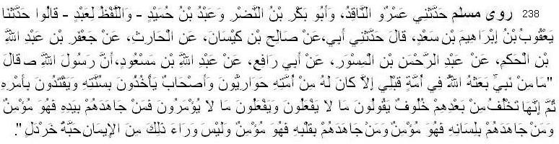
238 Muslim narrated ...................from ibn Mas'ud: The Messenger of Allah (pbuh) said: Never a Prophet had been sent before me by Allah towards his nation who had not among his people (his) disciples and companions who followed his sunnah and obeyed his command. Then there came after them their successors who said whatever they did not practise, and practised whatever they were not commanded to do. He who strove against them with his hand was a believer: he who strove against them with his tongue was a believer, and he who strove against them with his heart was a believer and beyond that there is no faith even to the extent of a mustard seed.
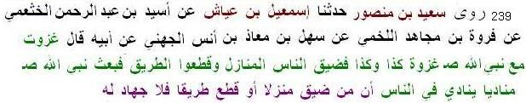
239 Saeed ibn Mansur narrated ..............from Mu'adh ibn Anas al-Juhani: I fought along with the Prophet (pbuh) in such and such battles. The people occupied much space and encroached on the road. The Prophet (pbuh) sent an announcer to announce among the people: Those who occupy much space or encroach on the road will not be credited with jihad. (also Abu Dawud )
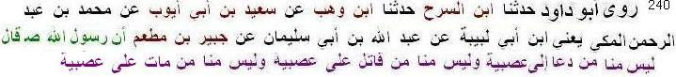
240 Abu Dawud narrated ...................from Jubair bin Mutim: The Messenger of Allah (pbuh) said: “He is not one of us who calls for asabiyyah, (tribalism/nationalism) or who fights for asabiyyah, or who dies for asabiyyah.”
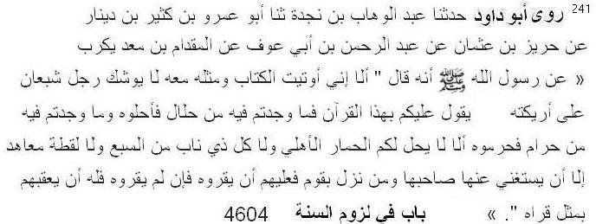
241 Abu Dawud narrated ...................from Miqdam bin Madikarib: The Messenger of Allah (pbuh) said: “Beware! I have been given the Quran and something like it, yet the time is coming when a man replete on his couch will say: 'Keep to the Quran; what you find in it to be permissible, treat as permissible; and what you find in it to be prohibited treat as prohibited.' Beware! The domestic ass, beasts of prey with fangs, a find belonging to Non-Muslim under treaty, unless its owner does not want it, are not permissible to you.

Dignity of Sahabis
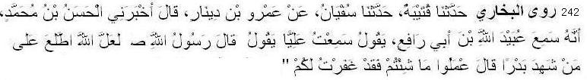
242 Bukhari narrated .................... from Ali: The Messenger of Allah (pbuh) said, Perhaps Allah looked at those who witnessed Badr and said, "O the people of Badr (i.e. Badr Muslim warriors), do what you like, for I have forgiven you.”
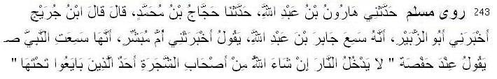
243 Muslim narrated ...................from Umm Mubashshir: She heard Messenger of Allah (pbuh) as saying in presence of Hafsa: Allah willing, the people of the Tree would never enter the fire of Hell one amongst those who owed allegiance under that.
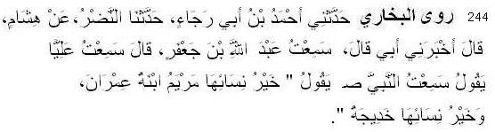
244 Bukhari narrated .................... from Ali: I heard the Prophet saying, "Mary, the daughter of `Imran, was the best among the women (of the world of her time) and Khadija is the best amongst the women. (of this nation). (also Muslim)

Antidefamation Guideline
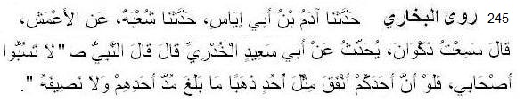
245 Bukhari narrated .................... from Abu Said: The Prophet (pbuh) said, "Do not abuse my companions for if any one of you spent gold equal to Uhud (in Allah's Cause) it would not be equal to a Mud or even a half Mud spent by one of them .
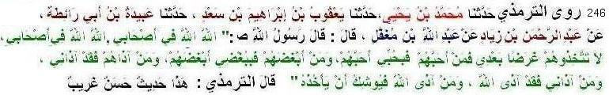
246 Tirmiji narrated .................... from ibn Mugaffal: The Prophet (pbuh) said: "Allah! Allah! (Keep the thought of Allah) concerning my companions. “Do not take them as a target” (for your obscenity or charges) after me, He who loves them, loves me but he who hate them, hates Me, and he who offends them, offends me and in turn offends Allah and he who offends Allah, Allah almost takes him"
Sunnah and Bid’ah
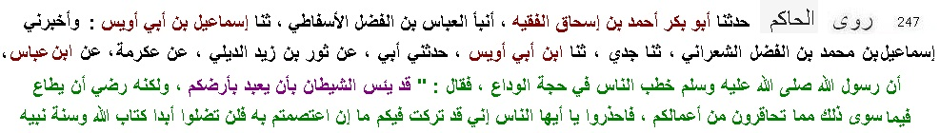
247 Hakim narrated .................... from Ibn Abbas:.Allah's Messenger (pbuh) said: "I have left two things with you. As long as you hold fast to them, you will not go astray. They are the Book of Allah and the Sunnah of His Prophet.” (also Muatta of Malik without complete sanad.)
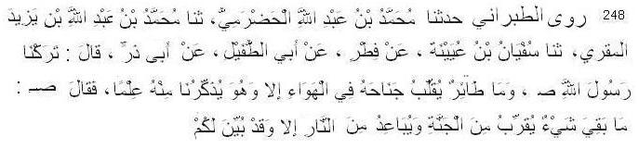
248 Tabarani narrated ................ from Abu Zarr: "The Messenger of Allah (pbuh) said: “There is nothing left which bring you near jannah and distant you from helfire but have been described to you. ” [also Maqdisi, IbnAbu Shaibah (from Ibn Masud), Hakim(from Ibn Masud)]
249 Ahmad narrated .................... from Aishah: Allah's Messenger (pbuh) said: Whoever performs a (good) deed which we have not ordered (anyone) to do, then that deed will be rejected. (also Muslim)
250 Ahmad narrated ................ from Aishah: The Messenger of Allah (pbuh) said: “If somebody innovates something which is not present in our religion, then that thing will be rejected. (also Bukhari, Abu Dawud)
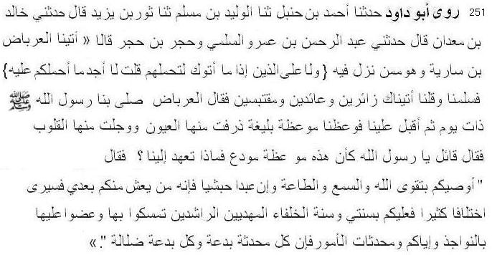
251 Abu Dawud narrated .................... from Al-'Irbadh bin Sariyah: "The Messenger of Allah (pbuh) gave us a sermon by which our hearts were filled with fear and tears came to our eyes. We said, 'O Messenger of Allah, it is as though this is a farewell sermon.' He said, I counsel you to fear Allah and to give absolute obedience, even if a slave becomes your leader. Verily, he amongst you who lives [long] will see great controversy, so you must keep to my Sunnah and to the Sunnah of the Rightly-Guided Caliphs. Cling to them stubbornly. Beware of newly invented matters. For ever invented matter is an innovation (bid'ah), and every bid'ah is a going astray.
In Nasai’s version “And every going astray in the Hell-Fire" is added.

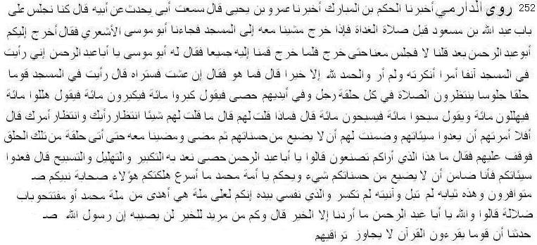
252 Daremi narrated .... Abu Musa informed Ibn Masud that a group of people gather in the masjid and sit in circles. A man among them instructs say Allahu Akbar 100 times, say SubhanAllah 100 times, say Alhamdu lillah 100 times. Ibn Masud went to a circle and said, What is this innovattion I see you practising? They said, O father of Abdur Rahman, We count our takbir, tasbih and tahlil. Ibn Masud said, Count your sins. I am a responsible to make sure that your virtue is not corrupted. O Ummah of Muhammad! You have reached deviation so soon while these companions of the Prophet are still alive among you! Have you found better tradition or you opened door to deviation. They said, We did it aspiring good. Ibn Masud said, How many people are there who aspire good but cannot get it! Messenger of Allah narrated to us, A group will recite the Quran which will not exceed their throats.
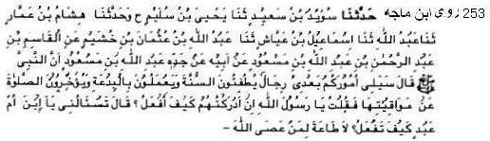
253 Ibn Mazah narrated ............ from Ibn Masud: The Prophet (pbuh) said: "Soon there will be a group of people will come after me who will damage sunnah and act on bidah and delay the prayer from its time," I said: O Messenger of Allah, if I know them, How do I do? He said: "You are asking me, O your mother’s son, how will you do? There is no obedience to those who disobey Allah." (also Ahmad, Tabarani, Ibn Asakir)
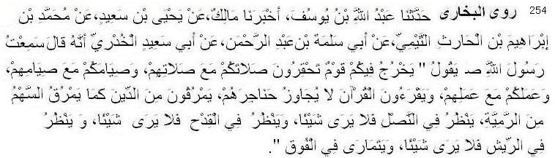
254 Bukhari narrated ........... from Abu Saeed Khudri: I heard Messenger of Allah (pbuh) saying, "There will appear some people among you whose prayer will make you look down upon yours, and whose fasting will make you look down upon yours, but they will recite the Quran which will not exceed their throats (they will not act on it) and they will go out of Islam as an arrow goes out through the game whereupon the archer would examine the arrowhead but see nothing, and look at the unfeathered arrow but see nothing, and look at the arrow feathers but see nothing, and finally he suspects to find something in the lower part of the arrow." (also Muslim)
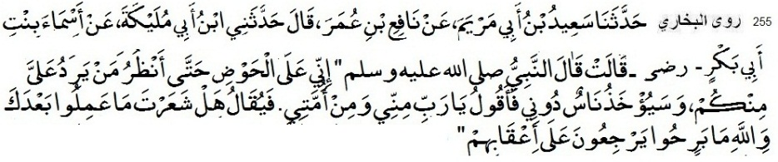
255 Bukhari narrated ...... from Asma bint Abu Bakr: The Prophet (pbuh) said, "I will be standing at the Lake-Fount so that I will see whom among you will come to me; and some people will be taken away from me, and I will say, 'O Lord, (they are) from me and from my followers.' Then it will be said, 'Did you notice what they did after you? By Allah, they kept on turning on their heels (turned as renegades).'
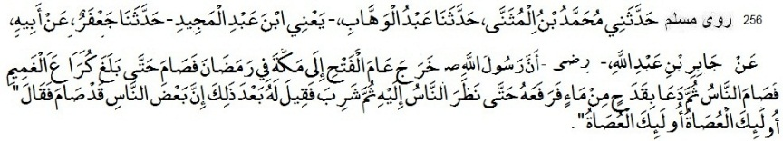
256 Muslim narrated ........... from Jabir: Messenger of Allah (pbuh) went out to Makkah in Ramadan in the year of Victory, and he and the people fasted till he came to Kura' al-Ghamim and the people also fasted. He then called for a cup of water which he raised till the people saw it, and then he drank. He was told afterwards that some people had continued to fast, and he said: These people are the disobedient ones; these are the disobedient ones.

Musical Instruments and Sports
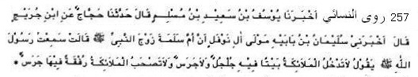
257 Nasai narrated ........... from Umm Salamah, the wife of the Prophet (pbuh). She said: "I heard the Messenger of Allah (pbuh) say: 'The angels do not enter a house in which there is a small bell, or a bell, and the angels do not accompany groups of people who have bells with them.'"
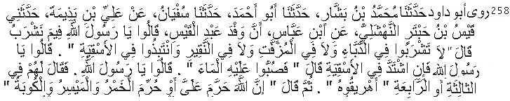
258 Abu Dawud narrated ......... from Ibn Abbas: The deputation of Abd Qais asked (the prophet):From which (vessels) should we drink ? He (the prophet) replied: Do not drink from the pumpkins, vessels smeared with pitch, and hollow stumps, and steep dates in skins. They asked: Messenger of Allah, if it ferments? He replied: infuse water in it. They asked: Messenger of Allah.” (repeating the same words). He replied to them third or fourth time: Pour it away. He then said: Allah has forbidden me, or he said: He has forbidden me wine, game of chance and drums (kubah). He said: Every intoxicant is unlawful. (also Ahmad; sahih)
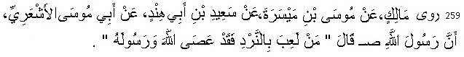
259 Malik narrated ......... from Abu Musa: Messenger of Allah (pbuh) said: He who plays dice disobeyed Allah and His Messenger. (also Ahmad, Abu Dawud, Ibn Mazah; sahih)
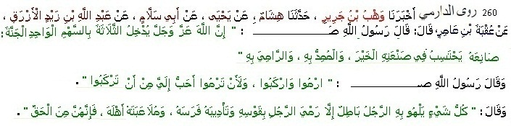
260 Daremi narrated ..... from Uqba bin Amir, Messenger of Allah (pbuh) said: Allah will reward three persons for one arrow: The manufacturer who makes it with intention of goodness, He who helps to launch it and He who launces it. Every game of any man is Batil except three: a man throws an arrow from his bow, he trains horse and a man plays with his wife. This are Justified. (also Hakim)

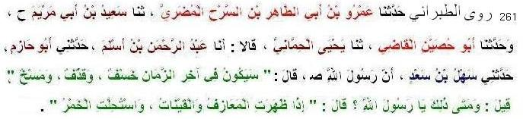
261 Tabarani narrated ........... from Sahl bin Sad: Allah's Messenger (pbuh) said: "There will befall this Ummat earthquakes, disfigurement of faces and showers of stones.' It was said: 'O Prophet! When will this happen?' The Prophet (pbuh) said: 'When musical instruments and singing girls become in profusion and liquor is made lawful."
Graves, Images and Idols
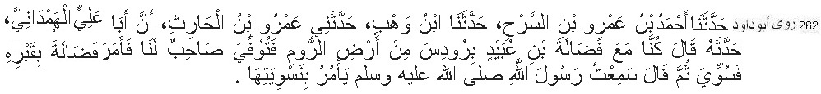
262 Abu Dawud narrated ............... from Abu 'Ali Hamdani: We were with Fudalah b. 'Ubaid at Rhodes in the land of Byzantine. One of our companions dies, Fudalah commanded us to dig his grave; it was (dug and) levelled. He then said: I heard the Messenger of Allah commanding to level them.
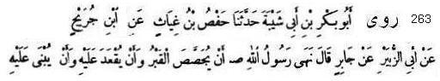
263 Ibn Abu Shaibah narrated .......... from Jabir: The Prophet (pbuh) forbade that the grave should not be plastered, or be used as a sitting place or a building should be built over it. (also Muslim 2242, Abu Dawud, Nasai)
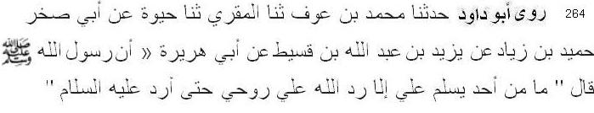
264 Abu Dawud narrated ................ from Abu Hurairah: Allah's Messenger (pbuh) said: Allah returns me my soul so that I might return the salam. (2041; hasan hadith)
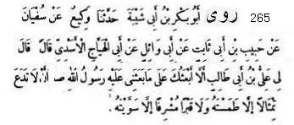
265 Ibn Abu Shaibah narrated ........ from Abu Haiyaj Asadi: Ali said to me: "Should I not depute you on
a mission on which I was sent by Allah's Messenger (pbuh)?: Deface all the pictures which you come across and demolish all the high graves to the level of earth." (also Muslim, Nasai, Abu Dawud, 3218).
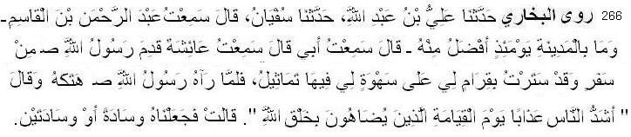
266 Bukhari narrated ................... from Aishah: The Messenger of Allah (pbuh) returned from a journey when I had placed a curtain of mine having pictures over (the door of) a chamber of mine. When Allah's Messenger saw it, he tore it and said, "The people who will receive the severest punishment on the Day of Resurrection will be those who try to make the like of Allah's creations." So we turned it (i.e., the curtain) into one or two cushions." (also Muslim)

Governance and Judgment
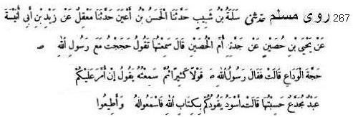
267 Muslim narrated ............ from Ummul Husain: I performed Hajj along with Allah's Messenger (pbuh) on the occasion of the Farewell Pilgrimage and saw him when he flung pebbles at Jamrat al-'Aqaba and returned while he was riding the camel, and Bilal and Usama were with him. One of them was leading his camel, while the other was raising his cloth over the head of Allah's Messenger (pbuh) to protect him from the sun. She (further) said: Allah's Messenger (pbuh) said so many things, and I heard him saying: If a slave having some limb of his missing and having dark complexion is appointed to govern you according to the Book of Allah the Exalted. listen to him and obey him. (Sahih Muslim - Kitabul Hajj )
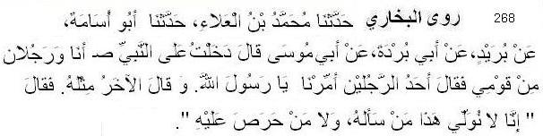
268 Bukhari narrated ........... from Abu Musa: Two men from my tribe and I entered upon the Prophet (pbuh). One of the two men said to the Prophet, "O Allah's Messenger! Appoint me as a governor," and so did the second. The Prophet said, "We do not assign the authority of ruling to those who ask for it, nor to those who are keen to have it." (also Muslim)
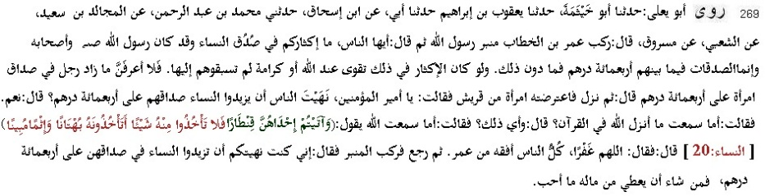
269 Abu Yala narrated .. .. from Masruq, Umar stood up on the pulpit of the Messenger of Allah and said, `O people! Why do you exaggerate concerning the dowry given to women. The Messenger of Allah and his companions used to pay up to four hundred Dirhams for a dowry, or less than that. Had paying more for a dowry been a part of Taqwa or an honor, you would not have led them in this practice. Therefore, I do not want to hear about a man who pays more than four hundred Dirhams for a dowry.' He then went down the Minbar, but a woman from Quraysh said to him, `O Leader of the Faithful! You prohibited people from paying more than four hundred Dirhams in a dowry for women' He said, `Yes.' She said, `Have you not heard what Allah sent down in the Quran' He said, `Which part of it' She said, `Have you not heard Allah's statement, (And you have given one of them a Qintar)' He said, `O Allah! Forgive me...' He then went back
and stood up on the Minbar saying, `I had prohibited you from paying more than four hundred Dirhams in a dowry for women. So, let everyone pay what he likes from his money.
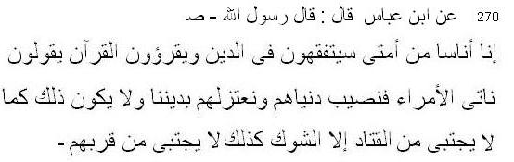
270 Ibn Majah narrated .................. from Ibn Abbas: the Messenger of Allah (pbuh) said: “Soon people from my ummah learn fiqh in religion and read the Quran, and they say: Let us go to the rulers and take our the worldly share from them and then we will come backe with our religion (keeping it intact). It can not be such. Beans cannot be collected from vetches (qatad); likewise there is no good from their company.”
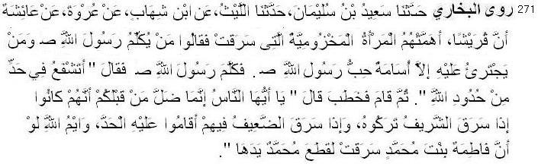
271 Bukhari narrated ........... from Aishah: The Quraish people became worried about the lady of Makhzum tribe who had committed theft. They said, "Nobody can speak (in favor of the lady) to the Messenger of Allah (pbuh) and nobody dares do that except Usama who is the favorite of the Messenger of Allah." When Usama spoke to the Messenger of Allah (pbuh) about that matter, the Messenger of Allah (pbuh) said, "Do you intercede (with me) to violate one of the legal punishment of Allah?" Then he got up and addressed the people, saying, "O people! The nations before you went astray because if a noble person committed theft, they used to leave him, but if a weak person among them committed theft, they used to inflict the punishment on him. By Allah, if Fatima, the daughter of Muhammad committed theft, Muhammad will cut off her hand." (also Muslim, Nasai)
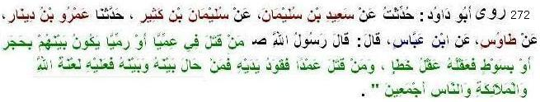
272 Abu Dawud narrated ..................from ibn Abbas: The Prophet (pbuh) said: If anyone is killed blindly or, when people are throwing stones, by a stone or a whip, his blood-wit is the blood-wit for an accidental murder. But if anyone is killed intentionally, retaliation is due. If anyone tries to prevent it, the curse of Allah, of angels, and of all the people will rest on him.
Hijab
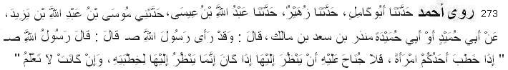
273 Ahmad narrated .............. from Abu Humaid Munjir bin Sa’d: The Messenger of Allah (pbuh) said: ‘If one of you proposes marriage to a woman, There is no sin for him that he might look at her only for proposal of marriage (it is permissible) even the woman is not informed.”
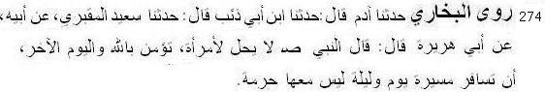
274 Bukhari narratedfrom Abu Huraira: The Messenger of Allah (pbuh) said: “It is unlawful for a woman who believes in Allah and the last day that she travels the distance of one day and one night without a Mahram accompanying her.” (Bukhari 1088, Muslim 3259)
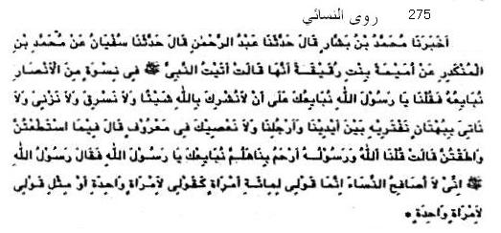
275 Nasai narrated .................. from Umayma bint Ruqayqa said, "I went to the Messenger of Allah (pbuh), with the women who took an oath of allegiance with him. They said, 'Messenger of Allah! We take a pledge with you not to associate anything with Allah, not to steal, not to commit adultery, not to kill our children, nor to produce any lie that we have devised between our hands and feet, and not to disobey you in what is known.' The Messenger of Allah (pbuh) said, 'In what you can do and are able.'"
Umayma continued, "They said, 'Allah and His Messenger are more merciful to us than ourselves. Come, let us give our hands to you, Messenger of Allah!' The Messenger of Allah, said, 'I do not shake hands with women. My word to a hundred women is like my word to one woman.'" (also Ahmad, Malik, Tirmiji)
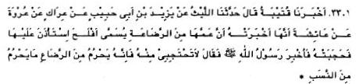
276 Nasai narrated ............ from Aisha: Aflah asked the permission to visit her but she did not allow him. This was infrormed to the Messenger of Allah (pbuh). The Messenger of Allah (pbuh) said, Do not use screen for him, because foster-suckling makes haram such lineage makes haram." (also Bukhari partially)
Friendship and separation
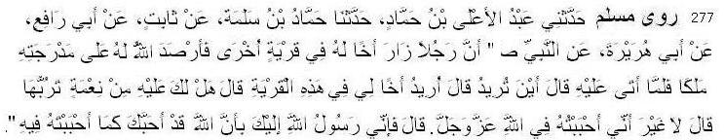
277 Muslim narrated ................ from Abu Hurairah: The Messenger of Allah (pbuh) said, A person visited his brother in another town and Allah deputed an angel to wait for him on his way. When he came to him he asked him, ‘Where do you intend to go?’ He said, ‘I intend to go to my brother in this town.’ He asked, ‘Have you any right over him (for the recompense of which you go there)?’ He said, ‘No, (the purpose of the visit is) nothing but I love him for the sake of Allah, the Glorious, the Majestic.’ The angel then disclosed to him, ‘I am a Messenger to you from Allah (to inform you) that Allah loves you as you love him (for His sake).’”
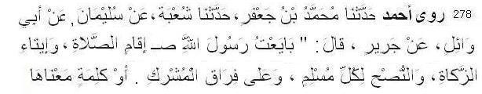
278 Ahmad narrated ............... from Jarir: When I gave the pledge of allegiance to Messenger of Allah
(pbuh), I took pledge to establish salah, to give zakat, tod give good advice to every Muslim and to remain separate from polytheists or word with similar meaning. (also Nasai. Bayhaqi, sahih)
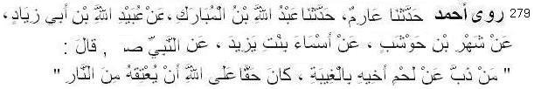
279 Ahmad narrated ................. from Asma' bint Yazid: The Prophet (pbuh) said: "Whoever defends his brother's honour in his absence, will be entitled to Allah's protection from the Fire."
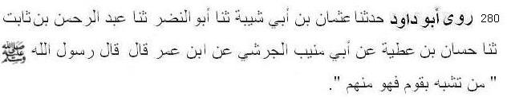
280 Abu Dawud narrated ........................ from Ibn Umar: The Prophet (pbuh) said: He who copies any people is one of them. (sahih)
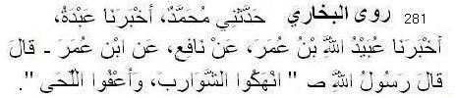
281 Bukhari narrated .............. from Ibn Umar: The Messenger of Allah (pbuh) said, "Cut the moustaches short and leave the beard (as it is). (also Nasai)

Dua and Zikr
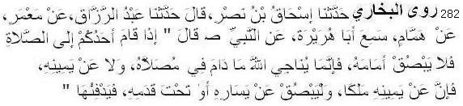
282 Bukhari narrated ............................. from Abu Huraira: The Prophet (pbuh) said, "If anyone of you stands for prayer, he should not spit in front of him because in prayer he is speaking in private to Allah and he should not spit on his right as there is an angel, but he can spit either on his left
or under his left foot and bury it (i.e. expectoration)."
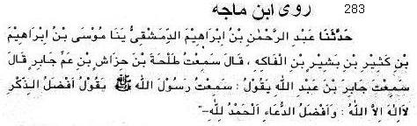
283 Ibn Mazah narrated ................... from Jabir: The Messenger of Allah (pbuh) said, The best zikr is la ilaha illallah and the best prayer (dua) is al-hamdu lillah. (also Tirmiji, Ibn Hibban)
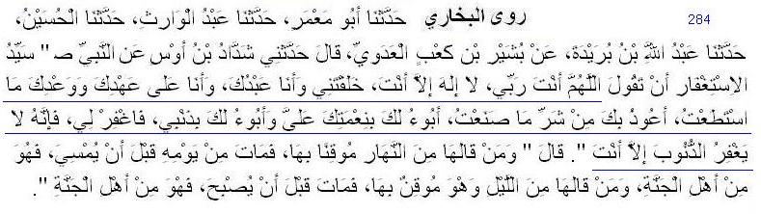
284 Bukhari narrated ................... from Shaddad bin Aus: The Prophet (pbuh) said "The most superior way of asking for forgiveness from Allah is: 'Allahumma anta Rabbi la ilaha illa anta, Anta Khalaqtani wa ana `Abduka, wa ana 'ala ahdika wa wa'dika mastata'tu, A`uzu bika min Sharri ma sana'tu, abu'u Laka bini'matika 'alaiya, wa abu'u laka bizanbi faghfir lee fa innahu la yaghfiru azzunuba illa anta." The Prophet (pbuh) added. "If somebody recites it during the day with firm faith in it, and dies on the same day before the evening, he will be from the people of Paradise; and if somebody recites it at night with firm faith in it, and dies before the morning, he will be from the people of Paradise." (also Ahmad, Nasai)
285 Bukhari narrated ................... from Abu Huraira: The Messenger of Allah (pbuh) said, "Whoever says, 'Subhan Allah wa bihamdihi,' one hundred times a day, will be forgiven all his sins even if they were as much as the foam of the sea. (also Muslim, Tirmiji)
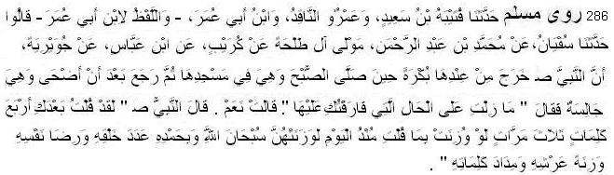
286 Muslim narrated .................. from Juwayriyah bint Al-Harith, the Mother of the Believers: came out from (her apartment) in the morning as she was busy in observing her dawn prayer in her place of worship. He came back in the forenoon and she was still sitting there. He said to her: You have been in the same seat since I left you. She said: Yes. Thereupon Allah's Messenger (pbuh) said: I recited four words three times after I left you and if these are to be weighed against what you have recited since morning these would outweigh them and (these words) are:" Subhan-Allahi wa bihamdihi, `adada khalqihi, wa rida nafsihi, wa zinatah `arshihi, wa midada kalimatihi. (also Nasai’s Amalul yawmi wal Lailah)
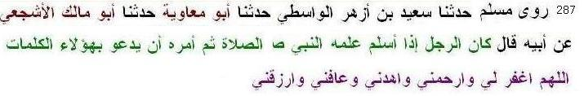
287 Muslim narrated ................... from Abu Malik Sa’d bin Tariq from His father (Tariq Ibn Ashim al-Ashja'ee, a sahabi): ''When a man embraced Islam, the prophet would teach him how to perform prayers, then tell him to make the following supplication (duaa): Allahumma ighfir li warhamni wahdini wa afini warzuqni''.
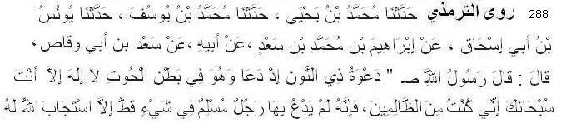
288 Tirmiji narrated ...................... from Sa’d ibn Waqqas: the Prophet (pbuh) said, “The supplication made by the Companion of the Fish (Prophet Yunus) in the belly of the fish was, ‘La ilaha illa anta, subhanaka, inni kuntu minaz-zalimin. If any Muslim supplicates in these words, his supplication will be accepted.”
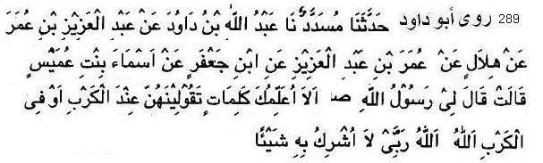
289 Abu Dawud narrated .............. from Asma’ bint ‘Umays: She said, ‘Rasulullah (pbuh) said to me, “Shall I teach you some words that you should say at the time of Karb or in Karb? Say: Allahu Allahu Rabbi laa ushriku bihi shay’a” (hasan; also Ibn mazah, Nasai in Amalul Yawmi wal lailah)
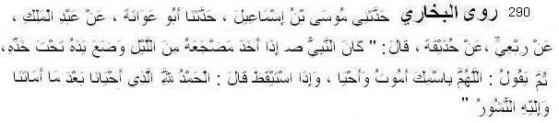
290 Bukhari narrated .................... from Huzaifa ibn Yaman: Whenever the Prophet (pbuh) lay down for sleep at night, he would place his (right) hand under his (right) cheek and supplicate: "Allahumma bismika amutu wa ahya." And when he woke up, he would supplicate: "Al-hamdu lillahil-ladhi ahyana ba'da ma amatana, wa ilaihin-nushur." (also Muslim, Abu Dawud)
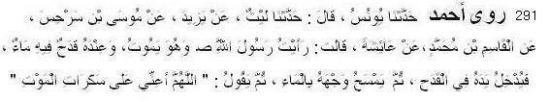
291 Ahmad narrated .............. from Aishah: The Messenger of Allah (pbuh) said, Allahumma a’inni ala sakaratil mawt. (also Tirmiji, Ibn Mazah, Hakim)
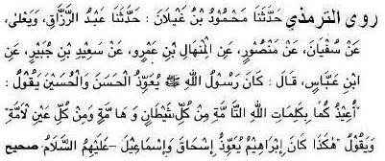
292 Tirmiji narrated ......................... from Ibn Abbas: The Prophet (pbuh) used to seek Allah's protection for Al-Hasan and Al-Husain by saying: 'U'eezukumaa bikalimaatil-laahit-taammah - min kulli shaytaanin wa haammah, wa min kulli 'aynin laammah.
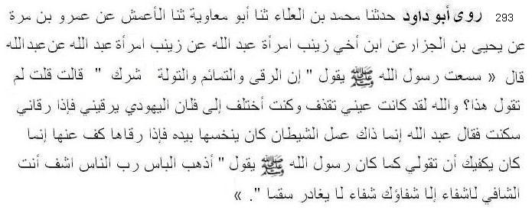
293 Abu Dawud narrated .............. from Abdullah ibn Mas'ud: Zaynab, the wife of Abdullah ibn Mas'ud, told that Abdullah said: I heard the Messenger of Allah (pbuh) saying: Spells, charms and love-potions are polytheism. I asked: Why do you say this? I swear by Allah, when my eye was discharging I used to go to so-and-so, the Jew, who applied a spell to me. When he applied the spell to me, it calmed down. Abdullah said: That was just the work of the Devil who was picking it with his hand, and when he uttered the spell on it, he desisted. All you need to do is to say as the Messenger of Allah (pbuh) used to say: Azhibil ba’s, Rabban-nas, Washfee, Antas Shafee, Laa shifaan illa shifaauk, Shifaan laa yugadireu sakama. [Remove the harm, O Lord of men, and heal. Thou art the Healer. There is no healing but Your Healing, a healing that will leave no ailment.] (sahih, also Ahmad, Hakim, Ibn Mazah, Ibn Hibban)
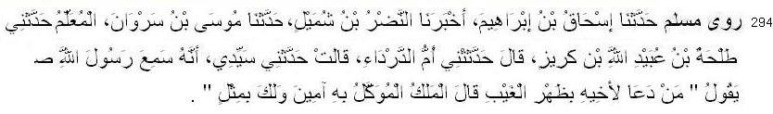
294 Muslim narrated ............... from Umm Darda': She said: My husband reported that he heard Allah's Messenger (pbuh) as saying: He who supplicates for his brother behind his back (in his absence), the Angel commissioned (for carrying supplication to his Lord) says: Amen, and it is for you also.
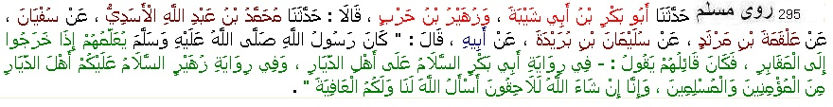
295 Muslim narrated ......... from Buraida, the Messenger of Allah (pbuh) used to teach them when they went out to the graveyard: “As salamu ‘alaykum ahlal-diyar minal-mu’mineen wa’l-Muslimeen, in sha Allahu bikum lalaahiqoon, as’alu Allaha lana wa lakum al-‘aafiyah. (Peace be upon you O people of the dwellings, believers and Muslims, In sha Allah, we will join you, I ask Allah to keep us and you safe and sound).”
Miscellaneous
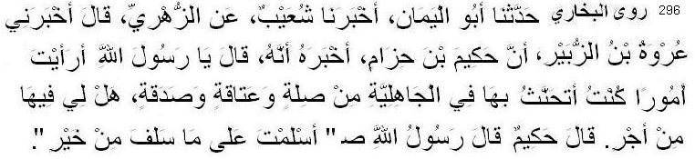
296 Bukhari narrated ......................... from Hakim bin Hizam: He said, "O Allah's Messenger! What do you think about my good deeds which I used to do during the period of ignorance like keeping good relations with my Kith and kin, manumitting of slaves and giving alms etc; Shall I receive the reward for that?" Allah's Messenger said, "You have embraced Islam with all those good deeds which you did.”
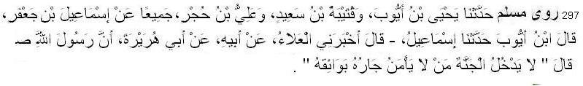
297 Muslim narrated .............. from Abu Huraira that the Messenger of Allah (pbuh) said: He will not enter Paradise whose neighbour is not secure from his wrongful conduct.
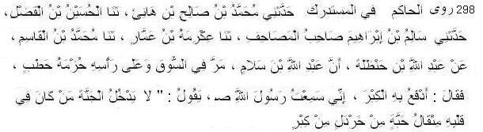
298 Hakim narrated .............. from ibn Hanzalah: Abdullah ibn Salam was seen in the marketplace with a heavy load of wood on his back. Someone said to him, “What makes you do this? Allah has freed you from doing such chores.” Ibn Salam answered, “I wished to rid myself of all signs of pride with this, as I heard the Messenger of Allah (s.a.w.s) say: 'No one will enter Paradise who has even a mustard-seed's weight of arrogance in his heart. (also Tabarani in Muzam Kabir)
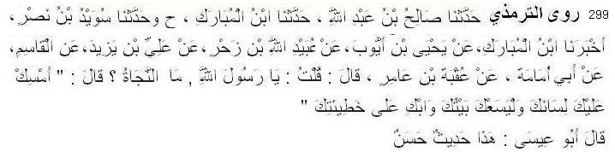
299 Tirmiji narrated ....................... from Uqba ibn Amir said, "I said, 'Messenger of Allah, what ensures safety?' He said, 'Holding your tongue, keeping to your house and weeping for your sins. (also Ahmad, Abdullah Ibn Mubarak in Kitabuj Juhd)
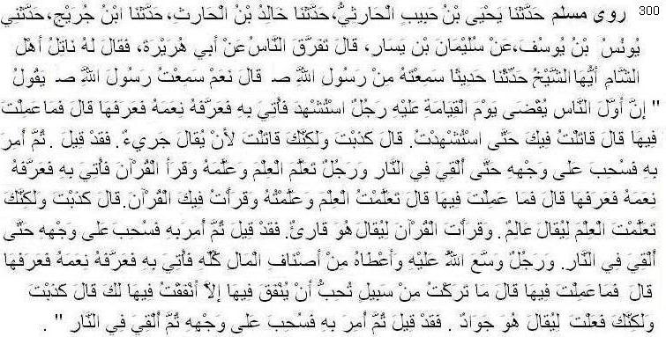
300 Muslim narrated .............from Sulaiman b. Yasar who said: People dispersed from around Abu Huraira, and Natil, who was from the Syrians, said to him: O Shaikh, relate (to us) a tradition you have heard from the Messenger of Allah (pbuh). He said: Yes. I heard the Messenger of Allah (pbuh) say: The first of men (whose case) will be decided on the Day of Judgment will be a man who died as a martyr. He shall be brought (before the Judgment Seat). Allah will make him recount His blessings and he will recount them. (Then) Allah will say: What did you do (to requite these blessings)? He will say: I fought for Thee until I died as a martyr. Allah will say: You have told a lie. You fought that you might be called a" brave warrior". And you were called so. (Then) orders will be passed against him and he will be dragged with his face downward and cast into Hell.
Then will be brought forward a man who acquired knowledge and imparted it (to others) and recited the Qur'an. He will be brought and Allah will make him recount His blessings and he will recount them. Then will Allah ask: What did you do (to requite these blessings)? He will say: I acquired knowledge and disseminated it and recited the Qur'an seeking Thy pleasure. Allah will say: You have told a lie. You acquired knowledge so that you might be called" a scholar," and you recited the Qur'an so that it might be said:" He is a Qari" and such has been said. Then orders will be passed against him and he shall be dragged with his face downward and cast into the Fire.
Then will be brought a man whom Allah had made abundantly rich and had granted every kind of wealth. He will be brought and Allah will make him recount His blessings and he will recount them. Allah will (then) ask: What have you done (to requite these blessings)? He will say: I spent money in every cause in which Thou wished that it should be spent. Allah will say: You are lying. You did (so) that it might be said about (You):" He is a generous fellow" and so it was said. Then will Allah pass orders and he will be dragged with his face downward and thrown into Hell. (also Nasai)
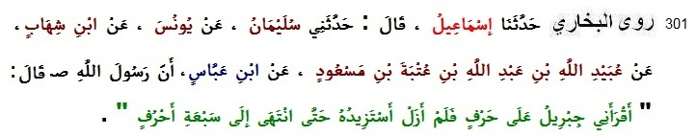
301 Bukhari narrated .............from Ibn Abbas: Allah's Apostle said, "Gabriel read the Qur'an to me in one dialect and I continued asking him to read it in different ways till he read it in seven different ways."
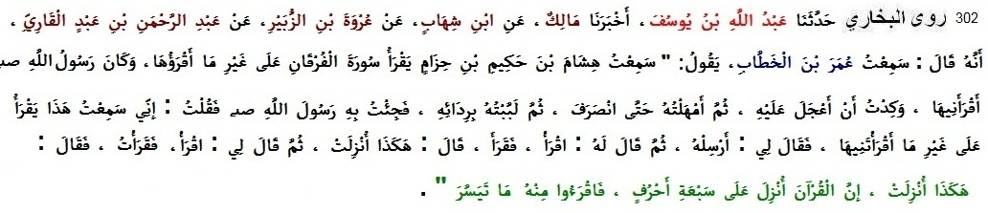
302 Bukhari narrated ............. from Umar b. Khattab: I heard Hisham b. Hakim reciting Surah Furqan in a style different from that in which I used to recite it, and in which Allah's Messenger (pbuh) had taught me to recite it. I was about to dispute with him (on this style) but I delayed till he had finished that (the recitation). Then I caught hold of his cloak and brought him to the Messenger of Allah (pbuh) and said: O Messenger of Allah, I heard this man reciting Surah Furqan in a style different from the one in which you recited to me. Upon this the Messenger of Allah (pbuh) said: Recite. He then recited in the style in which I heard him recite it. The Messenger of Allah (pbuh) then said: Thus was it sent down. He then said to me, Recite. So I recited it, and he said: Thus was it sent down. The Quran was sent down in seven dialects. So recite what seems easy therefrom.
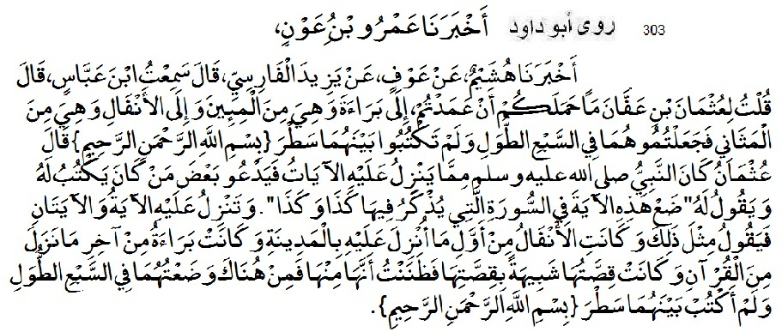
303 Abu Dawud narrated ............. from Yazid al-Farisi: I heard Ibn Abbas say: I asked Uthman ibn Affan: What moved you to put the (Surah) al-Bara'ah which belongs to the mi'in (surahs) (containing one hundred verses) and the (Surah) al-Anfal which belongs to the mathani (Surahs) in the category of sab'u tiwal (the first long surah or chapters of the Quran), and you did not write "In the name of Allah, the Compassionate, the Merciful" between them? Uthman replied: When the verses of the Quran were revealed to the Prophet (ﷺ), he called someone to write them down for him and said to him: Put this verse in the surah in which such and such has been mentioned; and when one or two verses were revealed, he used to say similarly (regarding them). (Surah) al-Anfal is the first surah that was revealed at Medina, and (Surah) al-Bara'ah was revealed last in the Quran, and its contents were similar to those of al-Anfal. I, therefore, thought that it was a part of al-Anfal. Hence I put them in the category of sab'u tiwal (the seven lengthy surahs), and I did not write "In the name of Allah, the Compassionate, the Merciful" between them. ” (also Ahmad, Tirmiji, Hakim)
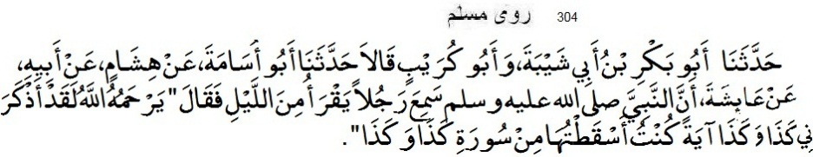
304 Muslim narrated .............from Aishah: The Messenger of Allah (pbuh) heard a person reciting the Quran at night. Upon this he said: May Allah show mercy to him; he has reminded me of such and such a verse which I had missed in such and such a surah.
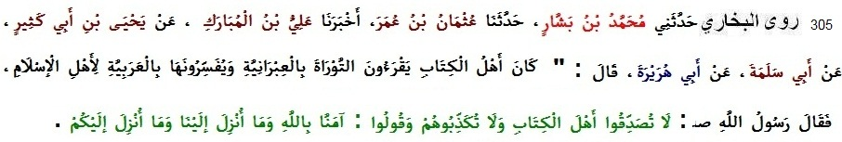
305 Bukhari narrated ............. from Abu Hurairah: "The People of the Book used to read the Torah in Hebrew and translate it into Arabic for the Muslims. The Messenger of Allah said, Do not believe the People of the Book, nor reject what they say. Rather, say, `We believe in Allah and in what was sent down to us and in what was sent down to you.
........................................
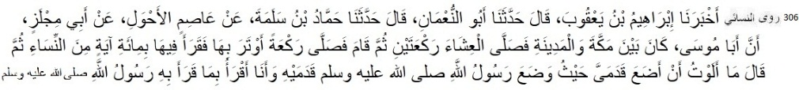
306 Nasai narrated ................... from Abu Mijlaz that: Abu Musa was between Makkah and Madinah. He prayed 'Isha with two rak'ahs, then he stood and prayed one rak'ah of witr in which he recited one hundred verses from Nisa'. Then he said: "I have not any mistakes to place my feet where the Messenger of Allah (pbuh) placed his, and to recite what the Messenger of Allah (pbuh) recited."

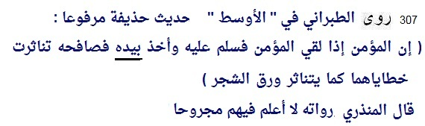
307 Tabarani narrated ............. from Hudhayfah: “When the believer meets a fellow believer and he greets him with salaam and takes him by the hand and shakes hands with him, their sins will fall like the leaves of a tree.” Al-Mundhiri said: I do not know of anyone who is majrooh (unacceptable) among its narrators. (in Muzam awsat)
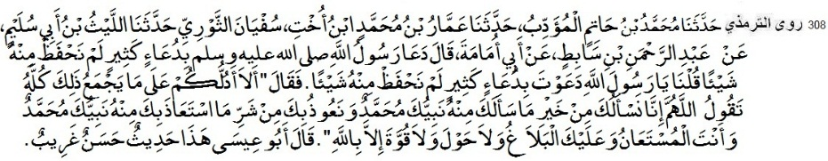
308 Tirmiji narrated ............. from Abu Umamah: “The Messenger of Allah (pbuh) supplicated with many supplications of which we did not preserve a thing. We said: ‘O Messenger of Allah, you supplicated with many supplications of which we did not preserve a thing.’ He said: ‘Should I not direct you to what will include all of that? That you say: O Allah, we ask You from the good of what Your Prophet Muhammad asked You for, and we seek refuge in You from the evil of that which Your Prophet Muhammad sought refuge in You from, and You are the one from Whom aid is sought, and it is for You to fulfill, and there is no might or power except by Allah (Allahumma Inna Nasa’luka Min Khairi Ma Sa’alaka Minhu Nabiyyuka Muhammad, Sallallahu Alaihi Wa Sallam, Wa Na’udhu Bika Min Sharri Masta’adha Minhu Nabiyyuka Muhammad, Sallallahu Alaihi Wa Sallam, Wa Antal-Musta’anu Wa Alaikal-Balagh, Wa La Hawla Wa La Quwwata Illa Billah.)’
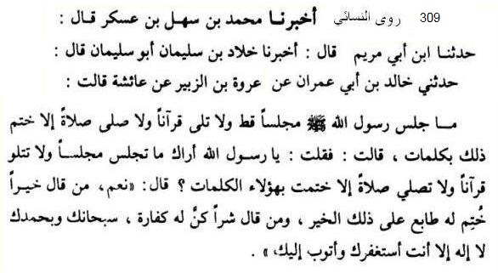
309 Nasai narrated ............. from Aishah, I said to the Prophet (pbuh), O Messenger of Allah! I see that whenever you sit in a meeting or read the Quran or say salah you say some word at the end. The Prophet (pbuh) said, “Yes. Whoever completes it this dua is agood seal for that and whoever makes any mistake this dua is expiation for him: Subhanaka wa bihamdika, laa ilaha illa anta, astagfiruka, wa atubu ilaik. (Reported in Amalul Yawmi wal Lailah)

Introduction to Rijal or narrators

Abbas - sahabi (companion), uncle of the Prophet (pbuh)
Abdu Khair – Tabei (follower of sahabi)
Abdullah ibn Abbas – cousin of the Prophet (pbuh)
Abdullah ibn Abdullah bin Umar – tabei trustworthy
Abdullah ibn Amr – sahabi
Abdullah ibn Amir – sahabi
Abdullah ibn Buhainah - sahabi
Abdullah bin Maslamah – trustworthy
Abdullah ibn Masud – sahabi

Abdullah ibn Mubarak – friend of Abu Hanifa,
teacher of Bukhari
Abdullah ibn Mugaffal – sahabi
Abdullah ibn Sargis – sahabi
Abdullah ibn Salam – sahabi
Abdullah ibn Umar – sahabi
Abdullah ibn Unais – sahabi
Abdullah ibn Yamar – sahabi
Abdullah ibn Yusuf- trustworthy
Abdullah ibn Zaid– sahabi

Abu Bakr Abdullah (632–634)– sahabi, father of Aishah and Asma, father-in-law of the Prophet and Zubair, first Khalifa,

Abu Bakr ibn Abu Shaibah - teacher of Bukhari
Abu Dawud Tayalisi – trustworthy compiler of a Sunan
Abu Dawud Sulaiman bin Ashach Sijistani – trustworthy, man of Sijistan or Sistan (east Iran), compiler of a Sunan
Abud Darda - sahabi
Abu Hurairah Dawsi - sahabi
Abu Kelaba – trustworthy (not a Mudallis)
Abul Ahwas – sahabi
Abu Humaid Munjir- sahabi
Abu Humaid Saeedi - sahabi
Abu Marsad Ganawi - sahabi
Abu masud – Badri sahabi
Abu Musa Ashaari - sahabi
Abu Muslim – trustworthy
Abu Nadrah – tabei trustworthy
Abu Qatadah - sahabi
Abu Said Khudri- sahabi
Abu Salama bin Abdur Rahman
Abu Thalaba Khushani - sahabi
Abu Umama – sahabi
Abu Zarr Giffari - sahabi
Abul Yaman – trustworthy
Adi bin Hatem Tai - sahabi, ex-Christian
Ahmad bin Hanbal – compiler of a musnad,
imam, mujtahid

Ahmad bin Ibrahim Durki – trustwothy
Aishah – wife of the Prophet, daughter of Abu Bakr

Alqamah ibn Waqqas – trustworthy, Tabi (follower of sahabi)
Ali bin Abu Talib– sahabi, cousin of the Prophet (pbuh), Fourth Khalifa, husband of Farinah bint Rasul
Ali bin Hujr -
A’mash - trustworthy
Ammar bin Yasar – sahabi
Amr ibnul As – sahabi
Amr ibn Awf – sahabi
Amr ibn Khalid – trustworthy

Amir bin Abdullah bin Jubaer – trustworthy

Anas – sahabi, khadem of the Prophet (pbuh). His mother,
Umm Sulaim, was distant aunt of the Prophet (pbuh)
from his mother’s side.
Asim bin Kulaib – trustworthy
Asma bint Abu Bakr (d. 73 AH) – sahabi, sister-in
-law of the Prophet
Asma bint Yazid (d 63 AH) – sahabi, Ansariya
Asma bint Umais (d 80AH) – wife of Ja’far (cousin of the Prophet), then wife of Abu Bakr, then wife of Ali
Awf bin Malik – sahabi
Awzaei - trustworthy

Bara bin Azeb – sahabi

Bukhari, Muhammafd bin Ismail – (810 – 870), was a Persian born in Bukhara. He authored the hadith collection known as Sahih al-Bukhari, regarded as one of the most sahih (authentic) hadith collections. He also wrote other books such as Al-Adab al-Mufrad.

Buraida - sahabi

Dahhak bin Sufiyan – shabi
Daremi Abu Muhammad - (181 AH - 255 AH/ 869 CE) was an important Muslim scholar and Imam. His most influential and best known work is Sunan al-Darimi a book collection of hadith.

Fatimah (d. 11) – sahabi, daughter of the Prophet (pbuh), wife of Ali

Hafsa bint Umar - wife of the Prophet
Hakim bin Hizam - sahabi
Hakim Nishapuri – trustworthy
Hammad bin Salama- – trustworthy
Harith bin Abdullah bin Awf – trustwothy

Hasan Basri - trustworthy, Tabi (follower of sahabi),
not a mudallis
Humaid bin Abu Humaid - trustworthy
Humaidi – trustworthy, teacher of Bukhari
Huzaifah bin Yaman - sahabi

Ibn Mazah – trustworthy, compiler of a Sunan
Ibrahim bin Sad – trustworthy
Irbaz bin Sariyah - sahabi
Isa bin Yunus – trustworthy
Ismail bin Ibrahim bin Maqsam Basri – trustworthy

Jabir bin Abdullah – sahabi
Jabir bin Samurah – sahabi
Jainab bint Abu Muawiyah – sahabi, wife of Ibn Masud
Jarir bin Abdullah – sahabi
Jayd bin Khalid – sahabi
Jayd bin Kharija– sahabi
Jayd bin Sabit – sahabi
Jubayr bin Muteem - sahabi
Juhayr - trustworthy,
Juhri (Ibn Shihab) - trustworthy,
Juwairiah – wife of the Prophet

Kabsha bint Kab – daughter of Ka’b bin Malik,
her father-in-law is Abu Qatada

Ka’b bin Malik– sahabi, famous for his attending Badr, also famous for being absent in Tabuk expedition and repenting for that, and ultimately receiving forgiveness announced in a Quranic verse.

Ka’b bin Uzra– sahabi

Khalid bin Salama – trustworthy
Khallad bin Sulaiman – trustworthy
Khansa bint Khidam - sahabi
Khawla bint Qays – sahabi
Kutayba bin Said – trustworthy

Laila Ansariyyah – maqbool (acceptable) narrator,
freed slave of Nusaybah bint Ka’b.
Laqeet bin Sabra - sahabi

Mahmud bin Labeed – sahabi
Makki bin Ibrahim – trustworthy, shaikh of Bukhari
Malik ibnul Huwairith - sahabi
Maimunah (d.49) - wife of the Prophet
Miqdam bin Ma’diqarib - sahabi
Muaz ibn Jabal - sahabi
Muawiyah ibnul Hakam – sahabi
Mugira bin Shuba – sahabi
Muhammad ibn Ajlan – saduq (truthful) but sometimes
made mistakes
Muhammad bin Amr bin Ata – tabei, trustworthy
Muhammad ibn Ibrahim – trustworthy,
Muhammad ibn Mukatil – trustworthy
Muhammad bin Sahl – trustworthy
Musa bin Talhah - trustworthy,
Musaddad - trustworthy,
Muslim bin Hajjaj Nīshāpūrī – commonly known as Imam Muslim, was a Persian known as a trustworthy muhaddith. His hadith collection, known as Sahih Muslim is regarded as one of the two most authentic (sahih) collections, alongside Sahih al-Bukhari.

Numan bin Bashir – sahabi

Nusaibah Umma Amarah - A member of the Banu Najjar tribe of Madina. When 74 leaders, warriors, and statesmen of Madina descended on al-Aqabah to swear an oath of allegiance to Islam in the city, Nusaybah and Umm Munee Asma bint Amr bin 'Adi were the only two women to personally pledge directly to the prophet. She returned to Madina and began teaching Islam to the women of the city. This bayah or pledge was the de facto handing over of power to Muhammad over the city, by its key figures. Her two sons Abdullah and Habib killed in battle.

Qabisa bin Dubaib – sahabi
Qatadah - trustworthy
Qays bin Asim - sahabi
Qays bin Sayid – sahabi

Rubaii bint Muawwiz – (d. 71-79) sahabiyah

Sabit Bunani – tebei
Sa’d bin Abu Waqqas – sahabi
Safiyyah bint Huyai (d. 50 AH) wife of the Prophet, daughter of Jewish leader Huyai

Saib ibn Yazid – sahabi
Said bin Mansoor – sahabi
Said Maqburi – trustworthy
Said ibnul Musayyab – trustworthy tabi’i, son in law of Abu Hurairah
Said bin Mihsan - sahabi
Said bin Yahya bin Said Umawi – trustworthy
Sahl bin Sa’d Saidi - sahabi

Salman – sahabi, the first Persian converted Muslim, raised as a Zoroastrian, then attracted to Christianity, and then converted to Islam after meeting the Prophet in Madina.

Salama ibn Akwa – sahabi
Salem – trustworthy, son of Ibn Umar
Samura bin Jundub – sahabi
Sawban (also spelt Thawban) – sahabi

Shaddad bin Aws –sahabi
Shayban - trustworthy

Sufiyan Sawri – trustworthy
Suhaira - tabei
Sulaiman Taimi – trustworthy (according to Imam Muslim and others)
Sulaiman b. Yasar – trustworthy
Suwaid bin Nasr - trustworthy

Talha bin Abdullah – trustworthy, tabe’i
Talha bin Nafi (Abu Sufiyan) – tabei, trustworthy
Tariq bin Ashyam Ashzaee – sahabi
Tariq bin Suwaid Hadrami- sahabi, man of Hadramaut

Ubadah ibn Samit - sahabi
Ubai ibn Kab – sahabi, famous as Quran-reciter
Ubaidullah bin Abdullah – trustworthy
Umaima bint Ruqayyaqa - sahabi

Umar ibnul Khattab - (born c.583 CE – d. 644 CE), He was a senior Sahabi and father-in-law of the Prophet. He succeeded Abu Bakr as the second caliph of the Rashidun Caliphate in 634. He was an expert jurist known for his pious and just nature, which earned him the epithet Al-Farooq ("the one who distinguishes between right and wrong").
Umm Ayman Barakah –sahabi, maidservant of the prophets father.
Umm Darda - sahabi
Umm Farwah – sahabi, aunt of Aishah, sister of Abu Bakr
Umm Hani’ – sister of Ali, cousin of the Prophet
Umm Kulsum bint Uqba- sahabi, daughter of mushriq-leader Uqba

Umm Kurj Ka’biah - sahabi,
Umm Mubashshir - sahabi
Umm Qays bint Mihsan - – sahabi,
Umm Rafi’ - sahabi
Umm Salama – sahabi, wife of the Prophet, former wife of Abu Salama.
Umm Shuraik Ansariyah- sahabi
Ummul Fadhl Lubaba - sahabi, wife of Abbas, uncle of
the Prophet
Ummul Husain – sahabi

Uqba bin Amer Juhani – sahabi
Urwa bin Zubair - tabei
Usman bin Affan – sahabi, son-in-law of the Prophet, third caliph of the Rashidun Caliphate
Usman bin Hakim – trustworthy

Yahya bin Said Umawi – trustworthy
Yaqub bin Ibrahim bin Saad -
Yazid al Faresi – Tafdili Shia, truthful (saduq)
Yunus bin Yazid – trustworthy

Wabisa ibn Ma’bad – sahabi
Wail ibn Hujur Hadrami- sahabi, inhabitant of Hadramaut (Oman)
Waki- trustworthy

INDEX

ablution 74-84, 111,141
associating others with Allah 1,2,5,7,8,9,29
azan 129,130
baiat h.n. 8, 275, 278
barzakh 23, 104, 264
bath (gusl) 85, 86, 87
bidat/bidah/innovation 48, 52, 247-256
Christians 5, 28
Christ 5, 28
companions/sahabi 139, 242-246
dawah 47, 51, 52
death 104, 291
divorce 230
dream h.n. 26
drink 210,211, 212, 213,
drug addiction 215, 216, 218
dua 282-295
dua Yunus 288
ekhlas (sincerity) 37, 300
fasting 19,182,183, 184, 185, 186, 187
fate h.n. 34,35,36
father 221, 222
food 210-213, 241
fostersuckling relationship 276
frotune-telling h.n. 3
graves 104, 138
hadith 47, 51
hadis Qudsi 2, 242
hajj 194-201
hell 1, 5, 13, 14, 13, 300
henna 220
herbal medicine 219, 220
hereafter 5, 11, 13, 14, 16, 114, 298, 300
hijab (veil) 196, 273 - 276
horoscope h.n. 2
human rights 237-241
husband 7, 236,
iftar (breakfast of fasting person) 182
intention (niyyat) 73
intercession 29, 33
iqamah/2nd azan 130, 131, 132
istigfar 284, 287
itikaaf 188
jannah 1, 11, 100, 114, 298
jahannam see hell
Jesus see Christ
Jews 5, 30
jihad (struggle) 271, 272
justice 271-272
kaffaratul majlis -
kalima shahadat -164
kawthar 11, 255
knowledge 42-50
knowledge of unseen 21, 31
language 50
Makkah 243
madhhab / mazhab 53, 54, 56, 57
marriage / nikah 225-228, 234,235
marriage without guardian 225-227
medicine 217-220
Messiah see Christ
Moses h.n. 23, 27
mosque 69, 137,138
mother 223, 224
munazat 282
musical instruments 257, 258, 261
muta/ temporary marriage 235
Non-Muslims ......... 241
night journey (miraj) 11,18
paradise see jannah
parents 221-224
pictures of animals
polytheism see associating others with Allah
politics
prayer
prayer times
predestination see fate
prophethood
prophet Muhammad is last prophet
prophet Muhammad had shadow h.n. 20
prophet Muhammad

qiamul lail/taraweeh
Quran
qurbani /sacrifice 200,201
Ramadan 22, 185, 186
shirk see associating others with Allah
sincerity see ekhlas
sleep
sport h.n.
sunnah
tableeg/tablig see dawah
taqdir see fate
taqlid / taqleed see madhhab
taraweeh
tombs
veil (hijab)
wali (guardian) 225, 226,227
where is Allah h.n. 3
wife 231-234
women
wudu see ablution
zakat 189,190,191

Subhanaka wa bihamdika,
La ilaha illa anta, astagfiruka
wa atubu ilaika

sanad of Malik 3
sanad of Ahmad 7
sanad of Ibn Abu Shaibah 1
sanad of Humaidi 3
sanad of Abu Dawud Tayalisi 1
sanad of Abu Dawud (Sijistani) 7
sanad of Bukhari 25
sanad of Muslim 23
sanad of Tirmiji 10
sanad of Ibn Mazah 4
sanad of Nasai 12
sanad of Khatib Baghdadi 2
sanad of Baihaqi 4
sanad of Daraqutni

Other Works of Abu Kab Anisur Rahman
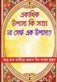 | Title: Are Many gods True or One God?  Language: English and Bangla  published: 2011
Title: Essays on Life and Science
Language: English
published: 2013 (online)
Title: Where Can We Find Pure Islam
Language: English
published: 2011
Title: Treasure Trove of Hadith
Language: English and Bangla
published: 2013 (online)
Title: Satya Qobul Kori
Language: Bangla
published: 2012

abukab.weebly.com

E-mail: abu.kab.anis@gmail.com

3 farsakh = 9 miles = 14.48 km. The hadith of 4 barid (=48 miles) is not authentic.
Causes of breaking Sawm: 1. To eat food, drink or inhale nutrition willingly 2. To vomit willingly 3. To intercourse with wife or to ejaculate willingly. 4. To make intention to break sawm 5. if haeiz or nefas of women begins. The sawm broken or not performed due illness, journey, haeiz, nefas, pregnancy and breastfeeding is to be performed later “one for one” (qada). If broken willingly then he must make kaffara i.e. to set free a slave or to fast two consecutive months or to feed sixty poor people.
The prophet (pbuh) used to celebrate his birthday weekly by fasting on Monday. not annually. There is no evidence that he had ever clelebrated his birthday on 12th of Rabi awwal.
. .. . Qasim bin Muhammad and Nafi (freed slave of Ibn Umar) said: . There is no i'tikaf without fasting. Imam Malik said . There is no i'tikaf without fasting.
Dirham is silver coin and Dinar is gold coin. 200 Dirham = 5 awkia = 52.5 vori silver. 20 Dinar = 25 gm 24 carat gold or 97 gm 21 carat gold or 113 gm 18 carat gold. The Messenger of Allah (pbuh) said: For forty pasturing camels, one she-camel in her third year is to be given. The camels are not to be separated from reckoning. (Abu Dawud)
It is said that Anas said: there is no zakat on ornaments. This statement is not authentic.
. . . . Hasan Basri narrates from Ibn Abbas that once, in the city of Basrah, he delivered a sermon towards the end of Ramadan. He said, "Pay charity (Sadaqat-ul-Fitr) on behalf of your fasts!" From among the congregation, no one knew how much to pay. Ibn Abbas asked, "Is their anyone from Madinah? If so, stand up and inform your brothers as they do not know how much to pay!" Thereafter Ibn Abbas stated, "The messenger of Allah (pbuh) has made obligatory the charity of fitr- one sa'a of dates or barely, or half a sa'a of wheat upon every free man or slave, male or female, young or old." (Nasai, Abu Dawud) Ahmad narrates Asma bint Abu Bakr said: We used to give two mudds of wheat as Jakatul fitr a the time of the Prophet (pbuh). Sa (of Madinah) = 3000 cc Sa (of Iraq) = 4000 cc 0ne mudd = 1/4th sa
It is recommended that one should remain in Arafah on 9th Julhijjah upto sunset. After the sunset one should go to Mujdalifah. However if anybody is unable to attend Arafah before sunset he must attend before Fazr.
The Prophet (pbuh) first threw stones, then slaughtered and then sahve his hair and at last made tawaf. He has given permission to alter the sequence of the tasks.
Generally one should sacrifice a sheep or camel or cow or goat. If it is impossible then one may take sacrifice a camel or goat sharing with other.
Believers cannot do whatever they wish as if they are in prison. A prisoner has to obey the jailor completely, whether he likes or not. Disbelievers do whatever they wish as if they are in paradise.
Zakaria Kandhalwi wrote: Ibrahim Adham said: Do not greed for anything in world and the Hereafter. Make yourself exclusively for Allah only. (Fazail Amal, Fazail Sadaqat (Bangla), Tabligi Kutubkhana 2007, p 478) This is not correct. Allah has promised jannah for the believers The Prophet (pbuh) used to ask Jannah.
Allah says: To hunt and to eat the fish of the sea is made lawful for you, a provision for you and for seafarers (Maidah 5:96) The animals which always live in water are halal both living and dead. So tortoise is halal. The animals which live in both water and land need to be slaughtered. Crab need not be slaughtered because it has no blood.Crocodiles not allowed, because they have fangs and live on land – even though they may spend a lot of time in the water. Frogs are not permitted to eat because the Prophet forbade killing them.
Ud al-Hindi or agarwood (Aquilaria malaccensis) is a species of plant found in Bangladesh, Bhutan, India, Indonesia, Laos, Malaysia, Myanmar and Thailand. It is threatened by habitat loss. The oil of this plant is used in the production of traditional medicine as anti-asthma antitoxic, antioxidant, hypertension (anti-stress), hepatitis, sirosis, diuretic, painkiller, and many other diseases.
Shaafe’i said: The Sunnah of the Messenger of Allaah and the view of most of the Muslim scholars indicate that the man must divide his time, night and day, among his wives, and must divide it equally, and that he is not allowed to be unfair in that. (Al-Umm, 5/110) Ahmad said – concerning a man who had two wives – he has the right to give one more than the other with regard to spending, desire and clothing, if the other has enough, and he may buy a finer garment for her, so long as the other has enough. (Al-Mughni, 7/232)
Aisha reported: Never did I find any woman more loving to me than Sauda bint Zam'a. I wished I could be exactly like her who was passionate. As she became old, she had made over her day (which she had to spend) with Allah's Messenger (pbuh) to Aisha. She said: I have made over my day with you to Aisha. So Allah's Messenger (pbuh) allotted two days to Aisha, her own day (when it was her turn) and that of Sauda (Muslim)
This hadith is the major proof that it is haram to keep more than four wives. ..............
This hadith proves that hartal, general strike is illegal in Islam. - - - - -
This hadith proves that tribalism/nationalism is illegal in Islam - - - - -
.......................................................... .................................. ..........................
.. . .. Nasai narrated from Abu Barza, Abu Bakr, became furious with someone who had mocked him. Abu-Barza offered to kill this man for Abu Bakr. Abu Bakr said that this right was not given to anyone after Muhammad; or in other words, only Muhammad had the right to kill those who mocked him. Defamation of companions is a punishable act, but punishment shall not be death penalty.
Any deed without recommendation or teaching of the Prophet (pbuh) is called bid’ah or innovation in religion. By adopting bid’ah the coppletenedss of Islam is mede under question or doubt. In other word it is diebelieved that the Prophet (pbuh) had performed his duty. In field of muamalah anything (food, drink, dress, vehicles etc.) which has not been prohibited in the Quran and sunnah is permissible (Za’iz). In field of ibadah or worship any deed (prayer, zikr, fasting etc.) is not permissible (Za’iz) for having no prohibition. Rather it requires clear approval. If the deeds like Milad, Urs, Chehlam were of virtue surely the prophet would inform it.
............... Ibn al-Jawzi narrated ........... from Abul Bakhtari: A man informed Ibn Masud that a group of people gather in the masjid after the magrib prayer. A man among them instructs say Allahu Akbar this times, say SubhanAllah this times, say Alhamdu lillah this times. Ibn Masud said, I am Ibn Masud. By Him who is the only God, You have certainly brought bidah (innovaion); or you thought you are superior to sahabis in knowledge. (Talbisu Iblis) There is no virtue in Milad, Qulkhani, Chehlam. As these are not approved in Quran or in Hadith.
In Durrul Mukhtar (a hanafi book) it is stated from, “Bishr Ibn al-Walid said: Abu Yusuf narrated that Abu Hanifa said: ‘It is not right that anyone should supplicate to Allah except by Him, and I hate that anyone should say: ‘By the right of so and so’ or ‘By the right of your Prophets and Messengers’ or ‘By the right of your sacred house and the sacred area (of Muzdalifah)’.
This (Hadith) is understood to refer to the elevated (Pre-Islamic) tombs they (Pagans) used to build with high and beautiful structures. But this also applies for tombs of Muslims.
Umar changed his fatwa on reminding him of evidence.
Ibnul Jawzi said: "And from the deceptions of Iblees upon the scholars is their mixing with the rulers and the kings, their flattering them and failure to correct them when they are able to do so. May be they make allowances for them where there is no allowance for them, in order to attain some worldly benefit. So this produces corruption from three angles. Firstly, the ruler is corrupted by that. He says, “If I were not upon what is correct, the scholar would correct me. And how can I not be correct when he is eating from my wealth!” Secondly, the common person because he says, “There is no harm in this ruler, nor in his wealth, nor in his actions, because such and such scholar, does not criticize him.” Thirdly, the scholar himself is corrupted by that. Because he corrupts his religion through this practice, and Iblees has deceived them into entering upon the rulers by saying to them, “You will just enter to intercede for the benefit of a Muslim.” Talbisu Iblis (pp. 121-122)
The lady who comitted theft was Fatimah bint Sufiyan ibn Aswad. Aisha asserted that Fatima “truly repented” and became pious woman.
During Umar ibn Khattab’s adminstration, people of Sana killed a slave. Umar said, "Had all the people of Sana joined forces against him, I would have killed them all." (Bukhari) The Prophet (pbuh) said: The blood-money for unintentional murder which appears intentional, such as is done with a whip and a stick is one hundred camels forty of which are pregnant (Nasai) The Jewish tribe of Banu Nadir invaded another Jewish tribe Banu Qurayzah during the time of Ignorance and defeated them. Hence, when a person from Banu Nadir kills a person from Banu Quraizah, he is not killed in retaliation, but only pays a hundred wasq of dates. However, when a person from Quraizah kills a Nadir man, he would be killed for him. Otherwise the Quraizah man pays two hundred wasq of dates (double the amount Nadir pays in ransom). So Allah commanded: << O you who believe! The Law of Equality in punishment is prescribed for you in case of murder: the free for the free, the slave for the slave, and the female for the female. But if the killer is forgiven by the brother of the killed against blood-money, then adhering to it with fairness and payment of the blood-money, to the heir should be made in fairness. This is alleviation and a mercy from your Lord. >> This law was applicable when it was impossible to identify the killer. Later the verse << And We ordained therein for them "Life for life, eye for eye, nose for nose, ear for ear, tooth for tooth, and wounds equal for equal." But if anyone remits the retaliation by way of charity, it shall be for him expiation. And whosoever does not judge by that which Allah has revealed, such are the unjust. >> was revealed. And the verse: the free for the free, the slave for the slave, and the female for the female was repealed. (Ibn Kathir)
Jabir ibn Abdullah narrated: The Messenger of Allah (pbuh) said: ‘If one of you proposes marriage to a woman, if he can look at her to see that which will encourage him to go ahead and marry her, then let him do so.’ (Abu Dawood) Sahl ibn Sa’d said: “A woman came to the Messenger of Allah (pbuh) and said: “O Messenger of Allah, I have come to give myself to you (in marriage).” The Messenger of Allah (pbuh) looked at her closely, then he lowered his head.” (Bukhari, Muslim, Nasa’i) Anas ibn Malik said: ‘The Prophet (pbuh) wanted to marry a woman, so he sent another woman to look at her and said, “Smell her mouth (front teeth) and look at the back of her ankles.” (Hakim) Al-Shaafe’i said: “If he wants to marry a woman, he is not allowed to see her without a headcover. He may look at her face and hands when she is covered, with or without her permission. Allaah says: ‘… and not to show off their adornment except only that which is apparent…’ [24:31]. He said: ‘The face and hands.’” (al-Haawi al-Kabeer, 9/34). Abul-Faraj Maqdisi said: “There is no dispute among the scholars that he is permitted to look at the face. the focus of beauty and the place at which one looks.” Please note Hadith no 196 in which the Prophet (pbuh) said, "The woman who is in ihram must not cover her face and wear gloves.” This indicates that when women were not in ihraam, women used to cover their faces. Allah says: O Prophet, tell your wives and your daughters and the women of the believers to bring down over themselves [part] of their outer garments. (Ahzab: 59) Ibn Hazm Andalusi said: The word Jilbaab means a cloak which covers the entire body including the head, face and hands. (Muhalla) Covering the face is obligatory for Muslim women who have reached the age of adolescence. It is not permissible for a woman to uncover her face in front of non-mahram men, except in cases of necessity, such as a medical doctor when no female doctor is available, so long as she is not alone with him (khulwah), or when proposing marriage, or when bearing witness in front of a qaadi (judge). In the cases mentioned above, it should be limited only to that which is necessary, and no more than that. During the last days of my ummah there will be women who are clothed but naked, with something on their heads like the humps of camels. Curse them, for they are cursed.” Another hadeeth adds: “They will not enter Paradise or even smell its fragrance, although its fragrance can be detected from such and such a distance.” (Muslim) Once Aisha’s niece, Hafsa bint Abdur Rahman came to visit her. She was wearing a scarf made of thin material. Aisha took it and ripped it up and gave her one of her own scarves made of a thicker material. (Muatta of Imam Malik) Once the Prophet (pbuh) asked: Which woman is best? Nobody could answer. Ali went to Fatimah. She said: The best woman is she who donot see any man and no man see her. Once Asma bint Abu Bakr came wearing a thin garment. The Prophet (pbuh) turned his face away from her and said: “Asma, it is not proper for a woman after having reached puberty to expose any part of her body except these.” Then he pointed to his face and hands. (Abu Dawud, Sunan 4092) Abu Dawud said: Khalid b. Durayk did not hear from Aisha. (i.e. the sanad is mursal) Mursal hadith is acceptable to some scholars.
Sanad is zaif because Shahr bin Hawshab is zaif. Shahr bin Hawshab is saduq but used to make mistakes. All statements of a zaif narrator are not always false. We accepted this one because there are similar reports in sahih chain. See Ghayah al-Maram (431) for more discussion on this hadith.
Examples of similarity with Christians: Milad similar to Christmas Examples of similarity with Hindus: New year clebration,
Munazat means speaking in private. So the best time for dua is during salah.
al-hamdu lillah = all praise belongs to Allah.
meaning: 'O Allah, You are my Lord, there is no God but You, You created me and I am your servant and I abide to your covenant and promise as best as I can, I take refuge in you from the evil of which I committed. I acknowledge your favour upon me and I acknowledge my sin, so forgive me, for verily no one can forgive sin except you.’
meaning: Hallowed be Allah and praise is due to Him according to the number of His creation and according to the pleasure of His Self and according to the weight of His Throne and according to the ink (used in recording) words (for His Praise).
meaning: O Allah, forgive me, have mercy on me, guide me, grant me good health and provide for me
meaning: There is no god but You, You are far exalted and above all weaknesses, and I was indeed the wrongdoer.
meaning: Allah Allah, My Lord! I do not associate anything as a partner/co-equal with Him! كرب (Karb or Karb) = heartache, distress, gloom
meaning: O Allah, with Your Name will I die and live (wake up). and All praise is due to Allah, Who has brought us back to life after He has caused us to die, and to Him is the return
meaning: O Allah, assist me in the difficulty of death. This hadith proves that even the prophets were not secure from pain of death, because they are human being. Of course, Allah made their deaths painless due to their virtue and dua.
meaning: I seek protection for you in the Perfect Words of Allah from every devil and every beast, and from every envious blameworthy eye.
This dua is also narrated by Aisha in Sahih Bukhari. .
It is permissible to raise the hands when reciting this du’aa’, because of the hadith of ‘Aa’ishah who said: “The Messenger of Allah (pbuh) went out one night, and I sent Bareerah to follow him and see where he went. She said, ‘He went towards Baqee’ Gharqad [the graveyard in Madinah], and he stood at the bottom of Baqee’ and raised his hands, then he went away.’ Barirah came back to me and told me, and when morning came I asked him about it. I said, ‘O Messenger of Allah, where did you go out to last night? He said, ‘I was sent to the people of al-Baqee’, to pray for them.’
All seven dialects are preserved through recitation. However the version with Quraishi dialect was compiled in book format by Uthman R.A. Other versions were also compiled in book format later. All versions have same surah same content. ..................... ..................... ..................... .....................
Tirmiji said: “Sanad is hasan. We do not find it except through Awf from Yazid Faresi.” Hakim said: its isnaad is saheeh, and al-Dhahabi agreed with him.
This is not strange. Allah says: By degrees shall we teach thee (Muhammad) to declare (the message), so thou shalt not forget, except as Allah wills (Sura 87:6-7)
We have believed in Allah and what has been revealed to us and what has been revealed to Abraham and Ishmael and Isaac and Jacob and the Descendants and what was given to Moses and Jesus and what was given to the prophets from their Lord. We make no distinction between any of them, and we are Muslims [in submission] to Him (Sura 2:136)
This right hand The Prophet (pbuh) took the hand of one of his companions in both of his hands as a sign of extra care in teaching, as it says in Sahih Bukhari (6265) and Sahih Muslim (402) that Ibn Mas’ud said: The Messenger of Allah (pbuh) taught me the tashahhud, holding my hand between both of his. But to shake hands using both hands, putting the palm of the left hand over the back of one’s brother’s hand, this is not proven to be Sunnah from the Prophet (pbuh) or from his companions. It was narrated that Hammaad ibn Zayd shook hands with Abdullaah ibn-Mubarak using both hands, as is stated in a mu’allaq report in Sahih Bukhari
This hadith proves that it is better to supplicate with duas as practiced and taught by the Prophet (pbuh) than with own words. .................................. ..........................

