https://edu.glogster.com/glog/geometry-of-the-alhambra/1v0k71m9lkx

Sancta Sophia
With Isidore of Miletus, Anthemius designed the Sancta Sophia basilica (the Holy Wisdom basilica) for Justinian I.
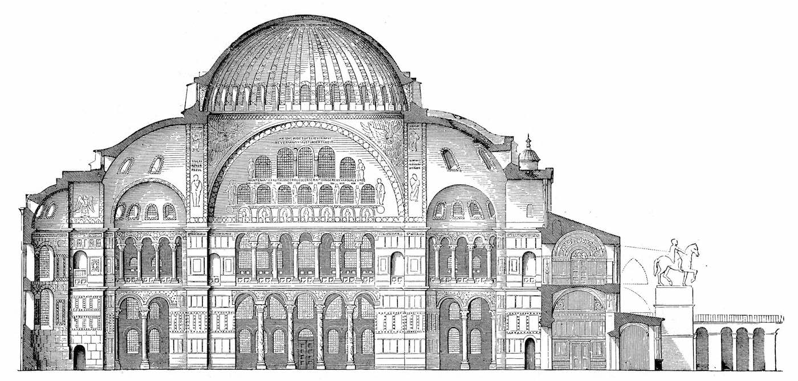
Sancta Sophia basilica (cross-sectional elevation)
During the Fourth Crusade, the church was ransacked and desecrated by the Crusaders in 1204. Eye-witness Niketas Choniates (d. 1217)) wrote in his Historia: “They respected nothing, neither the churches, nor the sacred images of Christ and his saints.”
Ernle Bradford (d. 1986) writes, “. . . they broke up the altar for the sake of their marbles and gold and silver. The wealth of the sacred vessels which had been accumulating in the cathedral throughout nine centuries was seized upon by the soldiers ignorant of everything save that they might be melted down and converted into coin.”
During the Latin occupation of Constantinople (1204–1261) the church became a Roman Catholic cathedral. It fell to the attacking Ottoman forces in 1453. Sultan Mehmet II ordered to convert into royal mosque.

Rumeli Fortress
location | Rumeli, Thrace (the European side of the Bosphorus)
 | Mehmed II in four months 1452

The Rumeli Fortress (Rumelihisari) was built to establish control of the waterway at this narrowest point of the strait (660m) where ships would need to approach the shore to avoid the strong currents. during the siege of Constantinople (1452CE) a battalion of four hundred soldiers were stationed at the fortress to prevent the passage of ships with canon fire.
The fortress is a walled-in enclosure 250 meters long and 130 meters wide at its longest. It has one small and three large towers and thirteen small watchtowers. The towers are named after three viziers -Halil Pasa Tower, Saruca Pasa Tower and Zaganos Pasa Tower. There are three entrances, one next to each large tower; a shallower outer wall protects the seaside entrance.
The peripheries of the Halil Pasa, Saruca Pasa and the Zaganos Pasa towers are 23.3 meters, 23.8meters and 26.70 meters respectively and their heights are 35, 33.3 and 25.30 meters excluding the conical roofs that once crowned the towers. The last two are round while the first is twelve-sided on the exterior. Inscriptive plaques in Arabic, referring to Zaganos Pasa were found at the southwest tower that is named after him and also at a smaller tower located at the southeast corner, at the water's edge. The space within each tower was divided up with wooden floors, each equipped with a furnace; only the Saruca Pasa Tower retains its wooden floors. All towers, watchtowers and walls are topped with crenellations.
The fortress had wooden houses for the soldiers and a small mosque, of which only the minaret shaft has remained. Water was supplied to the fortress from a large cistern underneath the mosque and distributed through three wall-fountains, of which only one has remained.
A new neighborhood was formed inside the fortress after it was abandoned in the 19th century.
Older photographs show a series of seaside mansions along the fortress walls, none of which have come to our day. Their place is taken today by a two-lane coastal highway that was built immediately outside the fortress walls in the 1960s.

The Üç Şerefeli Mosque
 | Edirne, Turkey
Main Dome dia. (outer) | 24 m
Minaret(s) | 4
height of the tallest minaret | 67 m
Materials | Burgaz marble
architect | unknown

The Üç Şerefeli Mosque was commissioned by Ottoman sultan Murad II (1421–1444,1446– 1451), and built between 1438 and 1447.[2] The name refers to unusual minaret with three balconies (Turkish: üç şerefeli).

photo

The two blue and turquoise underglaze-painted tile panels in the tympana of the windows were probably produced by the same group of tilemakers who had decorated the Yeşil Mosque (1419–21) in Bursa where the tiles are signed as "the work of the masters of Tabriz". The running pattern of the Chinese influenced floral border tiles is similar to those in the small Muradiye Mosque in Edirne.[4][5]
Malbork Castle
Malbork, Poland
1406
The Castle of the Teutonic Order in Malbork wass constructed by the Teutonic Knights, a German Catholic religious order of crusaders, in a form of an Ordensburg fortress. On its completion in 1406, the castle was largest brick castle in the world.^{[3]}
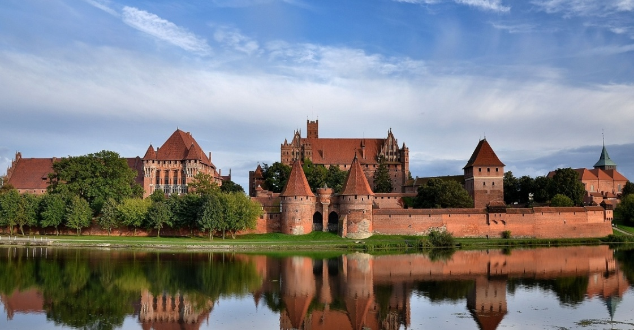
Malbork Castle (credit: )
The Teutonic Knights named it Marienburg in honour of Myriam (peace be upon her), mother of Jesus(peace be upon him). In 1457, during the Thirteen Years’ War, it was sold by the Bohemian mercenaries to King Casimir IV of Poland in lieu of indemnities and it since served as one of the several Polish royal residences and the seat of Polish offices and institutions. From 1772, the castle was under German rule for over 170 years. Following Germany's defeat in World War II in 1945, the land was assigned to Poland by the Allies. Heavily damaged, the castle was renovated.

Zvolen Castle
Zvolen, in central Slovakia.
between 1360 and 1382
Gothic architecture of the castle was inspired by Italian castles of the fourteenth century. Italian masons also contributed to a Renaissance reconstruction in 1548. In 1784, the chapel was rebuilt into the Baroque style.
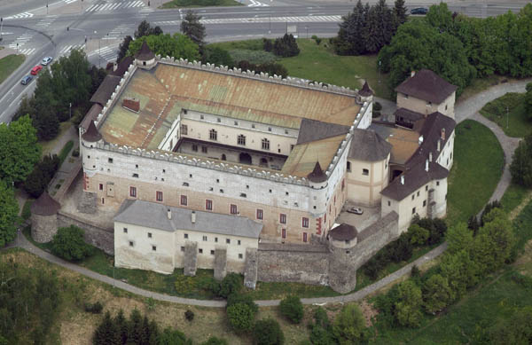
Zvolen Castle
Zvolen castle was built by Louis I of Hungary, who built it like a gothic hunting castle. It was finished in 1382, when it was witness to an engagement of his daughter Mary and Sigismund. John Jiskra of Brandýs, who became one of the most powerful commanders in Hungary and this castle was one of his manors from 1440 to 1462.
About 1500 the external fortifications were built up with four round bastions and entrance gate. In the middle of the 16th century was built another floor with embrasures and corner oriel towers. About 1590 an artillery bastion was built also.
Santa Maria del Fiore
Santa Maria del Fiore was built on the site of Florence's second cathedral dedicated to Saint Reparata^{[2]}; the first was the Basilica di San Lorenzo di Firenze, the first building of which was consecrated as a church in 393 by St. Ambrose of Milan.^{[3]} The ancient structure, founded in the early 5th century and having undergone many repairs, was crumbling with age, according to the 14th-century Nuova Cronica of Giovanni Villani,^{[4]} and was no longer large enough to serve the growing population of the city.^{[4]} Other major Tuscan cities had undertaken ambitious reconstructions of their cathedrals during the Late Medieval period, such as Pisa and particularly Siena where the enormous proposed extensions were never completed.

Nilometer
Alfraganus (c. 805-870CE) supervised the construction of the large ‘Miqyas an-Nil’ (Nilometer) on the island of al-Rawda In Cairo in the year 861.
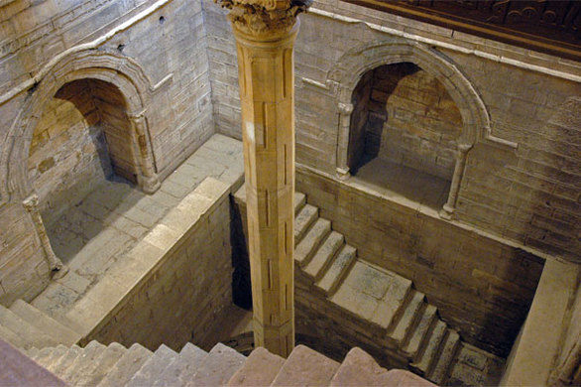
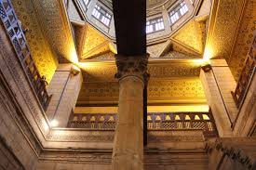
Nilometer
Nilometer is a structure which has been used for measuring the Nile River's clarity and water level during the annual flood season. The main component of nilometer is a vertical column calibrated in Egyptian cubits housed in a strong building. There is a tunnel from the monitoring station leading to the Nile below low water level. The building is decorated with calligraphy. A stairway is provided for maintenance.
As per rule of hydraulics, water level in the river is same as the level in the Nilometer column.
Generally, if the water level was low, there would be famine. If it was too high, it would be destructive. There was a specific mark that indicated how high the flood should be if the fields were to get good soil. The agrometrologists determined relation between gauge reading and crop yield. And the economists estimated amount of tax to be collected.

Conwy Castle

Conwy Castle
located | Conwy, North Wales
 | between 1283 and 1289
Conwy Castle was built by Edward I, during his conquest of Wales. Constructed as part of a wider project to create the walled town of Conwy, the combined defences cost around £15,000, a huge sum for the period. Over the next few centuries, the castle played an important part in several wars. It withstood the siege of Madog ap Llywelyn in the winter of 1294–95, acted as a temporary haven for Richard II in 1399 and was held for several months by forces loyal to Owain Glyndŵr in 1401.
Following the outbreak of the English Civil War in 1642, the castle was held by forces loyal to Charles I, holding out until 1646 when it surrendered to the Parliamentary armies. In the aftermath, the castle was partially slighted by Parliament to prevent it being used in any further revolt, and was finally completely ruined in 1665 when its remaining iron and lead was stripped and sold off. Conwy Castle became an attractive destination for painters in the late 18th and early 19th centuries. Visitor numbers grew and initial restoration work was carried out in the second half of the 19th century. In the 21st century, the ruined castle is managed by Cadw as a tourist attraction.
UNESCO considers Conwy to be one of "the finest examples of late 13th century and early 14th century military architecture in Europe". The rectangular castle is built from local and imported stone and occupies a coastal ridge, originally overlooking an important crossing point over the River Conwy. Divided into an Inner and an Outer Ward, it is defended by eight large towers and two barbicans, with a postern gate leading down to the river, allowing the castle to be resupplied from the sea. It retains the earliest surviving stone machicolations in Britain and what historian Jeremy Ashbee has described as the "best preserved suite of medieval private royal chambers in England and Wales".^{[2]} In keeping with other Edwardian castles in North Wales, the architecture of Conwy has close links to that found in the Kingdom of Savoy during the same period, an influence probably derived from the Savoy origins of the main architect, James of Saint George.
Conwy Castle is a fortification in Conwy, located in North Wales. It was built by Edward I, during his conquest of Wales, between 1283 and 1289. UNESCO considers Conwy to be one of "the finest examples of late 13th century and early 14th century military architecture in Europe".^{[1]}
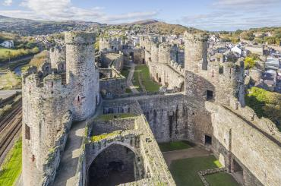
Conwy Castle (credit: Cadw)
Constructed as part of a wider project to create the walled town of Conwy, the combined defences cost around £15,000, a huge sum for the period. Over the next few centuries, the castle played an important part in several wars. It withstood the siege of Madog ap Llywelyn in the winter of 1294–95, acted as a temporary haven for Richard II in 1399 and was held for several months by forces loyal to Owain Glyndŵr in 1401.
The rectangular castle is built from local and imported stone and occupies a coastal ridge, originally overlooking an important crossing point over the River Conwy. Divided into an Inner and an Outer Ward, it is defended by eight large towers and two barbicans, with a postern gate leading down to the river, allowing the castle to be resupplied from the sea. It retains the earliest surviving stone machicolations in Britain and what historian Jeremy Ashbee has described as the "best preserved suite of medieval private royal chambers in England and Wales".^{[2]} In keeping with other Edwardian castles in North Wales, the architecture of Conwy has close links to that found in the Kingdom of Savoy during the same period, an influence probably derived from the Savoy origins of the main architect, James of Saint George.
Work began on cutting the ditch around Conwy Castle within days of Edward's decision.^{[8]} The work was controlled by Sir John Bonvillars and overseen by master mason James of St. George, and the first phase of work between 1283 and 1284 focused on creating the exterior curtain walls and towers.^{[9]} In the second phase, from 1284 and 1286, the interior buildings were erected, while work began on the walls for the neighbouring town.^{[10]} By 1287, the castle was complete.^{[10]} The builders recruited huge numbers of labourers from across England for the task. At each summer building season, the labourers massed at Chester and then walked into Wales.^{[11]} Edward's accountants did not separate the costs of the town walls from that of the castle, but the total cost of the two projects came to around £15,000, a huge sum for the period.^{[10][nb 1]}

Lincoln Castle
Lincoln Castle is a major Norman castle constructed in Lincoln, England, during the late 11th century by William the Conqueror. The castle is unusual in that it has two mottes.^{[1]} Lincoln Castle remained in use as a prison and law court into modern times.
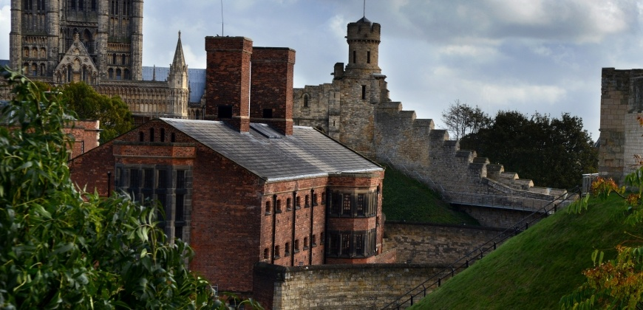
Lincoln Castle (credit: Lincolnshire County Council)
Lincoln Castle is bounded by a stone curtain wall, with ditches on all sides except the south. From an early stage, the outer walls which enclose the site were built in stone and they date from before 1115.

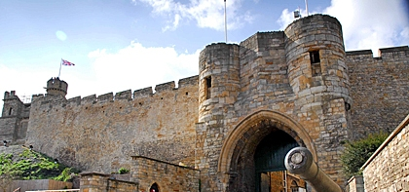
Gate of Lincoln Castle (credit: Lincolnshire County Council)

On the south side the walls are interrupted by two earthen mottes. One motte is in the south-east corner, and was probably an original feature of William's the Conqueror's castle, while the other motte occupies the south-west corner. The Observatory Tower, a square tower, stands on top of the first mound, standing above the outer walls to dominate the city of Lincoln. The second mound is crowned by the 'Lucy Tower', which was probably built in the 12th century and was named after Lucy of Bolingbroke, the Countess of Chester.^{[22]}

Mont-Saint-Michel Abbey
Location | island of Mont-Saint-Michel in Normandy
built | 10th century, rebuilt in 1115-1125  from 1446 to 1523

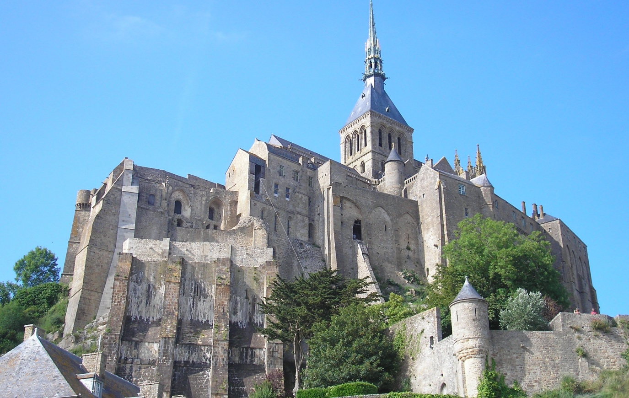
Mont-Saint-Michel Abbey (credit: Ikmo-ned)
The abbey is an essential part of the structural composition of the town the feudal society constructed. On top the abbey, and monastery; below this, the Great halls, then stores and housing, and at the bottom (outside the walls), fishermen's and farmers' housing.

Kutubiyya Mosque^{[1]} (Koutoubia Mosque is the largest mosque in Marrakesh, Morocco.^{[2]} The mosque's name is also variably rendered as Jami' al-Kutubiyah, Kutubiya Mosque, Kutubiyyin Mosque, and Mosque of the Booksellers.^{[3]} It is located in the southwest medina quarter of Marrakesh, near the famous public place of Jemaa el-Fna, and is flanked by large gardens.
The mosque was founded in 1147 by the Almohad caliph Abd al-Mu'min right after he conquered Marrakesh from the Almoravids. A second version of the mosque was entirely rebuilt by Abd al-Mu'min around 1158, with Ya'qub al-Mansur possibly finalizing construction of the minaret around 1195.^{[4]} This second mosque is the structure that stands today. It is considered a classic and important example of Almohad architecture and of Moroccan mosque architecture generally.^{[4]} The minaret tower, 77 metres (253 ft) in height, is decorated with varying geometric arch motifs and topped by a spire and metal orbs. It likely inspired other buildings such as the Giralda of Seville and the Hassan Tower of Rabat, which were built shortly after in the same era.^{[5][6][7][8]} The minaret is also considered an important landmark and symbol of Marrakesh.

Type | Mosque
Completed | Late 12th century
Specifications
Minaret(s) | One
Minaret height | 77 m
Spire(s) | One
Spire height | 8 m
Materials | Brick, san
Chateau Gaillard
location | commune of Les Andelys, department of Eure, Normandy, France
Built by | Richard the Lionheart, King of England
Date established | 1196–1198
Demolished | 1599–1611

The impressive fortress of Chateau Gaillard stands on a loop of land sticking out into the River seine, in northern France. It was constructed between 1195 and 1198 by Richard I, king of England, and was supposed to be impregnable. By 1204, however, it had fallen to the troops of his fiercest enemy, Philip II of France.
As king of England, Richard I ( ruled 1189 to 1199) had inherited huge estates in northern and western France. But most of Richard’s French possessions were also claimed by the French kings, who resented the huge power the English had in France. Richard I decided to build Chateau Gaillard to protect his frontier French invasions.
Walls of butter!
The English king built his castle on spur of rock 90m above the Seine to dominate the surrounding countryside. He boasted he could hold his castle “even if the walls were made of butter”. But he died before his claim could be put to the test, and his brother john became king.
The siege: Philip II first attacked Chateau Gaillard in 1203, soon encircling the castle itself. The English commander, Roger de lacy, drove out all the women, children and elderly from the castle in order to save his food stocks for the soldiers. But Philip II refused to accept them, forcing them all to spend the winter shivering and hungry near the castle moat until he eventually relented.
In spring 1204, the siege began in earnest. The French hauled up catapults and a belfry, and began to fill in the castle moat so that they could approach the outer walls on level ground. Protected by mantlets-large wooden shields-sappers (miners) began to undermine one of the outer towers. According to one contemporary source, the tower came tumbling down.
Victory: The French rushed into the outer courtyard and discovered an unguarded latrine shaft, which gave them easy, if smelly, access up through the walls to the middle courtyard. Here, they drew up a trebuchet and began to attack the thinner, innermost walls. Sappers set to work, and these walls too came tumbling down. As the French stormed in, the English garrison surrendered and the 140 defenders were taken prisoner. Chateau was now in French hands.

Cristo de la Luz
Location | Puerta del Sol, Toledo, Spain
Construction completed | 999 CE
Architect | Musa ibn Alí
Financed by | Ahmad ibn Hadidi
Purpose | Mosque, converted into a church around 1085
Cristo de la Luz was known as Mezquita Bab-al-Mardum, deriving its name from the city gate Bab al-Mardum.
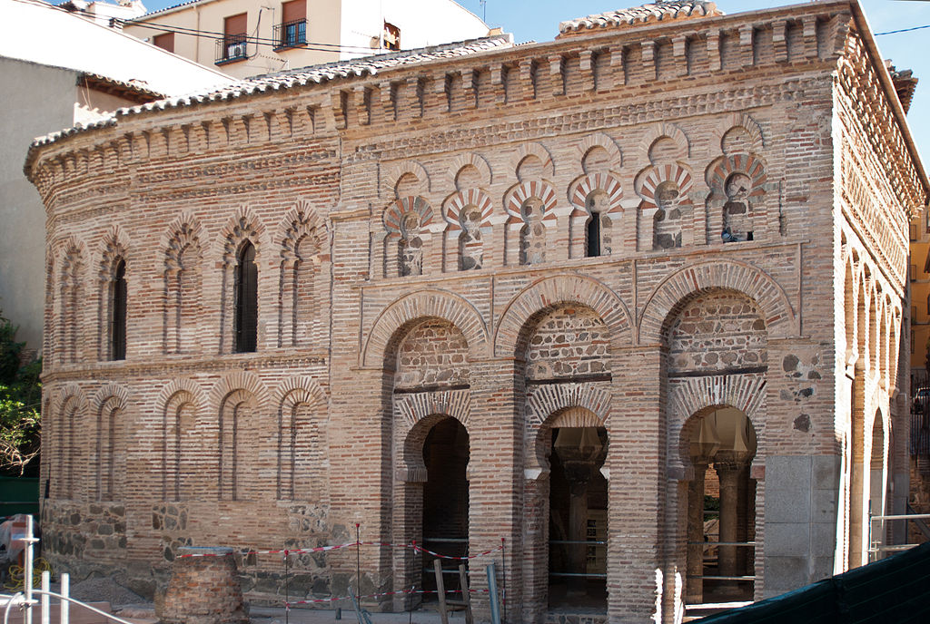

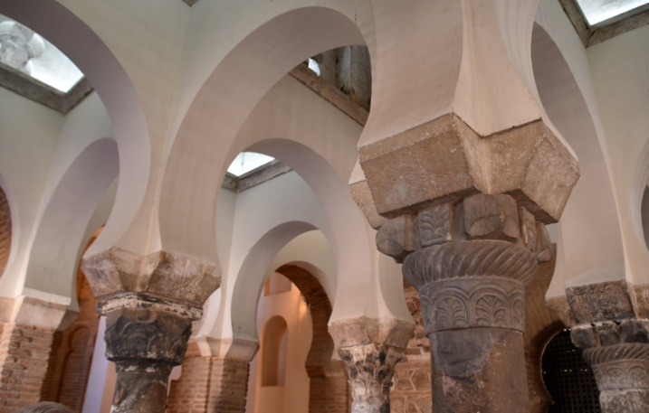 | 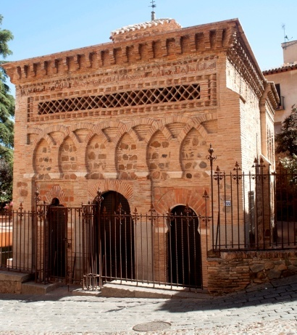
This building is a rarity in that it is in much the same state as it was when it was originally built.^{[1]} The building is a small square structure. It measures roughly 8 m × 8 m. Four columns capped with Visigothic capitals divide the interior into nine compartments. Covering each of these bays is a vault that has a distinctive design that is unique unto itself. The central vault is higher than the other ones and acts as a cupola for the structure. Each vault employs the use of ribs to create the designs that make them unique. Each of them follows the basic ideas of Islamic design. The ribs typically do not cross in the center, an idea that is seen in many Muslim designs. Some of the designs are more rectilinear while others embrace the curved forms of the vault more prominently. Within each one is a piece of their culture and tradition of building.^{[1]} The columns and the capitals both had been taken from previous buildings and are therefore known as spolia. The building is constructed of brick and small stones. These techniques are a reflection of both the local building tradition as well as the influence from the caliphate in Córdoba. Originally the Eastern wall was a continuous stretch of brick and served as the qibla wall for the mosque. Also located along this side would have been a mihrab used for worship. The other three facades are articulated by three-bay arcades. All are similar, but individual in their decoration.^{[2]} The Western wall which served as the main entrance is unique in how the arcade is articulated. This facade has a lobed arch, horseshoe arch, and a wider version of a horseshoe arch. Brickwork arches provide the decoration for the facade which are influenced by the architecture in Córdoba. In later years a Mudejar semi-circular apse was added. In the process of the addition the qibla wall and mihrab were lost. The use of the mudejar style provided a smooth transition from the original structure to the apse, as the addition uses the same style of decoration and materials as the original. The continuation of the arch motif isanimportant link between the two sections of the building
El Generalife (huerta del arquitecto)
location | Albaicín, Granada
built | Muhammed II (1273-1302), Sultan of Granada
Generalife is Spanish form of Arabic Phrase ‘Jannatul arif’ meaning Garden of Architect.
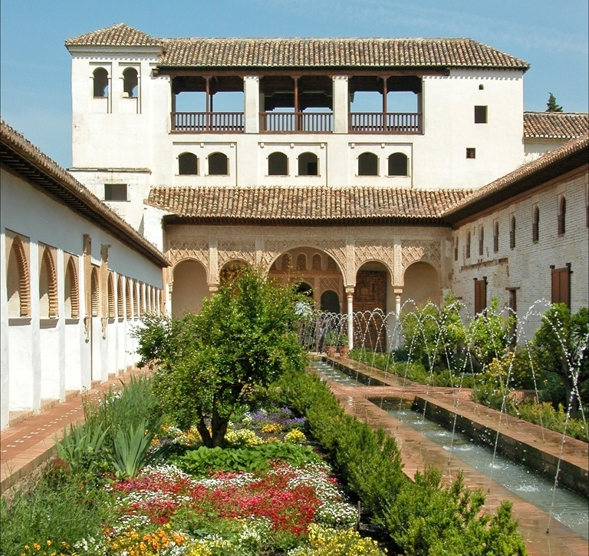  Patio de la Acequia | Patio de la Acequia (Court of the Water Channel or Water-Garden Courtyard), has a long pool framed by flowerbeds, fountains, colonnades and pavilions. It is the best preserve the style of the medieval Persian garden in Al-Andalus. Originally the palace was linked to the Alhambra by a covered walkway across the ravine that now divides them. The Generalife is one of the oldest surviving Moorish gardens.^{[3]}
The complex consists of the Patio de la Acequia (Court of the Water Channel) and the Jardím de la Sultana (Sultana's Garden).
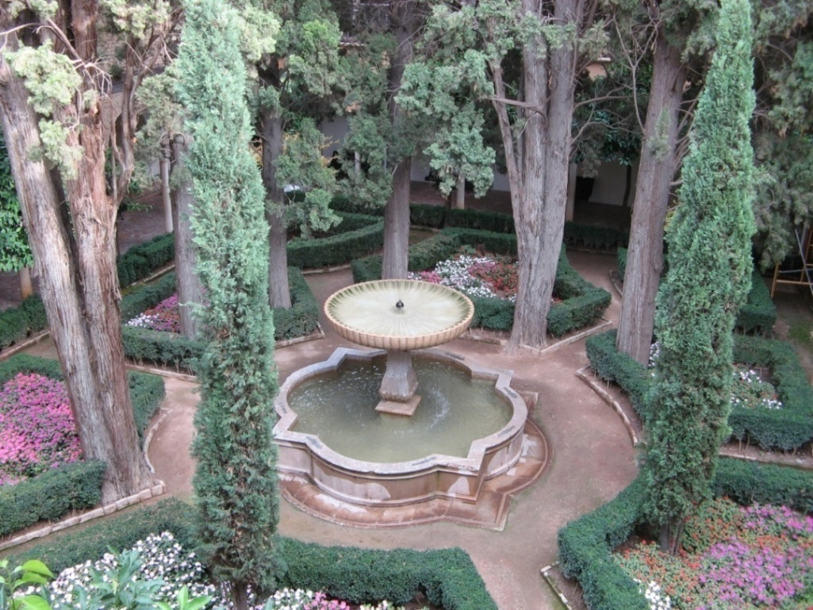  Jardím de la Sultana | Jardím de la Sultana (Garden of Sultana or Courtyard of the Cypress) . . . . .  Cypress trees are . . . . .  .. . . . . . .

Santa María la Blanca
location | Toledo
Erected in | 1180 CE
architect | Muslim Moorish architects
purpose | Synagogue, turned into a church in 1405
Santa María la Blanc, a Jewish religious establishment is result of Jewish spiritual need, patronage of Christian kings and expertise of Muslim architects. It took the name of Santa María la Blanca (Saint Mary the White) in 1405 when synagogue was turned into a church. It is one of the finest example of Almohad architecture because of its construction elements and style.
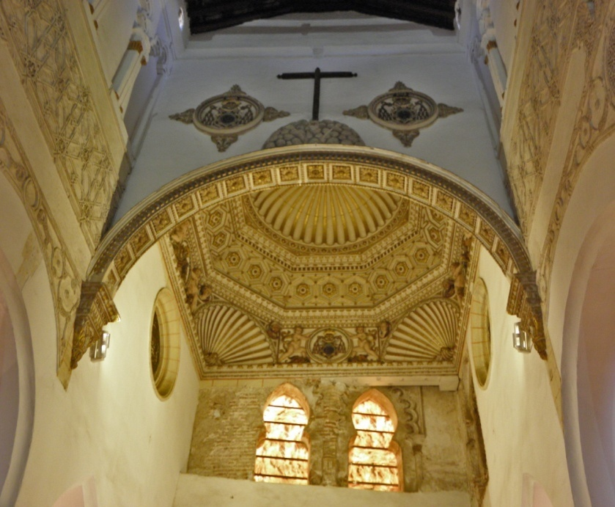  Santa María la Blanca | 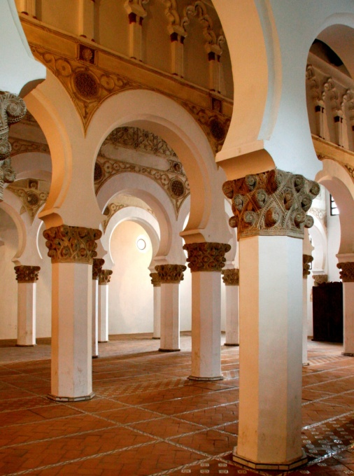
The plain white interior walls as well as the use of brick and of pillars instead of columns are characteristics of Almohad architecture.^{[1]} There are also nuances in its architectural classification, because although it was constructed as a synagogue, its hypostyle room make it closer in character to a mosque. Though it does not have a women's gallery today, an early twentieth century architect suggested that it did at one time have a one.^{[2]}

Madraza de Granada

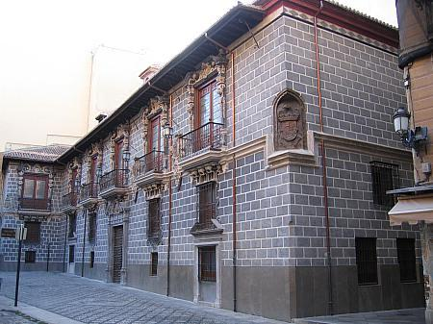
Photo: Madraza de Granada
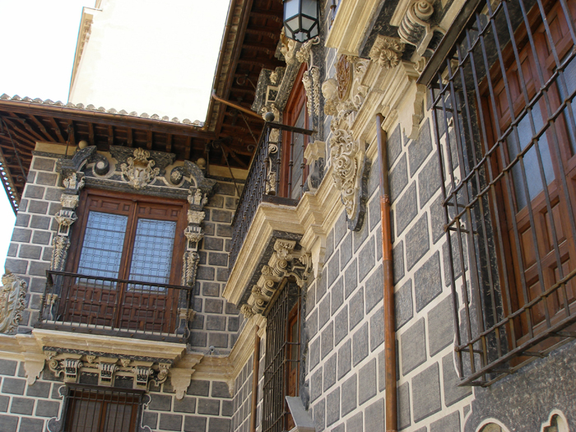
Baroque facade of the Madraza de Granada
Madraza de Granada was founded in 1349 by Sultan of Granada. The madraza functioned as a university until 1500. In 1976, the madraza building became part of the University of Granada.

Castelo dos Mouros
Castelo dos Mouros (Castle of the Moors) is a hilltop medieval castle and was an important strategic point during the Reconquista, and was taken by Christian forces after the fall of Lisbon in 1147.
location | Santa Maria e São Miguel, in the municipality of Sintra, Portugal
Built | in the 9th century
 | by the Moors

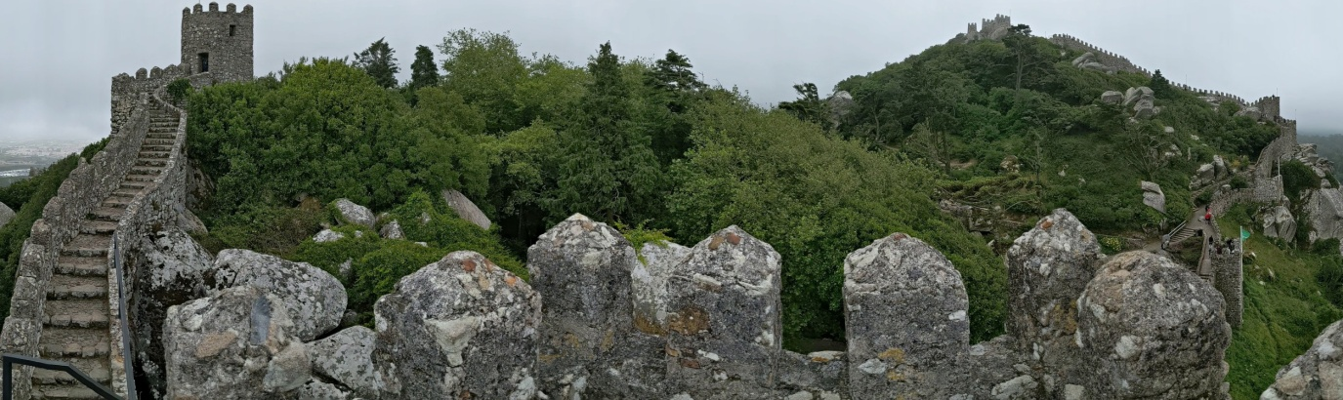

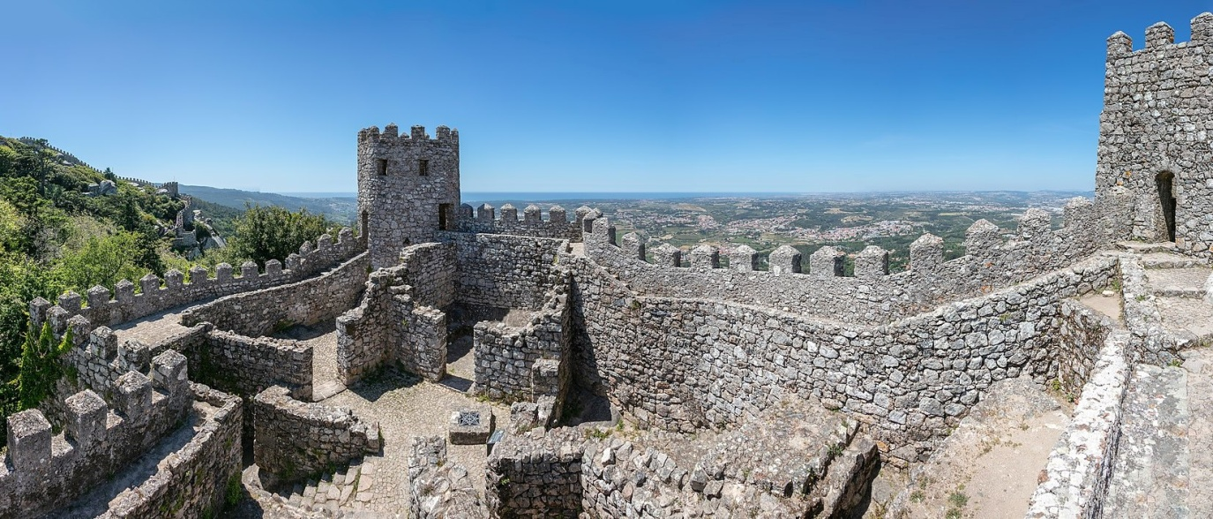
The castle is an irregularly planned military outpost that follows a 450-metre perimeter on top of a mountainous cliff, oriented southwest to northwest. It consists of a double line of military walls that meanders over the granite terrain of the promontory. Its place on the hilltop, surrounded by and including the natural and exotic vegetation, accentuates the Romantic character of the place. The Moorish Castle, due to its geographic place and design, was considered, along with Santarém, one of the principal points of the military plan of Belata (the Muslim province which corresponds to the Ribatejo and Estremadura).^{[5]} The property was remodelled and expanded over time, resulting in a Romantic-era ruins, that included damage caused over time and the public works of Ferdinand II.^{[2]} The towers, which initially included two floors, has a modified appearance, without many of the internal divisions or roofing typical of the period. However, the location of the turrets seem to coincide with the design represented in the engravings of Duarte de Armas.
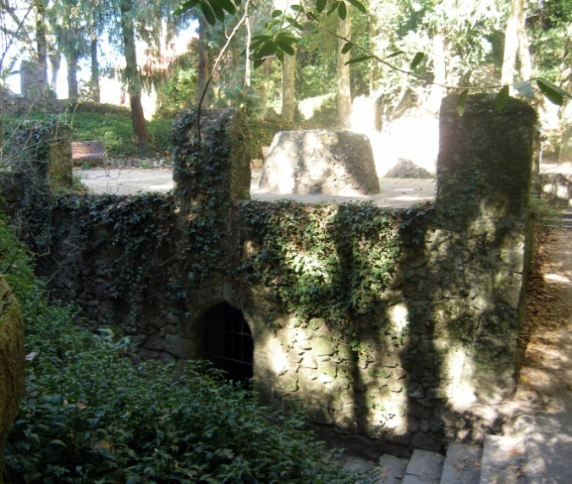

After the conquest of Lisbon (1147) by forces loyal to Afonso Henriques, the castle surrendered to Christian forces.
The outer walls open near Abelheira (west of Tapada dos Bichos), from a main access door, where several paths wind around the hilltop of the castle. A second ring of walls reinforces the castle with both circular and square turrets, thick wall battlements and railings, and crowned with pyramid-shaped merlons. At this second wall is the main entrance to the castle, protected by two turrets and battlements. Near these secondary walls and entrance are the main ruins of the old buildings, corresponding to the cellars, animal pens and cistern. The subterranean cistern, accessible from a three-metre accessway, is 18 metres long by 6 metres wide, and 6 metres in height, where water was collected from openings on its "roof".^{[5]} The interior walls are punctuated by five rectangular towers and one circular tower, surmounted by pyramidal merlons, while surrounding these structures are remnants of older constructions.^{[5]} A small door, normally covered in underbrush, opens to the northern façade of the castle, corresponding to the Traitors Gate, accessing the main "military square" with the structure.^{[2]} In the southwest corner is the highest tower, known as the royal tower.
Along the perimeter of the castle exist various bins or silos, originating from the Arab occupation, many of which are plant covered.^{[2]}
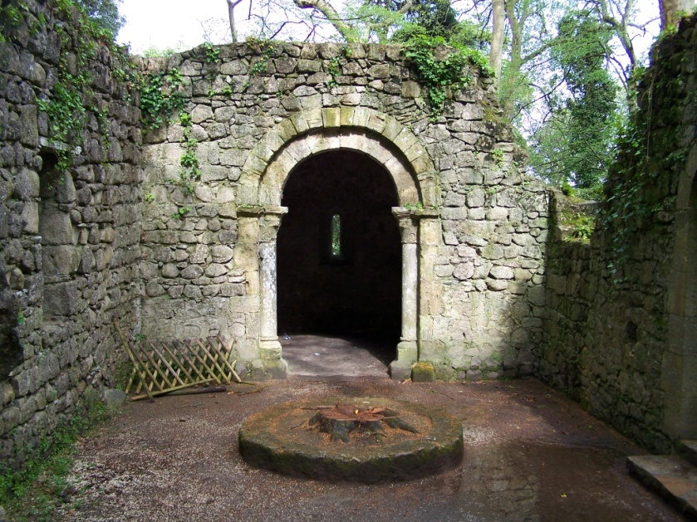 | Chapel: The Chapel of São Pedro de Penaferrim, with the arched doorway and decorated capitals.A chapel with rectangular nave and narrow, lower presbytery lies outside the secondary wall, not too far from the entrance. These ruins were constructed of limestone and masonry, and the interior is accessible from the western or southern façades. The southern wall is highlighted by an arched doorway, supported by colonnades and decorative capitals, with vegetation or fantastical animal motifs (gryphons and basilisks).^{[2][5][7]} The northern façade, with a 1.5 metre opening, corresponds to a primitive door, elevated owing to the accentuated terrain.^{[2]} A triumphal arch based on double columns, based on the similar portal in the south, includes carved capitals with phytomorphic bezels and vestiges of a door.^{[8]} The main chapel has a cradle vault with remains of frescoes, representing a halo in the sky with a figure corresponding to the patron saint, surrounded by floral and geometric motifs, all surrounded by a frieze with geometric designs. Alongside the area designated for the oratory, is a small rectangular niche for religious equipment.^{[2]} The fact that the chapel was located within the walls of the castle led to the tradition that the structure served as mosque prior to the Reconquista.^{[5]}

sainte chapple paris
guildhall of London
Westminster
windsor
Palacio de la Aljafería

Alhambra

Mosque–Cathedral of Córdoba

Castle of Ourém
location
completed | -

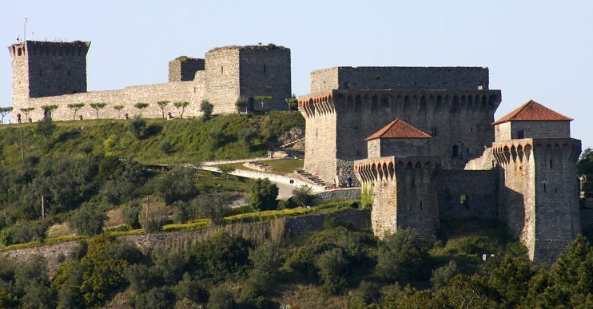
Castle of Ourém

The two towers flanking the entrance are located in the front right, with the ruins of the large palace of Count Afonso just behind them. The oldest portions of the castle are located in the back left of the image.
The Giralda
Seville Cathedral |  |  | The Giralda
location | Seville, Spain |  |  | Seville, Spain
completed | Mosque 1171-1176.  New Cathedral 1401- |  |  | 1184-1198
 |  |  | Architect | Ahmad ibn Basuh (Sevillan) and Abu Layth Al-Siqilli (Sicilian)
 |  |  | brick decoration | Ali al-Ghumari (Berber craftsman)
Length | 135 metres (443 ft)
Width | 100 metres (330 ft)
Nave width | 15 metres (49 ft)
Height | 42 metres (138 ft) |  | height | 104.1 m (342 ft)
The Giralda (Spanish: La Giralda) minaret for the Great Mosque of Seville, now serve as the bell tower of Cathedral of Saint Mary of the See (Seville Cathedral). A Renaissance-style top added by the Catholics after the expulsion of the Muslims from the area.
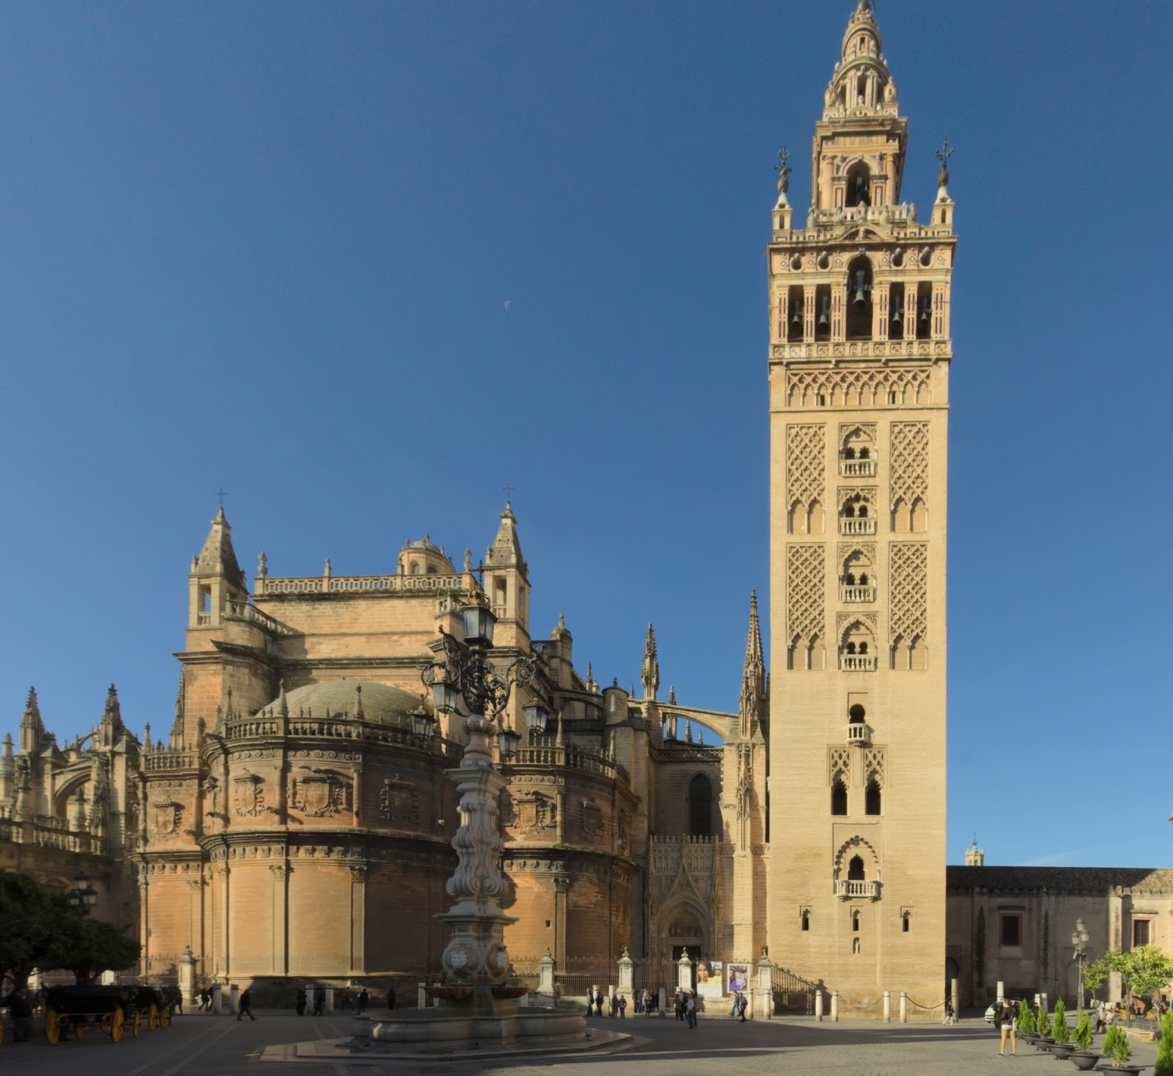
Seville Cathedral (constructed by replacing former mosque) and the Giralda (credit: Ingo Mehling)
Craftsmen from all over Spain and West Africa were enlisted in the mosque's planning, construction, and decoration, and the caliph himself was highly invested in the process and visited the site daily.^{[2][3]} By 1176, the mosque was complete, save for the minaret.^{[2]}
Construction stalled once again in 1184 with the death of the architect, and a month and a half later, the caliph died.^{[3]} It was picked up four years later by the caliph's son, Abu Yusuf Yaqub al-Mansur.^{[3][4][2]} The minaret was built using both local bricks and recycled marble from old Umayyad monuments.^{[3]} On 10 March 1198, the tower was completed with the addition of four precious metal spheres (either gold or bronze) at the tower's peak to commemorate al-Mansur's victory over Alfonso VIII of Castile, which had taken place four years prior.^{[5][2]}
Before its partial destruction in a 1356 earthquake, the mosque was comparable in size to the great mosque of Cordoba and its walls faced the cardinal directions with mathematical preciseness.^{[6][2]} The prayer hall was symmetrical and airy, with a still-extant courtyard, the Patio de los Naranjos, or "Courtyard of Orange Trees."^{[6]} Its interior had a stucco-carved dome over the mihrab, as well as several matching carvings over the arched doorways.^{[2]} The minbar was decorated in a Cordoban style, constructed from expensive wood and embellished with sandalwood, ivory, ebony, gold, and silver.^{[2]}
The minaret, which still stands as the Giralda, contains a series of ramps winding around the perimeter of several vaulted chambers at the tower's core.^{[7]} These ramps were designed with enough width and height to accommodate "beasts of burden, people, and the custodians," according to one chronicler from the era.^{[2]} The decorated facades and windows on the tower are stepped to match the ramps in order to maximize light to the chambers inside.^{[7]} The facades of the tower did contain some plaster embellishment, but they were removed during a modern restoration.^{[7]}

Alcazar de Segovia

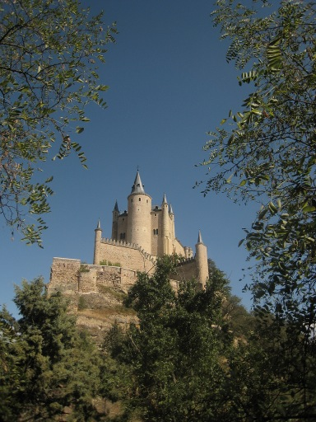
A photograph of the Alcazar in Segovia, looking up from the dry moat beneath it. (Credit: Harshil Shah, CC-BY-SA-2.0)

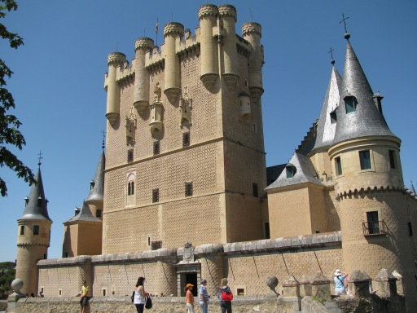
The Torre de Juan II at the entrance of the castle.
a Moorish inspired, arched window on our left of the tower, one third up from the base ‍may be noticed. (Credit: Gabor Tokai, CC-BY-SA-2.0.)

The Alcazar is located in Segovia, which is an-hour-and-a-bit from Madrid.
A Ship Shaped Fortress
The Alcazar of Segovia is particularly special in that it was built upon a large rock promontory, which is shaped rather like the bow of a ship. Indeed, if you stroll along el Camino de la Cuesta de los Hoyos, the small, wooded road which runs in front of the castle, it almost appears as if the alcazar is sailing towards you – cutting through the arid plains of Spain, perhaps in search of the New World.
Important Islamic Influences
Islamic warriors built the first wooden fortress where the Alcazar stands today – using the spot to mark their influence over the surrounding lands.
However, because their early fortifications were made of wood, we’ve little evidence of these structures. The Spanish reconquista resulted in the capture of Segovia as early as 1085, meaning that the majority of castle architecture is Spanish in origin.
Despite this, Islamic building styles became increasingly fashionable in Early Modern Spain (ironically, after the Moors were expelled from the country), and most of the present buildings of the Alcazar de Segovia bear homage to Islamic ancestry.
This is clearly visible in some of the modern castle stucco-ceilings, and the elaborate reading-windows at the front of the fortress. Indeed, the word Alcazar actually stems from the arabic ‘Al-qasr’, meaning fortress.
Probably the first buildings of the Alcazar were laid in about the 1200s, but from the c13th onwards, Fernando III and subsequently Alfonso X built the majority of the rooms we see today.
The Alcazar de Segovia is arranged around two main courtyards: the larger being el Patio de Armas, and the smaller one, el Patio del Reloj.
Each of the rooms is an intriguing mix of Gothic, Romanesque and Moorish influences.
The most notable of all rooms is the Hall of Kings, which can be found at the front of the castle – that’s the bow of the ship.
The hall filled with 52 intricate, raised portraits of various Spanish monarchs of Castile and Leone. These little statuettes form an elaborate, golden-plated frieze which encircles the upper part of the room – a pretty spectacular overview of Spanish history.
Note that the ornate, Islamic ceiling is a modern replica of an original destroyed by fire.
At the opposite end of the castle situeated the impressive Tower of Juan II, foundations of which were laid in the 1300s.
This geometric edifice (rather like a upturned matchbox) is more than 80m in height. You’ll note that its arched windows have a distinctive, Arabic style – and, as an aside, the tower was used as a jail in Early Modern times. Learn more about Medieval prisons and dungeons.
Despite the tower’s lofty appearance today, it wasn’t always this height. If you look closely at the photo above, you’ll notice that the brickwork from about half-way up is a little different – during the 1550s, building-work to strengthen the defences of the Alcazar nearly doubled its height.
You may have to use your imagination a little, but you might be able to make out the silhouette of la mujer muerte (literally: the dead woman). The peaks and valleys of the Sierra de Guadarrama, which stretch across the horizon, apparently resemble the body of a woman, lying on her back with her knees slightly bent.
The Mighty Fire
In 1862, fire-ripped through the Alcazar, destroying the roofing, turrets and upper floors of almost every building in the castle. The architects restoring the Alcazar in Segovia chose to exaggerate all aspects of the castle – creating more fanciful turrets and larger, spiralling towers.

Bibliography

Alan Colquhoun, Modern Architecture, Oxford University Press, Hong Kong, 2002.
Alfred Dwight Foster Hamlin, A Text-Book of the History of Architecture, 7th edition, Longmans, Green and Co., New York, 1909.
Anisur Rahman Abu Kab, Eminent Researchers of the Medieval Period, Bangladesh Green Building Academy, Dhaka, 2019.
Arthur L. Guptill, Rendering in Pen and Ink, Published by Watson-Guptill Publications, 1976.
Bai Shouyi et al., A History of Chinese Muslims, 2003.
Barbara Penner, Iain Borden and Murray Fraser, Forty Ways to Think About Architecture, Wiley, West Sussex, 2014.
Catherine B. Asher, Architecture of Mughal India: The Cambridge History of India, Cambridge University Press, 2008.
Cyril Manton Harris, Dictionary of Architecture and Construction, McGraw-Hill Education, 2006
Doris Heyden, Pre-Columbian Architecture of Mesoamerica, Henry Abrams Incorporated, NY, 1975.
Donald R. Hill, Studies in Medieval Islamic Technology, 1st edition, Routledge, Abingdon, UK, 1998.
Ernle Bradford, The Great Betrayal: The Great Siege of Constantinople, Open Road Integrated Media, New York, 2014.
Francis DK Ching, A Global History of Architecture, John Wiley and sons, Inc., Hoboken, New Jersey, 2011.
Francis DK Ching, Architecture: Form, Space & Order, 3rd ed. John Wiley, Hoboken 2007.
Francis DK Ching, A Visual Dictionary of Architecture, Van Nostrand Reinhold, New York 1995.
George Sarton, Introduction to the History of Science, 3 vols., Williams and Wilkins, Baltimore, 1948.
G L Huxley, Biography in Dictionary of Scientific Biography, New York, 1990.
Graham E. Fuller, A World without Islam, Back Bay Book, New York, 2012.
Harriet Goldstein and Vetta Goldstein, Art in Everyday Life (3rd ed.), Macmillan New York, 1940.
John Mansbridge, Graphic History of Architecture, 1999 Francis Ching, A Visual Dictionary of Architecture, 2nd Edition, John Wiley and sons Inc., New Jersey, 2012.
Jonathan A Hale. Building Ideas: An Introduction to Architectural Theory, John Wiley & Sons, 2000.
Jonathan Glancey, Architecture: A Visual History, Dorking Kindersley Limited, London, 2017.
L. Peck, Delhi- A Thousand Years of Building, Roli Books, New Delhi, 2005.
Mario Livio, The Golden Ratio, Broadway, New York, 2003.
Mary Ellen Miller, Maya Art and Architecture, Thames and Hudson Inc., NY, 1999.
Massimo Scolari, Oblique Drawing: A History of Anti-perspective, MIT Press, Massachusetts, USA, 2012.
MJL Young, Religion, Learning and Science in the Abbasid Period, Cambridge University Press, 2006.
Nicole Bridge, Architecture 101: From Frank Gehry to Ziggurats, an Essential Guide to Building Styles and Materials, Adams Media, 2015.
Robert Harbison, Travels in the History of Architecture, Reaktion Books Ltd., London 2009.
Robert Layton and Julian Thomas, Destruction and Conservation of Cultural Property, Routledge, Abingdon, UK, 2003.
Sharmin Khan, History of Indian Architecture: Buddhist, Jain and Hindu Period, CBS Publishers and Distributors, New Delhi, 2014.
Sharmin Khan, History of Islamic Architecture: Delhi Sultanate, Mughal and Provincial Period, CBS Publishers and Distributors, New Delhi, 2016.
Simon Adams, Castles and Forts, Kingfisher Books Ltd, 2006.
Steven Groak, Idea of Building: Thought and Action in the Design and Production of Buildings, Taylor & Francis, 1992.
Tatiana Proskouriakoff, An Album of Maya Architecture, Dover Publications Inc., Mineola, 2002.
Thomas J. and Lynn B. Abercrombie, Traveling the World for National Geographic, Birch Landing Press, 2011.
T L Heath, A History of Greek Mathematics, 2 Vols., Oxford, UK, 1921.

hammer-beam roof? Where does a voissoir fit in an arch? What churches did Nicholas Hawksmoor design?

Translation taken from Ernle Bradford (1967), The Great Betrayal: The Great Siege of Constantinople, p148.
Ernle Bradford, The Great Betrayal: The Great Siege of Constantinople, p148.
Ernle Bradford writes, “The behavior of the Christian conquerors in 1204 contrasts unfavourably even with that of the Turks, when they took the city in 1453. More hatred seems to have been displayed by these Christian conquerors towards their co-religionists than was to be shown by the Moslems some two hundred years later to their religious enemies. It is a depressing fact that Moslems were usually more tolerant than Christians in their dealings with captured cities and conquered territories.” (The Great Betrayal: The Great Siege of Constantinople, p. ix)

