Magnificence of the Medieval Architecture

Abu Kab Anisur Rahman

Title: Magnificence of the Medieval Architecture
Written by: Abu Kab Anisur Rahman,
MSc (Civil and Geotechnical Engg.)
Email: abukabanis@yandex.com
Feedback and enquiries: abukab.weebly.com

Published by: Independently Published

Printed at: ??????????????? , Dhaka.

First Publication: 27 Safar 1442 AH (2021-03-30 English calendar)

Price: 400.00 BDT (3.00 USD)

© All rights reserved by the Author

Magnificence of the Medieval Architecture- The book gives readers an encyclopedic view of the medieval architecture from around the world. . . . .

Content
Preface …………………………  Introduction ……………………..  Japan  China  Vietnam  Indian Subcontinent  Persia and Turkistan  Arabia and the Levant ………….  Anatolia  Egypt  Northern and Western Africa  Greece  Germany  Italy  England  France  Iberia  Bibliography ……………………. | 5  13  15  34  37  39  40  43  45  49  51  54  198

Preface
Praise be to the Almighty God, the Creator and Sustainer. All efforts come to a success though His permission and mercy.
As a civil engineer, architecture is a minor subject for me. But my interest for architecture and curiosity in the Medieval Period are immense.
Earlier, I wrote a book on achievements by science and philosophy personalities of the medieval period. During the study I got more interested to the architectural achievements of the period.

In this book, I tried to give my sight over the whole world. The landmarks discussed here are from different lands and representative of different cultures of the world.
I thank Mr. Refat Jamil and others who have given us the permission to use their photos. I am also grateful to all others who were involved in different sections of this publication.
Any suggestion from valued readers to improve the quality of this publication will be highly appreciated.

Abu Kab Anisur Rahman
Dhaka, Bangladesh

Introduction
Architecture is both the process and the product of planning, designing, and constructing buildings or other structures.

Cyril Harris defined: architecture refers to the art and science of designing and building structures, or large groups of structures, in keeping with aesthetic and functional criteria

There is an old equation

Architecture = building + something

or large groups fdfg. . . . . . . https://archnet.org/sites/2809

Qian men

Ludwig Mies on der Rohe said, Architecture is the will of an epoch translated into space.
Ludwig Mies on der Rohe also said, Architecture starts when you carefully put two bricks together.

The English word architecture is borrowed from Latin architectura. Originally it is from ἀρχι (arkhi) meaning chief and téktōn (τέκτων) builder.
Architectural works, in the material form of buildings, are often perceived as cultural symbols and as works of art. Historical civilizations are often identified with their surviving architectural achievements.
English poet William Shakespeare wrote:
When we mean to build,
We first survey the plot, then draw the model;
And when we see the figure of the house,
Then must we rate the cost of the erection.
To me, poetry is very similar to architecture. While poetry is arrangement of word in beautiful and meaningful manner, architecture is arrangement of materials in beautiful and meaningful manner.
Henry Wadsworth Longfellow said,
The architect
Built his great heart into these sculptured stones,
And with him toiled his children, and their lives
Were builded, with his own, into the walls,
As offerings unto God.
John Prebble said: Architects and engineers are among the most fortunate of men since they build their own monuments with public consent, public approval and often public money.
John Milton wrote:
The hasty multitude
Admiring enter'd, and the work some praise,
And some the architect: his hand was known
In heaven by many a tower'd structure high,
Where scepter'd angels held their residence,
And sat as princes.

Ludwig Mies on der Rohe said,. . . ce.

Some Architectural Terms
Alcove: A large recess in a room separated by an arch or so.
Arch: A mechanical arrangement of wedge shaped blocks mutually supporting each other forming an opening and resting on two ends over columns or walls.
Atrium: An atrium is an area, usually under a roof, in which plantings dominate. The roof admits light needed by the plants. The atrium might have paved paths and private places to sit and relax. Often, rooms open onto it or have glass walls facing it. If totally enclosed, it provides year-around greenery to the interior rooms.
Balcony: A horizontal projection of roofs fitted with railing serving as a sitting out place.
Bay window: A window projecting upward from the wall having rectangular or curved form.
Basement: It is a floor situated below the ground level.
Beam: Beam is a horizontal member used to support load over opening.
Brace: a slanted member used in roof frame for tightening and framing.
Canopy: a covering which can be done on roof tops.
Chancel: In church architecture, the chancel is the space around the altar, including the choir and the sanctuary (sometimes called the presbytery), at the liturgical east end of a traditional Christian church building.
Church house: A church building or church house, often simply called a church, is a building used for Christian religious activities.
Castle: A castle is a type of fortified structure built during the middle Ages by the nobility or royalty and by military orders. Usually it is considered to be the private fortified residence of a lord or noble. This is distinct from a palace, which is not fortified; from a fortress, which was not always a residence for royalty or nobility; and from a fort, which was a public defence – though there are many similarities among these types of construction.
Cistern: Cistern is a tank for storing water for flushing pans, urinals water closets and drains.
Column: A column or pillar in architecture and structural engineering is a structural element that transmits, through compression, the weight of the structure above to other structural elements below. In other words, a column is a compression member. The term column applies especially to a large round support (the shaft of the column) with a capital and a base or pedestal, which is made of stone or appearing to be so. A small wooden or metal support is typically called a post, and supports with a rectangular or other non-round section are usually called piers.
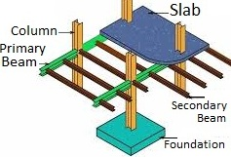  Beam and column | coping
Condominium: It is a dwelling of individual ownership in a multi-unit building having undivided interest in common areas and facilities.
Conduit: It is a pipe or a channel for conveying wiring and water.
Coping: It is a covering on wall-top usually sloped to through off moisture.
Corbel: A projection from wall to form a support.
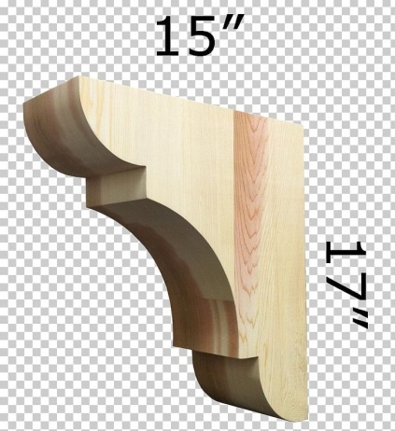  Corbel | 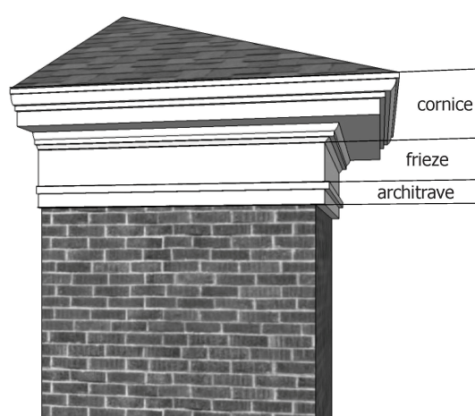  Cornice | Dropwall
Corridor: It is a narrow verandah or a gallery for communication to different parts of the building.
Cornice: Horizontal projection of the roof.
Dormer window: a window set vertically into a slopping roof.
Drop wall: A wall coming downward from roof to protect verandah, balcony or open space.
D.P.C.: Damp Proof Course.
Eaves: A paved open space around the building to facilitate movement and through off rain water.
Esplanade: An esplanade or promenade is a long, open, level area, usually next to a river or large body of water, where people may walk. The historical definition of esplanade was a large, open, level area outside fortress or city walls to provide clear fields of fire for the fortress's guns. In modern usage the space allows people to pave the area as a pedestrian walk; esplanades are often on sea fronts, and allow walking whatever the state of the tide, without having to walk on the beach.
Façade: The principal front of a building.
Fort: A fort is a military construction or building designed for the defense of territories in warfare.
Gallery: A gallery is an interior area which serves as a passage way. It often opens onto a courtyard. Usually, it connects with the foyer. One wall may be glass. The gallery might contain pieces of furniture.
Grouting: Making repairs with the help of strong cement mortar run into cavities and joints of the masonry works.
Lintel: Horizontal beam like member over the opening of door and window.
L.C.: Lime concrete (usually placed on the last roof).
Louver: Louver is inclined or straight opening with series of slates permitting ventilation but preventing rain and sun.
Lobby: An entrance space or hall is called lobby.
Minaret: Minaret is a type of tower typically built into or adjacent to mosques for announcing call for prayer. The term is borrowed from Arabic manara, literally “lighthouse”.
Mosque: Mosque is a place of worship for Muslims, often having at least one minaret. The term Mosque, meaning ground on which prostration is done, is derived from Hebrew/Arabic word sajad (סָגַד) meaning prostration.
Nave: The nave is the central part of a church, stretching from the (normally western) main entrance or rear wall, to the transepts, or in a church without transepts, to the chancel. When a church contains side aisles, as in a basilica-type building, the strict definition of the term ‘nave’ is restricted to the central aisle. In a broader, more colloquial sense, the nave includes all areas available for the lay worshippers, including the side-aisles and transepts. Either way, the nave is distinct from the area reserved for the choir and clergy.
Nosing: Rounded and projected edges of the cornice or stair.
Loggia: A loggia is a roofed, open gallery along the front or side of a building. It serves as a passage connecting areas of a house. Loggias may be on both ground and second story levels. Modern versions may have doors which can be used to enclose the area in bad weather. The difference between a veranda and a loggia is that a veranda is a roofed structure attached to the outside of the main building, whereas the a loggia forms part of the main architectural structure.

Pagoda: A religious building, generally a multi-storey tower erected as a Buddhist temple.
 | 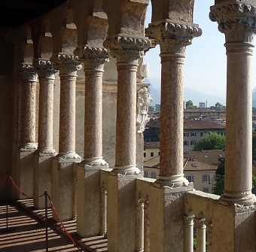
pagoda | loggia | portico

Pantry: A small room (generally adjacent to the dining room) for keeping cooked food.
Parging: thin coat of plastering to smooth off rough walls.
Parapet: A low height wall provided in the last roof and is used as railing.
Pendentive: The concave triangular sections of vaulting that provide the transition between a dome and the square base on which it is set and transfer the weight of the dome.
Portico: An open space usually with roof provided in front of an entrance for stopover of cars.
R.B.: Reinforced brick work.
Setback: Placing of a building at specified distance from road.
Soffit: A partial ceiling lower than the main one.
Stilt: A tall pillar or post used to support some structure; often above water.
Temple: A temple is a building reserved for religious rituals and activities.
soffit | terrace | stilt

Terrace: A terrace is an external, raised, open, flat area in either a landscape (such as a park or garden) near a building, or as a roof terrace on a flat roof.

Regional Architecture
Architecture developed in different parts of the world in different styles owing to environment, political situation, literacy of the learned folk of the area. Dana Arnold wrote: Architectural History is more than just the study of buildings. Architecture of the past and the present remains an essential emblem of a distinctive social system and set of cultural values, and as a result it has been the subject of study of a variety of disciplines.
Traditional architecture is well integrated into the natural setting such as mountains and hills, rivers, ponds, lakes, trees. As a result, the architectural structure adds beauty to the surrounding scenery, while the setting also helps to enhance the value and charm of the building. In places where some elements of the necessary natural scenery are wanting, human beings create artificial lakes, mountains or plant trees.
We begin with Chinese architecture which demonstrates an architectural style that developed over millennia in China and spread out to influence architecture throughout East Asia. Since the solidification of the style in the early imperial period, the structural principles of Chinese architecture have remained largely unchanged, the main changes being only the decorative details. Chinese architecture is typified by various features; such as, bilateral symmetry, use of enclosed open spaces, the incorporation of ideas related to feng shui such as directional hierarchies, a horizontal emphasis, and allusion to various cosmological, mythological, or other symbolism.

Chinese architecture traditionally classifies structures according to type, ranging from pagodas to palaces. In part because of an emphasis on the use of wood, a relatively perishable material, and due to a de-emphasis on major monumental structures built of less-organic but more durable materials, much of the historical knowledge of Chinese architecture derives from surviving miniature models in ceramic and published planning diagrams and specifications. Some of the architecture of China shows the influence of other types or styles from outside of China, such as the influences on mosque structures originating in the Middle East. Although displaying certain unifying aspects, rather than being completely homogeneous, Chinese architecture has many types of variation based on status or affiliation, such as dependence on whether the structures were constructed for emperors, commoners, or used for religious purposes. Other variations in Chinese architecture are shown in the varying styles associated with different geographic regions and in ethnic architectural design.

Chinese architect Liang Sicheng commented, “The architecture of China is as old as Chinese civilization. From every source of information—literary, graphic, exemplary—there is strong evidence testifying to the fact that the Chinese have always enjoyed an indigenous system of construction that has retained its principal characteristics from prehistoric times to the present day. Over the vast area from Chinese Turkistan to Japan, from Manchuria to the northern half of French Indochina, the same system of construction is prevalent; and this was the area of Chinese cultural influence. That this system of construction could perpetuate itself for more than four thousand years over such a vast territory and still remain a living architecture, retaining its principal characteristics in spite of repeated foreign invasions—military, intellectual, and spiritual—is a phenomenon comparable only to the continuity of the civilization of which it is an integral part.”

The Yingzao Fashi (Chinese literally: 'Treatise on Architectural Standards') is a technical treatise on architecture and craftsmanship written by the Chinese architect Li Jie (1065–1110), of the Directorate of Buildings and Construction during the mid Song Dynasty. He completed the work and presented to Emperor Zhezong of Song. The emperor's successor, Emperor Huizong, had the book published in 1103 in order to provide a unified set of architectural standards for builders, architects, and literate craftsmen.
Even mosques and churches in China follow Yingzao Fashi.
The color of the house depends on the color of the construction materials; wooden components have a brown natural color, are painted red or gilded; the walls are painted with white lime; ordinary tiles are either red, yellow, blue or have the color of pearls.
Chinese roofs are not straight but curved.
Starting with the Tang dynasty, Chinese architecture has had a major influence on the architectural styles of Japan, Korea, Mongolia and Vietnam, and a varying amount of influence on the architectural styles of Southeast and South Asia including Malaysia, Singapore, Indonesia, Sri Lanka, Thailand, Laos, Cambodia and the Philippines. In Japan, Mongolia, Vietnam and some other countries Chinese architecture is was followed with modifications or adaptations.
Traditional Vietnamese buildings are similar with China’s, but has some differences:
Vietnam architecture is impressive and diverse. It can be divided into five main parts – vernacular, Chinese, ethnic, colonial and modern.
Wooden Structures & Steep Roofs: Traditional Vietnamese architecture involves wooden structures and steep roofs. Both large and small buildings have an odd number of compartments (l, 3, 5, 7, 9, 11) with sets of beams and rafters; the depth of the interior of the house is determined by the number of columns in each compartment. The wooden beams, rafters, tendons and mortises, and other components constitute a solid framework which supports the roof. The house may have a wooden wall or a wall of uncoated bricks with curved upward coats of mortar in-between the bricks. The wall must be linked to the system of outer columns; the brick wall must be constructed so as to surround the frame system, playing a protective and load-bearing role. The whole house stands on the floor foundation (with a system of stone bases which support the columns).
The ancient steep roof is curved at four ends, and its edges are decorated with high relief motifs. Both gables of the house are decorated. As a result, the roof looks quite light in spite of its large size. Over time, the wooden frame has experienced gradual changes, going from super-posed ties, gong-hanger ties to arm-shaped ties, from front ties and back shorter ties with (or without) cross-struts to ties provided with multi-tiered horizontal consoles for supporting the roof, from rough and heavy to slender and light beams and ties. The big roof curving at four angles has gradually replaced by a straight roof which looks a bit curved due to the effect of the edge of the roof and has two layers with space in-between them.
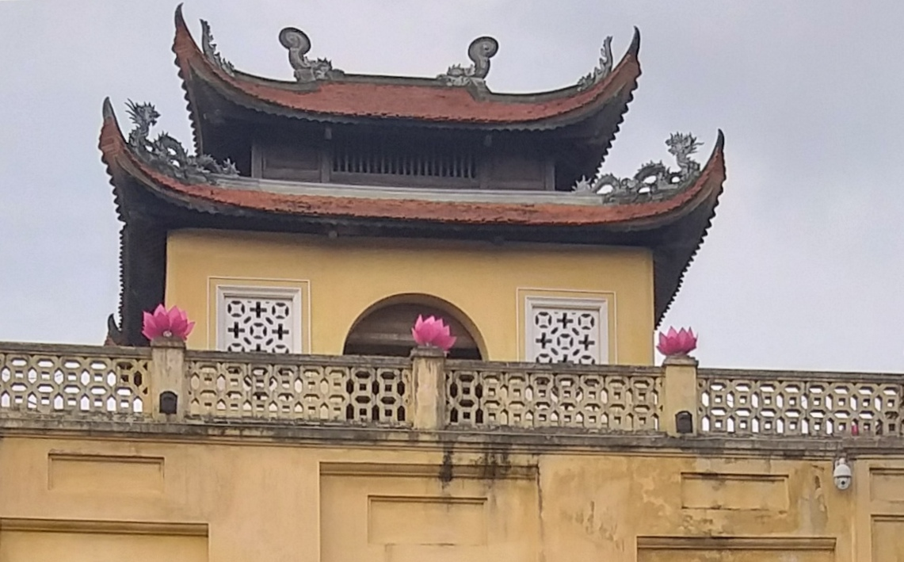
Thang long, Vietnam (credit: Abu Kab Anis)
Formerly, the roof of the house was covered with “fish scale” “dragon scale” or tube tiles; baked or enameled colored tiles. Each building usually comprised an interior space (which was closed) and a verandah space (half-closed); at first, there was only one interior space for one house, but later the interior space of two houses could be linked thanks to a complimentary roof.
Stilt Houses:
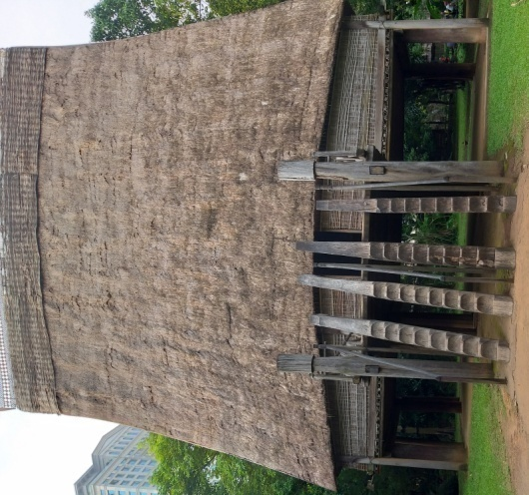  Community house (credit: Abu Kab) | Vietnamese traditional wood architecture originated from the house on stilts dating back to the time of the Dong Son culture (3rd century BC). Nowadays, wooden houses on stilts are still seen in the highlands and midlands inhabited by the Tay, Nung, Thai, Muong, Ede and Bahnar. The house on stilts of these ethnic groups may differ with regard to the layout, structure of beams and rafters, and other components.
The composition of the floor space: All buildings must follow the principle of symmetry and balance, a principle which originated from primitive religious beliefs. Specifically, each house as a basic unit, having an odd number of rooms. The floor space of the house resembles a certain geometrical figure rectangle, square, hexagon, octagon and the following Chinese characters:
The letter H is the simplest and initial layout of houses. In other more complex arrangements, there is an internal courtyard for the sake of ventilation and more light. Individual houses are brought together to form a large architectural group.
This floor space composition is based on wood structure.
The outlook of a Vietnam’s traditional architectural construction is made up of 3 components:
Roof: The roof must be curved at its ends. The bigger the house, the higher the roof, as seen in communal houses. The edges of the roof are decorated. The roof stretches beyond the wall and the verandah of the house.
Wall: The wall has an evenly-arranged set of columns, and in-between the columns are doors (simple doors, artistically structured and decorated doors).
Floor: The Floor (including outer staircases) on which the house is based; it may be high or low depending on the type of house and the terrain.

In general, traditional Vietnamese gates are decorated.
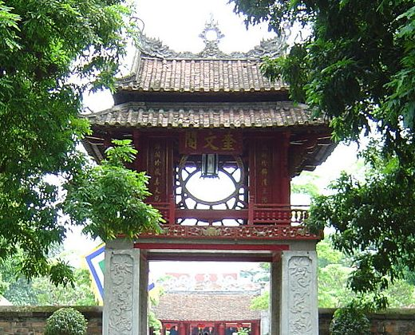
Artistic Forms & Decorations in Traditional Vietnamese Architecture
The Floor Foundation & Courtyard: The floor foundation (including the outer staircases) and the courtyard can be covered with stone or baked bricks with flower patterns.
The Outer Three-Level Stair: The outer three-level stairs of big houses and monuments have stone balustrades. The ends of the support pillars of the balustrades have the form of a non-blooming lotus flower, and in- between them are sculptured stone panels, while various parts of the balusters are linked to the supporting pillars by tendons and mortises. The design of the balustrade reflects Chinese influence.
Balusters: In some pagodas and temples, the wooden balustrades are provided with flutes and beautifully-shaped balusters. Wooden balustrades are also seen in the upper parts of the doors of some private houses.
Columns, beams and rafters: The round columns are lozenge-shaped at the top and in the middle and cylindrical at the lower parts, each column is usually made from one single trunk) and have a good proportion. They are either plain, polished or are painted red and gilded with decorations of dragon motifs (particularly in the case of pagodas, temples and palaces).
In traditional architecture, decorations are usually focused on the space below the roof, and particularly the main compartment located in the central part of the house.
Colors: In terms of colors, the traditional architecture uses indigenous paints to protect the wooden parts against humidity and termites; yellow-red is the dominant color with red as the background, which helps to bring out the gilded decorations.
Decorative Motifs: Traditional architecture has rich decorative motifs, such as stylized lotus flowers, chrysanthemum flowers, dragons and phoenixes, clouds and water waves, fairies, musicians or ordinary life scenes, stylized Chinese characters ‘van’ (myriad), ‘phuc’ (happiness), ‘loc’ (luck), ‘tho’ (longevity). Some pagodas have wooden window frames in the form of a Chinese character.
In India, there is rich Hindu, Buddhist and Jain architecture. The architecture of Muslim dynasties (Slave dynasty, Khilji, Lodi and Mughal dynasty) has made India even richer. Mughal architecture is not discussed in this book excepting one of the first and finest Mughal structures which was constructed in ending of medieval period.
The 23 ft high Iron Pillar of Quwwatul Islam mosque located in Delhi is notable for the rust-resistant composition of the metals used in its construction.
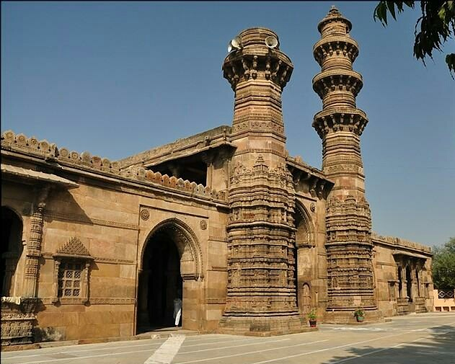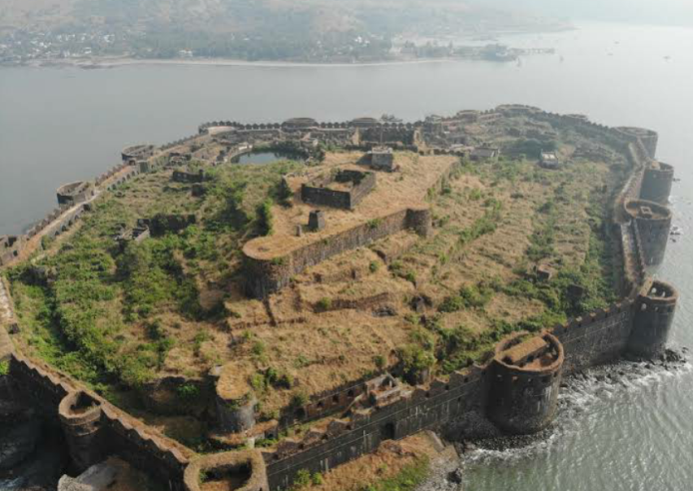
Jhulta Minar in 1866CE | Murud-Janjira Fort

Jhulta Minar, the twin minarets of Sidi Bashir Mosque in Ahmedabad, is a fascinating monument. When one of the minarets is shaken, the other corresponding minarets start vibrating after a few seconds but the area between the minarets does not exhibit any vibrations at all. Till date there is no explanation to this phenomenon. The mosque exhibits exquisite architectural splendour and reflect Lodi and Rajputana styles of architecture.

Most castles and fortresses have been founded upon spots which offer a natural defensive advantage. Murud-Janjira is considered one of the strongest marine forts in India. It is situated on an oval-shaped rock off the Arabian Sea coast near Rajapuri, 165 km south of Bombay.
The main gate of the fort faces Rajapuri on the shore. It has a small postern gate ('Darya Darwaza') towards the open sea for escape.
The fort has 26 rounded bastions, still intact. There are many cannons of native make rusting on the bastions. The fort in its heyday had all the necessary facilities, e.g., palaces, quarters for officers, mosque, two small 60-foot-deep natural fresh water lakes, etc.
Concentric Castles
During the second half of the 13th century CE, a new type of castle appeared in Western Europe, many of them built by Edward I of England. The concentric castle, with its double ring of defensive walls and other groundbreaking features such as a reinforced gatehouse, was based on an old design, but it proved remarkably effective in keeping out attackers.
The first stone castles had been constructed with a single outer wall. This was strong and tall, but vulnerable to siege was effectively over and the castle easily occupied. A better system of defence was required to make a castle truly impregnable.
The first concentric castle to be built in Britain, Caerphilly castle, was constructed between 1268 and 1271 by Gilbert de Clare (1243-1295)
Caerphilly castle, in Wales, had concentric design, strong gatehouse and surrounding moat. These features made it the strongest castle in the south of the principality.
It was the crusader who carried back this new design to Western Europe, as well as using it to design their own castles, notably Krak des Chevaliers. The concentric design proved very effective, since defenders on the high inner walls could fire over the heads of their fellow defenders on the lower outer walls without, in theory, harming them.
If required, the defenders on the outer walls could also rush out to attack the besieging enemy, confident that the castle remained well-defended from its inner walls. Cylindrical towers stood at each corner of the inner walls, while access to the castle was limited to one or two heavily fortified twin-towered gatehouses. The overall design varied from site to site, but many of these new castles were regular in shape, and some almost perfectly square.
Concentric castles soon sprouted up across Europe. Existing castles were given new outer sets of walls, while ten new castles were built by Edward I in north Wales to subdue the principality after its conquest in 1282. This vast programme of castle building involved 150 masons and 400 carpenters, as well as 1,000 diggers and 8,000 woodcutters to clear the land before construction began.
The first castles were built to protect their inhabitants from attack, as well as to provide a safe garrison for local soldiers. But by the 11th century CE, castles were mainly used as bases from which the 1066 conquest of England by William of Normady. Faced with a hostile saxon population, king William needed to assert his authority over his new kingdom.
The motte and bailey
William brought with him a design for a castle he had developed in Normandy. This consisted of a wooden-fenced bailey (courtyard0, surrounded by a moat and protected by an earthen rampart. Within the bailey were stables, workshops, the well and perhaps even a chapel. Separated from the bailey by its own moat was the motte-a mound of pressed layers of soil at least 5m high-on which stood a wooden tower and lookout post. Access to the motte was by drawbridge.
Mass-construction
Motte and Bailey castles were simple to construct, because they used local wood and could be built using forced Saxon labour. Within 100 years of the Norman conquest, about 600 of these castles had been built in England and wales alone. They were the largest buildings seen in Britain since Roman times, and terrified the local population into submission.
Strategy
Most Motte and Bailey castles were built on strategic sites commanding the local countryside. Some were on bends of rivers or by river crossing, and others guarded ports or defended the coastline from possible invasion. All followed a basic plan, although the motte could be anything up to 25m tall, and the bailey up to 25ha in area (equivalent to 10 large fields).
The coming of stone
Motte and Bailey castles were often thrown up in a hurry and were not design to last. Their replacement by stone structures, often on the same site, was a slow process, for the stone had to be quarried and moved to the site before it could be cut and assembled. One by one, the wooden castles disappeared, replaced by permanent structures that the Normans were now totally in charge and had no intention of leaving England.

Chateau Gaillard
The impressive fortress of Chateau Gaillard, in northern France was constructed between 1195 and 1198 by Richard I. The English king built his castle on spur of rock 90m above the Seine to dominate the surrounding countryside. He boasted he could hold his castle “even if the walls were made of butter”. But he died before his claim could be put to the test, and his brother john became king.

Most castles and fortresses have been founded upon spots which offer a natural defensive advantage. Mottes were made out of earth and flattened on top, and it can be very hard to determine whether a mound is artificial or natural without excavation
A bailey or ward in a fortification is a courtyard enclosed by a curtain wall. In particular, an early type of European castle was known as a motte-and-bailey. Castles can have more than one bailey. Their layout depends both on the local topography and the level of fortification technology employed, ranging from simple enclosures to elaborate concentric defences. In addition to the gradual evolution of more complex castle plans, there are also significant differences in regional traditions of military architecture regarding the subdivision into baileys. | 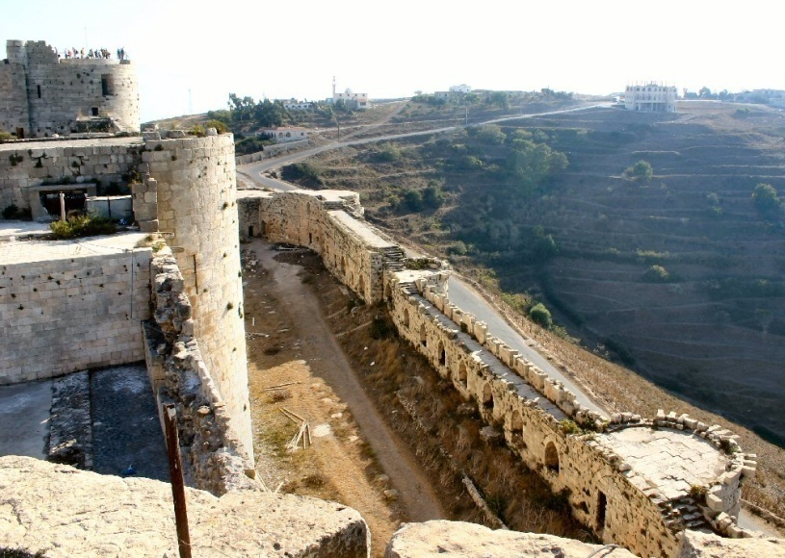  Outer (lower) bailey of Krak des Chevaliers as seen from the inner (upper) bailey

Horyu-ji Pagoda
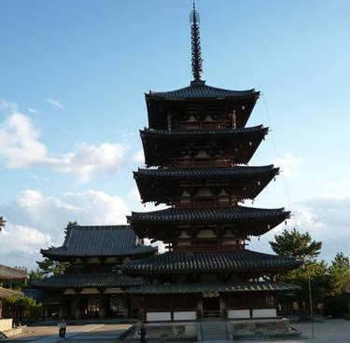
Horyu-ji pagoda (credit: UNESCO)

Location: | Sai-in area, Ikaruga, Nara Prefecture, Japan
Founder: | Empress Suiko, Prince Shotoku
Completed: | 607 CE
Height: | five-story 32.45 meters (122 feet)

Horyu-ji (lit. Temple of the Flourishing Law) is a pagoda or Buddhist temple. The Horyu-ji temple covers an area of 14.6 hectares. The Buddhist monuments in the Horyu-ji Area are the earliest Buddhist monuments in Japan, and had a profound influence on subsequent religious architecture.

The pagoda is one of the oldest extant wooden buildings in the world. According to dendrochronological analysis the wood used in the axis mundi of the pagoda had been felled in 594CE. The axis mundi rests three meters below the surface of the massive foundation stone, stretching into the ground.

The kondo or the Golden Hall, located side-by-side to the Pagoda in Sai-in, is another one of the oldest wood buildings extant in the world. The hall measures 18.5 meters by 15.2 meters. The hall has two stories, with roofs curved in the corners. Only the first story has a double roof. This was added later in the Nara period with extra posts to hold up the original first roof because it extended more than four meters past the building.

According to dendrochronological analysis, some of them were felled prior to 670 CE. The hall holds Shaka Triad, together with a bronze Yakushi and Amida Nyorai statues.

The structures are based on a modified version of post-and-lintel construction with cloud-shaped bracketing designed to transfer the weight of the heavy tiled roof down to the wooden columns.

Himeji Castle
Location: | Himeji, Japan
Creator: | Samurai people
Date established: | erected in 1333, expanded 1614 CE
Height: | 47 m (7-storey)

Himeji Castle, also known as Hakuro-jo (white egret castle) and Shirasagi-jo (white heron castle) for its gleaming white surface, is a national treasure of Japan. It is considered the archetype of Japanese castle architecture.
It is a hill castle designed to a complex plan, with many secret passages running between the main tower and three subsidiary towers, to ensure that even security was breached, the castle can be defended internally. It’s security system was highly advanced for its time, with 84 gates and three moats (though only 21 gates and the inner moat exist now), looming towers, impossible-to-climb slanted walls, and more. However it was never besieged.

Himeji Castle (credit: Bernard Gagnon)
Himeji Castle (credit: Bernard Gagnon)
The shiny gem of this priceless cultural asset is the recently-restored main keep (daitenshu), a hall with great, wooden doors. It has six floors and a 385 square meter basement containing special facilities not seen in other castles, including lavatories, a drain board, and a kitchen.
The 554 square meter first floor of the keep is lined with more than 330 straw mats, and is often called the “thousand-mat room.” The walls of the first floor are clad with weapon racks for matchlocks and spears. At one point, the castle contained as many as 280 guns and 90 spears.

Stone--throwing windows of Himeji Castle (Credit: Jason Haidar) | The fortress has approximately 1,000 loop-holes (in the shapes of circles, triangles, squares, and rectangles) strategically placed for archers and armed guards to pick off any potential intruders. There are also a variety of “stone-drop windows”.  It also have small enclosed rooms called “warrior hiding places”, from which defenders could surprise attackers who entered the keep.

During World War II, a firebomb was dropped directly on the fortress but did not go off, leaving Himeji Castle still standing. Its most recent feat was remaining unscathed by the 1995 Great Hanshin earthquake. In 2010 an extensive five-year, 2.3 billion yen restoration, was done focusing on anti-seismic reinforcement, roof replacement, and reapplying the castle’s signature white plaster.

The Forbidden City in Beijing

Location | Beijing, China
Area | 72 hectares
Built | 1406–1420 CE
Builder | Kuai Xiang (Architect engineer)

The Forbidden City was the Chinese imperial palace between 1420 and 1912. It served as the home of 24 emperors as the ceremonial and political centre of Chinese government.
Construction began in 1406, when Emperor Zhu moved the capital from Nanjing to Beijing. By the time it was completed, the complex covered more than 180 acres and included 980 buildings.
The Forbidden City, as its name suggests, was not generally open to the masses. The Outer Court (the southern part of the complex), with its courtyards and pavilions, was used for public audiences and ceremonies; while the Inner Court (northern part) contained residences for the royal family, servants and so on.The Forbidden City was built in a way that typifies traditional palatial architecture, with the emphasis on articulation and bilateral symmetry to signify balance.
Classical Chinese buildings emphasise breadth rather than height, particularly those of the wealthy. They often feature an enclosed, heavy platform, covered with a large roof that appears to 'float' because of the lack of emphasis on the supporting vertical walls.
The halls and palaces have relatively low ceilings compared with similar western architecture.
The Forbidden City is laid out in a rectangle, measuring 961 m from north to south, and 753 m from east to west. It is surrounded by a wall measuring 7.9 m high, and a moat measuring 6 m deep by 52 m wide. The corners of the walls are expressed by four towers with roofs formed by 72 ridges.
The structures are largely made from timber logs, and large blocks of marble. Baked ‘golden’ bricks were used to pave the floors of several of the more important halls. The roofs include yellow glazed tiles. One of the most famous features is the Wu (Meridian Gate), the imposing 38 m high southern entrance. This opens onto a large courtyard through which the Golden River runs, crossed by five white marble bridges.
Towering above the Outer Court is the most iconic structure of the complex, the Hall of Supreme Harmony, which contains the throne of the emperor. This is the largest building of the complex, and is the largest surviving wooden structure in China.
Adjacent to the three halls of the Inner Court, the 3 acre Imperial Garden offers a place of relaxation.

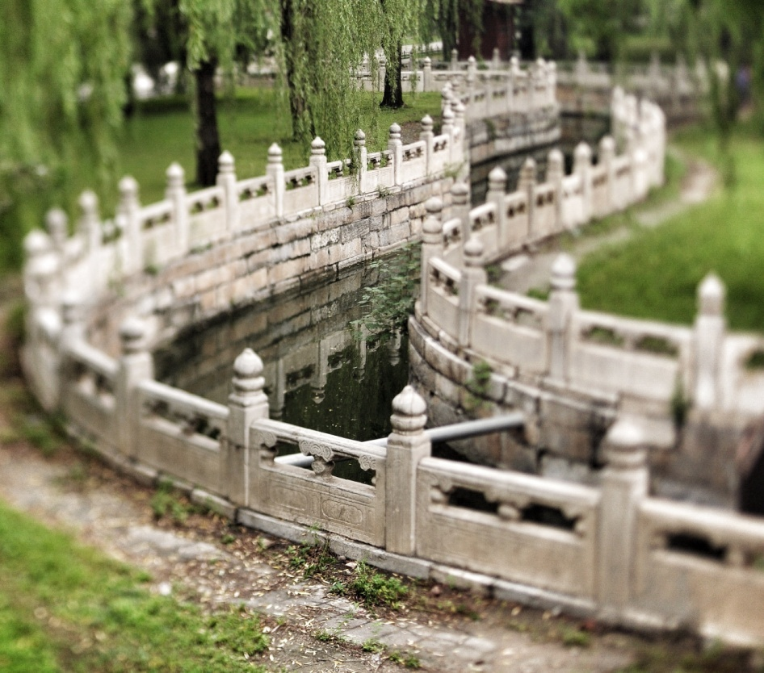  The Golden Water River (Credit (蒋亦炯)) | Behind the Meridian Gate, one can see five bridges with a courtyard named the Inner Golden Water River Bridges.  An artificial stream named the Golden River flows beneath the Bridges. The river served as a water reservoir as well as being a decorative feature.  The bridges have marble balustrades richly carved with dragon and phoenix motifs.

Xian Mosque
https://archnet.org/sites/3973
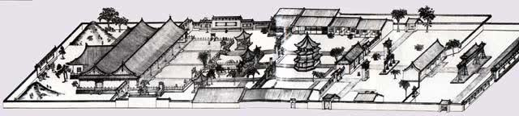

Citadel of Thang Long
Location | Hanoi, Vietnam
Builder
Date established

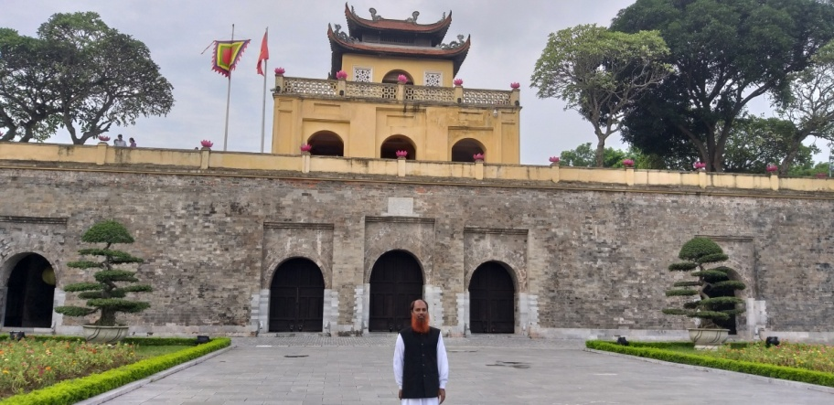
Curved roof of Citadel of Thang Long (credit: Refat Jamil)

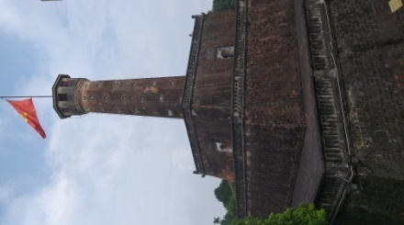  Thang Long Flag Tower (credit: Abu Kab) | The Thang Long Flag tower was built in 1812 during the Nguyen dynasty as an observation post to the Hanoi Citadel.

Sawduro Bor Mosque
owned by Rohingyas Muslims.

The 800-year-old ancient mosque called “Sawduro Bor Masjid” in the western town was burnt down by extrimist Buddhist monks, with the help of military personnel on Sunday.
The fire, which continued for two hours, also damaged several houses around the Mosque,
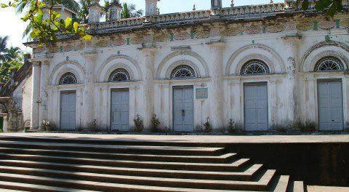
Sawduro Bor Mosque (credit: www.thestateless.com)
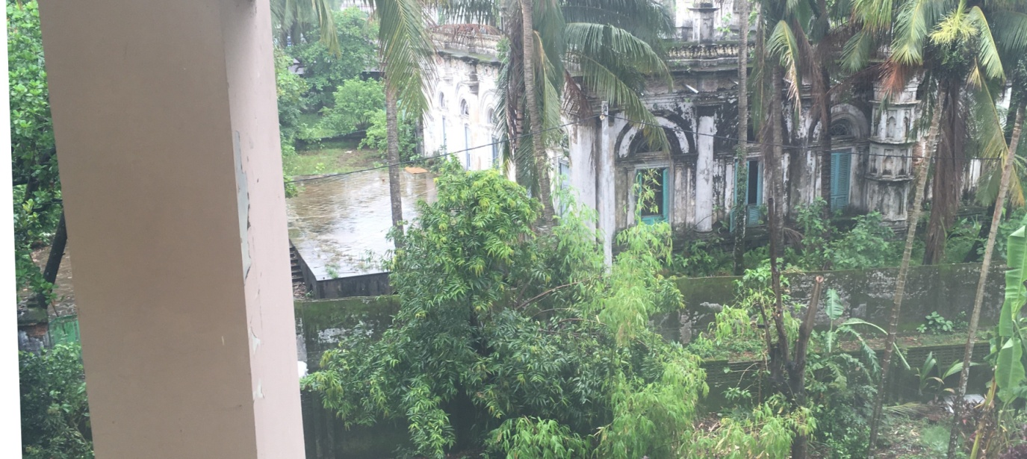
Sawduro Bor Mosque (credit: Cresa Pugh)

Darasbari Mosque

Location | Chapai Nawabganj District, Bangladesh
Builder | Shamsuddin Yusuf Shah (King)
Date established | 1479 CE

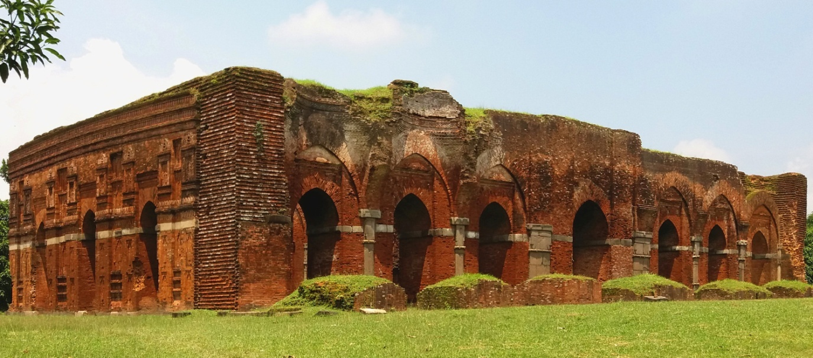
Darasbari Mosque (credit: Ashiqur Rahman)

According to an inscription, Darasbari Mosque was constructed by sultan Shamsuddin Yusuf Shah, son of Barbak Shah. In size, it is the third largest mosque in the city of Gaur-Lakhnauti after Bara Sona and Guntanta mosque. Externally it measures 34m by 20.6m and internally 30.3m by 11.7m. It is built of brick but the pillars are stone. ^{[2]}
The roof of the mosque with verandah was covered with 24 domes and 4 chauchala vaults. Presently, the mosque has no roof and has a fallen verandah. The prayer room is accessed from the east by seven pointed-arch openings from the verandah. On the other hand, there are three pointed archways in the southern wall and two in the northern wall.
Inside the prayer chamber, there are the remains of a royal gallery to its north-west corner. The qiblah wall contains eleven mihrabs (two of these belong to the royal gallery at the upper level). It was ornamented by terracotta plaques. Some terracotta plaques are still visible on the western and southern outer wall surface under the cornice.

Sixty-Gumbad Mosque
Location | Bagerhat, Khulna Division, Bangladesh
Builder | Khan Jahan Ali (architect and king)
Date established | 1459??
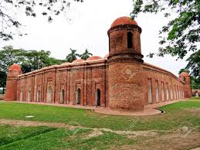
Sixty-Gumbad Mosque (credit: Jason Billam)
The lack of fortifications is attributable to the possibilities of retreat into the impenetrable mangrove swamps of the Sunderbans. The quality of the infrastructures - the supply and evacuation of water, the cisterns and reservoirs, the roads and bridges - all reveal a perfect mastery of the techniques of planning and a will towards spatial organization.
Criterion (iv): Shait-Gumbad is one of the largest mosques and represents the flavour of the traditional orthodox mosque plan and it is the only example of its kind in the whole of Bengal. The site exhibits a unique architectural style, known as Khan-e-Jahan (15th Century), which is the only known example in the history of architecture.
Integrity: The original picturesque location and the natural setting of these densely located religious and secular monuments along with the medieval form and design are intact.
Authenticity: In order to preserve the authenticity of the monuments, conservation and restoration actions have respected the use of original materials (lime and mortar). Notwithstanding, some of the original features, such as stone pillars inside the mosques, reticulated windows, pediment, upper band of cornice, were lost in earlier interventions.

The Kailasha Temple
Location | Ellora Caves, Maharashtra, India.
Builder
Date established

The Kailasha temple is the largest of the rock-cut Hindu temples at the Ellora Caves, Maharashtra, India. A megalith carved from a rock cliff face, it is considered one of the most remarkable cave temples in the world because of its size, architecture and sculptural treatment,^{[1]} and "the climax of the rock-cut phase of Indian architecture".^{[2]}

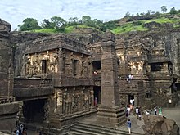
One side of the courtyard, from the top of the gopuram

The top of the superstructure over the sanctuary is 32.6 metres (107 feet) above the level of the court below,^{[3]} although the rock face slopes downwards from the rear of the temple to the front.
The Kailasa temple (Cave 16) is the largest of the 34 Buddhist, Jain and Hindu cave temples and monasteries known collectively as the Ellora Caves, ranging for over 2 kilometres along the sloping basalt cliff at the site.^{[4]} Most of the excavation of the temple is generally attributed to the eighth century Rashtrakuta king Krishna I (r. c. 756 – 773), with some elements completed later. The temple architecture shows traces of Pallava and Chalukya styles. The temple contains a number of relief and free-standing sculptures on a grand scale equal to the architecture, though only traces remain of the paintings which originally decorated it.^{[5]}

History: Kailasa temple lacks a dedicatory inscription, but there is no doubt that it was commissioned by a Rashtrakuta ruler.^{[6]} Its construction is generally attributed to the Rashtrakuta king Krishna I (r. 756-773 CE), based on two epigraphs that link the temple to "Krishnaraja":^{[6][7]}
- The Vadodara copper-plate inscription (c. 812-813 CE) of Karkaraja II (a ruler of a Rashtrakuta branch of Gujarat) records the grant of a village in present-day Gujarat. It mentions Krishnaraja as the patron of Kailasanatha, and also mentions a Shiva temple at Elapura (Ellora). It states that the king constructed a temple so wondrous that even the gods and the architect were astonished.^{[7]} Most scholars believe that this is a reference to the Kailasa Shiva temple at Elora.^{[8]}
- The Kadaba grant of Govinda Prabhutavarsha similarly appears to credit Krishnaraja with the construction of the temple.^{[6]}

http://earthbeforeflood.com/c_pilz_kailash_temple_at_ellora_%20preserving_ancient_wisdom_for_mankind.html

Ranakpur Jain temple
Creator | Darna Shah
Date established | 1437 CE

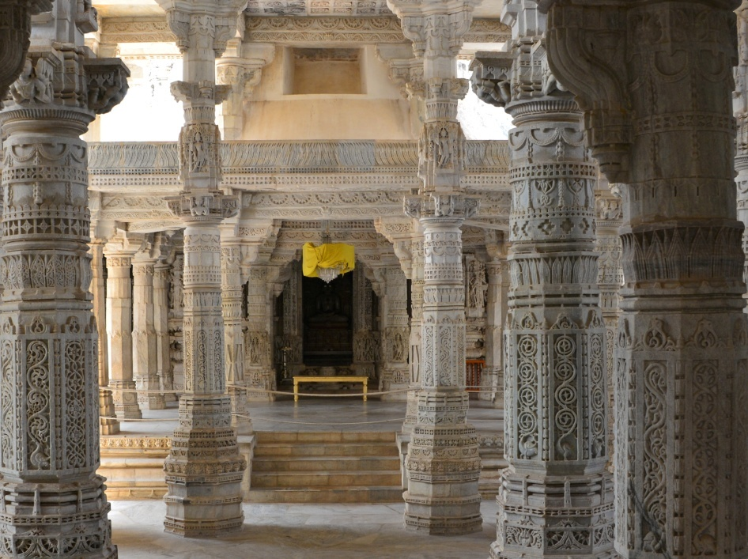
Ranakpur Jain temple (credit: Clément Bardot)
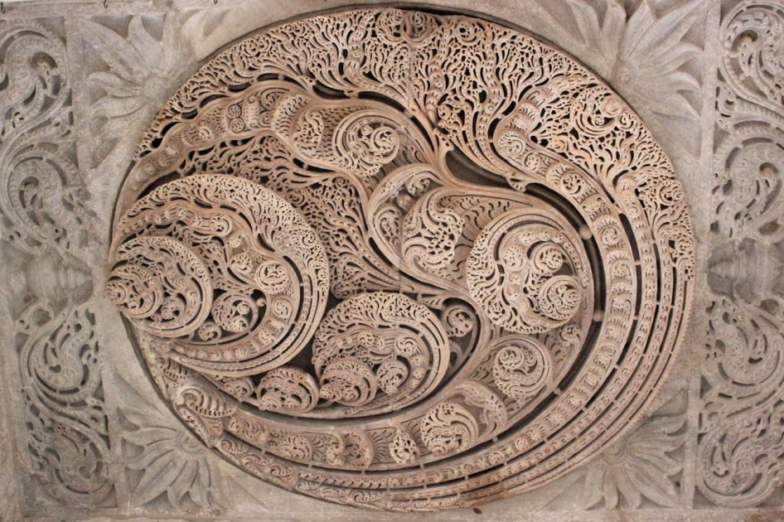
Depiction of Kalpavriksha in roof (credit: Nagarjun Kandukuru)
If you can believe it, this spectacular roof was hand-crafted from marble.

Dakhil Darwaza
Location | Gaur, Malda, West Bengal
Creator | Barbak Shah, Sultan of Bengal
Date established | 1465 CE

Dakhil Darwaza is a surviving gate of an old castle from the 15th century. The gate itself is a gateway to a fort. In the south-east corner of the fort, high wall encloses the ruins of an old palace. The gate is also known as Salami Darwaza as cannons used to be fired from it.
photo

Dakhil Darwaza (credit: Abu Kab)
The gateway is 75’ wide and 60’ high structure, comprising of central domed passage. The structure was built in brick. There are towers at the entrance of the wall. It has security rooms on either side of the entrance.

Baroduari Mosque

Location | Gaur, Malda, West Bengal
Builder | Alauddin Husain Shah, Sultan of Bengal and his son Nasiruddin Nasrat Shah
Date established | 1526 CE

The Mosque's name, literally means twelve gates, though it has only eleven. The mosque is also known as Baro Shona Masjid (Great golden mosque) due to its earlier gilded wall surface and crowns of the turrets.

photo
Baroduari Mosque (credit: Abu Kab)
The mosque is composed of eleven entrances, two buttresses, four corner towers and a spacious courtyard which is almost seventy meters in diameter. The building is faced in plain stone and the doors would originally have been framed by mosaics of glazed colored tiles in floral patterns. The roof was strewn with 44 hemispherical domes, of which 11 on the corridor still remain. These domes were originally gilded, and, hence, gave the mosque its name. From the interior, these domes are arcaded, half in brick and half in stone.

It is the largest building still standing in Gaur.

The eleven arched entrances of the east façade open into a long domed verandah formed by wide piers on the east and west sides. The verandah in turn, opens onto a prayer chamber composed of three aisles with eleven bays each.
an open square in front of 200 feet diameter, with handsome arched gateways in the middle of three of its sides the sanctuary, a rectangular structure of brick faced with stone is 168 feet long by 76 feet wide, its parapet 20 feet high forming a long shallow curve below which is spaced a series of eleven pointed arches between the octagonal turrets at the angles, its interior contains impressive aisles of arches carried in front of the western wall within which is a mihrab opposite each bay.

Like the verandah, the prayer chambers, now in ruins was entirely covered with pendentives. In the northwestern corner of the mosque. Traces remain on a large Takht, the mosque is stoned faced, but the surface is not carved to imitate brickwork, the only ornamentation is a string coursing running across the structure at half its height, majestic and somber, the ornamentation on the aro Shona Masjid stands in contrast to the ornamentally carved brick Jami mosque at Begha, built only three years earlier by the same Sultan. This difference in styles raises interesting questions regarding the sultan's role in the appearance of the architecture he commissioned.

Qadam Rasul Mosque  (credit: Abu Kab) | Sultan Nasiruddin Nusrat Shah also built the mosque called Nusrat Shah Mosque (or Kadam Rasool mosque) in 1530 CE.  Plan of the mosque is 63’x50’. Walls are built in brick while colums are of basalt. The roof pattern has been copied from traditional Bengali style roof, made of bamboo and thatch.  It has a verandah forming a barrel-vaulted corridor on three sides which is elaborately decorated on the eastern side. Arched entrances pierce the north, south and east sides.

Adina Mosque of Pandua

Location | Pandua, Malda, West Bengal
Creator | Sikandar Shah
Date established | 1526 CE
The Adina Mosque was the largest mosque in India subcontinent at the time.
The Mosque complex is a rectangle of 507’x 285’ and has a courtyard of 400x154’ surrounded by 260 pillars of basalt and 88 archways.
The prayer hall is five aisles deep, while the north, south and east cloisters around the courtyard consist of triple aisles. In total, these aisles have 370 domed bays.
The interior of the courtyard is a continuous façade of 92 arches surmounted by a parapet, beyond which the domes of the bays can be seen. Each bay is covered by a dome.
If one looks closer one can see the intensity and disciple in the engravings that have been created on the walls and arches. Stone flowers were integrated into the arches of the interior and exterior all around the building.
There is an upper storey, the gallery of the Sultan and his officials, on the northern side. This storey rests over fluted columns, having brackets. The lower storey was constructed in basalt masonry.
The center of the Iwan had a pointed arch over 70’ and was spanned over 34’ (now ruined).
The nave of the complex is roofless.
The arches were built in brickwork and were domed. The domes were built in stone.
Adina mosque (credit: Abu Kab)
Adina Mosque bears a strong resemblance to the Great Mosque of Damascus as it consists of bricks designed with stones.
The Sultan's tomb chamber is attached with the western wall.

Babri Masjid

Location: | Oudhe
Builder: | Mir Baqi
Date established: | 1528 CE

The mosque was built in 1528 by general Mir Baqi on orders of the Mughal emperor Babur. It was constructed in a style small with a single aisle arrangement of three domed bays along the western wall. The gateway of the middle bay was considerably higher than those of the side bays. Stones were utilized in its construction. A traditional style of 'hypostyle' plan had been introduced, but indigenous architectural elements had been employed to align it with the regional needs and climate. Thus Babri Mosque was a blend of the Western Asian style of architecture and the local style.
It has a central dome and two secondary domes. Two parallel walls surround the mosque and also the huge central courtyard which possesses a deep well. Rectangular coarse-grained sandstone blocks have been employed to create the walls of Babri Mosque whose domes are thin, being composed of burnt bricks. Coarse grains of sand combined with 'chunam' paste are the basic ingredients of the material used for constructing the walls.
Babri Mosque's Central Courtyard has been surrounded by beautifully curved columns which have been built with an aim to improve the height of the ceilings. The architecture of this mosque has been influenced by that of the Begumpur Friday Mosque of Jahanpanah instead of the exclusive Mughal style of architecture. It has been observed that the Hindu masons who erected the mosque had utilized typical Hindu motifs and decorative traditions while creating the religious structure. Their architectural expertise has been manifested through the intricate lotus designs and vegetal scrolls.

Acoustics: Graham Pickford, architect to William Bentinck (1828–33), said: "A whisper from the Babri Masjid Mihrab could be heard clearly at the other end, 200 feet [60 m] away and through the length and breadth of the central court" The mosque's acoustics were mentioned by him in his book Historic Structures of Oudhe where he says "for a 16th-century building the deployment and projection of voice from the pulpit is considerably advanced, the unique deployment of sound in this structure will astonish the visitor".
Modern architects have attributed this intriguing acoustic feature to a large recess in the wall of the Mihrab and several recesses in the surrounding walls which functioned as resonators; this design helped everyone to hear the speaker at the Mihrab. The sandstone used in building the Babri Mosque also had resonant qualities which contributed to the unique acoustics.

Ventilation: The Babri mosque's style integrated other design components and techniques, such as air cooling systems disguised as Islamic architectural elements like arches, vaults and domes. In the Babri Masjid a passive environmental control system comprised the high ceiling, domes, and six large grille windows. The system helped keep the interior cool by allowing natural ventilation as well as daylight.
During the British rule, some British authors started allegation that it had been on site of Hindu Temple. Later this idea became popular through propaganda of RSS and its associates (VHP and others). In 2003, by the order of an Indian court, the Archaeological Survey of India (ASI) was asked to conduct a study and an excavation to ascertain the type of structure that was beneath the rubble.^{[54]} The excavation was conducted from 12 March 2003 to 7 August 2003.
Thre were difference in interim report and final report.. .

Ashish Chadha in a PhD thesis submitted to the Department of Cultural and Social Anthropology at Stanford University in 2007 points out that the ASI project on “the archaeology of the Ramayana sites” was solely responsible for providing an archaeological basis for demolishing the Babri masjid (2007:24).

The report was differed by Supriya Varma, one of the archeologists . . Supriya Varma, one of the archeologists who has challenged the ASI's 2003 findings,
Two archeologists, Supriya Varma and Jaya Menon, accused the ASI of having preconceived notions ahead of the dig, and violating ethical codes and procedures during the excavation. Varma, professor of archeology at JNU and Menon, who heads the history department at Shiv Nadar University, told the court that the excavation did not find anything that supported ASI's conclusion. Supriya Varma said in an interview: “Underneath the Babri Masjid, there are actually older mosques.”
The mosque was attacked and demolished by Vishaw Hindu Parisad activists in 6 December 1992.

Quwat ul Islam Mosque and Qutub Minar
location | Mehrauli area of Delhi
Builder | Qutbuddin Aibak, Sultan of Delhi
Date established | 1193-1198 (mosque), 1199-1225 (minaret)
height | five stories, total 73 m (238 feet)

The Qutb Minar, part of Quwat ul Islam Mosque is more famous than the mosque. Quwat ul Islam mosque measures 214’x149’ externally. The courtyard is paved and surrounded by colonnades on North, East and South. The arches were constructed by the method of corbelling.

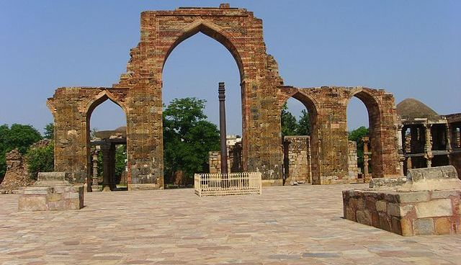
Quwat ul Islam mosque in 2011 (credit: stevekc)

Qutb Minar is a tapering tower minaret that has a 14.3 metres (48 feet) base diameter, reducing to 2.7 metres (9 feet) at the top of the peak.
The tower has five superposed, stories. The lowest three comprise fluted cylindrical shafts or columns of pale red sandstone, separated by flanges and by storeyed balconies, carried on Muqarnas corbels. The fourth column is of marble, and is relatively plain. The fifth is of marble and sandstone. The flanges are darker red sandstone throughout, and are engraved with Quranic texts and decorative elements. The whole tower contains a spiral staircase of 379 steps. At the foot of the tower is the Quwatul Islam Mosque. The minar tilts just over 65 cm from the vertical, which is considered to be within safe limits.
The Iron Pillar of Quwwatul Islam mosque located in Delhi, India, is a 7 m (23 ft) column in the Qutb complex, notable for the rust-resistant composition of the metals used in its construction.
The pillar has attracted the attention of archaeologists and materials scientists and has been called "a testament to the skill of ancient Indian blacksmiths" because of its high resistance to corrosion. The corrosion resistance results from an even layer of crystalline iron hydrogen phosphate forming on the high phosphorus content iron, which serves to protect it from the effects of the local Delhi climate.
Qutb Minar was an inspiration and prototype for many minarets and towers built. During Sultan Feroze Shah's rule, a five-storey tower Feroze Minar was built in Gaur, Malda as replica of Qutb Minar. The Chand Minar and Mini Qutb Minar also bear resemblance to the Qutb Minar and inspired from it.

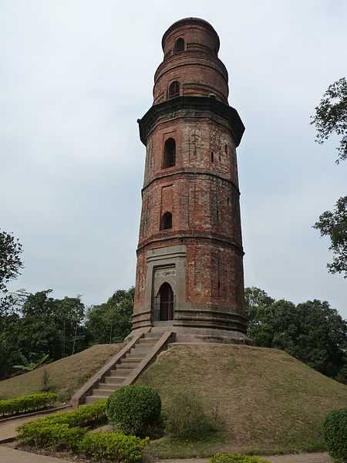  Feroze Minar (credit: Abu Kab) | 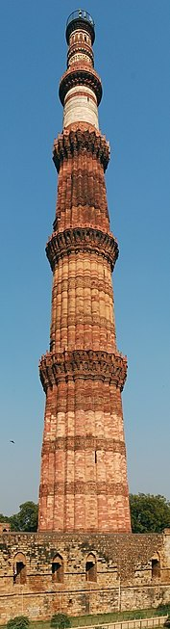  Qutub Minar (credit: Marcin Białek)

Sidi Bashir Mosque
Location | Ahmedabad, Gujarat
Builder | Sidi Bashir
Date established | 1452

The mosque was constructed by Sidi Bashir, a slave of Sultan Ahmed Shah. It has been dated to 1452. The body of the building was destroyed in 1753 during the war between the Marathas and the Khan of Gujarat Sultanate; only two minarets and the arched central gateway connecting them remain.
The mosque is simple but its minerats are wonderful. Monier Williams, the English scholar observed in the 19th century a phenomenon. A gentle shaking of either minaret results in the other minaret vibrating after a few seconds, but the area between the minarets do not exhibit any vibrations at all. The mechanism of this is not known, although the layered construction is thought to be a factor. The minarets are able to withstand fast-moving trains passing close by. The minarets are three stories tall with carved balconies.
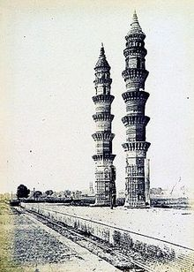
Jhulta Minar in 1866CE
This phenomenon has had many archaeologists and other experts stumped. Till date there is no explanation to this phenomenon. The minarets also exhibit exquisite architectural splendour and reflect Mughal and Rajputana styles of architecture.
Though much damaged, especially near the foot, the stairs inside the minarets may still be used. [3]

Shah Hamadan Mosque
Location | Zaina Kadal, Srinagar, Kashmir
Founder | Sultan Sikandar
Completed | 1395 CE, Rebuilt 1732 CE

Shah-e-Hamadan Masjid, also known as Khanqah-e-Moula is a mosque located in the Old City of Srinagar, Kashmir, India. Situated on the right bank of the river Jhelum between the Fateh Kadal and Zaina Kadal bridges, it was first built in 1395 CE, commissioned by Sultan Sikendar. It is one of the best examples of Kashmiri wooden architecture, and is decorated with papier mache.
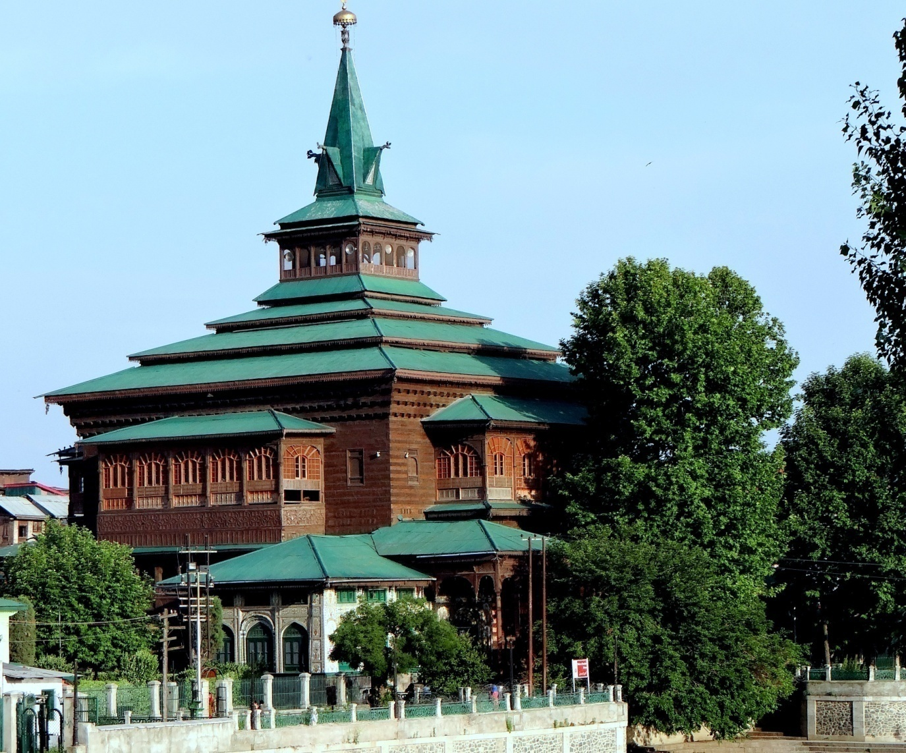

The mosque was commissioned by Sultan Sikandar Butshikan in 1395 CE in memory of the Islamic preacher Mir Sayyid Ali Hamadani, the central figure involved in the widespread conversion to Islam in Kashmir. Also known as Shah-e-Hamadan (the King of Hamadan), the preacher came to Kashmir from the city of Hamadan in Persia in the 14th century. He is credited for the spread of Islam in Kashmir. In 1480 AD, the shrine was destroyed due to fire. The then ruler, Sultan Hassan Shah, expanded its premises and rebuilt it. In 1731 AD, the Khanqah was again destroyed by fire and then rebuilt by Abdul Barkat Khan.

Gor-e-Amīr
Location | Samarkand, Uzbekistan
King | Timur (aka Tamerlane)
Date established | 1403-1404CE

Gor-e-Amir is a mausoleum constructed by Timur after the sudden death of Prince Muhammad Sultan, Tamerlane's beloved grandson. Gor-e-Amir is Persian for "Tomb of the Leader". This architectural complex with its azure dome contains the tombs of Tamerlane, his sons Shah Rukh and Miran Shah and grandsons Ulugh Beg and Muhammad Sultan. Also the tomb ofTimur's teacher Sayyid Baraka. Now only the foundations of the madrasah and khanaka, the entrance portal and a part of one of four minarets remains.
Timur had built himself a smaller tomb in Shahrisabz near his Ak-Saray palace. However, when Timur died in 1405 on campaign on his military expedition to China, the passes to Shahrisabz were snowed in, so he was buried here instead. Ulugh Beg, another grandson of Tamerlane, completed the work. During his reign the mausoleum became the family crypt of the Timurid Dynasty.
Architecture: The entrance portal to the Muhammad Sultan ensemble is richly decorated with carved bricks and various mosaics. Gor-e-Amir Mausoleum is an octahedral building crowned by an azure fluted dome. a one-cupola building. It is famous for its simplicity of construction and for its solemn monumentality of appearance. The exterior decoration of the walls consists of the blue, light-blue and white tiles organized into geometrical and epigraphic ornaments against a background of terracotta bricks. The dome (diameter–15 m (49.21 ft), height – 12.5 m (41.01 ft)) is of a bright blue color with deep rosettes and white spots. Heavy ribbed fluting gives an amazing expressiveness to the cupola.
During the reign of Ulugh Beg a doorway was made to provide an entrance into the mausoleum.
Inwardly the mausoleum appears as a large, high chamber with deep niches at the sides and diverse decoration. The lower part of the walls covered are by onyx slabs composed as one panel. Each of these slabs is decorated with refined paintings. Above the panel there is a marble stalactite cornice. Large expanses of the walls are decorated with painted plaster; the arches and the internal dome are ornamented by high-relief papier-mache cartouches, gilded and painted. The ornate carved headstones in the inner room of the mausoleum merely indicate the location of the actual tombs in a crypt directly underneath the main chamber. Under Ulugh Beg's government a solid block of dark green jade was placed over the grave of Tamerlane. Formerly this stone had been used at a place of worship in the Chinese emperor's palace, then as the throne of Duwa (a descendant of Genghis Khan) in Chagatay Khanate. Next to Tamerlane's grave lie the marble tombstones of his sons Miran Shah and Shah Rukh and also of grandsons – Muhammad Sultan and Ulugh Beg. Tamerlane's spiritual teacher Mir Said Baraka, also rests here.
In the 1950s the dome, main portal and minarets were refurbished. By that time the majolica tiles had mostly fallen away. In the 1970s, the restoration of the interior was undertaken.

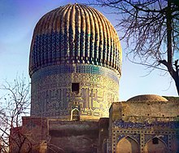

The tomb of Timur, as photographed by Sergey Prokudin-Gorsky c. 1910.

Inside the mausoleum – deep niches and diverse muqarnas decoration.

Ulugh Beg Observatory
The Ulugh Beg Observatory is an observatory in Samarkand, Uzbekistan. Built in the 1420s by the Timurid astronomer Ulugh Beg, it is one of the finest observatories in the Islamic world.^{[1]} Astronomers who worked at the observatory include Al-Kashi, Ali Qushji and Ulugh Beg himself. The observatory was destroyed in 1449 and rediscovered in 1908.
Ulugh Beg's Observatory, also widely known as the Samarquand Observatory, is one of the most important observatories in bringing new discoveries in mathematics and astronomy^{[2]}.
Ulugh Beg, the son of Shāhrukh and grandson of sultan Teymūr, became the ruler of Samarkand in the 9th century. Ulugh Beg was very skilled in mathematics and astronomy. He taught many important astronomers; one example is the famous Ali Qushji.
The Ulugh Beg Observatory was built around 824-1422. Different sources mention different dates; however, many sources mention around 830 to be the date of the observatory’s foundation and 1422-1428 to be the construction competition of the observatory^{[3]}. Many Old Persian texts include the Samarkand Observatory and the great Ulugh Beg.
He invited skillful mathematicians and astronomers to help build this observatory and also a madrassa in Samarkand. Among those he invited were Ghīyāth al-Dīn Jamshid al-Kashi, Mu’in al-Din al-Kashi, Mu’in al-Din al-Kashi, Salah al-Din Qadi Zada Rumi, and Ali Qushiji^{[3]}. Over 60 mathematicians and astronomers were invited to the observatory. Jamshid Al-Kashi was appointed as the first director of the observatory. After al-Kashi’s death Qada Zada became the director of the observatory. After the death of Qadi Zada, Qushji led the observatory as the last and final director.
Ulugh Beg’s observatory was built according to the plans of the Maragha observatory, which was designed by Nasir al-din al-Tusi^{[5]}. Ulugh Beg’s observatory included the largest quadrant principle device. The building was not tall but was allowed a maximal size for the arc of the circle. This device was carefully oriented, and the arc was scaled very accurately. This device was very versatile. It could accurately measure the sun from the horizon, the altitude of a star and other planets. The duration of the year, period of planets, and eclipses were measured by this device. Ulugh Beg’s measurements of planets closely relate to today’s measurement, showing us the phenomenal accuracy of the device^{[5]}.
People visiting Ulugh Beg's observatory today, can only see the foundations and the buried part of the marble quadrant^{[5]}. Those are the only original vestiges from the observatory.
Ulugh Beg's death, In around 1449, caused chaos within the observatory. The observatory was destroyed and dozens of talented astronomers and mathematicians were driven away.^{[6]} In 1908, the Russian archaeologist Vassily Vyatkin uncovered the remains of the observatory.^{[6]}
Ulugh Beg fostered an environment consisting of the some of the best astronomers of the time, and they all observed and calculated the positions of thousands of stars. ^{[13]} Ulugh Beg's main work was the Zij-i Sultani. ^{[14]} Written in 1437, this work was in Persian, and it was also greatly influenced by Nasir al-Din Tusi.^{[1]} Ulugh Beg was surrounded with other astronomers such as Ali Qushji, who is considered today as a great Ottoman mathematician and astronomer.

Ulugh Beg’s observatory was built on a hill 21 meters above the ground. The observatory has a cylindrical shaped building with a diameter of 46 meters and a height of 30 to 33 meters, the sextant was in the middle of this cylinder. The building was made of brick, which was readily available but not particularly stable. According to the radius of the sextant the height would have to be so large that it could cause the building to be too tall and could potentially fall. They were able to solve this problem by building half of the sextant underground. This allowed the size of the sextant to be maintained without the height being dangerously tall.^{[16]}
The observatory was made up of three stories, the first story was for the staff to live in. All observations were made from the second and third stories, which had many arches to look through. The roof of the observatory was flat, allowing instruments to be utilized on top of the building.^{[16]}
The entrance of the observatory has been modified several times in recent years. This is primarily for athestic reasons and is not to improve the observatory's accuracy.

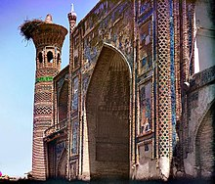
Ulugh Beg Madrasah was an important centre of astronomical study in Central Asia

The Ulugh Beg Madrasa
The Ulugh Beg Madrasa is a religious educational institution in Samarkand, Uzbekistan. It was built by Ulugh Beg during the Timurid dynasty at the Registan in the heart of the ancient city of Samarkand.
Appearance of the madrasa[edit]
Ulugh Beg Madrasa as seen in 1868
The madrasa was built from 1417 to 1420. Some buildings at the Registan are very close to it in the west. This right angular madrasa has two floors of 56x81 meters. The facade is directed towards the main square, and the structure can be widely seen with its height of 16.5 m. Next to it there are gardens with various types of flowers and trees. The arch is 32 meters in height.
The building is crowned by an azure fluted dome. The exterior decoration of the walls consists of blue, light-blue and white tiles organized into geometrical and epigraphic ornaments against a background of terracotta bricks. All the patterns are designed in the Greek style. The dome has a bright blue color with deep rosettes and white spots. With the help of historical stained windows the room is illuminated during daytime.
Design of the madrasa
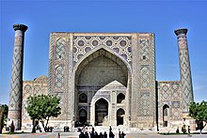
Frontal view of entrance hall

In every section are halls, living-rooms and extra rooms. All four corners of the madrasa are covered with studying and lesson-preparing rooms.
Hidden tombs are located as a large, high cavities with deep places at the sides and unusual decoration. Almost all parts of the walls are covered with many geometric ornaments and done by burnt brick to make the building more attractive. As a result, no one can see the tombs at the first looking. Each of these tombs is decorated with paintings.
Behind the building is the mausoleum “Chorsu Hovli” (30x30 m). Around this are 48 double-store sections. The ornate carved headstones in the inner room of the mausoleum merely indicate the location of the actual tombs in a crypt directly underneath the main chamber.
In the east a big and wide building is placed. It is a mosque constructed for Ulugh Beg. All of its ornaments are special because of their historical handwriting.

Bibi Khanym Mosque

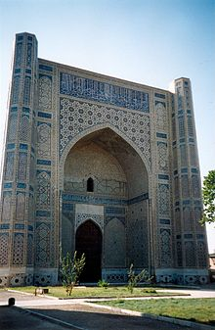 | 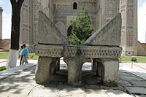  Stone Koran stand  In the middle of the courtyard is located the stone pedestal — the huge Quran stand — crafted from ornate marble blocks. This remarkable sight originates from the time of Timur.

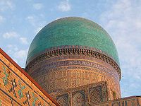
The cupola of the main chamber is 40 m high.

location | Samarkand
Builder | Timur
Completed | 1404
Dome height (outer) | 40 m

The mosque Bibi-Khanym Mosque is one of the most important monuments of Samarkand. By the mid-20th century only a grandiose ruin of it still survived, but major parts of the mosque were restored during the Soviet period.
Timur was not happy with the progress of construction, and immediately had various changes made, especially on the main cupola From the beginning of the construction, problems of structural integrity of the structure revealed themselves. Various reconstructions and reinforcements were undertaken in order to save the mosque. However, after just a few years, the first bricks had begun to fall out of the huge dome over the mihrab.^{[3]} The scale of Timur's plans pushed the building techniques of the time to their limit, and the building's integrity was not helped by the rushed nature of its construction.^{[4][5]}
With no restoration works since 1590, Bibi-Khanym Mosque, the mosque slowly deteriorated and became a ruins gnawed at by the wind, weather, and earthquakes. The inner arch of the portal construction finally collapsed in an earthquake in 1897.
During the centuries the ruins were plundered in search of building material, especially the brick of the masonry galleries along with the marble columns.
A first basic investigation into securing the ruins was made in Soviet times. Late in the 20th century, the Uzbek government began restoration of three dome buildings and the main portal. In 1974 the government of the then-Uzbek SSR began the complex reconstruction of the mosque.^{[9]} The decoration of domes and facades was extensively restored and supplemented. During these restorations, a band of inscriptions revealing Chapter “The Cow” of the Quran was added to the main sanctuary iwan of the mosque.
According to the manuscripts, the mosque was erected by the order of Timur in 1399-1405. It possesses the traits typical for many Muslim medieval constructions, especially aivanyard compositions.^{[12]} The mosque follows the basic plan of the courtyard mosque. Its outer walls enclose a rectangular area which measures 167 metres (182.63 yards) in length and 109 metres (119.20 yards) wide and runs roughly from northeast to southwest — the Qibla accordingly. However the size of the site vacant of covered galleries was only 78 by 64 meters.^{[13]}

Entering the Mosque from the northeast through the vast (35 metres high) parade portal leads to the courtyard. A monumental dome above a square base, around 40 m[15] high, rises on the opposite site of the courtyard. The dome is the largest cupola of the mosque. Nevertheless, the dome cannot be seen from the courtyard, for whole building is covered up from inside by the grandiose pischtak, which framed a monumental, deeply embedded Iwan. The Iwan does not allow getting inside the underlying construction supporting the dome; this can only be done from the sides. Two other domes associated with the Iwans, more modest in size, face the center of the long sides of the courtyard. Thus the Bibi-Khanym Mosque implements the classic architectural type of the "Four-Iwan scheme".
Formerly, there were open galleries measuring 7.2 m high inside the courtyard. Their cover was formed from the juxtaposition of many small, flat brick vaults and domes supported by a forest of more than 400 marble columns and buttresses. Today, only hints of the galleries can be seen.
Four minarets at the outer corners of the site have been restored. Four other, more majestic minarets that flanked the Portal arch of the entrance and the Pischtak of the main domed building are not completed yet.
The huge Bibi-Khanym Mosque with its three domed rooms, the covered galleries and the open courtyard was intended to gather the entire male population of Samarkand city.
In the construction of three domes of Bibi-Khanym mosque, sophisticated in Timur's time, one important innovation was applied: a two-fold construction, where the internal dome hall neither by the form nor by height corresponds to the dome's shape from outside. There is a hollow space between the inner ceiling and the outer cupola. This dome construction allowed the main hall of the mosque to be committed to the proportions and the aesthetics of the 30 m high interior above the mihrab. Meanwhile, the 40 m high outer dome of the main building could be designed for maximal impression and visibility. This scheme was applied also to the lateral dome structures that allowed making modest buildings the figuration tower-like structures with elegant melon-shaped and longitudinally ribbed outer domes.
The interiors of the mosque contain gilding, imitating local brocade embroideries.

Khodaafarin Bridges
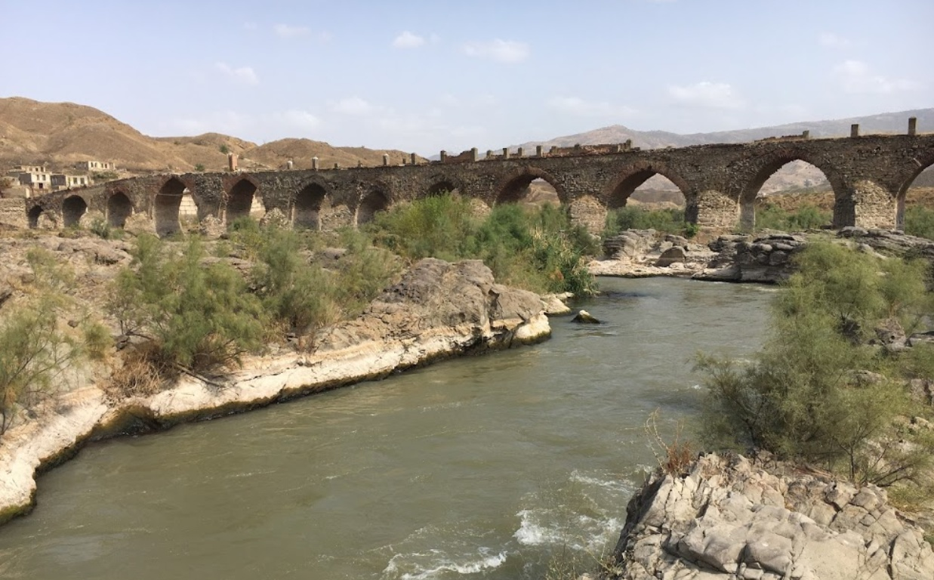
The second bridge in Khodaafarin
The bridges of Khodaafarin (Azerbaijani: Xudaferin korpuleri, Persian Pol-e Khodaaferin) are two bridges over the Aras river, which forms the border between Azerbaijan and Iranian province of east Azerbaijan. The first bridge was built in the 11th century by Shaddadid emir Fadhlun the Kurd and the second bridge in the 13th century by the Seljuks.
The first bridge: The first bridge has eleven arches and is in the vicinity of the Khoda Afarin reservoir in Iran. It uses rocky outcrops as abutments and has different span sizes. In the middle part of the river, the spans are longer and higher. Closer to the banks, the spans are smaller in both width and height. The total length of the bridge is 130 meters, the width is 6 meters and the maximum height is 12 meters above the water. Only three of her arches are completely preserved.
The second bridge: The second bridge is located 800 m downstream of the first. It is larger, about 200 meters, having 15 arches. All 15 arches are still intact. It is narrower than the first bridge, at only 4.5 meters wide and the highest point is ten meters above the WL. The bridge was built with river cobblestones (breakwaters and vaults) and square-fired brick (upper parapet). The breakwaters are used to protect the bridge piers when the WL rises. They are triangular in shape and built with river pavers. On the reverse, the breakwaters are semi-circular in shape. It was built using the stones of the river for arches and breakwaters. The structure of the bridge also rests on the basement of the river, which made it possible not to dig any significant foundations. But this has several consequences: the arches are of different sizes and the bridge, in order to follow the structure of the ground, is not perfectly straight, but rather curved.

Krak des Chevaliers aka Fort of the Kurds
Location: | The castle sits atop a 650-metre-high (2,130 ft) hill east of Tartus, Syria,
Builder: | Shibl al-Dawla Nasr (first castle)  Knights Hospitaller (second castle)
Date established: | 1031 (first castle)  1142–1170 (second castle)
Materials | Limestone

According to the 13th-century Arab historian Ibn Shaddad, in 1031, the Mirdasid emir of Aleppo and Homs, Shibl ad-Dawla Nasr, established a settlement of Kurdish tribesmen at the site of the castle, [Salibi, Kamal S. (February 1973). "The Sayfās and the Eyalet of Tripoli 1579–1640". Arabica. Brill. 20 (1): 27] Nasr restored Hisn al-Safh to help reestablish the Mirdasids' access to the coast of Tripoli after they lost nearby Hisn Ibn Akkar to the Fatimids in 1029. Due to Nasr's garrisoning of Kurdish troops at the site, the castle became known as "Ḥiṣn al-Akrād" (Fortress of the Kurds). The castle was strategically located at the southern edge of the Jibal al-Alawiyin mountain range and dominated the road between Homs and Tripoli. When building castles, engineers often chose elevated sites, such as hills and mountains, that provided natural obstacles.[Kennedy 1994, p. 63Kennedy, Hugh (1994), Crusader Castles, Cambridge: Cambridge University Press, ISBN 0-521-42068-7 ]
In January 1099 on the journey to Jerusalem during the First Crusade, the company of Raymond IV of Toulouse came under attack from the garrison of Hisn al-Akrad, the forerunner of the Krak, who harried Raymond's foragers. The following day Raymond marched on the castle and found it deserted. The crusaders briefly occupied the castle in February of the same year but abandoned it when they continued their march towards Jerusalem. Permanent occupation began in 1110 when Tancred, Prince of Galilee took control of the site. The early castle was substantially different from the extant remains and no trace of this first castle survives at the site.

It was the crusader who carried back this new design to Western Europe, as well as using it to design their own castles, notably Krak des Chevaliers. The concentric design proved very effective, since defenders on the high inner walls could fire over the heads of their fellow defenders on the lower outer walls without, in theory, harming them.
If required, the defenders on the outer walls could also rush out to attack the besieging enemy, confident that the castle remained well-defended from its inner walls. Cylindrical towers stood at each corner of the inner walls, while access to the castle was limited to one or two heavily fortified twin-towered gatehouses. The overall design varied from site to site, but many of these new castles were regular in shape, and some almost perfectly square.
Concentric castles soon sprouted up across Europe. Existing castles were given new outer sets of walls, while ten new castles were built by Edward I in north Wales to subdue the principality after its conquest in 1282. This vast programme of castle building involved 150 masons and 400 carpenters, as well as 1,000 diggers and 8,000 woodcutters to clear the land before construction began.
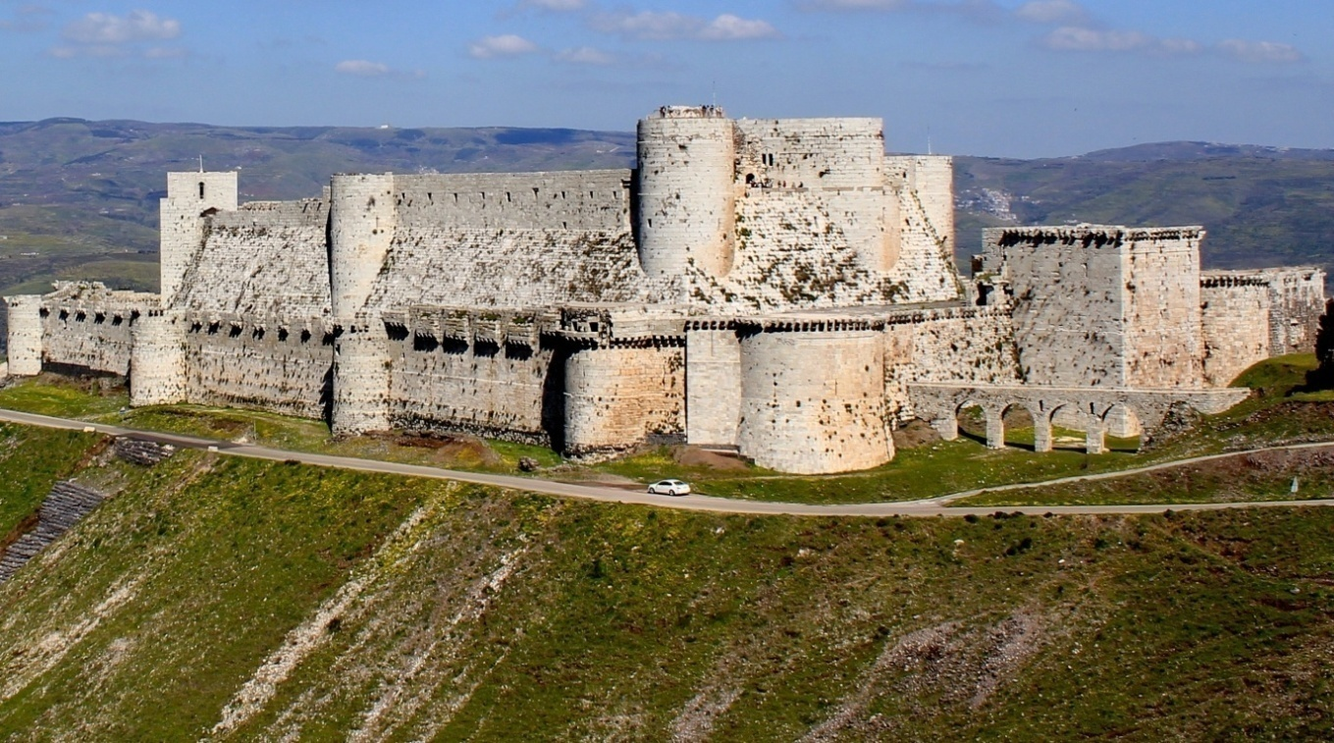
Krak de cheavaliers, in what is now western Syria, was a fortress until captured in 1099 in 1144, the Crusader ruler of the area gave the fortress to the knights hospitallers, a religious order of knights, who turned it into the vast and impressive castle
Krak des Chevaliers -the castle of Knights-stands above the west bank of the river oronets, from where it could command the strategic north to south route from Syria. The castle could only be approached from one direction, making it almost impregnable. But the Knights hospitallers took no chances when rebuilding Krak des Chevaliers. They copied many of the Muslim fortifications they had encountered on crusade.
Siege after siege
Krak des Chevaliers was repeatedly besieged by Kurdish force. Saladin (1138-11930 failed to conquer it in 1188, as did his successors. But in 1270, an Egyptian army, led by sultan Baybars (ruled 1260 to 1277), surrounded the castle and cut off its water supply. The 200 knights inside the castle held out for six weeks, but Baybars siege engines caused serious damage to the outer walls, allowing his forces to enter the castle. The hospitallers surrendered on favourable terms and were allowed to leave the castle alive. Krak des chevaliers was finally captured.

Kubbat sakhra
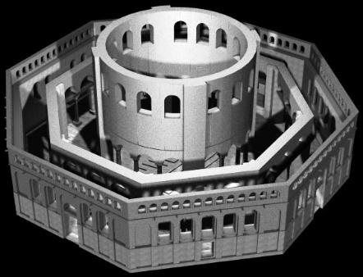
Kubbat sakhra

Mughal emperor Aurangzeb protected Hindu temples more often than he demolished them
These religious institutions were entitled to Mughal state protection, and Aurangzeb generally endeavoured to ensure their well-being. By the same token, from a Mughal perspective, that goodwill could be revoked when specific temples or their associates acted against imperial interests. Accordingly, emperor Aurangzeb authorised targeted temple destructions and desecrations throughout his rule.
Many modern people view Aurangzeb’s orders to harm specific temples as symptomatic of a larger vendetta against Hindus. Such views have roots in colonial-era scholarship, where positing timeless Hindu-Muslim animosity embodied the British strategy of divide and conquer. Today multiple websites claim to list Aurangzeb’s “atrocities” against Hindus (typically playing fast and loose with the facts) and fuel communal fires.
There are, however, numerous gaping holes in the proposition that Aurangzeb razed temples because he hated Hindus.
Most glaringly, Aurangzeb counted thousands of Hindu temples within his domains and yet destroyed, at most, a few dozen. This incongruity makes little sense if we cling to a vision of Aurangzeb as a cartoon bigot driven by a single-minded agenda of ridding India of Hindu places of worship. A historically legitimate view of Aurangzeb must explain why he protected Hindu temples more often than he demolished them.
urangzeb followed Islamic law in granting protection to non-Muslim religious leaders and institutions. Indo-Muslim rulers had counted Hindus as dhimmis, a protected class under Islamic law, since the eighth century, and Hindus were thus entitled to certain rights and state defences. Yet, Aurangzeb went beyond the requirements of Islamic law in his conduct towards Hindu and Jain religious communities. Instead, for Aurangzeb, protecting and, at times, razing temples served the cause of ensuring justice for all throughout the Mughal Empire.
Aurangzeb’s notion of justice included a certain measure of freedom of religion, which led him to protect most places of Hindu worship. Mughal rulers in general allowed their subjects great leeway—shockingly so, compared to the draconian measures instituted by many European sovereigns of the era—to follow their own religious ideas and inclinations.
Nonetheless, state interests constrained religious freedom in Mughal India, and Aurangzeb did not hesitate to strike hard against religious institutions and leaders that he deemed seditious or immoral. But in the absence of such concerns, Aurangzeb’s vision of himself as an even-handed ruler of all Indians prompted him to extend state security to temples.
Aurangzeb laid out his vision of how good kings ought to treat temples and other non-Muslim religious sites in a princely order (nishan in Persian) that he sent to Rana Raj Singh, the Hindu Rajput ruler of Mewar, in 1654: “Because the persons of great kings are shadows of god, the attention of this elevated class, who are the pillars of god’s court, is devoted to this: that men of various dispositions and different religions should live in the vale of peace and pass their days in prosperity, and no one should meddle in the affairs of another.”
When we strip away the flowery style of formal Persian, Aurangzeb’s point is this: kings represent god on earth and are thus obliged to ensure peace among religious communities.
In the same princely order Aurangzeb condemned any king “who resorted to bigotry (taassub)” as guilty of “razing god’s prosperous creations and destroying divine foundations.” Aurangzeb promised to turn his back on such un-Islamic practices once he ascended the throne and instead to “cast lustre on the four-cornered, inhabited world” by following “the revered practices and established regulations” of his “great ancestors.” In Aurangzeb’s eyes Islamic teachings and the Mughal tradition enjoined him to protect Hindu temples, pilgrimage destinations, and holy men.
Aurangzeb had forty-nine years to make good on his princely promise of cultivating religious tolerance in the Mughal Empire, and he got off to a strong start.
In one of his early acts as emperor, Aurangzeb issued an imperial order (farman) to local Mughal officials at Benares that directed them to halt any interference in the affairs of local temples.
Writing in February of 1659 Aurangzeb said he had learned that “several people have, out of spite and rancour, harassed the Hindu residents of Benares and nearby places, including a group of Brahmins who are in charge of ancient temples there.” The king then ordered his officials: “You must see that nobody unlawfully disturbs the Brahmins or other Hindus of that region, so that they might remain in their traditional place and pray for the continuance of the Empire.”
The ending of the 1659 Benares farman became a common refrain in the many imperial commands penned by Aurangzeb that protected temples and their caretakers: they should be left alone so that Brahmins could pray for the longevity of the Mughal state.
Throughout his reign Aurangzeb’s default policy was to ensure the well-being of Hindu religious institutions and their leaders.
He issued dozens of orders that directed officials to shield temples from unwanted interference, granted land to Hindu communities, and provided stipends to Hindu spiritual figures.
For instance, in the ninth year of his reign Aurangzeb dispensed a farman to the Umanand Temple at Guwahati in Assam, confirming an earlier land grant and the associated right to collect revenue. In 1680 he directed that Bhagwant Gosain, a Hindu ascetic who lived on the banks of the Ganges in Benares, should be kept free from harassment.

In 1687, the emperor gave some empty land on a ghat in Benares (which was, incidentally, near a mosque) to Ramjivan Gosain in order to build houses for “pious Brahmins and holy faqirs.” In 1691 Aurangzeb conferred eight villages and a sizable chunk of tax-free land on Mahant Balak Das Nirvani of Chitrakoot to support the Balaji Temple. In 1698 he gifted rent-free land to a Brahmin named Rang Bhatt, son of Nek Bhatt, in eastern Khandesh in central India. The list goes on and includes temples and individuals in Allahabad, Vrindavan, Bihar, and elsewhere.

Aurangzeb carried on the traditions of his forefathers in granting favours to Hindu religious communities, a continuity underscored by his dealings with the Jangam, a Shaivite group. The Jangam benefited from Mughal orders beginning under Akbar, who confirmed their legal rights to land in 1564. The same Jangam received several farmans from Aurangzeb that restored land that had been unfairly confiscated (1667), protected them from a disruptive local Muslim (1672), and returned illegally charged rent (1674). Such measures ensured that pious individuals could continue their religious activities, a component of Aurangzeb’s vision of justice.

Aurangzeb enacted similarly favourable policies towards Jain religious institutions. Again following Akbar’s example, Aurangzeb granted land at Shatrunjaya, Girnar, and Mount Abu—all Jain pilgrimage destinations in Gujarat—to specific Jain communities in the late 1650s. He gave Lal Vijay, a Jain monk, a monastery (poshala), probably sometime before 1681, and granted relief for a resting house (upashraya) in 1679.
As late as 1703, Aurangzeb issued orders prohibiting people from harassing Jina Chandra Suri, a Jain religious leader. Given such actions, it is unsurprising that we find laudatory descriptions of the emperor in vernacular Jain works of this period, such as, “Aurangzeb Shah is a brave and powerful king” (mardano aur mahabali aurangasahi naranda).
Excerpted with permission from Aurangzeb: The Man and the Myth, Audrey Truschke, Viking, Penguin Random House India.
She also gave the reason why some people selectively highlight the Moghal ruler’s acts. She said, “it serves the interest of the present”.

Cyril Manton Harris, Dictionary of Architecture and Construction, McGraw-Hill Education, 2006.
William Shakespeare, Henry IV, Part II, Act I, scene 3, line 41.
Henry Wadsworth Longfellow, Christus, The Golden Legend, Part III. In the Cathedral.
John Prebble, Disaster at Dundee, 1956. p. 16.
John Milton, Paradise Lost, Book I, line 730.
Steven Groak, The Idea of Building, 1992.
Dana Arnold, Reading Architectural History Routledge, London, 2002.
Feng shui (Chinese: 風水), also known as Chinese geomancy, is a pseudoscientific traditional practice originating from ancient China, which claims to use energy forces to harmonize individuals with their surrounding environment. The term feng shui literally translates as "wind-water" in English.
Liang Sicheng, year 12, A pictorial history of Chinese architecture : a study of the development of its structural system and the evolution of its types, ed. by Wilma Fairbank, Cambridge (Mass.): MIT Press. 1984
John Whitney Hall (1988), The Cambridge history of Japan Cambridge University, p.175.
Mason, Penelope (2005), History of Japanese Art (Second ed.). Upper Saddle River, NJ: Pearson. p. 65.
Seiroku Noma (2003), The Arts of Japan, p. 40, John Rosenfeld (Trans.). Kodansha International.
Indian Islamic architecture .. . . ..
Indian Islamic architecture .. . . ..
Brown, Percy; Indian architecture; pp. 40.
Michell, George; The Islamic Heritage Of Bengal; pp. 66.
Pandua is located at a distance of 16kms from the Malda Town. It was the old Capital of Bengal which is in between 14th to 15 century by the Muslim rulers..
Indian Islamic architecture .. . . ..
Indian Islamic architecture .. . . ..
Banerji, Naseem Ahmed (1 January 2002), The Architecture of the Adina Mosque in Pandua, India: Medieval Tradition and Innovation. Edwin Mellen Press.
Two stone tablets are existent near the entrance of the domed structure which are decorated with Persian inscriptions which depict that it had been constructed by a certain man named Mir Baqi, upon the royal orders of Mughal emperor Babur.
In 1838, British surveyor Montgomery Martin wrote that the pillars in the mosque were taken from a Hindu temple. A section of historians, such as R. S. Sharma, deny this, and state that such claims of temple demolition sprang up only after the 18th century( Robert Layton and Julian Thomas, 2003, pp. 2–9)
The summary of the ASI report indicated what appears to be the presence of a 10th-century shrine under the mosque.^{[4][56]} According to the ASI team, the human activity at the site dates back to the 13th century BC. The next few layers date back to the Shunga period (second-first century BC) and the Kushan period. During the early medieval period (11–12th century), a but short-lived huge structure of nearly 50 metres north-south orientation was constructed. On the remains of this structure, another massive structure was constructed: this structure had at least three structural phases and three successive floors attached with it. The report concluded that it was over the top of this construction that the disputed structure was constructed during the early 16th century.^{[57]} The Allahabad High Court, however, upheld the ASI's findings.^{[60]} .
Syed Rabe Hasan Nadvi, chairman of the All India Muslim Personal Law Board alleged that ASI failed to mention any evidence of a temple in its interim reports and only revealed it in the final report which was submitted during a time of national tension, making the report highly suspect.^{[59]} .
Economic and Political Weekly: https://www.epw.in/journal/2010/50/verdict-ayodhya-special-issues/was-there-temple-under-babri-masjid-reading.
https://www.huffingtonpost.in/amp/2018/12/04/there-is-no-evidence-of-a-temple-under-the-babri-masjid-asi-lied-to-the-country-say-archeologists_a_23604990/
Indian Islamic architecture .. . . ..
Mocárabe, is a form of ornamented vaulting in Islamic architecture.
Indian Islamic architecture .. . . ...
Wright, Colin. "Rao Petarah's Temple, Delhi". www.bl.uk. Archived from the original on 8 July 2019. Retrieved 8 July 2019.
Sultanate Architecture". The Ahmedabad Chronicle: Imprints of a millennium. Vastu-Shilpa Foundation for Studies and Research in Environmental Design. 2002. p. 134.

