Eminent Researchers of the Medieval Period

Abu Kab Anisur Rahman

Bangladesh Green Building Academy

Title: Eminent Researchers of the Medieval Period
Written by: Abu Kab Anisur Rahman,
MSc (Civil and Geotechnical Engg.)
Email: abukabanis@gmail.com; website: abukab.weebly.com

Published by: Bangladesh Green Building Academy,
BMWPoint, Sonargaon Janapath Road, Sector 7,
Uttara, Dhaka-1230, Bangladesh.
Phone: +8801977483523.
www.greenbuildingacademy.com.bd

Printing Support: RP TECH BANGLADESH, Mirpur, Dhaka.

First Publication: 05 Dhu al Hijjah, 1440 (2019-08-07)

Cover Design: Muhammad Rashed Miah
Front Cover: Nilometer; Courtesy: Ministry of Tourism, Egypt
Back Cover: Noria at Granada, Spain

Price: 300.00 BDT (3.00 USD)

© All rights reserved by the Author

Content
Foreword ……………………….  Preface …………………………  Introduction ……………………..  Anthemius of Tralles …………..  Paulus Aegineta ………………..  Al-Fazari ………………………..  Geber ………….……………….  Ibn Turk Jili ……………………  Algorithmi …………………….  Sanad bin Ali ………………….  Alfraganus ……………………  Abbas Ibn Firnas …………….  Abu Kamil ………………….  Rhazes ……………………….  Albategnius ………………….  Azophi Arabus ……….……….  Abulcasis …………………….  Ibn Sahl ……………………..  Abul-Wafa Buzhjani …………  Al-Sijzi ……………………….  Methilem of Madrid …………..  Ibn Wahshiyyah the Nabataean ..  Alhazen ……………………..  Ahmad Al-Biruni ……………  Avicenna …………………….  Bi Sheng ……………………..  Su Song ………………………  Arzachel …………………….  Omar Khayyam ……………..  Abu Hamid al-Gazali …………  Buhahylyha Bingezla …………  Baruch ben Malka …………….  Avempace ……………………  Adelard of Bath ……………….  Al-Idrisi ………………………  Abul-Faraj Ibnul-Jawzi …………  Al-Samawal …………………….  Fakhruddin Razi ……………….  Fibonacci ………………………  Ibnul Awwam ……………….  Abul-Izz Al-Jazari ……………  Anselm Turmeda …………….  Ibn Shatir …………………….  Al-Qalasadi ………………….  Orban …………………………  Pietru Caxaro ………………….  Martin Behaim ………………….  Bibliography ……………………. | 5  13  15  34  37  39  40  43  45  49  51  54  55  60  76  78  79  81  84  87  90  91  94  101  107  110  112  114  116  123  127  130  133  138  140  149  151  154  156  163  165  172  182  186  188  189  194  198

Foreword
Italian statesman Leonardo Bruni was the first historian to use tripartite division of historical ages in his ‘History of the Florentine People’ (1442), with a middle period "between the fall of the Roman Empire and the revival of city life sometime in late eleventh and twelfth centuries". However, in later studies, the medieval period is counted from the 5th to the 15th century.
Italian poet Francesco Petrarch (1304-1374 CE) regarded the post-Roman centuries as ‘dark’ compared to the light of classical antiquity. And thus the concept of a ‘Dark Age’ originated. But, was Petrarch right?
Let us consider the knowledge and skills of European people during Petrarch’s lifetime:
a) In 1144, English Arabist Robert of Chester (who studied mathematics in Segovia, Spain) translated Algorithmi’s book into Latin as ‘Liber algebrae et almucabala’. John of Seville produced another Latin version. Thus Algebra had been introduced in Europe.
b) Through the writings of Fibonacci (d. 1245), decimal numeral system or the place value concept arrived in Europe. Fibonacci didn’t invent the system, he just combined ideas from Algorithmi’s book and defined them for a new audience.
c) Europeans were using paper produced in Xativa Paper Mill (founded in 1056), Spain.
d) Magnificent castles had been built across Europe.
e) Kings learnt that they had to serve their people, as well as themselves. They began to establish hospitals and colleges.
f) Universities were founded in European cities as well as African and Asian cities. The University of Bologna was founded in 1088 CE and the University of Oxford in 1096, the University of Salamanca in 1134, the University of Paris in 1150 while the University of Padua in 1222.
There were research institutes in Baghdad, Cairo and Damascus. According to the account of Mustawfi (d. 1349), there were "359 colleges in Herat, 12,000 shops all fully occupied, 6,000 bath-houses; besides caravanserais and mills, also a darwish convent and a fire temple". In the medieval period, the East was brighter than the West. Paper, printing press and mechanical devices were invented in China.
In later part of the period, invention of mechanical clocks, heavy plough, blast furnaces, wheelbarrow, noria, crankshaft, spinning wheel, eyeglasses, treadmill crane and improvements of canon and astrolabes advanced the world. Double entry bookkeeping in accounting evolved in this period.
British art critic Waldemar Januszczak shows in his documentary ‘The Dark Ages: An Age of Light’ that the medieval era was an age of light, by looking at the art and architecture. The documentary was broadcast by the British Broadcasting Corporation in November and December 2012.
Anisur Rahman focuses, in his book “Eminent Researchers of the

Medieval Period”, on philosophical and scientific developments in the medieval period and introduces to us prominent agents.
Another important aspect of civilization is morality. This issue has not been discussed in the book. But we might compare morality of people of different ages. For understanding moral issues, we have to recall some real stories. We should admit that hatred and fraudulence are more prevalent in modern times in comparison to the Medieval Period. There were just and generous leaders who tried to win the hearts of people they ruled although they were not elected democratically.
Byzantine emperor Justinian I patronized learning of laws. His Committee of jurists developed Code of Justinian, a collection of laws and legal interpretations, under the sponsorship of Justinian I. Persian emperor Khosro I (r. 531–579) introduced a rational system of taxation based upon a survey of landed possessions and tried to increase the welfare and the revenues of his empire. In Babylonia he built or restored the canals. His army was disciplined. He was called ‘Anushiruwan the Just’. His successors were not competent and they were defeated by Arabs.
In the 7th century Arabia, Prophet Muhammad (peace be upon him), the teacher and ruler, judge and legislator, philanthropist and social reformer became prominent. William Draper said, “Four years after the death of Justinian, A.D. 569, was born in Mecca, in Arabia, the man Muhammad, who of all men, has exercised the greatest influence upon the human race. To be the religious head of many
empires, to guide the daily life of one-third of the human race, may perhaps justify the title of a Messenger of God.” (William Draper, History of Intellectual Development of Europe, 1876)
Chinese emperor Zhu Yuanzhang (r. 1368–1398) said,
The universe began with the heavenly tablet recording his name.
The religion-delivering great sage, born in the western realm.
Conferring and receiving heavenly scripture in thirty parts, universally transforming all created beings.
Master of the trillion rulers, leader of the ten thousand sages.
Assisted by destiny, protector of the community.
In each of the five prayers, he silently supplicates
for their total well-being.
His intention is that Allah should remember the needy.
Deliver them from tribulations to safety, Knower of the unseen.
Exalted above every soul and spirit,
free from any blameworthy deeds.
A mercy to all of the worlds, whose path is preeminent for all time.
Renounce spiritual ignorance; return to The One – that is the religion called Islam.
Muhammad is the most noble sage.
(Praising the Prophet Muhammad in Chinese: A new translation and analysis of Emperor Zhu Yuanzhang’s Ode to the Prophet Muhammad, translated by Brendan Newlon, The Matheson Trust, page 3.)
Robert Briffault stated in The Making of Humanity: “The ideas of freedom for all human beings, of human brotherhood, of the equality

of all men before the law of democratic government, by consultation and universal suffrage, the ideas that inspired the French Revolution and the Declaration of Rights, that guided the framing of the American Constitution and inflamed the struggle for independence in the Latin-American countries were not inventions of the West. They find their ultimate inspiration and source in the Holy Quran, They are the quintessence of what the intelligentsia of medieval Europe acquired from Islam over a period of centuries through the various societies that developed in Europe in the wake of the Crusades in imitation of the brotherhood associations of Islam. It is highly probable that but for the Arabs modern European civilization would never have arisen at an, it is absolutely certain that but for them it would never have assumed that character which has enabled it to transcend all previous phases of evolution.” (KJ Ahmad, Hundred Great Muslims p. 9)
Ramakrishna Rao said: “The personality of Muhammad, it is most difficult to get into the whole truth of it. Only a glimpse of it I can catch. What a dramatic succession of picturesque scenes. There is Muhammad the Prophet. There is Muhammad the Warrior; Muhammad the Businessman; Muhammad the Statesman; Muhammad the Orator; Muhammad the Reformer; Muhammad the Refuge of Orphans; Muhammad the Protector of Slaves; Muhammad the Emancipator of Women; Muhammad the Judge; Muhammad the Saint. All in all these magnificent roles, in all these departments of human activities, he is alike a hero.” (K. S. Ramakrishna Rao, Muhammad the Prophet of Islam, 1979)
Muhammad (pbuh) gave very valuable instructions for mankind. He said, "A strong person is not the person who throws his adversaries to the ground. A strong person is the person who contains himself when he is angry."
He said, “The Almighty God will not be merciful to those who are not merciful to people.”
He said: “Envy consumes good deeds just as fire burns wood. Charity extinguishes sinful deeds just as water extinguishes fire.”
He said: “The Almighty will punish those who punish the people in this world.”
He said: I hope that when I meet Allah, none of you will have any claim on me for an injustice regarding blood or property.
He said: “The best of mankind are those who are most beneficial to mankind.”
He said, "A believing man should not hate a believing woman. If he dislikes something in her character, he should be pleased with some other or another trait of hers."
Caliph Umar (r. 634–644) said, “For those who practice tyranny and deprive others of their rights, I will be harsh and stern, but for those who follow the law, I will be most soft and tender.”
Alfred the Great, king of Wessex from 871 to 899, promoted a
revival of education, scholarship, law and administration. He said, “I desired to live worthily as long as I lived, and to leave after my life, to the men who should come after me, the memory of me in good works.”
He said, “Doom very evenly! Do not doom one doom to the rich; another to the poor! Nor doom one doom to your friend; another to your foe!”
When Saladin (r. 1174–93) reclaimed Jerusalem, he ordered his men not to kill and plunder. When he ruled Cairo, he built hospitals and universities for the city. In his dealings with the Crusaders, Saladin allowed them to ‘save face’ by permitting Christian pilgrimages to Jerusalem, even though he controlled the city. In an era when chivalry was just developing in Europe, Saladin won the reputation of being exceptionally ‘chivalrous.’ He and Richard the First each became the other's ‘favorite’ opponent.
Saladin said, “I warn you against shedding blood, indulging in it or making a habit of it, for blood never sleeps.” He said, “Victory is Changing the Hearts of Your Opponents by Gentleness and Kindness."
Nasiruddin, emperor of India (r. 1246-65) was a man of saintly disposition, who would take almost nothing from the treasury.
We are aware that genocides were committed in Jerusalem (killing of thirty thousand civilian in Siege of Jerusalem in 1099), Greece (killing of two thousand Greek civilian in Sack of Constantinople in 1204), France (killing of two million Cathars in 1229), Spain (killing of one hundred thousand Moors of Granada in 1492) and in many other places. We are also aware that more widespread genocides were committed in modern period, for example: genocide of six million European Jews by Nazi Germany, Bangladesh genocide in 1971, killing of 1.7 million people from 1975 to 1979 in Cambodia, the Srebrenica massacre (killing of eight thousand people in 1995), killing of ten thousand Rohingya and expulsion of eight million Rohingyas during 2016-2017.
In 1944 and 1945, napalm bombs were dropped in Japan and Korea. Atomic bombs ‘Little Boy’ and ‘Fat Man’ were dropped over civilian area in two Japanese cities Hiroshima and Nagasaki in 1945. The American air campaign during the Vietnam War was the largest in military history. Chief of Staff of the US Air Force Curtis LeMay stated that "we're going to bomb them back into the Stone Age". It is evident that modern-day atrocities are crueler.
So we do have justification to differ with Petrarch. And we may wisely conclude that the medieval period is not a dark era but an era of scientific and moral progress.
To present a good book is a painstaking task. “Eminent Researchers of the Medieval Period” is certainly a good composition and it has been done with care. But it might include more personalities. I sincerely wish it a wide circulation.
Muhammad Shoeb Abedin
Rajshahi, Bangladesh

Preface
Praise be to the Almighty God, the Creator and Sustainer. I wished to write a book on talented personalities and I have been able to do so by His grace.
I had a colleague who used to ask so many questions. What is the golden ratio? What is Fibonacci series? What is ephelion? What is perihelion? How was the Roman numeral system replaced by Decimal numeral system? Who constructed the first globe? What is hieroglyphics?
Well, we may find answers to some of these questions in school textbooks. But for some questions, we have to go through encyclopaedias to get answers. However, these questions made me curious. Can a handy book contain all these? This book is result of the study driven by the curiosity.
It goes without saying that much of primary and high school level mathematics and science topics had been discovered or invented in the Medieval Period. Indeed, there are many good books on medieval history; for example, George Sarton’s “Introduction to the History of Science”, Donald Hill’s “Studies in Medieval Islamic Technology”, Al-Nuwayri’s “The Ultimate Ambition in the Arts of Erudition: A Compendium of Knowledge from the Classical Islamic World”, Firas Alkhateeb’s “Lost Islamic History: Reclaiming Muslim Civilisation from the Past”, Maria Rosa Menocal’s “The Ornament of the World”, Jacqueline de Weever’s “Sheba’s Daughters: Whitening and Demonizing the Saracen Woman in Medieval French Epic” and so on.
I intended to write a book that is concise, focusing on achievements by science and philosophy personalities of the Medieval Period. These personalities are from various fields and different corners of the world. Some of them are mathematicians; some are astronomers, some chemist, some botanist, some linguist and some philosophers and historians. They are from China, from Central Asia, from Persia, Arabia, Greece, Spain, Germany, Malta, Italy, Hungary and Britain.
I express my indebtedness to Dr. Prof. Mohammed Kabirul Islam and Dr. Prof. Mohammad Kamaluddin. Mr. Eng. Sayeedur Rahman and Dr. Sultanul Haque Aftabi, MD have given me encouragement. I express my gratitude to Dr. Shoeb Abedin, MD for writing for me foreword for this book.
I thank Eng. Al-Emran Hossain, the Chairman of Bangladesh Green Building Academy for his sponsorship of the publication of this book. My daughter Suwaibah kept on insisting to publish the book without delay. I am also thankful to all who were involved in different sections of this publication.
Any suggestion from valued readers to improve quality of this publication will be highly appreciated.
Abu Kab Anisur Rahman,
Dhaka, Bangladesh

Introduction
You are going to read a printed book. And printing press was invented in China by Bi Sheng in 1050 CE and in Germany by Johannes Gutenberg in 1440. That is in medieval period. In our early school days we learn the numbers 0, 1, 2, 3, 4, 5, 6, 7, 8, 9 (European form) or ०, १, २, ३, ४, ५, ६, ७, ८, ९ (Indian). Then we also learn Roman symbols for 1 to 9 are: I, II, III, IV, V, VI, VII, VIII, IX, X. The decimal numeral system was devised in India by Brahmagupta (d.668) in medieval period. Brahmagupta also defined the properties of the number zero. The word zero comes from Arabic word ‘sifr’ meaning empty. Why? Because, decimal numeral system traveled west from India to Persia, then to Arabia and North Africa, and then to Europe. In higher classes we began to use a,b,c or x,y,z as numbers and memorized the formulas like (a+b)² = a²+2ab+b². This is Algebra, the study of mathematical symbols and the rules for manipulating these symbols. The famous formula E=mc² is an algebraic equation. This branch of mathematics was invented in Persia during medieval period. If studied carefully, achievements of medieval period is found to be fascinating. Because it is the time when dark days of ignorance ended and science and technology flourished.
Medieval period is a term coined in Europe, but now used worldwide. Medieval period began with the founding of the Kingdom of Italy (fall of the Western Roman Empire) and ended with Fall of Granada and subsequent Inquisition. Medieval period lasted from the 5th to the 15th century. In history of Europe, Medieval period is succeeded by European Age of Discovery which lasted from the 15th century until the end of the 18th century. But in Arabia, the medieval period itself was the Age of Discovery. In the Americas, there is nothing such as medieval period. Ages in Americas is divided into two categories: Pre-Columbian and Post-Columbian. And see, Post-Columbian period starts with the end of medieval period.
A number of historians marked the medieval period as Dark Age. But this is must be rejected. In parts of Europe, there was age of darkness but in other parts of Europe and in West Asia and North Africa there was a tremendous amount of activities in fields of mathematics, science, technology, arts and architecture.
Daniel of Morley narrated, “I stopped a while in Paris. There I saw asses rather than men occupying the Chairs and pretending to be very important. They had desks in front of them heaving under the weight of two or three immovable tomes, painting Roman Law in golden letters. With leaden styluses in their hands they inserted asterisks and obelisks here and there with a grave and reverent air. But because they did not know anything they were no better than marble statues: by their silence alone they wished to seem wise, and as soon as they tried to say anything, I found them completely unable to express a word. When I discovered things were like this, I did not want to get infected by a similar petrification, … . …. ..…. [and] when I heard that the doctrine of the Arabs, which is devoted almost entirely to the
quadrivium, was all the fashion in Toledo in those days, I hurried there as quickly as I could, so I could hear the wisest philosophers of the world … Eventually, my friends begged me to come back from Spain; so on their invitation, I arrived in England, bringing a precious multitude of books with me.”
In ancient and medieval times, there were many hurdles for acquisition and dissemination of knowledge.
- Expensive writing material
In ancient and medieval times, writing media were scarce and expensive. Clay tablets, leather, bones, wood and barks were used. The first paper-making process was invented in China during c. 105CE. The paper was transported many kilometers as a Chinese luxury product. After the battle of Talas, knowledgeable Chinese prisoners of war were engaged to produce paper in Samarkand. Thus the first Arab-owned paper mill was founded in Samarkand by 751. Paper mills were founded in Baghdad by 793, in Egypt by 900 and in Fez by 1100. The first paper mill in Europe was in Xativa (Shaitbah), Spain in 1056.
- Unavailability of printing press
Printing press was invented in China by Bi Sheng in 1050. But it was not available outside China. Johannes Gutenberg had to invent it again in 1440CE.
- Low speed of transportation
In 1769 the first steam-powered automobile capable of human transportation was built by Cugnot. Until spread of automobiles people used to ride on horses and camels, and used boats for long distance travel. The gallop averages 40 to 48 kilometres per hour. The speed of camel is 32 to 38 kilometres per hour. So broadcasting news would take days and months and even years.
Since communication was a major problem in those days, dissemination of knowledge was very slow. For example consider the dissemination of numeral system from India to Europe.
From India the new numbers traveled west to Persia, then to Arabia and North Africa, and then to Europe. As the numbers moved westward, their shapes changed somewhat. In Europe, people used to call the new numbers Arabic numbers. Today the system is most often called the Hindu-Arabic number system.
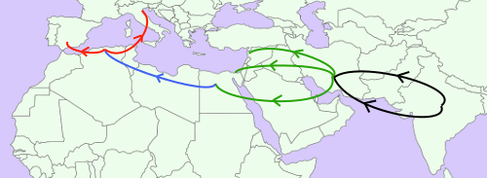
Fig. The new number system spread westward.

Brahmagupta introduced negative numbers into Indian mathematics. And 300 years after him negative numbers were used by Abul Wafa (940-998) for the first time in the Middle East.
The medieval scientists were brilliant as they introduced algebra and trigonometry, invented printing press twice (Bi Sheng in 1050 and Johannes Gutenberg in 1440CE), built huge ocean-going ships (Columbus, Zheng He) and invented robots (with only mechanical techniques without electricity), and they invented astrolabe. An astrolabe is actually a compuer which runs without electricity.

They founded universities (University of Al Quaraouiyine at Fez in 859CE, University of Ez-Zitouna Tunis in 737, Al-Azhar University in 972, House of Wisdom in Baghdad, University of Bologna in 1080 and University of Oxford in 1096).

This book is intended to explore the capacities of the philosophers of medieval period; philosophers here are those having love for knowledge in diverse subjects, it be natural science, history, mathematics, geography or any other branch of studies. But emphasis has been given on science study.
I have used the term ‘researchers’ in the title to denote ‘philosophers’.

Significant events in Middle Age:
A. Shift from Flat Earth model to Globe:
Eratosthenes considered the earth to be spherical. After him, Aryabhata, Alfraganus and other medieval scientists held idea of a spherical Earth. They even calculated its cumference.

 | Circumference in Roman miles
Eratosthenes (d. 194BC) | 24662 miles (252,000 stadia)
Aryabhata (d. 550CE) | 40000 miles (4967 jozans)
Algorithmi (d.850 CE) | 24,000 miles
Alfraganus (d. 870) | 29791 miles
Al Biruni (d. 1048) | 24750 miles
National Geospatial-Intelligence Agency, USA | 24901 miles

David A. King tells us that Muslim scholars held to the spherical Earth theory. Spanish polymath Ibn Hazm stated that there had been consensus among Muslim theologians on the Earth's sphericity.

But it took entire medieval period to spread this idea to change minds of the majority of people. Even the map of Orlando Ferguson preserved in the Library of Congress depicts a ‘square and stationary’ Earth.
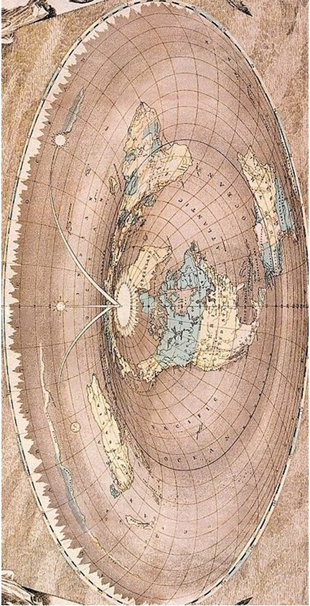
Flat Earth map of Orlando Ferguson (1846-1911)

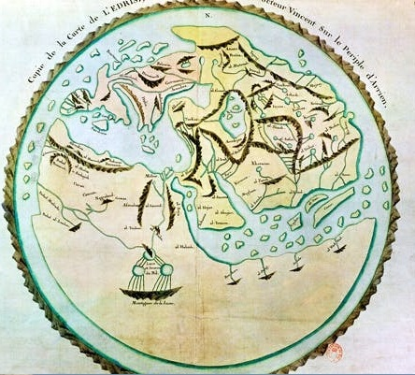
Idrisi’s world map (flat Earth)
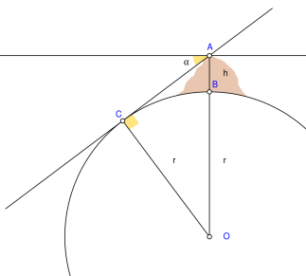
Al Biruni’s diagram for measuring the diameter of the Earth
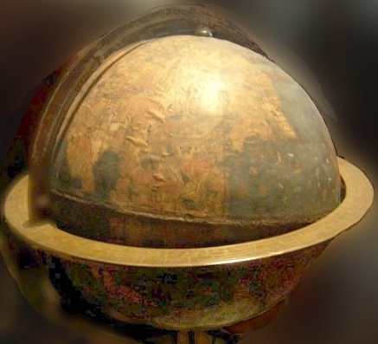
Erdapfel (German: lit. earth apple): The terrestrial globe constructed by Martin Behaim from 1490–1492.

B. Shift of concept of solar system model:
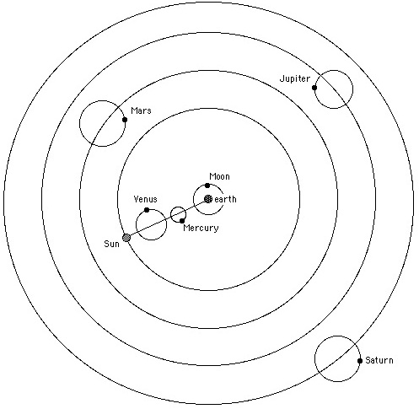
Fig: Ptolemy’s model

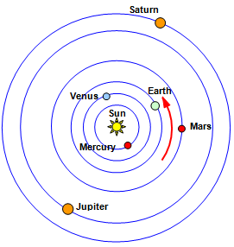
Fig: Copernicus model

C. Establishment of the oldest universities.
University of Al Quaraouiyine was established in at Fez in 859CE, University of Ez-Zitouna-Tunis in 737, House of Wisdom Baghdad in circa 830, Al-Azhar University in 972, University of Bologna in 1088, and University of Oxford in 1096. University of Salamanca was founded in 1134, University of Paris in 1150, University of Padua in 1222. University of Heidelberg was founded in 1386.

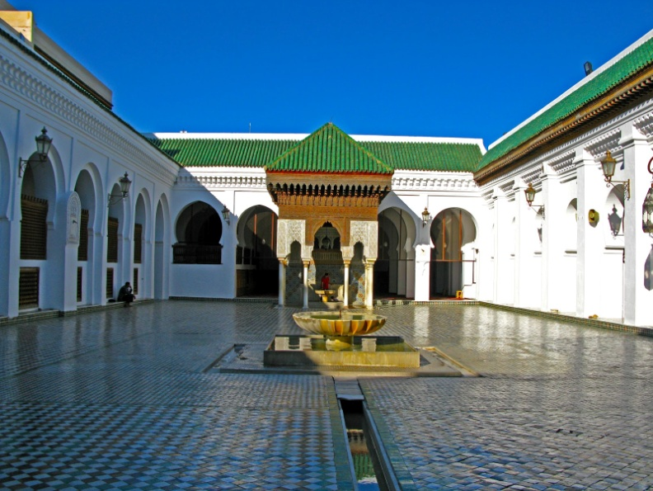
Photo: University of Al Quaraouiyine at Fez, the oldest university in the world, founded by Fatima Fihriya in 859CE.
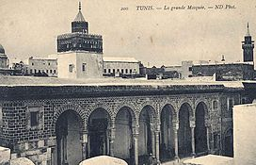
Photo: University of Ez-Zitouna established in 737CE in Tunis.
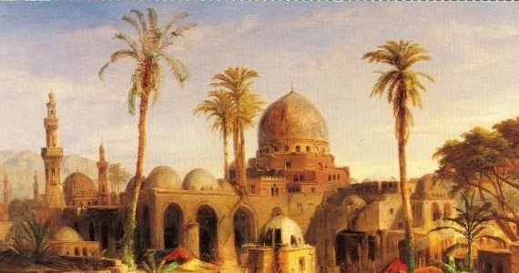
Illustration: House of Wisdom (Baitul Hikmah) in Baghdad (c.830 -destruction 1258CE)

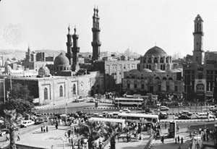
Photo: Al-Azhar University in Cairo founded by Fatimids in 972CE.

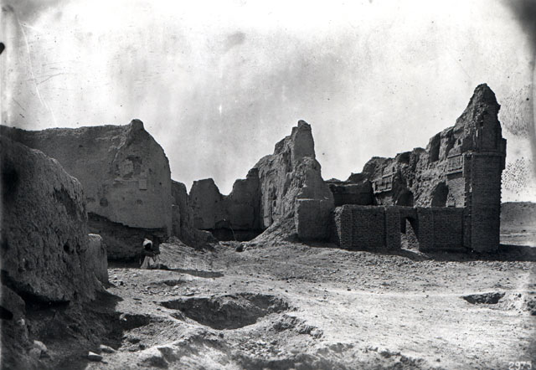
Photo: Al Nizamiyya: Founded in 1065 in Baghdad by Nizamul Mulk (destruction 1258CE)
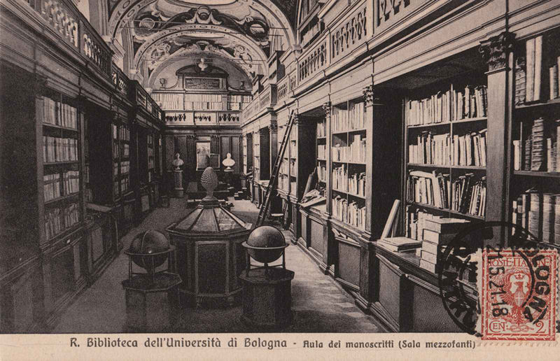
University of Bologna, Italy founded in 1088CE
(Irnerius, Nicolaus Copernicus, Leon Battista Alberti, Paracelsus were students of University of Bologna.)
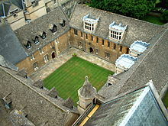
Fig. University of Oxford, founded in 1096.
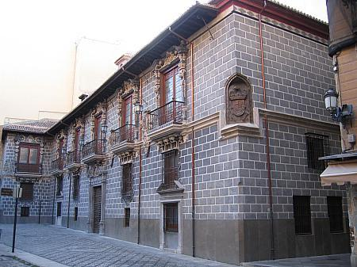
Photo: Madraza de Granada
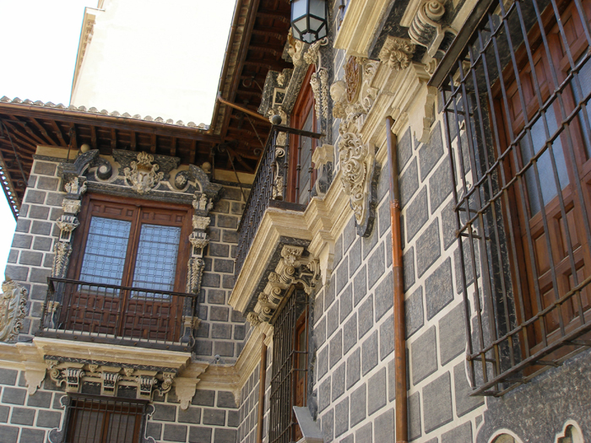
Baroque facade of the Madraza de Granada
Madraza de Granada was founded in 1349 by Sultan of Granada.
The madraza functioned as a university until 1500. In 1976, the madraza building became part of the University of Granada.
Cultural exchange in medieval era:
Ancient Europe’s leadership was not in London or Paris, rather it was in Athens and Rome. Library of Alexandria was established probably during the reign of Ptolemy II (285–246 BC). In 642, Alexandria was captured by the Muslim army. Muslims obtained Greek books of sciences and made translations into Arabic. Several later Arabic sources describe the library's destruction by Muslims. Later scholars, including Eusèbe Renaudot in 1793, are skeptical of this story, given time passed before they were written down and the political motivations of the various writers.
Many scientific words in Arabic have been derived from Greek and Latin words. For example, falasafah form philosophy, al-Asturlab from astrolabos, wajima from oedema, malgam from málagma, mindil from amntle, sabun from sapo.
Let us talk about astrolabe, computer of medieval people. The word astrolabe comes from Greek ἀστρολάβος astrolabes meaning star-taker. An astrolabe is an elaborate inclinometer, historically used by astronomers and navigators to measure the altitude above the horizon of a celestial body, day or night. It can be used to identify stars or planets, to determine local latitude given local time (and vice versa), to survey, or to triangulate. Al-Fazari (d. 806) built the first astrolabe in the Arab world. Astrolabes were upgraded by many scientists namely Albategnius (d.929), Azophi (d. 986), Mariam al-Ijliyyah bint al-Ijliyy (10th century), Pope Sylvester II (d.1003), Al-Sijzi (d.1020), Ibn al-Saffar (d.1035), Ibn Zarqala (d.1087) and Johannes Stöffler (d.1531).
It had been in use even in modern times until 18th century.
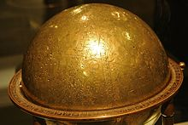
Celestial Globe, Isfahan, Iran 1144 at the Louvre Museum.
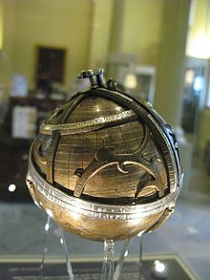
A spherical astrolabe dated c. 1480, in the Museum of the History of Science, Oxford
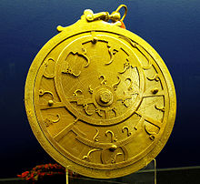
An 18th-century Persian astrolabe

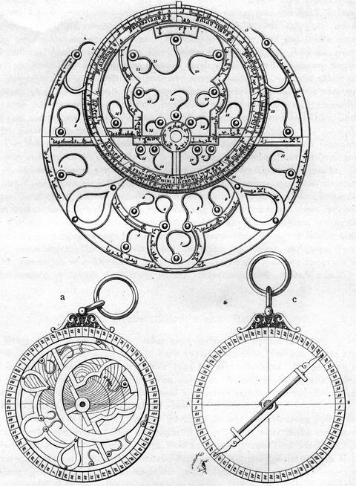
Fig. Different Parts of astrolabe

Coffee is a popular drink today. The word coffee is derived from Arabic word ‘Qahwa’. In 1258, Sheikh Omar, the founder of the city of Mocha (Arabic Mukhah) in Yemen, was driven by his enemies into the desert along with his supporters. Omar found in a bush some strange red berries and figured: “I’m going to die anyway so I may as well take a chance and chew on these.” They were extremely bitter and, seeing as they hadn’t poisoned him, he tried to make them palatable by roasting them. After cooking the beans were less bitter but they were now too hard to be chewed. “Let’s boil them and see what happens”, said one clever chap. The beans remained inedible but in their desperation they drank the resultant brown water. Thus Omar and his men discovered the taste of coffee. They returned to Mocha and shared their discovery. Once ‘Mocha coffee’ was known as the best quality coffee.

And like qahwa, there are other words of Arabic origin in European Languages as well. Alcohol, alkali, attar, alizarin, alcove, alidade, algorithm, almanac, arsenal, candy, jar, jumper, zenith, nadir, noria, tariff, cheque and many other words are of Arabic origin.

European Solfege syllables “do, re, mi, fa, sol, la, ti” derive from “dāl, rā', mīm, fā', sād, lām, tā'” the syllables of an Arabic solmization system Durar Mufassalat (Detailed Pearls), mentioned in the works of Francisci Mesgnien Meninski in 1680 and later discussed by Jean-Benjamin de La Borde in 1780. Solfege is an exercise used for sight-reading vocal music in which each scale degree is assigned a coordinating syllable.

Thus medieval period has brilliant achievements, result of some very telaented scholars and hard-working workers.

Anthemius of Tralles
Anthemius was a Greek mathematician and an architect. He lived during c. 474 - 533CE. He was son of Stephanus, a physician from Tralles (modern Aydın in Turkey). He worked as a geometer and architect in Constantinople.
Heath mentions that Anthemius assumed a property of ellipses not found in Apollonius of Perga's Conics: the equality of the angles subtended at a focus by two tangents drawn from a point.
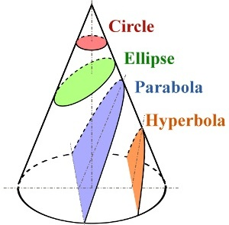
Fig. Conic sections were discussed by Apollonius of Perga
Anthemius’s famous book ‘On Burning Mirrors’ describes the focal properties of a parabola. He described the construction of an ellipse with a string fixed at the two foci. Heath gives one of his problems
which leads to the ellipse construction: To contrive that a ray of the sun (admitted through a small hole or window) shall fall in a given spot, without moving away at any hour and season.
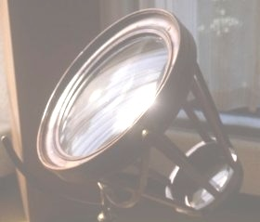
Fig. Burning Mirror.
Heath gives Anthemius's solution: “This is contrived by constructing an elliptical mirror one focus of which is at the point where the ray of the sun is admitted while the other is at the point to which the ray is required to be reflected at all times. Anthemius studied the focal properties of the parabola and proves that: ... parallel rays can be reflected to one single point from a parabolic mirror of which the point is the focus. The directrix is used in the construction, which follows, mutatis mutandis, the same course as the above construction in the case of the ellipse.”
He compiled a survey of remarkable mirror configurations in his work ‘On remarkable mechanical devices’ which was known to certain of the Arab mathematicians such as Alhazen.
With Isidore of Miletus, he designed the Sancta Sophia basilica (the Holy Wisdom basilica) for Justinian I.
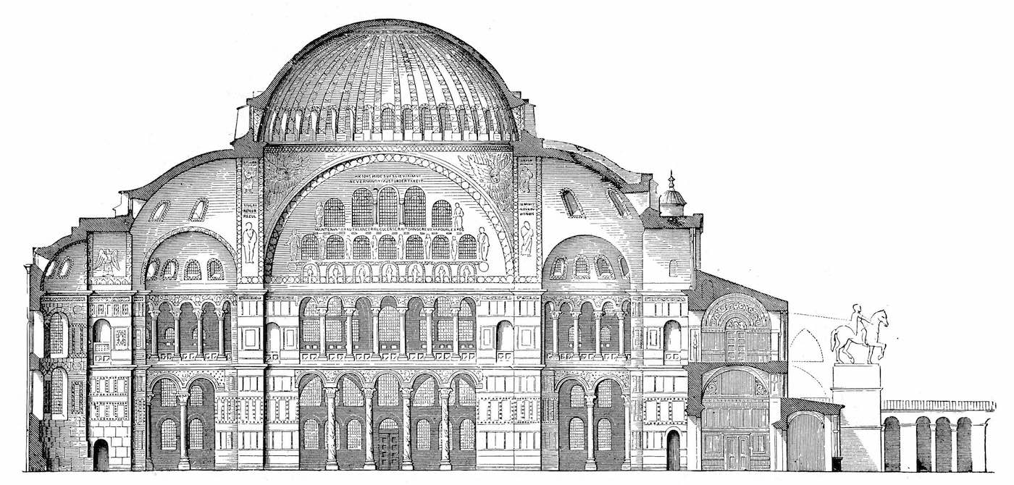
Sancta Sophia basilica (cross-sectional elevation)
There are a number of stories told of Anthemius which may be totally fictitious but, as is often the case with such stories, they may give an indication of his character. Huxley writes: “Anthemius persecuted a neighbour and rival Zenon by reflecting sunlight into his house. He also produced the impression of an earthquake in Zenon's house by the use of steam led under pressure through pipes connected to a boiler.”

Paulus Aegineta
Paulus Aegineta was a 7th-century Byzantine Greek physician, best known for writing ‘Epitomes iatrikes biblia hepta’ (Medical Compendium in Seven Books).
Nothing is known about his life, except that he was born in the Greek island of Aegina, and that he travelled a good deal, visiting, among other places, Alexandria. The exact time when he lived is not known; Arab historian Abul Faraj ibnul Jawzi placed him in the latter half of the 7th century. This is correct because he quotes Alexander of Tralles, and is himself quoted by Serapion the Elder.

Soudas says that Paulus wrote several medical works, of which Medical Compendium in Seven Books is still extant. This work is chiefly a compilation from earlier writers. For many years in the Byzantine Empire, this work contained the sum of all Western medical knowledge and was unrivaled in its accuracy and completeness. The whole work in the original Greek was published in Venice in 1528, and another edition appeared in Basel in 1538. His work was translated into Arabic by Arab Nestorian translator Hunayn ibn Ishaq.

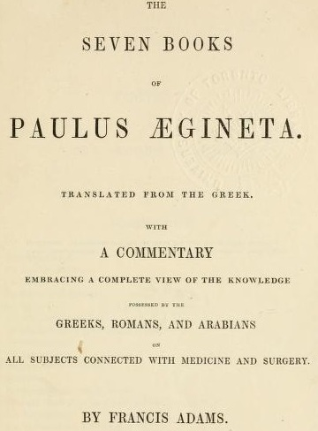
Medical Compendium in Seven Books
In this work, he describes the operation to fix a hernia similar to modern techniques writing, "After making the incision to the extent of three fingers' breadth transversely across the tumor to the groin, and removing the membranes and fat, and the peritoneum being exposed in the middle where it is raised up to a point, let the knob of the probe be applied by which the intestines will be pressed deep down. The prominence, then, of the peritoneum, formed on each side of the knob of the probe, are to be joined together by sutures, and then we extract the probe, neither cutting the peritoneum nor removing the testicle, nor anything else, but curing it with applications used for fresh wounds."

Al-Fazari
Muhammad bin Ibrahim Al-Fazari (died 796/806) was a Muslim mathematician and astronomer. Al-Fazari translated many scientific books into Arabic and Persian. He is credited to have built the first astrolabe in the Muslim world.
Fig. Different Parts of an astrolabe
Along with Yaqub ibn Tariq and his father he helped translate Brahmasphutasiddhanta, the astronomical text by Indian scientist Brahmagupta, into Arabic as Az-Zij ‛ala Sini al-Arab, or ‘the Sindhind’. This translation was possibly the vehicle by means of which the Indian numerals were transmitted from India to Persia.

Geber
Jabir Ibn Hayyan was one of the pioneers in chemistry. Latinate form of his name is Geber. He lived during c. 721-815CE. According to E.J. Holmyard, Jabir was born in the town of Tus, in Khorasan, in modern Iran. After his father’s death, Jabir's family went to Baghdad, where Jabir studied under the scholar Harbi Himyari. In later years, he became the disciple of Jafar Sadiq, a scholar and imam (leader) revered by Sunnis and Shiahs. He used to practice medicine. For the caliph Harun, Jabir wrote an alchemical work, The Book of the Blossom, which included information on experimental techniques. He had facilitated the acquisition of copies of Greek and Latin authors for translation into Arabic.
In 803, Geber went to Kufa, where he is said to have lived long. Jabir kept a working laboratory in Kufa.
The contribution of Geber includes the following important chemical processes:
- The manufacture of nitric and sulfuric acids;
- The separation of gold from other metals through the agency of lead and saltpeter (potassium nitrate).
- The concept of a chemical compound; the mineral cinnabar, for example, as being composed of sulfur and mercury
- The purification of mercury.
- The classification of salts as water soluble, under the generic title "sal."
- The introduction of the word "alkali" to designate substances such as lye and other bases.
- The production of nitric acid by distilling a mixture of saltpeter (potassium nitrate), copper vitriol (copper sulfate), and alum (naturally occuring sulfate of iron, potassium, sodium or aluminum).
- The production of sulfuric acid through the heating of alum.
- The production of aqua regia, a solvent capable of dissolving gold, by mixing salmiac (ammonium chloride) and nitric acid.
- The production of alum from alum shale by recrystallizing it from water.
- The purification of substances through crystallization
- The precipitation of silver nitrate crystals from a solution by the addition of common salt, thus establishing a test for the presence of both silver and salt.
- The preparation of mercuric oxide from mercury by heating it with a metalic oxide, and mercuric chloride by heating mercury with common salt, alum and saltpeter.
- The preparation of arsenious acid.
- The dissolving of sulfur in solutions of alkalies, and its transformation when it interacts with aqua regia.
- L The theory that the different metals are composed of varying degrees of sulfur and mercury.
- The production of saltpeter by mixing potash (potassium carbonate) and nitric acid.
Geber’s works introduced improved laboratory equipment such as water baths, furnaces, and systems for filtration and distillation.
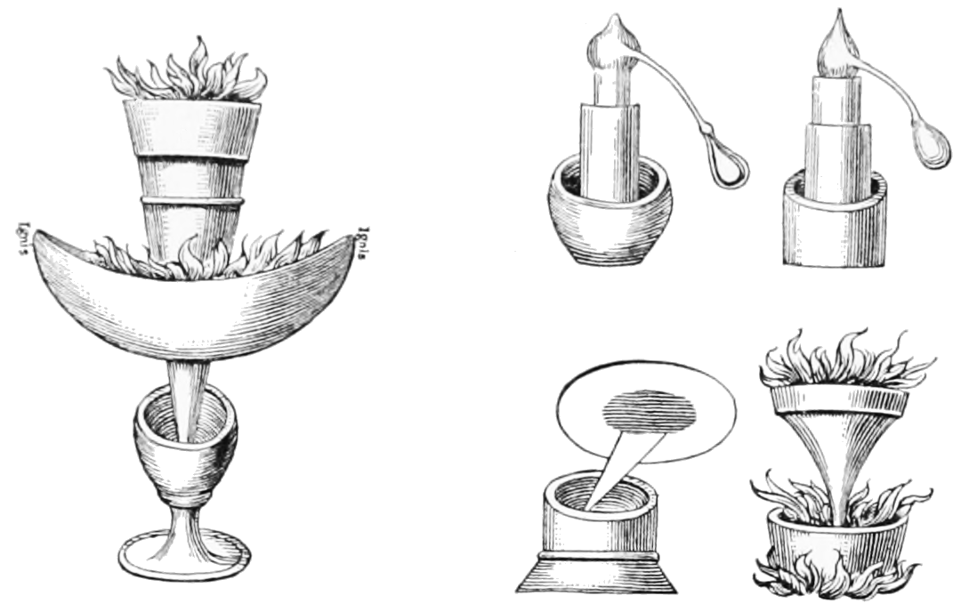
Fig.: An illustration of the various experiments and instruments used by Geber

Geber's works paved the way for most of the later alchemists, including Rhazes, Tughrai and al-Iraqi.

Ibn Turk Jili
Abdul-Hamid ibn Turk Jili was a ninth-century (floruit c. 830CE) Muslim mathematician. Not much is known about his biography. Jili means from Gilan. David Pingree states that he originally hailed from Khuttal or Gilan.
He wrote a work on algebra of which only a chapter called "Logical Necessities in Mixed Equations" on the solution of quadratic equations has survived. This work is very similar to Algorithmi’s Al-Jabr and was published at around the same time as, or even possibly earlier than, Al-Jabr. The manuscript gives exactly the same geometric demonstration as is found in Al-Jabr, and in one case the same example as found in Al-Jabr, and even goes beyond Al-Jabr by giving a geometric proof that if the discriminant is negative then the quadratic equation has no solution.
Carl Boyer in wrote, “The Algebra of al-Khwarizmi usually is regarded as the first work on the subject, but a recent publication in Turkey raises some questions about this. A manuscript of a work by Abdul-Hamid ibn-Turk, entitled "Logical Necessities in Mixed Equations," was part of a book on Al-jabr wal muqabalah which was evidently very much the same as that by al-Khwarizmi and was published at about the same time - possibly even earlier. The surviving chapters on "Logical Necessities" give precisely the same type of geometric demonstration as al-Khwarizmi's Algebra and in one case the same illustrative example x² + 21 =10x. In one respect Abdul-Hamad's exposition is more thorough than that of al-Khwarizmi for he gives geometric figures to prove that if the discriminant is negative, a quadratic equation has no solution. Similarities in the works of the two men and the systematic organization found in them seem to indicate that algebra in their day was not so recent a development as has usually been assumed. When textbooks with a conventional and well-ordered exposition appear simultaneously, a subject is likely to be considerably beyond the formative stage. ... Note the omission of Diophantus and Pappus, authors who evidently were not at first known in Arabia, although the Diophantine Arithmetica became familiar before the end of the tenth century.”
Abu Kamil wrote in the introduction of his Algebra: I have studied with great attention the writings of the mathematicians, examined their assertions, and scrutinized what they explain in their works; I thus observed that the book by Muhammad ibn Musa al-Khwarizmi known as Al-Jabr (Algebra) is superior in the accuracy of its principle and the exactness of its argumentation.

Algorithmi
Algorithmi was a mathematician, astronomer and geographer. Algorithmi is Latinate form of original Arabic name Muhammad ibn Musa al-Khwarizmi. He lived during c.780– c.850CE. He was born in Khwarizm oasis in Persia. Algorithmi was one of the researchers at the House of Wisdom, a university in Baghdad.
Algorithmi’s contribution to medieval geography was of great importance. The text of his book ‘Surat al-Ard’ (The Shape of the Earth) exists in a manuscript; the maps have not been preserved, although modern scholars have been able to reconstruct them from Algorithmi’s descriptions. He supervised the work of 70 geographers to create a map of the then “known world”. His work became known in Europe through Latin translations.
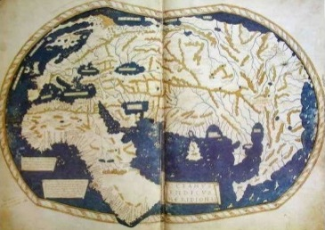
Algorithmi’s world map
Algorithmi developed the concept of the algorithm in mathematics. This is why he is called the grandfather of computer science by some people. His most recognized work as mentioned above and one that is so named after him is the mathematical concept Algorithm. The modern meaning of the word relates to a specific practice for solving a particular problem. Today, people use algorithms to do addition and long division, principles that are found in Algorithmi’s text.
Algorithmi’s algebra is regarded as the foundation and cornerstone of the sciences. The world “algebra” derives from the title of his greatest mathematical work, Hisab al-Jabr wal-Muqabala (The Book on Calculation by Completion and Balancing, c. 813–833 CE). The book works out several hundred simple quadratic equations by analysis as well as by geometrical example. It also has sections on methods of dividing up inheritances and surveying plots of land. It is largely concerned with methods for solving practical computational problems rather than algebra as the term is now understood. ‘Algebra’ is one of the earliest Arab work still in existence in Arabic. Algorithmi was also responsible for introducing the Arabic numbers to Europe.

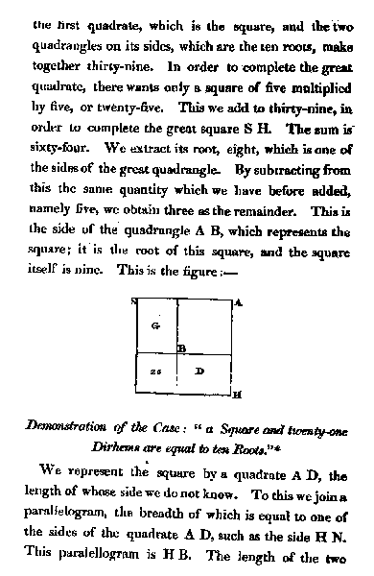
Fig. A page from The Algebra of Algorithmi (Hisab al-Jabr wal-Muqabala)

Algorithmi confined his discussion to equations of the first and second degrees. He also wrote an important work on astronomy, covering calendars, calculating true positions of the sun, moon and planets, tables of sines and tangents, spherical astronomy, astrological tables, parallax and eclipse calculations, and visibility of the moon. His astronomical work, Zij al-sindhind, is based on the work of other scientists.
Algorithmi made several important improvements to the theory and construction of sundials, which he inherited from his Indian and Hellenistic predecessors. He made tables for these instruments which considerably shortened the time needed to make specific calculations. His sundial was universal and could be observed from anywhere on the Earth. From then on, sundials were frequently placed on mosques to determine the time of prayer. The shadow square, an instrument used to determine the linear height of an object, in conjunction with the alidade for angular observations, was also invented by Algorithmi.
A number of minor works were written by al-Khwarizmi on topics such as the astrolabe, on which he wrote on the Jewish calendar.
Abu Kamil wrote in the introduction of his Algebra: I have studied with great attention the writings of the mathematicians, examined their assertions, and scrutinized what they explain in their works; I thus observed that the book by Muḥammad ibn Musa al-Khwarizmi known as Algebra is superior in the accuracy of its principle and the exactness of its argumentation. It thus behooves us, the community of mathematicians, to recognize his priority and to admit his knowledge and his superiority, as in writing his book on algebra he was an initiator and the discoverer of its principles

Sanad ibn Ali
Sanad ibn Ali was a mathematician and astronomer in Baghdad during the 9th century (died c. 864 CE). Sanad's father was a learned Jewish astronomer who lived and worked in Baghdad.
In his youth, Sanad studied several scientific books, among them the Almagest. He tried to gain access to the illustrious circle of scholars around Abbss ibn Saeed al‐Jawhari (d.860), who regularly met in his house to discuss the latest scholarly and social news. But being merely 20 years old at this time proved to be an obstacle.
According to a story told by Ahmad ibn Yusuf ibn al‐Daya (d. c. 952) on the authority of Abu Kamil Shuja (d. 930), Sanad convinced Jawhari of his superior knowledge of the Almagest. As a result, Sanad was not only permitted to take part in the talks of the illustrious circle, but Jawhari, introduced him to Caliph Mamun and recommended him as a promising scholar. Upon Mamun’s invitation, Sanad converted to Islam.
Sanad wrote four mathematical texts on algebra, Indian arithmetic, mental calculation, and Euclidean irrational quantities, the latter being one of the earliest commentaries on Book X of Euclid's Elements.
He wrote a commentary on Kitab al-Jabr wal-muqabala and helped prove the works of al-Khwarizmi. The decimal point notation to the Arabic numerals was introduced by Sanad ibn Ali.
He composed a zij (astronomical handbook) and explained a method for determining the circumference of the Earth by observations of the Sun. There is also a report by Biruni in his The Determination of the Coordinates of Cities (Ali, 1967, pp. 185–186) that Sanad had found the size of the Earth by measuring the dip of the horizon from the summit of a high mountain, a method later used to good effect by Biruni himself; this had been done “in the company of Mamun when he made his campaign against the Byzantines.” His zij is presumably lost, and thus it is unclear how it was related to the famous so called al‐Zij al‐mumtahan (The verified zij) produced by a group of astronomers from Mamun's court.
According to an account of the Egyptian astronomer Ibn Yunus of the astronomical excursions carried out by the court astronomers in Mamun's lifetime, Sanad had himself written such an account in which he claimed to have participated in one of these expeditions.
Sanad built and headed an observatory behind the Bab Shammasiyya in Baghdad, collaborating there with a group of observers.

Alfraganus
Alfraganus was one of the most famous astronomers in the 9th century. He lived during c. 805-870CE. He was born in Farghana and was a Persian Muslim. Alfraganus is the Latinate form of original Arabic name Ahmad ibn Muhammad al-Farghani.
His textbook Kitab fi Jawami Ilm al-Nujum (A Compendium of the Science of the Stars) written about 833, was a descriptive summary of Ptolemy's Almagest with updates. It was translated into Latin in the12th century and remained very popular in Europe. Dante Alighieri's knowledge of Ptolemaic astronomy had been drawn from his reading of Alfraganus. In the 17th century Jacob Golius published the Arabic text with a new Latin translation.
He was involved in the calculation of the diameter of the Earth by the measurement of the meridian arc length, together with a team of scientists under the patronage of the caliph al-Mamun in Baghdad.
The estimate fof Alfraganus for the Earth's circumference was 29791 miles.
In the 15th century, Christopher Columbus used estimate of Alfraganus for the Earth's circumference as the basis for his voyages to America. However, Columbus mistook Alfraganus's 7091-foot Arabic mile to be a 4856-foot Roman mile, causing him to underestimate the Earth's circumference, believing he could take a shortcut to Asia. (Douglas McCormick, Columbus’s Geographical Miscalculations, 2012)

Later he moved to Cairo, where he composed a treatise on the astrolabe around 856. In Cairo he supervised the construction of the large ‘Miqyas an-Nil’ (Nilometer) on the island of al-Rawda in the year 861.
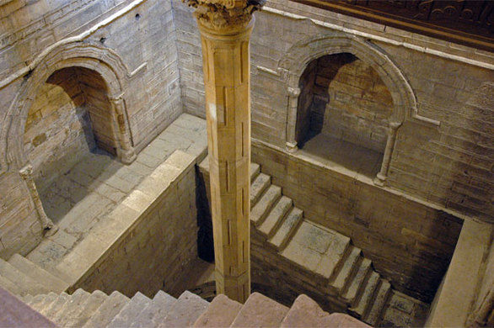
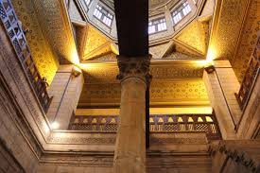
Nilometer
Nilometer is a structure which has been used for measuring the Nile River's clarity and water level during the annual flood season. The main component of nilometer is a vertical column calibrated in Egyptian cubits housed in a strong building. There is a tunnel from the monitoring station leading to the Nile below low water level. The building is decorated with calligraphy. A stairway is provided for maintenance.
As per rule of hydraulics, water level in the river is same as the level in the Nilometer column.
Generally, if the water level was low, there would be famine. If it was too high, it would be destructive. There was a specific mark that indicated how high the flood should be if the fields were to get good soil. The agrometrologists determined relation between gauge reading and crop yield. And the economists estimated amount of tax to be collected.
According to Ibn Abi Usaibia: The Banu Musa brothers out of sheer professional jealousy kept Sanad bin Ali away from Caliph al-Mutawakkil at his new capital Samarra and had caused Sanad to be sent away to Baghdad. Banu Musa brothers delegated the work of digging a great canal instead to Al-Farghani and thus ignoring Sanad, the better engineer. Alfraganus committed a great error, making the beginning of the canal deeper than the rest and water never reached the new garrison. News of this greatly angered al-Mutawakkil and the two Banu Musa brothers were saved from severe punishment only by the gracious willingness of Sanad ibn Ali, to vouch the corrections of Al-Farghani's calculations.

Abbas Ibn Firnas
Abbas Ibn Firnas was a Spanish Berber physician and engineer and made contributions in a variety of fields and is most known for his contributions to ways of manufacturing and using glass.
Ibn Firnas lived during 810 – 887CE. He was born in Ronda, a city in the Spanish province of Malaga. Young Abbas studied medicine and astronomy but was more interested in engineering and making his own inventions.
Algerian historian Ahmed Mohammad al-Maqqari (d. 1632) wrote a description of Firnas that included the following: Among other very curious experiments which he made, one is his trying to fly. He covered himself with feathers for the purpose, attached a couple of wings to his body, and getting on an eminence, flung himself down into the air, when according to the testimony of several trustworthy writers who witnessed the performance, he flew a considerable distance, as if he had been a bird, but, in alighting again on the place whence he had started, his back was very much hurt, for not knowing that birds when they alight come down upon their tails, he forgot to provide himself with one.
He lived another 12 years after his flight. He studied the shortcomings of his landing and came to the conclusion that besides wings there is a necessity of having a tail to act a rudder to control flight.
Ibn Firnas also experimented with crystal, quartz and sand to create transparent glass.

Abu Kamil
Abu Kamil was an Egyptian mathematician. Latinate form of his name Auoquamel is rarely used. He lived during c.850 – c.930CE. He is considered the first mathematician to systematically use and accept irrational numbers as solutions and coefficients to equations. Many of his examples and algebraic techniques were later copied by Fibonacci in his ‘Practica geometriae’ and other works. Unmistakable borrowings, but without Abu Kamil being mentioned and perhaps mediated by lost treatises, are found in Fibonacci's Liber Abaci. Thus Abu Kamil took an important part in introducing algebra to Europe.
He was the first Muslim mathematician to work with algebraic equations with powers higher than x² (up to x⁸), and solved sets of non-linear simultaneous equations with three unknown variables. He illustrated the rules of signs for expanding the multiplication (a±b)(c±d). He also enumerated all the possible solutions to some of his problems. He wrote all problems rhetorically, and some of his books lacked any mathematical notation beside those of integers. For example, he uses Arabic expression ‘mal mal shayʾ (square-square-thing) for x⁵ (as x².x².x).

Book of Algebra (Kitab fil-jabr wal-muqabala): Abu Kamil's most influential work is Book of Algebra, which he intended to supersede and expand upon that of Algorithmi. Whereas the Algebra of Algorithmi was geared towards the general public, Abu Kamil was addressing mathematicians. Abu Kamil solves systems of equations whose solutions are whole numbers and fractions, and accepted irrational numbers (in the form of a square root or fourth root) as solutions and coefficients to quadratic equations. The first chapter teaches algebra by solving problems of application to geometry, often involving an unknown variable and square roots. The second chapter deals with the six types of problems found in Algorithmi's book, but some of which, especially those of x², were now worked out directly instead of first solving for x and accompanied with geometrical illustrations and proofs. The third chapter contains examples of quadratic irrationalities as solutions and coefficients. The fourth chapter shows how these irrationalities are used to solve problems involving polygons. The rest of the book contains solutions for sets of indeterminate equations, problems of application in realistic situations, and problems involving unrealistic situations intended for recreational mathematics. In the 15th century the whole work appeared in a Hebrew translation by Mordekhai Finzi.

Book of Rare Things in the Art of Calculation (Kitabul-taraif fil-hisab): Abu Kamil describes a number of systematic procedures for finding integral solutions for indeterminate equations. It is also the earliest known Arabic work where solutions are sought to the type of indeterminate equations found in Diophantus's Arithmetica. However, Abu Kamil explains certain methods not found in any extant copy of the Arithmetica.

Treatise on the Pentagon and Decagon (Kitabul mukhammas wal-muashshar): In this treatise algebraic methods are used to solve geometrical problems. Abu Kamil uses the equation x⁴+3125=125x² to calculate a numerical approximation for the side of a regular pentagon in a circle of diameter 10. He also uses the golden ratio in some of his calculations.

Two quantities are in the golden ratio if their ratio is the same as the ratio of their sum to the larger of the two quantities.

Expressed algebraically, for quantities a and b with a > b > 0,

golden ratio (phi)= 1.61803 (approximate)

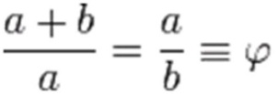

The figure below illustrates the geometric relationship.

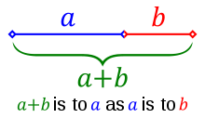

Fibonacci knew about this treatise and made extensive use of it in his Practica geometriae.

Book of Birds (Kitab al-tair): A small treatise teaching how to solve indeterminate linear systems with positive integral solutions. The title is derived from a type of problems known in the east which involve the purchase of different species of birds. Abu Kamil wrote in the introduction: I found myself before a problem that I solved and for which I discovered a great many solutions; looking deeper for its solutions, I obtained two thousand six hundred and seventy-six correct ones. My astonishment about that was great, but I found out that, when I recounted this discovery, those who did not know me were arrogant, shocked, and suspicious of me. I thus decided to write a book on this kind of calculations, with the purpose of facilitating its treatment and making it more accessible.

Book on Measurement and Geometry (Kitabul misaha wal handasa): A manual of geometry for non-mathematicians, like land surveyors, which presents a set of rules for calculating the volume and surface area of solids (mainly rectangular parallelepipeds, right circular prisms, square pyramids and circular cones). The first few chapters contain rules for determining area, diagonal, perimeter, and other parameters for different types of triangles, rectangles and squares.

Lost works: Some of Abu Kamil's lost works include: A treatise on the use of double false position, known as the Book of the Two Errors (Kitab al-khaṭaayn), Book on Augmentation and Diminution (Kitab al-jam wal-tafriq), Book of Estate Sharing using Algebra (Kitab al-wasaya bi al-jabr wal muqabala), which contains algebraic solutions for problems of Islamic inheritance. Ibn al-Nadim in his Fihrist listed the following additional titles: Book of Fortune (Kitab al-falah), Book of the Key to Fortune (Kitab miftah al-falah), Book of the Adequate (Kitab al-kifaya), and Book of the Kernel (Kitab al-asir).
According to Jacques Sesiano, Abu Kamil remained seemingly unparalleled throughout the Middle Ages in trying to find all the possible solutions to some of his problems. Ibn Khaldun classified Abu Kamil as the second greatest algebraist chronologically after Algorithmi.

Rhazes
Rhazes was a scientist and important figure in the history of medicine. ‘Rhazes’ is the Latinate form of original Arabic name Muhammad ibn Zakariya al-Razi. Rhazes lived during 854–925CE. George Sarton said that Rhazes was the greatest physician of Islam and the Medieval Ages. Razi made fundamental and enduring contributions to various fields, which he recorded in over 200 manuscripts, and is remembered for numerous advances in experimental medicine. EG Browne considers him as "probably the greatest and most original of all the Muslim physicians, and one of the most prolific as an author". Cyril Elgood remarks, “By writing a monograph on 'Diseases in Children' he may also be looked upon as the father of paediatrics.”
He has been described as a doctor's doctor, He was a pioneer of ophthalmology, because, he was the first to recognize the reaction of the eye's pupil to light.
Rhazes was born in the city of Rey near Tehran, hence his title Razi, meaning "from the city of Rey". In his youth, Razi moved to Baghdad where he studied and practiced at the local hospital. Later, he was invited back to Rey by the governor of Rey, and became a hospital head.

In Baghdad: Rhazes was invited to Baghdad where he became director in a new hospital founded by Mutadid (d. 902 CE). Under the reign of Mutadid's son, Muktafi (r. 902-908) Razi was commissioned to build a new large hospital. To pick the future hospital's location, Rhazes adopted an evidence-based approach suggesting having fresh meat hung in various places throughout the city and to build the hospital where meat took longest to rot.
Razi's book al-Judari wal-Hasbah (On Smallpox and Measles) was the first book describing smallpox and measles as distinct diseases. Symptoms, pathology and treatment were clearly discussed. Its lack of dogmatism and its reliance on clinical observation show Razi's medical methods. Rhazes wrote: Smallpox appears when blood "boils" and is infected, resulting in vapours being expelled. Thus juvenile blood (which looks like wet extracts appearing on the skin) is being transformed into richer blood, having the color of mature wine. At this stage, smallpox shows up essentially as "bubbles found in wine" (as blisters) ... this disease can also occur at other times (meaning: not only during childhood).

The best thing to do during this first stage is to keep away from it, otherwise this disease might turn into an epidemic. He wrote: “The eruption of smallpox is preceded by a continued fever, pain in the back, itching in the nose and nightmares during sleep. These are the more acute symptoms of its approach together with a noticeable pain in the back accompanied by fever and an itching felt by the patient all over his

body. A swelling of the face appears, which comes and goes, and one notices an overall inflammatory color noticeable as a strong redness on both cheeks and around both eyes. One experiences a heaviness of the whole body and great restlessness, which expresses itself as a lot of stretching and yawning. There is a pain in the throat and chest and one finds it difficult to breathe and cough. Additional symptoms are: dryness of breath, thick spittle, hoarseness of the voice, pain and heaviness of the head, restlessness, nausea and anxiety.” (Note the difference: restlessness, nausea and anxiety occur more frequently with "measles" than with smallpox. At the other hand, pain in the back is more apparent with smallpox than with measles). Altogether one experiences heat over the whole body, one has an inflamed colon and one shows an overall shining redness, with a very pronounced redness of the gums. (Rhazes, Encyclopaedia of Medicine)
The Bulletin of the World Health Organization mentions: His writings on smallpox and measles show originality and accuracy, and his essay on infectious diseases was the first scientific treatise on the subject. (The Bulletin of the WHO, May 1970)
He also discovered numerous compounds and chemicals including alcohol and sulfuric acid.
Through translation, his medical works and ideas became known among medieval European practitioners and influenced medical education in the Latin West. Some volumes of his work Al-Mansuri, namely "On Surgery" and "A General Book on Therapy", became part of the medical curriculum in Western universities.
Meningitis: Razi compared the outcome of patients with meningitis treated with blood-letting with the outcome of those treated without it to see if blood-letting could help.
Pharmacy: Rhazes contributed in many ways to the early practice of pharmacy by compiling texts, in which he introduces the use of "mercurial ointments" and his development of apparatus such as mortars, flasks, spatulas and phials, which were used in pharmacies until the early twentieth century.
Ethics of medicine: On a professional level, Rhazes introduced many practical, progressive, medical and psychological ideas. He attacked charlatans and fake doctors who roamed the cities and countryside selling their nostrums and "cures". At the same time, he warned that even highly educated doctors did not have the answers to all medical problems and could not cure all sicknesses or heal every disease, which was humanly speaking impossible. Razi advised practitioners to keep up with advanced knowledge by continually studying medical books and exposing themselves to new information. He made a distinction between curable and incurable diseases. He commented that in the case of advanced cases of cancer and leprosy the physician should not be blamed when he could not cure them. To add a humorous note, Razi felt great pity for physicians who took care for the well being of princes, nobility, and women, because they did not obey the doctor's orders to restrict their diet or get medical treatment, thus making it most difficult being their physician.
He also wrote the following on medical ethics: “The doctor's aim is to do good, even to our enemies, so much more to our friends,

and my profession forbids us to do harm to our kindred, as it is instituted for the benefit and welfare of the human race, and Allah imposed on physicians the oath not to compose mortiferous remedies.”
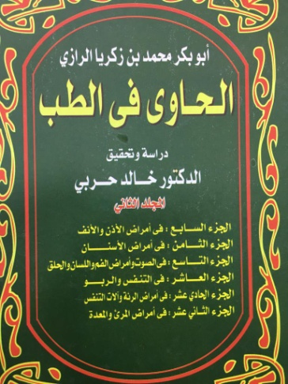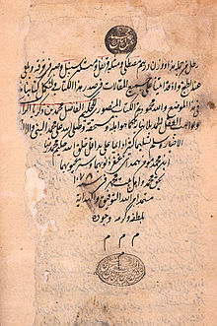
Fig: Razi's Book of Medicine (AlHawi) and its colophon(different printings).

Kitab al-Hawi: The al-Hawi is a posthumous compilation of Razi's working notebooks, which included knowledge gathered from other books as well as original observations on diseases and therapies, based on his own clinical experience. This monumental medical encyclopedia in nine volumes is known in Europe as The Virtuous Life, also as The Large Comprehensive or Continens Liber. Because of this book alone, many scholars consider Razi the greatest medical doctor of the Middle Ages. It is significant since it contains a celebrated monograph on smallpox, the earliest one known.
Razi also criticized, in Al-Hawi, the views of Galen, after Razi had observed many clinical cases which did not follow Galen's descriptions of fevers. For example, he stated that Galen's descriptions of urinary ailments were inaccurate as he had only seen three cases, while Razi had studied hundreds of such cases in hospitals of Baghdad and Rey.
For One Who Has No Physician to Attend Him (Manla Yahduruhu Al-Tabib): Rhazes was possibly the first Persian doctor to deliberately write a home medical manual directed at the general public. He dedicated it to the poor, the traveler and the ordinary citizen who could consult it for treatment of common ailments when a doctor was not available. Razi described in its 36 chapters, diets and drug components that can be found in either an apothecary, a market place, in well-equipped kitchens, or and in military camps. Thus, every intelligent person could follow its instructions and prepare the proper recipes with good results.
Some of the illnesses treated were headaches, colds, coughing, melancholy and diseases of the eye, ear, and stomach. For example, he prescribed for a feverish headache: "2 parts of oily extract of rose, to be mixed with 1 part of vinegar, in which a piece of linen cloth is dipped and compressed on the forehead". He recommended as a laxative, "7 drams of dried violet flowers with 20 pears, macerated and well mixed, then strained. Add to this filtrate, 20 drams of sugar for a drink. In cases of melancholy, he invariably recommended prescriptions, which included either poppies or its juice (opium), Cuscuta epithymum (clover dodder) or both. For an eye-remedy, he advised myrrh, saffron, and frankincense, 2 drams each, to be mixed with 1 dram of yellow arsenic formed into tablets. Each tablet was to be dissolved in a sufficient quantity of coriander water and used as eye drops.
‘Shukuk ala Jalinus’ (Doubts about Galen): In his book ‘Shukuk ala Jalinus’, Razi rejects several claims (superiority of the Greek language) and many of his cosmological and medical views made by Galen. He links medicine with philosophy, and states that sound practice demands independent thinking. He reports that Galen's descriptions do not agree with his own clinical observations regarding the run of a fever. And in some cases he finds that his clinical experience exceeds Galen's.
Moreover, he criticized Galen's theory that the body possessed four separate ‘humors’ (liquid substances), whose balance are the key to health and a natural body-temperature. A sure way to upset such a system was to insert a liquid with a different temperature into the body resulting in an increase or decrease of bodily heat, which resembled the temperature of that particular fluid. Razi noted that a warm drink would heat up the body to a degree much higher than its own natural temperature. Thus the drink would trigger a response from the body, rather than transferring only its own warmth or coldness to it.
This line of criticism essentially had the potential to completely refute Galen's theory of humors, as well as Aristotle's theory of the four elements, on which it was grounded. Razi's own alchemical experiments suggested other qualities of matter, such as "oiliness" and "sulphurousness", or inflammability and salinity, which were not readily explained by the traditional fire, water, earth, and air division of elements.
Razi repeatedly expressed his praise and gratitude to Galen for his contributions and labors, saying: “I prayed to Allah to direct and lead me to the truth in writing this book. It grieves me to oppose and criticize the man Galen from whose sea of knowledge I have
drawn much. Indeed, he is the Master and I am the disciple. Although this reverence and appreciation will and should not prevent me from doubting, as I did, what is erroneous in his theories. I imagine and feel deeply in my heart that Galen has chosen me to undertake this task, and if he were alive, he would have congratulated me on what I am doing. I say this because Galen's aim was to seek and find the truth and bring light out of darkness. I wish indeed he were alive to read what I have published.”
Razi believed that contemporary scientists are by far better equipped, more knowledgeable, and more competent than the ancient ones, due to the accumulated knowledge at their disposal. Razi's attempt to overthrow blind acceptance of the unchallenged authority of ancient sages encouraged and stimulated research and advances in sciences.

List of Razi's books and articles
This is a partial list of Razi's books and articles, according to Ibn Abi Usaybiah. Some books may have been copied or printed under different names: al-Hawi al-Kabir {known as The Virtuous Life, Continens Liber}, Isbateh Elmeh Pezeshki (Proving the Science of Medicine), Dar Amadi bar Elmh Pezeshki (Outcome of the Science of Medicine), Rade Manaategha 'tibb jahez, Rade Naghzotibbeh Nashi, The Experimentation of Medical Science and its Application, Kenash, The Classification of Diseases, Royal Medicine, For One Without a Doctor, The Book of Simple Medicine, The Great Book of Krabadin, The Little Book of Krabadin, Kitab Taj (The Book of the Crown), The Book of Disasters, Food and its Harmfulness, Al-Judari wal-Hasbah (A treatise on the Small-pox and Measles), Ketab dar Padid Amadaneh Sangrizeh (The Book of Formation of small stones (Stones in the Kidney and Bladder), Ketabeh Dardeh Roodeha (The Book of Pains in the Intestine), Ketab dar Dard Paay va Dardeh Peyvandhayyeh Andam (The Book of Pains in Legs and in Linked Limbs), Ketab dar Falej, The Book of Tooth Aches, Dar Hey'ateh Kabed (About the Liver), Dar Hey'ateh Qalb (About the Heart), About the Nature of Doctors, About the Earwhole, Dar Rag Zadan (About Handling Vessels), Seydeh neh, Ketabeh Ibdal, Food For Patients, Soodhayeh Serkangabin (Benefits of Honey and Vinegar Mixture), Darmanhayeh Abneh, The Book of Surgical Instruments, The Book on Oil, Fruits Before and After Lunch, Book on Medical Discussion (with Jarir Tabib), Book on Medical Discussion II (with Abu Feiz), About the Menstrual Cycle, Ghi Kardan (on vomiting), Snow and Medicine, Fatal Diseases, Soil in Medicine, The Thirst of Fish, Sleep Sweating, Warmth in Clothing, Spring and Disease, Misconceptions of a Doctor's Capabilities, The Social Role of Doctors.

Razi's notable books and articles on medicine translated into English include: The Book for the Elite (Mofid al Khavas), The Book of Experiences, The Cause of the Death of Most Animals because of Poisonous Winds, The Physicians' Experiments, The Person Who Has No Access to Physician, The Big Pharmacology, The Small Pharmacology, Gout, The Doubt on Galen (Al Shakook ala Jalinoos), Kidney and Bladder Stones, The Spiritual Physik of Rhazes (Ketab tibb ar-Ruhani).

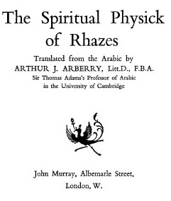

Works on Alchemy:

The transmutation of metals: Razi's contemporaries believed that he had obtained the secret of turning iron and copper into gold. Half a century after Razi's death, Ibn Nadim in his book The Philosophers Stone (Lapis Philosophorum in Latin) mentioned Razi's interest in alchemy and his strong belief in the possibility of transmutation of lesser metals to silver and gold. Nadim attributed a series of twelve books to Razi, plus an additional seven, including his refutation to al-

Kindi's (801-873 CE) denial of the validity of alchemy. Biographer Khosro Moetazed reports in Mohammad Zakaria Razi that a certain General Simjur confronted Razi in public, and asked whether that was the underlying reason for his willingness to treat patients without a fee. "It appeared to those present that Razi was reluctant to answer; he looked sideways at the general and replied": “I understand alchemy and I have been working on the characteristic properties of metals for an extended time. However, it still has not turned out to be evident to me, how one can transmute gold from copper. Despite the research from the ancient scientists done over the past centuries, there has been no answer. I very much doubt if it is possible.”

Razi developed several chemical instruments that remain in use to this day. He has perfected methods of distillation and extraction. His alchemical stockroom was enriched with products of Persian mining and manufacturing, even with sal ammoniac, a Chinese discovery. He relied predominantly on the concept of 'dominant' forms or essences, which is the Neoplatonic conception of causality rather than an intellectual approach or a mechanical one.

Razi's alchemy brings forward such empiric qualities as salinity and inflammability -the latter associated to 'oiliness' and 'sulphurousness'. These properties are not readily explained by the traditional composition of the elements such as: fire, water, earth and air.

Major works on alchemy: Razi's works present the first systematic classification of carefully observed and verified facts regarding chemical substances, reactions and apparatus, described in a language free from mysticism and ambiguity.

The Secret (Al-Asrar): This book was written in response to a request from Razi's close friend, colleague, and former student, Abu Mohammad b. Yunis of Bukhara.

In his book Sirr al-Asrar, Razi divides the subject of "Matter' into three categories, as in his previous book al-Asrar.

1.Knowledge and identification of the medical components within substances derived from plants, animals and minerals, and descriptions of the best types for medical treatments.

2.Knowledge of equipment and tools of interest to and used by either alchemists or apothecaries.

3.Knowledge of seven alchemical procedures and techniques: sublimation and condensation of mercury, precipitation of sulphur, and arsenic calcination of minerals (gold, silver, copper, lead, and iron), salts, glass, talc, shells, and waxing.

This last category contains additional descriptions of other methods and applications used in transmutation:

* The added mixture and use of solvent vehicles.

* The amount of heat (fire) used, 'bodies and stones' (al-ajsad and al-ahjar), that can or cannot be transmuted into corporal substances such of metals and Id salts (al-amlah).

* The use of a liquid mordant which quickly and permanently colors lesser metals for more lucrative sale and profit.

Razi gives methods and procedures of coloring a silver object to imitate gold (gold leafing) and the reverse technique of removing its color back to silver. Gilding and silvering of other metals (alum, calcium salts, iron, copper, and tutty) are also described, as well as how colors will last for years without tarnishing or changing.

Razi classified minerals into six divisions:

1. Four spirits (AL-ARWAH): mercury, sal ammoniac, sulfur and arsenic sulphide (orpiment and realgar).

2. Seven bodies (AL-AJSAD): silver, gold, copper, iron, black lead (plumbago), zinc (Kharsind) and tin.

3.Thirteen stones (AL-AHJAR): Pyrites marcasite (marqashita), magnesia, malachite, tutty Zinc oxide (tutiya), talcum, lapis lazuli, gypsum, azurite, magnesia, haematite (iron oxide), arsenic oxide, mica and asbestos and glass (then identified as made of sand and alkali of which the transparent crystal Damascene is considered the best),

4. Seven vitriols (AL-ZAJAT): alum (al-shabb), and white (qalqadis), black, red (suri), and yellow (qulqutar) vitriols (the impure sulfates of iron, copper, etc.), green (qalqand).

5. Seven borates: natron, and impure sodium borate.

6. Eleven salts (AL-AMLAH): including brine, common salt, ashes, naphtha, live lime, and urine, rock, and sea salts. Then he separately defines and describes each of these substances, the best forms and colors of each, and the qualities of various adulterations.

Razi gives also a list of apparatus used in alchemy. This consists of 2 classes:

1.Instruments used for the dissolving and melting of metals such as the Blacksmith's hearth, bellows, crucible, thongs (tongue or ladle), macerator, stirring rod, cutter, grinder (pestle), file, shears, descensory and semi-cylindrical iron mould.

2.Utensils used to carry out the process of transmutation and various parts of the distilling apparatus: the retort, alembic, shallow iron pan, potters kiln and blowers, large oven, cylindrical stove, glass cups, flasks, phials, beakers, glass funnel, crucible, alundel, heating lamps, mortar, cauldron, hair-cloth, sand- and water-bath, sieve, flat stone mortar and chafing-dish.

Secret of Secrets (Sirr al-asrar): In this book, he gives systematic attention to basic chemical operations important to the history of pharmacy.

Books on alchemy: Here is a list of Razi's known books on alchemy, mostly in Persian:

Modkhele Taalimi, Elaleh Ma'aaden, Isbaate Sanaa'at, Ketabeh Sang, Ketabe Tadbir, Ketabe Aksir, Ketabe Sharafe Sanaa'at, Ketabe Tartib (Ketabe Rahat, The Simple Book), Ketabe Tadabir, Ketabe Shavahed, Ketabe Azmayeshe Zar va Sim (Experimentation on Gold), Ketabe Serre Hakimaan, Ketabe Serr (The Book of Secrets), Ketabe Serre Serr (The Secret of Secrets), The First Book on Experiments, The Second Book on Experiments, Resaale'ei Be Faan, Arezooyeh Arezookhah, A letter to Vazir Ghasem ben Abidellah, Ketabe Tabvib.

Views on religion: A number of contradictory statements about religion have been ascribed to Razi. Adamson points out to a work

by Razi where Razi is quoted as citing the Quran and the prophets to support his views. Biruni listed works of Razi on religion, including Fi Wujub Dawat al-Nabi ala Man Nakara bil-Nubuwwat (Obligation to Propagate the Teachings of the Prophet against Those who Denied Prophecies) and Fi anna li al-Insan Khaliqan Mutqinan Hakiman (That Man has a Wise and Perfect Creator), listed under his works on the "divine sciences". Biruni mentioned in his ‘Bibliography of Razi’ that Razi had written two ‘heretical books’: Fil-Nubuwwat (On Prophecies) and Fi Ḥiyalul Mutanabbin (On the Tricks of False Prophets). Biruni criticized and expressed caution about Razi's religious views. None of Razi’s works on religion are now extant in full.
Abu Hatim Razi, an Ismaili missionary, quoted views ascribed to Razi in a book called Alam al-nubuwwa (Signs of Prophecy). Abu Hatim debated Razi, and whether he has faithfully recorded the views of Razi is disputed. According to Abdul Latif , professor at Cairo University, Abu Hatim and his student, Hamiduddin Karmani were Ismaili extremists who often misrepresented the views of Razi in their works. Al-Shahrastani noted "that such accusations should be doubted since they were made by Ismailis, who had been attacked by Razi". Abdul Latif points out that the views allegedly expressed by
Razi contradict what is found in Razi's own works, like the Spiritual Healing (Fil-tibb alruhani). Peter Adamson concurs that Abu Hatim

may have "deliberately misdescribed" Razi's position. Instead, Razi was only arguing against the use of miracles to prove anthropomorphism and the uncritical acceptance of taqlid vs nazar.
He spent the last years of his life in Rey suffering from glaucoma. He was approached by a physician offering an ointment to cure his blindness. Al-Razi then asked him how many layers does the eye contain and when he was unable to receive an answer, he declined the treatment stating "my eyes will not be treated by one who does not know the basics of its anatomy".
Razi died in Rey in 925. Razi was a generous person, treated the poor without payment. One former pupil from Tabaristan came to look after him. Razi rewarded him for his intentions and sent him back home, proclaiming that his final days were approaching.
Ibn al-Nadim recorded an account by Razi of a Chinese student who copied down all of Galen's works in Chinese as Razi read them to him out loud after the student learned fluent Arabic in five months and attended Razi's lectures.

Albategnius
Copernicus in his famous book 'De Revolutionibus Orbium Clestium' expresses his indebtedness to Albategnius and quotes his work several times. Albategnius was regarded as as one of the most famous observers and a leader in geometry, theoretical and practical astronomy. Albategnius is Latinate form of original name Mohammad ibn Jabir al-Harrani al-Battani.
Albategnius was born around 858 C.E. in Harran. His father was Jabir ibn Sinan al-Sabi. His family had been members of the Sabian sect, a religious sect of star worshippers. But Albategnius was not a believer in the Sabian religion. His name “Abu Abdallah Mohammad” indicates that he was certainly a Muslim. Jabir had a high reputation as an instrument maker in Harran. Battani was first educated by his father and he learnt these skills. He then moved to Raqqa.
Albategnius made remarkably accurate astronomical observations at Antioch and Raqqah. The main achievements of Albategnius are:
• He cataloged 489 stars. He dedicated all his life until his death to the observation of planets and stars.
• He refined the existing values for the length of the year, which he gave as 365 days 5 hours 46 minutes 24 seconds, and of the seasons.
• He calculated 54.5″ per year for the precession of the equinoxes and obtained the value of 23° 35′ for the inclination of the ecliptic.
• He showed that the farthest distance of the Sun from the Earth varies and, as a result, annular eclipses of the Sun are possible as well as total eclipses.
Rather than using geometrical methods Albategnius used trigonometric methods which were an important advancement. Albategnius produced a number of trigonometrical relationships:
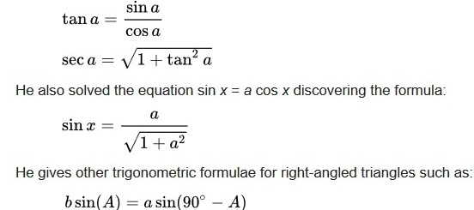
Albategnius used al-Marwazi's idea of tangents ("shadows") to develop equations for calculating tangents and cotangents, compiling tables of them. He also discovered the reciprocal functions of secant and cosecant, and produced the first table of cosecants, which he referred to as a "table of shadows" (in reference to the shadow of a gnomon), for each degree from 1° to 90°.
Al-Battani's major work is Kitab az-Zij (Book of Astronomical Tables). It went through Latin translation De Motu Stellarum in 1116. He composed work on astronomy, with tables, containing his own observations of the sun and moon and a more accurate description of their motions than that given in Ptolemy’s ‘Almagest’. It was largely based on Ptolemy's theory, and other Greco-Syriac sources. In his zij, he provided descriptions of a quadrant instrument.
He migrated to Samarra, where he worked till the end of his life. Albategnius died in 317 H./929CE, near Mousul in Iraq.

Azophi Arabus
Azophi Arabus was a Persian astronomer also known as Abd ar-Rahman as-Sufi. He lived during 903 to 986 CE. He was born in Rey, Iran.
Azophi published his famous Book of Fixed Stars (kitab suwar al-kawakib) in 964, describing both in textual descriptions and pictures.
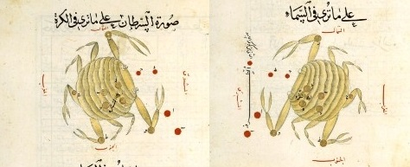
Fig. For each constellation (here constellation crab), he provided two drawings, one from the outside of a celestial globe, and the other from the inside (as seen from the Earth).

He identified the Large Magellanic Cloud, which is visible from Yemen, though not from Isfahan; it was not seen by Europeans until Magellan's voyage. He also made the earliest recorded observation of the Andromeda Galaxy in 964; describing it as a "small cloud".
He observed that the ecliptic plane is inclined with respect to the celestial equator.

Azophi also wrote about the astrolabe, finding numerous additional uses for it: he described over 1000 different uses.

Abulcasis
Abulcasis was a scientist in Spain. Abulcasis is the Latinate form of original Arabic name Abul Qasim Khalaf Zahrawi. He lived during 936-1013CE. He was born in Medina Azahara. He wrote numerous medical texts, developed many innovative surgical instruments and developed new surgical techniques and practices.
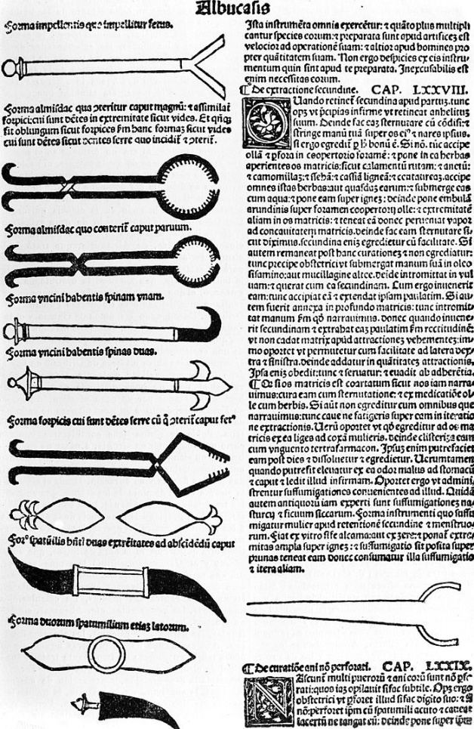
Stefan K. Estreicher wrote, "Al-Zahrawi (936-1013), better known as Albucasis, writes a 30-volume medical encyclopedia and designs modern-looking surgical instruments. Many consider him the father
of surgery."
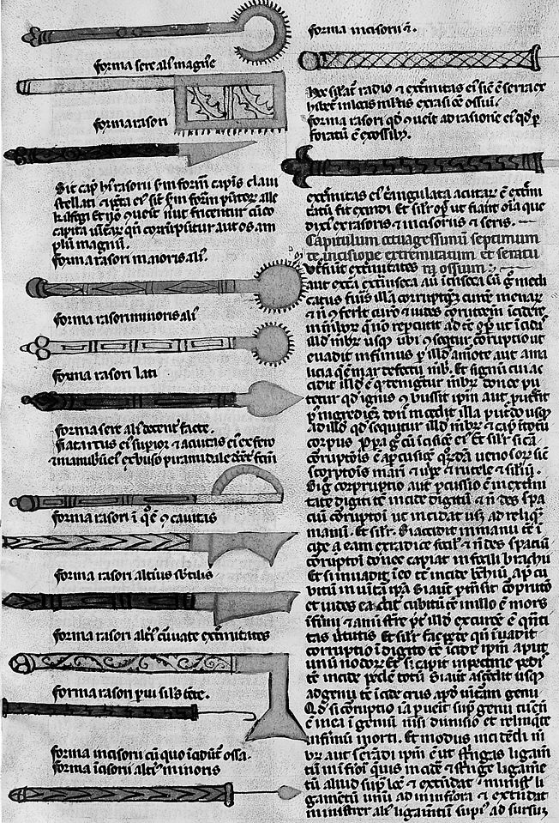
His texts were considered the definitive works on surgery in Europe until the Renaissance. E. Michael Gerli wrote, "Book 30, on surgery, was translated in the twelfth century by Gerard of Cremona (Liber Alsahravi de cirurgia) and it established the reputation of Abulcasis as the greatest surgeon of the Middle Ages.”

Ibn Sahl
Al-Ala Ibn Sahl was a Persian mathematician and physicist. He lived during c.940–1000. He was patronized by the Buwayhid court of Baghdad.

Ibn Sahl wrote an optical treatise around 984 CE. The text of this treatise was reconstructed by Roshdi Rashed from two manuscripts (edited 1993): Damascus, al-Zahiriya MS 4871, 3 fols., and Tehran, Milli MS 867, 51 fols. The Tehran manuscript is much longer, but it is badly damaged, and the Damascus ms. contains a section missing entirely from the Tehran ms. The Damascus ms. has the title Fil-'ala al-muhriqa "On the burning instruments", the Tehran ms. has a title added in a later hand Kitab al-harraqat "The book of burners".
Ibn Sahl is the first Muslim scholar known to have studied Ptolemy's Optics, and as such an important precursor to the Book of Optics by Alhazen, written some thirty years later. Ibn Sahl dealt with the optical properties of curved mirrors and lenses and has been described as the discoverer of the law of refraction (Snell's law).
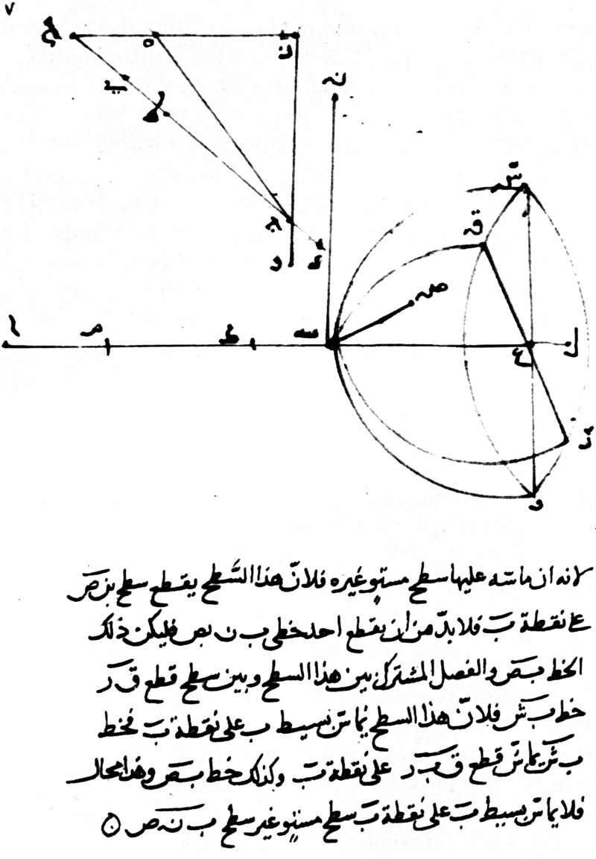
Fig. Reproduction of Milli MS 867 fol. 7r, showing his discovery of the law of refraction (from Rashed, 1990).
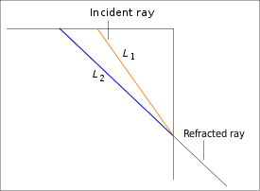
Interpretation of Ibn Sahl's construction: If the ratio of lengths L1/L2 is kept equal to n1/n2 then the rays satisfy the law of sines, or Snell's law. The inner hypotenuse of the right-angled triangle shows the path of an incident ray and the outer hypotenuse shows an extension of the path of the refracted ray if the incident ray met a crystal whose face is vertical at the point where the two hypotenuses intersect. The ratio of the length of the smaller hypotenuse to the larger is the reciprocal of the refractive index of the crystal. The lower part of the figure shows a representation of a plano-convex lens (at the right) and its principal axis (the intersecting horizontal line). The curvature of the convex part of the lens brings all rays parallel to the horizontal axis (and approaching the lens from the right) to a focal point on the axis at the left.
Ibn Sahl uses this law to derive lens shapes that focus light with no geometric aberrations, known as anaclastic lenses. In the remaining parts of the treatise, Ibn Sahl dealt with parabolic mirrors, ellipsoidal mirrors, biconvex lenses, and techniques for drawing hyperbolic arcs.

Abul-Wafa Buzhjani
Abul-Wafa Muḥammad Buzhjani was a Persian mathematician and astronomer who worked in Baghdad. He lived during 10June 940–15July 998. He made important innovations in spherical trigonometry, and his work on arithmetic for businessmen contains the first instance of using negative numbers in a medieval Muslim text.
His "A Book on What is Necessary from the Science of Arithmetic for Scribes and Businessmen" (Kitab fi ma yahtaj ilayh al-kuttab wal-ummal min ilmil-hisab) is the first book where negative numbers have been used in the medieval Arabic texts.
He is also credited with compiling the tables of sines and tangents at 15' intervals. He also introduced the secant and cosecant functions, as well studied the interrelations between the six trigonometric lines associated with an arc. His Almagest was widely read by medieval Arab astronomers in the centuries after his death. He is known to have written several other books that have not survived.
He was born in Buzhgan, now Torbat-e-Jam in Iran. At age 19, in 959 CE, he moved to Baghdad and remained there till his death in 998. In Baghdad, he received patronage by members of the Buyid court.
Albategnius describes a quadrant instrument in his Kitab az-Zij. But Abul Wafa was the first to build a wall quadrant to observe the sky.

His use of tangent helped to solve problems involving right-angled spherical triangles, and developed a new technique to calculate sine
tables, allowing him to construct more accurate tables than his predecessors.
In 997, he participated in an experiment to determine the difference in local time between his location and that of al-Biruni. The result was very close to present-day calculations, showing a difference of approximately 1 hour between the two longitudes. While what is extant from his works lacks theoretical innovation, his observational data were used by many later astronomers, including al-Biruni.
Works:
Almagest: Among his works on astronomy, only the first seven treatises of his Almagest (Kitab al-Majisti) are now extant. The work covers numerous topics in the fields of plane and spherical trigonometry, planetary theory, and solutions to determine the direction of Qibla.
He established several trigonometric identities such as sin(a ± b) in their modern form, where the Ancient Greek mathematicians had expressed the equivalent identities in terms of chords.
sin(α ± β) = sinαcosβ ± cosαsinβ
sin(a + b) = sin(a)cos(b) + cos(a)sin(b)
cos(2a) = 1−2sin2(a)
sin(2a) = 2 sin(a)cos(a)
He also discovered the law of sines for spherical triangles:
sinAsina = sinBsinb =sinCsinc
where A, B, C are the sides (measured in radians on the unit sphere) and a, b, c are the opposing angles.
Abul-Wafa wrote an astronomical handbook called ‘Zij al‐wazih’ which is no longer extant.
His ‘Book on Those Geometric Constructions Which Are Necessary for a Craftsman’ (Kitab fi ma yahtaj ilayh al-sani min al-amal al-handasiyya) contains over one hundred geometric constructions, including for a regular heptagon, which have been reviewed and compared with other mathematical treatises.
He also wrote translations and commentaries on the algebraic works of Diophantus, Alrorithmi and Euclid's Elements.

Al-Sijzi
Ahmad ibn Mohammed al-Sijzi was a Muslim astronomer and mathematician. He lived during c. 945 - c. 1020. Al-Sijzi means man of Sizistan or Sistan. He is notable for proposing that the Earth rotates around its axis in the 10th century. He also worked in Shiraz making astronomical observations from 969 to 970CE.
Al Sijzi wrote a geometrical treatise. In work on geometrical algebra al-Sijzi proves geometrically that (a+b)³ = a³+3ab(a+b)+b³.
He does this by decomposing a cube of side a + b into the sum of two cubes of sides a and b and a number of parallelepipeds of total volume 3ab(a+b). This is considered by most historians to be a three-dimensional extension by Al-Sijzi of the geometrical algebra propositions in Book 2 of Euclid's Elements.
Al-Sijzi studied intersections of conic sections and circles.
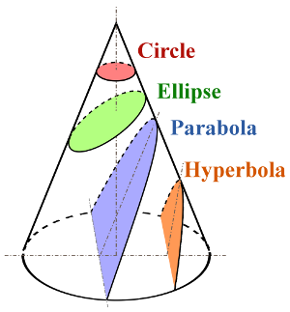
Fig. Conic sections were discussed by Apollonius of Perga
He replaced the old kinematical trisection of an angle by a purely geometric solution (intersection of a circle and an equilateral hyperbola.)
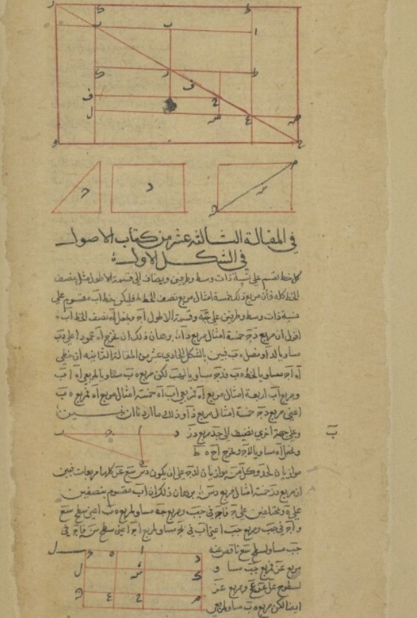
Fig. A page from Al Sijzi's geometrical treatise.

Earth's rotation: Al-Biruni tells that Al-Sijzi invented an astrolabe, called ‘al-zuraqi’, whose design was based on the idea that the Earth rotates: I have seen the astrolabe called Zuraqi invented by Abu Sa'id Al-Sijzi. I liked it very much and praised him a great deal, as it is based on the idea entertained by some to the effect that the motion we see is due to the Earth's movement and not to that of the sky. By my life, it is a problem difficult of solution and refutation. [...] For it is the same whether you take it that the Earth is in motion or the sky. For, in both cases, it does not affect the Astronomical Science. It is just for the physicist to see if it is possible to refute it.
The fact that some people held view that the earth is moving on its own axis is further confirmed by a reference from the 13th century which states: "According to the geometers, the earth is in constant circular motion, and what appears to be the motion of the heavens is actually due to the motion of the earth and not the stars."

Methilem of Madrid
Maslamah Al-Majriti, also known as Methilem in Latin liturature, was a Spanish Arab mathematician, astronomer and chemist. He made contributions in inventing new techniques for surveying, updating the astronomical tables of algorithmi and being the earliest Alchemist to record the usage and experimentation of mercuric oxide.

He lived during c. 950 –1007CE. He was born in Madrid (Arabic Majrit), hence his title Majriti. Methilem died in Cordoba.
Maslamah took part in the translation of Ptolemy's Planispherium, improved existing translations of the Almagest, revised and improved the astronomical tables of Algorithmi.
He aided historians by working out tables to convert Persian dates to Hijri years. He introduced the techniques of surveying and triangulation by working closely with his student and colleague Ibn al-Saffar.
He introduced new surveying methods. He also wrote a book on taxation and the economy of Spain.
He edited parts of the Encyclopedia of the Brethren of Sincerity when the encyclopaedia arrived in Spain.
He built a school of Astronomy and Mathematics and marked the beginning of organized scientific research in southern Spain. Among his students were Ibn al-Saffar, Abu al-Salt and Al-Tartushi.

Ibn Wahshiyyah the Nabataean
Ibn Wahshiyyah (fl. 9th/10th centuries) was a Nabataean alchemist, agriculturalist, farm toxicologist and Egyptologist. He was born at Qusayn near Kufa in Iraq in 9th century. He died in 10th century.

He was one of the first Egyptologists to be able to partly decipher ancient Egyptian hieroglyphs, by relating them to the contemporary Coptic language used by Coptic priests in his time.

The Egyptians invented the pictorial script. The appearance of these distinctive figures in 3000 BCE marked the beginning of Egyptian civilization. Though based on images, Egyptian script was more than a sophisticated form of picture-writing. Each picture/glyph served three functions: (1) to represent the image of a thing or action, (2) to stand for the sound of a syllable, and (3) to clarify the precise meaning of adjoining glyphs. Writing hieroglyphs required some artistic skill, limiting the number chosen to learn it. Only those privileged with an extensive education (i.e. the Pharaoh, nobility and priests) were able to read and write hieroglyphs; others used simpler 'joined-up' versions: demotic and hieratic script. Knowledge of the hieroglyphs had been lost completely by the medieval period. An Arabic manuscript of Ibn Wahshiyya's book Kitab Shawq al-Mustaham, a work that discusses a number of ancient alphabets, in which he deciphered a number of Egyptian hieroglyphs, was later read by Athanasius Kircher in the 17th century, and then translated and published in English by Joseph von Hammer-Purgstall in 1806 as ‘Ancient Alphabets and Hieroglyphic Characters Explained; with an Account of the Egyptian Priests, their Classes, Initiation, and Sacrifices in the Arabic Language by Ahmad Bin Abubekr Bin Wahishih’, 16 years before Jean-François Champollion's complete decipherment of Egyptian hieroglyphs.
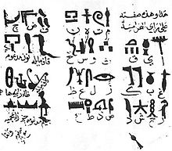
Ibn Wahshiyya's 985 CE translation of the Ancient Egyptian hieroglyph alphabet

Ibn Wahshiyya translated from Nabataean the Nabataean Agriculture (Kitab al-falaha al-nabatiya; c. 904), a major treatise on the subject, which was said to be based on ancient Babylonian sources.

The book extols Babylonian civilization against that of the conquering Arabs. It contains valuable information on agriculture and superstitions, and in particular discusses beliefs attributed to the Sabians – understood as people who lived before Adam – that Adam had parents and that he came from India. These ideas were discussed by the Jewish philosophers Yehuda Halevi and Maimonides, through which they became an influence on the seventeenth century French Millenarian Isaac La Peyrère.

S. H. Nasr said, “In agriculture, the ‘Filahat al-Nabatiyyah’ (Nabataean Agriculture) of Ibn Wahshiyya is the most influential of all Muslim works on the subject. Written in the third/ninth century and drawn mostly from Chaldaean and Babylonian sources, the book deals not only with agriculture but also with the esoteric sciences, especially magic and sorcery, and has always been considered to be one of the important books in Arabic on the occult sciences.”

His works on alchemy were co-authored with an alchemist named Abu Talib al-Zalyat; their works were used by Shams al-Din al-Ansari al-Dimashqi.

Alhazen
Alhazen was a polymath; the author of 90 works on topics as diverse as optics, vision, number theory, geometry, theology, astronomy, poetry, and healing. He made important contributions in the fields of optics and mathematics. Alhazen lived during c. 965 – c. 1040CE. Alhazen personally acknowledged authorship of 90 books, of which 55 still exist.
Alhazen is the Latinate form of original Arabic name Abu Ali al-Hasan ibn al-Haytham. Alhazen explained how the images formed in cameras are upside down, solved ‘Alhazen’s problem’ concerning the reflection of light from curved surfaces, and discovered a general method to find the sum of any integral power. He used this general method to discover the sum of fourth power positive integers and hence find the volume of a paraboloid.
Alhazen was born into a Muslim family in Basra, Iraq. Alhazen became a vizier in Basra and spent his spare time working on mathematics, writing a treatise on the ancient (and impossible) problem of squaring the circle.
In about 1000 CE, Alhazen left Basra for Cairo to work for its king, Hakim, who was a supporter of the sciences.

Attempt to FLOOD Management: Agriculture in Egypt was wholly dependent on annual floods of the River Nile, but these had become increasingly unreliable. Alhazen believed he could make them reliable again by regulating flow of the Nile with a dam. The king was excited by Alhazen’s plans and put him in charge of the project.
Unfortunately, Alhazen could not fulfill his promises, which terrified him, because the king had a fearsome reputation for punishing failure brutally. Alhazen feigned insanity and hid in a mosque. Alhazen did some of his greatest work while taking refuge. When the king died in 1021, Alhazen reemerged to enjoy about 19 years of freedom until his own death in Cairo in about 1040.
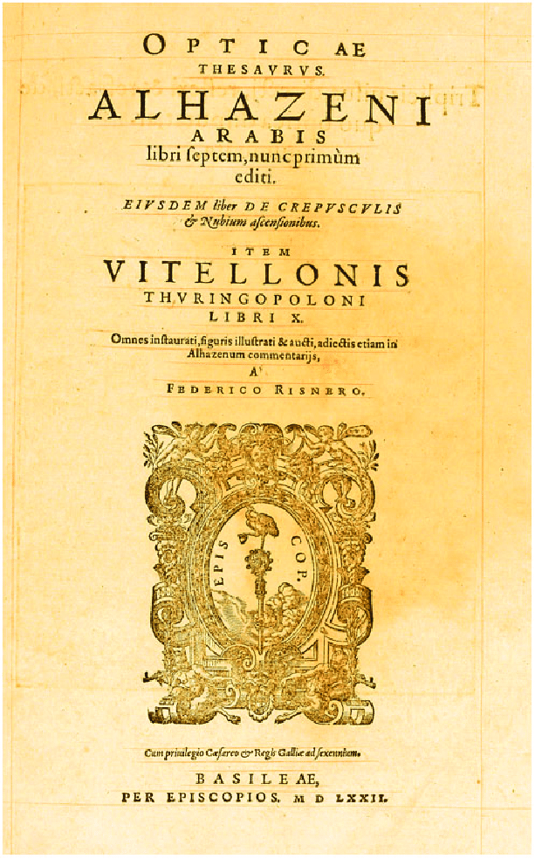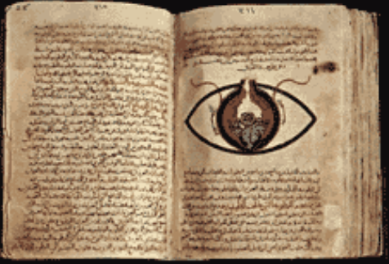
The Book of Optics
In his great work Book of Optics, Alhazen correctly identified that our eyes do not emit rays.
Alhazen was aware of two schools of thought from Ancient Greece about light and vision:
(A) Plato, Euclid, Galen, and Ptolemy promoted the idea that our eyes emit rays which land on objects allowing us to see them. They realized light is not really emitted by our eyes, it comes from luminous sources such as the sun. They used the eye ray theory to explain an number of puzzling problems – for example, you don’t see a small object on the ground even though you are looking at the general area it is in until rays from your eyes actually land directly on it.
(B) Aristotle said our eyes do not emit rays. In the sixth century John Philoponus said our eyes receive rays of light. He said air allows colors to pass through it without becoming colored itself. He supported this with his observation that a stained-glass window casts colors on floors and walls but does not color the air.
He argued that light affects the eye – for example we can damage our eyes by looking directly at the sun – but our eyes do not affect light. Moreover, he said that if we look at a bright object, an afterimage remains with us after we close our eyes. Again this suggests that our eyes have been affected by light. Otherwise, Alhazen supported most aspects of Galen’s incorrect assessment of how the eye works, such as the lens is the receptive organ of sight.
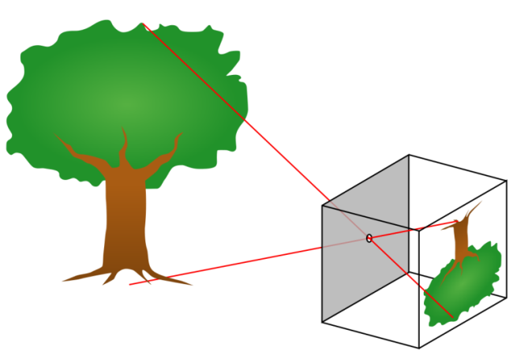
A pinhole camera produces an inverted image.
The Camera Obscura: Camera is a Latin word meaning an arched or vaulted room, while obscura means dark.
In ancient times, different cultures discovered that a tiny hole in an external wall of a dark room allows images of the outdoors to form upside down inside the room, as shown below. The effect can also be seen in a pinhole camera, consisting of a dark box with a small hole in it.
Alhazen carried out experiments with pinhole cameras and candles and explained correctly how the image is formed by rays of light traveling in straight lines.
As we have seen, Alhazen was fascinated by light and vision. This led him to make an intriguing mathematical discovery that suggested a link between algebra and geometry. The link was later reinforced by Omar Khayyam and fully developed by Descartes and Fermat.
An Ancient Greek book entitled Catoptrics compiled probably between the times of Euclid and Theon considered the behavior of reflected light and established the law of light reflection. A work by Hero of Alexandria made the assumption that light rays always take the shortest path between two points.
Alhazen considered an observer and a mirror shaped like the inside of a circle. He pictured a ray of light arriving at the mirror from a light source. He asked the question: at what point on the mirror must a light ray arrive so that it is reflected into the eye of the observer? He sought to solve the problem for the light source and observer in any positions. This question became known as Alhazen’s Problem, and is often called Alhazen’s Billiard Problem.
Alhazen’s Billiard Problem
The behavior of a billiard ball is helpful in understanding Alhazen’s problem.
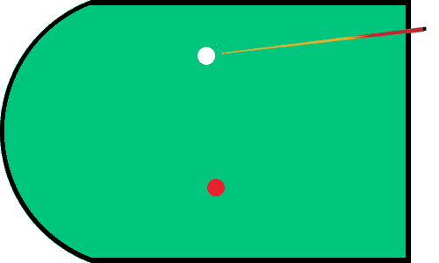
Alhazen’s billiard problem: At which point on the circular side of the table must you aim the cue ball so that it hits the center of the red ball? Solve the problem for the cue ball and red ball in all possible locations.
By means of long, complicated geometrical arguments and proofs, Alhazen solved the problem by considering a circle’s intersection with a hyperbola.
The Sum of Fourth Powers
Alhazen discovered the formula for the sum of fourth powers when he took on the challenge of calculating the volume of a paraboloid.
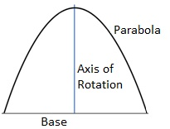
Fig. Rotating the parabola around the axis creates a hill-shaped paraboloid.

Alhazen approached the problem in the way Eudoxus or Archimedes would have, by the method of exhaustion, summing slices of the shape. Archimedes had used this technique brilliantly to find the volume of a sphere.
Alhazen applied the method of exhaustion to the paraboloid and found he needed the formula for the sum of fourth powers to calculate the answer. The formula for the sum of second powers had been discovered by Archimedes, and third powers by the great Indian mathematician Aryabhata. There was, however, no formula for the sum of fourth powers. Alhazen realized he would have to discover this for himself. And he did discover it.
In fact, the method Alhazen developed to discover the formula was valid for any power, so he could have found the sum of the fifth power, sixth power, seventh power, etc.
Sums of Powers:
Alhazen invented a method to find sums of powers shown below. He wrote them in words, but modern notation is easier to follow:

Sum of first powers:
As per formula, sum of first powers:
1+2+3+. . . . . . .+100= (100)² /2+100/2=5050.

Sum of second powers:
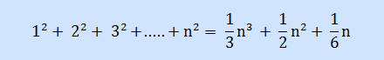
Sum of third powers:
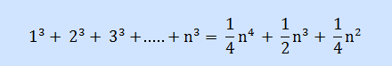
Sum of fourth powers:
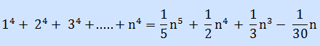

Alhazen described eloquenty his personal view of what being a scientist means: “The duty of the man who investigates the writings of scientists, if learning the truth is his goal, is to make himself an enemy of all that he reads, and, applying his mind to the core and margins of its content, attack it from every side. He should also suspect himself as he performs his critical examination of it, so that he may avoid falling into either prejudice or leniency.”

Ahmad Al-Biruni
Al-Biruni was one of the greatest scientists of all time and was an accomplished cartographer and linguist. Royalty and powerful members of society sought out Al-Biruni to conduct research and study to uncover certain findings. George Sarton wrote that al-Biruni was “one of the very greatest scientists of Islam, and, all considered, one of the greatest of all times”. Al-Biruni was well ahead of the state of European scientific thought. Al-Biruni was the first to compute the radius of the earth.
Al-Biruni lived during 973-1048CE. He was conversant in Khwarezmian (mother tongue), Persian, Arabic, Sanskrit and also knew Greek, Hebrew and Syriac. Al-Biruni spent the first 25 years of his life in Khwarezm where he studied grammar, mathematics, astronomy, medicine, philosophy, theology and the original works of several ancient Greek scientists and mathematicians. He left his homeland for Bukhara. There he corresponded with Avicenna and there are extant exchanges of views between these two scholars.
In 998, he went to the court of the amir of Tabaristan. There he wrote his first important work, al-Atharul-Baqiya 'anil Qorunil Khaliyya (Chronology of ancient nations) on historical and scientific chronology.
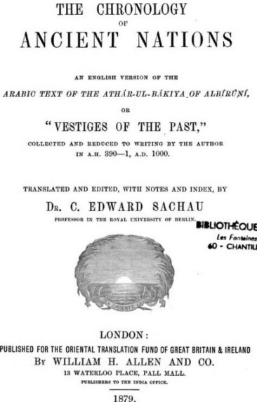
In 1017CE, Mahmud of Ghazni took Rey. Most scholars, including al-Biruni, were taken to Ghazni. Biruni accompanied Mahmud on his invasions into India, living there for a few years. Biruni became acquainted with all things related to India.
Al-Biruni’s Codex Masudicus’ (1037) is an encyclopedia of sciences; title is after Masud, son of sultan Mahmud Ghaznavi. In ‘Codex Masudicus’ he theorized the existence of a landmass along the vast ocean between Asia and Europe, or what we know today as the continents of north and south America. He deduced its existence on the basis of his accurate estimations of the Earth's circumference; amazingly his measurements were just 10.44 miles less than the modernly accepted circumference, and Afro-Eurasia's size, which he found spanned only two-fifths of the Earth's circumference, and his discovery of the concept of specific gravity, from which he deduced that the geological processes that gave rise to Europe and Asia must
have also given rise to lands in the vast ocean between Asia and Europe. Not only did he predict the existence of the Americas, but he also submitted that this landmass must be inhabited by human beings, which he deduced from his knowledge of humans inhabiting the broad north-south band stretching from Russia to South India and Sub-Saharan Africa, assuming that the landmass would most likely lie along the same band.
Also in ‘Codex Masudicus’, he discussed the possibility that the sun is stationary and that the earth revolves around it. Copernicus published in 1543 the Copernican theory, which is commonly regarded as a definitive work on heliocentric theory.
Demonstrating al-Biruni’s method for measuring the earth’s radius
The Greek mathematician Eratosthenes (276-194 BC) had the distinction of being the first to measure the circumference (and, consequently the radius) of the earth. Al-Biruni applied some pure mathematics to devise a much more efficient, and potentially more accurate, method. Eratosthenes’ method relied on knowing the distance between Alexandria and Syene which are about 800 km apart. Al-Biruni’s method did not require the laborious and inaccurate task of measuring the long distance between two sites (probably by walking and counting paces), but could be performed by a single person measuring three angles (with an astrolabe) and a reasonably short distance (between 500 to 1000 meters in al-Biruni’s case). He performed his calculation at Nandana Fort at Pind Dadan Khan city, Jhelum (in Pakistan).
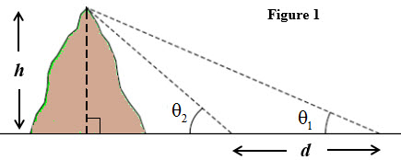
Al-Biruni measured the horizontal distance d between two points and the angle of elevation from each of the points to the top of a nearby mountain (Figure 1). Using trigonometry and algebra, al-Biruni derived the following formula for the height h of the mountain in terms of only the two angles of elevation θ 1 and θ 2 and the horizontal distance d between the points where θ 1 and θ 2 were measured.
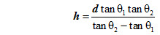
The third required angle measured by al-Biruni was the ‘dip angle’ φ – the angle of depression from the top of the mountain to the distant horizon. Al-Biruni then imagined a very large right triangle (Figure 2) with its three vertices being the top of the mountain, the center of the earth, and the point on the horizon that was sited from the top of the mountain.
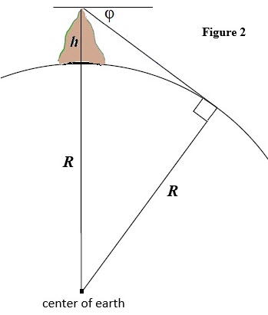
Using this triangle, al-Biruni again used some pure mathematics – algebra and trigonometry – to derive a formula for the radius of the earth R, expressed only in terms of the height h of the mountain and the dip angle φ .
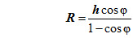
Al-Biruni computed the radius of the earth to be about 6339 km (converting from cubits – the distance measure that al-Biruni used) which gives the earth’s circumference to be about 39830 km which is more accurate that Eratosthenes’ calculation of about 39690 km. The earth is not a perfect sphere (radius to the poles is shorter than to the equator). The mean radius and circumference are 6371.0 km and 40030 km. Eratosthenes had to deal with significant measurement inaccuracies – in measuring the angle of inclination of the sun and especially in measuring the distance between Alexandria and Syene. Although the one distance required for al-Biruni’s method was inherently more accurate it was difficult to measure angles with a great deal of accuracy. The astrolabe that al-Biruni used would certainly have been more accurate than whatever angle measuring device that Eratosthenes had used. Historians have surmised that al-Biruni’s astrolabe was probably able to measure angles up to 1 minute of an arc which is 1/60 of a degree.
Various “tools” were used for the development and execution of the method. a) an astrolabe (or giant protractor) and counting paces to measure distance; b) algebra was also a necessary “tool” that was absolutely critical for finding the two formulas that were central to Al-Biruni’s method; c) there was another necessary “tool” it was necessary to evaluate trigonometric functions in order to apply the two formulas. How would al-Biruni have evaluated a trigonometric function (e.g. evaluate tan 0.57∘ )? It’s now been more than 30 years since students routinely used tables (and interpolation when necessary) to evaluate trigonometric functions. Of course, Al-Biruni would have valued his trigonometric tables just as much – if not more so – than his precisely crafted astrolabe.
He wrote approximately 150 books on a wide range of subjects – including mathematics, astronomy, physics, geography and history. He wrote “study of India”, Book of Instruction in the Elements of the Art of Astrology (Kitab tafhim li-wa’il sina‘at al-tanjim) and other books.

Avicenna
Avicenna was a true polymath with his contributions ranging from medicine, psychology and pharmacology to geology, physics, astronomy, chemistry theology and philosophy. Avicenna is the Latinized version of original Arabic name Ibn Sina.
He lived during c. 980-1037CE. Avicenna was born in the village of Afshana, near Bukhara, now in Uzbekistan, which is also his mother’s hometown. His father, Abdullah an advocate of the Ismaili Shiah sect, was from Balkh which is now a part of Afghanistan. Ibn Sina received his early education in his home town and by the age of ten he had memorized the Quran. He had exceptional intellectual skills which enabled him to overtake his teachers at the age of fourteen. Ibn Sina was a religious man. When he was still young, Ibn Sina was highly baffled by the work of Aristotle on metaphysics so much so that he would pray to Allah to guide him. Finally after reading a manual by al-Farabi, he found the solutions to his difficulties.
At the age of sixteen he dedicated all his efforts to learn medicine and by the time he was eighteen gained the status of a reputed physician. During this time he cured Nuh II, Ruler of Bukhara, of an illness in which all the renowned physicians had given up hope. On this great effort, the Amir wished to reward him, and Avicenna requested consent to use his exclusively stocked royal library. During the next few years he devoted himself to Muslim jurisprudence, philosophy and natural science and studied logic, Euclid, and Ptolemy’s Almagest.
On his father’s death, when Ibn Sina was twenty-two years old, he moved to Jurjan near the Caspian Sea where he lectured on logic and astronomy. Here he also met al-Biruni. Later he travelled to Rey and then to Hamadan (both in present day Iran), where he wrote and taught his works. Here he also prescribed for Shams al-Dawla, the Emir of Hamadan.
From Hamadan, he moved to Isfahan, where he finished his epic writings. Nevertheless, he continued to travel and too much mental exertion as well as political chaos affected his health. The last decade or so of his life, he spent in the service of a military commander Ala al-Dawla Muhammad. He served him as a physician and general literary and scientific consultant, including during his campaigns. He died during June 1037CE and was buried in Hamedan, Iran.
Works
Avicenna’s famous book “The Canon of Medicine” was an immense encyclopedia of medicine including over a million words. It comprised of medical knowledge available from ancient and Muslim sources. This book was translated into Latin in the twelfth century and was used as the standard medical text in European universities until the mid-seventeenth century.
His other major work was “The Book of Healing”, a scientific and philosophical encyclopedia. This book was intended to ‘heal’ the soul. It was split into four parts: logic, natural sciences, mathematics and metaphysics. In his book, he developed his own system of logic, Avicennian logic.

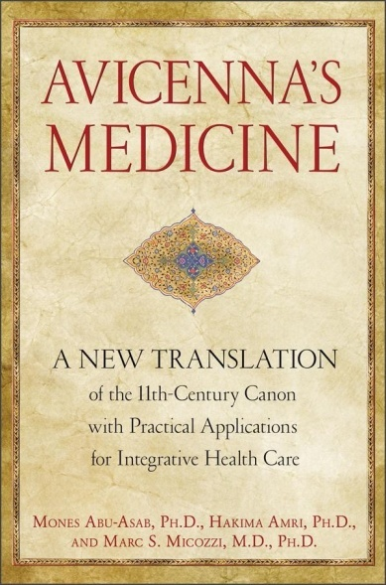

In astronomy, Avicenna proposed that Venus was closer to the Sun than the Earth. He invented an instrument for observing the coordinates of a star. He made several astronomical observations and stated that the stars were self-luminous.
In mathematics, Avicenna explained the arithmetical concept and application of the “casting out of nines”. Avicenna also contributed to poetry, religion and music. In total, Avicenna wrote over 400 works, of which around 240 have survived.

Bi Sheng
Bi Sheng was a Chinese artisan and inventor of the world's first movable type printing technology. Bi Sheng's system was made of Chinese porcelain and was invented between 1041 and 1048. Movable type is the system and technology of printing and typography that uses movable components to reproduce the elements of a document (usually individual alphanumeric characters or punctuation marks) usually on the medium of paper.
Bi Sheng was born in Yingshan County, Hubei. His ancestry and details were not recorded. He lived during 990–1051CE. He was recorded only in the Dream Pool Essays by Chinese scholar-official and polymath Shen Kuo (1031–1095). The book records detailed description on the technical details of Bi Sheng's invention of movable type:
“During the reign of Chingli (Qìnglì), 1041–1048, Bi Sheng, a man of unofficial position, made movable type. His method was as follows: he took sticky clay and cut in it characters as thin as the edge of a coin. Each character formed, as it were, a single type. He baked them in the fire to make them hard. He had previously prepared an iron plate and he had covered his plate with a mixture of pine resin, wax, and paper ashes. When he wished to print, he took an iron frame and set it on the iron plate. In this he placed the types, set close together. When the frame was full, the whole made one solid block of type. He then placed it near the fire to warm it. When the paste [at the back] was slightly melted, he took a smooth board and pressed it over the surface, so that the block of type became as even as a whetstone.
For each character there were several types, and for certain common characters there were twenty or more types each, in order to be prepared for the repetition of characters on the same page. When the characters were not in use he had them arranged with paper labels, one label for each rhyme-group, and kept them in wooden cases.”

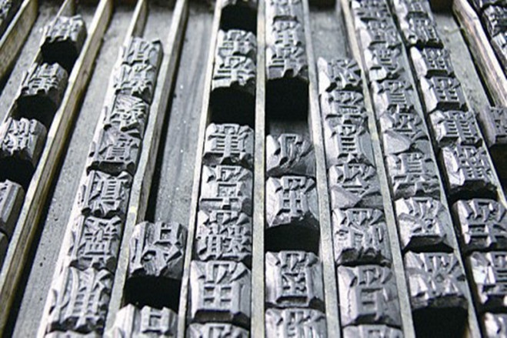

Bi Sheng’s printing press was one of the great inventions of China.

Su Song
Su Song was a renowned astronomer, medical doctor, mechanical and architectural engineer. He lived during 1020–1101 CE. The son of a high-ranking official, Su Song successfully passed his Jinshi degree examination and was offered a post in the Imperial Library in 1053. In 1057 the Song court appointed him to revise the medical classics. By 1062 he revised and enlarged work on pharmacology and natural history in China.

After having served for nine years in the Imperial Library, Su Song accepted a position in local government in order to improve his family’s economic situation. He was, however, unable to work his way up in the central administration because he and other conservative officials did not like Wang Anshi’s reforms. He served as envoy to the Khitan state Liao and governor of the capital of Kaifeng in 1078. He was demoted for a short time because a member of his staff had failed in certain assignments. However, he eventually became Vice-minister of Personnel Affairs and Minister of Justice in 1086.

In the same year the Song government issued orders for the inspection of existing astronomical equipment and the creation of an astronomical clock. Two years later a wooden model was presented to the emperor and in 1090 the metal parts for an armillary sphere and a celestial globe were cast in bronze. The emperor appointed Su Song deputy prime minister in 1090 and prime minister in 1092. He then submitted to the emperor Xin I Xiang Fayao, a thesis describing the construction of a mechanical clock.
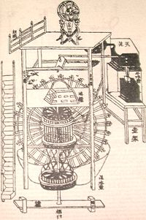
The original diagram of Su's book showing his clocktower

He retired in the same year when the reform party controlled the Song court. One of his descendants compiled Su Song’s collected works under the title Su Weigong Wenji.

Arzachel
Copernicus in his famous book 'De Revolutionibus Orbium Clestium' expresses his indebtedness to foremost Spanish Arab astronomer Arzachel and quotes his work several times. Arzachel is Latinate form of original name Abu Ishaq Ibrahim ibn Zarqala. He lived during 1028–1087 in Spain. He was born in Toledo. Arzachel greatly expanded the understanding and accuracy of planetary models and terrestrial measurements used for navigation. He developed key technologies including the equatorium and universal latitude-independent astrolabe.
Arzachel carried out a series of astronomical observations at Toledo and compiled them in what is known as his famous Toledan Tables. He corrected the geographical data from Ptolemy and Algorithmi. Specifically, Arzachel corrected Ptolemy's estimate of the length of the Mediterranean sea from 62 degrees to the value of 42 degrees.
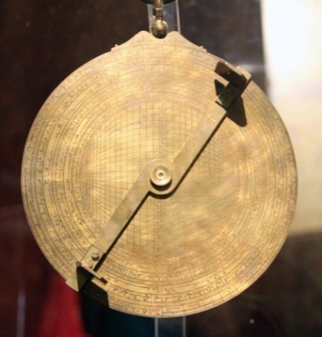
A copy of Arzachel's astrolabe as featured in the Calahorra Tower, Calahorra, Spain.

Arzachel was the first to prove conclusively the motion of the Aphelion relative to the stars.
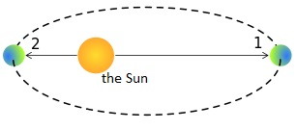
Fig. aphelion and perihelion (1. Planet at aphelion 2. Planet at perihelion)

The aphelion is the point in the orbit of an object where it is farthest from the Sun. The point in orbit where an object is nearest to the sun is called the perihelion. The word aphelion derives from the Greek words, apo meaning away, apart and Helios meaning the Sun. The Earth's orbit has its aphelion about July 4.
He measured its rate of motion as 12.04 seconds per year, which is remarkably close to the modern calculation of 11.8 seconds. Arzachel invented a flat astrolabe which is known as Safihah. Its details were published in Latin, Hebrew and several European languages.

Omar Khayyam

The poetry of Omar Khayyam is better known in the West than any other non-Western poet. Khayyam was an astronomer, physician, philosopher and mathematician: he made outstanding contributions in algebra.
Omar Khayyam lived during 1048 – 1131CE. Khayyam was born in the city of Nishapur in Iran in a Muslim family. Omar’s father was Ibrahim Khayyam, a wealthy physician. Omar’s forefathers earned a living making tents, because Khayyam means tent-maker. His father employed a mathematician by the name of Bahmanyar, son of Marzban, to tutor Omar. Bahmanyar was a devotee of Zoroastrianism and he had been a student of Avicenna. Omar received a thorough education in science, philosophy and mathematics from Bahmanyar and studed astronomy, Ptolemy’s Almagest from Anbar. In his early teens Omar worked in his father’s surgery. In1066, Omar’s father died. After few months Omar’s tutor Bahmanyar also died.
Khayyam joined one of the regular caravans making a three month journey from Nishapur to the city of Samarkand. Khayyam arrived there probably in 1068. In Samarkand, he made contact with his father’s old friend Abu Tahir, who was governor and chief judge of the city. Abu Tahir, observing Khayyam’s extraordinary talent, gave him a job in his office. Soon Khayyam was given a job in the king’s treasury. While living in Samarkand, Khayyam made a major advance in algebra after Algorithmi.

At school, we learn about equations of the form ax² + bx + c = 0; these are called quadratic equations. Cubic equations are of the form ax³ + bx² + cx + d = 0. Naturally, cubic equations are harder to solve than quadratics. Khayyam conjectured correctly that it is not possible to solve cubic equations using the traditional Ancient Greek geometrical tools of straightedge and compass. Other methods are required.
At the age of 22, in 1070CE, Khayyam published one of his greatest works: Treatise on Demonstration of Problems of Algebra and Balancing. In it he showed that a cubic equation can have more than one solution. He also showed how the intersections of conic sections such as parabolas and circles can be utilized to yield geometric solutions of cubic equations.
Archimedes had actually started work in this field over a thousand years earlier, when he considered the specific problem of finding the ratio of the volume of one part of a sphere to another.
Khayyam considered the problem in a more general, methodical way.

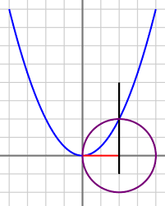
Fig. In the language of modern mathematics, Khayyam’s solution to the equation x³ + a²x = b features a parabola of equation x² = ay, a circle with diameter b/a², and a vertical line through the intersection point. The solution is given by the distance on the x-axis between the origin and the right-hand side vertical line.

Khayyam’s solutions avoided negative coefficients and negative roots, although Abul Wafa (940-998) used negative numbers and Brahmagupta had introduced negative numbers 400 years earlier.
Though Khayyam’s achievement was magnificent, he was disappointed that he needed to utilize geometry to solve cubic equations – he had hoped to discover an algorithm using only algebra. Following Khayyam’s breakthrough there was little significant progress on cubic equations until 1535, when Niccolo Tartaglia found general solutions for all cubic equations.

Khayyam’s algebra was not the system of letters and signs we use today. His algebra was expressed in words. So, where today we write: Solve for x: x² + 6 = 5x, Khayyam wrote: What is the amount of a square so that when 6 dirhams are added to it, it becomes equal to five roots of that square?
Linking Algebra and Geometry: Khayyam’s work with cubics had made him certain that algebra and geometry were linked, and he cited Euclid’s Elements to support the idea: Whoever thinks algebra is a trick in obtaining unknowns has thought it in vain. No attention should be paid to the fact that algebra and geometry are different in appearance. Algebras are geometric facts which are proved by Propositions 5 and 6 of Book 2 of Euclid’s Elements. The link was later fully developed by Descartes and Fermat in the 1600s, resulting in the modern x-y coordinate system.
Length of Year: In the year 1072CE, Khayyam documented the most accurate year length ever calculated – a figure still accurate enough for most purposes in the modern world.
In 1073 CE, Khayyam received an invitation from Malik Shah, Sultan of the Seljuq Empire, and Nizamul-Mulk, his vizier to Isfahan, capital of the Seljuk Empire, to prepare a calendar that would work in an orderly way and be accurate forever. This was an era in which year lengths were regularly changed. Khayyam recruited other talented scientists to accompany him to Isfahan. There he was paid an extraordinarily high salary. Malik Shah paid Omar Khayyam to found an observatory with an initial aim of making observations of the
heavens for 30 years, during which time Saturn, the most distant planet then known, would complete an orbit.
During his time in Isfahan, Khayyam measured the length of a year – to be specific the tropical year length – with remarkable accuracy and precision. Khayyam found that 1,029,983 days made 2,820 years. This gives a tropical year length of 365.2422 days to seven significant figures. Today we know that the length of a tropical year actually changes by as much as 30 minutes from year to year. The average tropical year length quoted today is 365.242189 days, which to seven significant figures is 365.2422 days – exactly the figure Khayyam arrived.
Malik Shah introduced Khayyam’s new calendar in the Seljuk Empire on March 15, 1079. It was used until the 20th century.
The Parallel Postulate: The fifth of Euclid’s five postulates was the parallel postulate. The parallel postulate proved to be a source of puzzlement, irritation, and joy for mathematicians for millennia. The joy was usually short-lived, belonging to mathematicians who thought they had proven the postulate only to be disappointed when an error was identified in their ‘proof.’
Euclid had considered a straight line crossing two other straight lines. He looked at the situation when the interior angles (shown in the image below) add to less than 180 degrees. In these circumstances, he said that the two straight lines will eventually meet on the side of the two angles that add to less than 180 degrees.
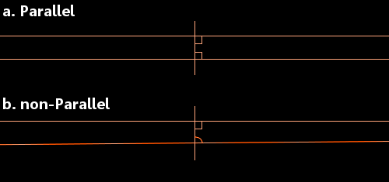
a. When each angle is 90 degrees, the lines are parallel.
b. If one or both of the angles is less than 90 degrees, the lines will meet.

Since the time Elements was first published, mathematicians had been trying to use Euclid’s first four postulates to prove the parallel postulate. They were doomed to fail. We now know that it is impossible to prove the parallel postulate using Euclid’s other postulates.
Khayyam’s attempt was interesting. In his Explanations of the Difficulties in the Postulates in Euclid’s Elements he asks his readers to consider a straight line AB:
He asks his readers to consider two equal lines that are perpendicular to AB and sees three possible arrangements, which can produce four-sided figures:
He then refutes the possibility that angles C and/or D can be anything other than right-angles and in the image above only the central option is possible. So, he believes he has proven the parallel postulate. In fact, he has not done so, all he has done is stated it in a different way.

In Khayyam’s ideas the first glimmers of non-Euclidean geometry are seen.
In 1092CE, Malik Shah died probably by poisoning and his vizier by assassination. Khayyam went into hiding during the resulting power struggle. He had been Malik Shah’s personal physician and close friend – which had made him enemies – and Khayyam’s poetry contained metaphor and rhetoric which may not be religious – and this had also made him enemies.
After the power struggle, it took about 20 years for Khayyam to be fully rehabilitated and for him to emerge again, in the company of powerful people. However, he refused to teach. His survival depended on lying low.
Khayyam died in his hometown of Nishapur in 1131CE.

Abu Hamid al-Gazali
Al-Ghazali was a prominent and influential Persian philosopher, theologian, jurist and economist. His full name Abu Ḥamid Muḥammad al-Ghazali; Latinate form Algazelus is rarely used. He lived during c. 1058 – 19 December 1111CE. He was born in Tus, Khorasan. His book titled Tahafut al-Falasifa (Incoherence of the Philosophers) is a significant landmark in the history of philosophy, as it advances the critique of Aristotelian science developed later in 14th-century Europe. The encounter with skepticism led al-Ghazali to embrace a form of theological occasionalism, or the belief that all causal events and interactions are not the product of material conjunctions but rather the immediate and present Will of God.
Al-Ghazali gave as an example of the illusion of independent laws of cause the fact that cotton burns when coming into contact with fire. While it might seem as though a natural law was at work, it happened each and every time only because God willed it to happen—the event was "a direct product of divine intervention as any more attention grabbing miracle". Averroes, by contrast insisted while God created the natural law, humans "could more usefully say that fire caused cotton to burn—because creation had a pattern that they could discern."
The Incoherence also marked a turning point in philosophy in its vehement rejections of Aristotle and Plato. The book took aim at the falasifa, a group of Muslim philosophers from the 8th through the 11th centuries (most notable among them Avicenna and Al-Farabi) who drew intellectually upon the Ancient Greeks. Hassan Hassan in 2012 commented, “Al Ghazali's critique of falsafa was in fact meant to encourage independent inquiry. He argued that some fundamentalists, who perceive falsafa to be incompatible with religion, tend to categorically reject all views adopted by "philosophers", including scientific fact like the lunar and solar eclipse. And when that person is later persuaded of a certain view, he tends to blindly accept all other views held by philosophers. Al- Ghazali sought to dissect such "incoherence" within falsafa; he effectively differentiated between philosophy and logic on one hand and physics and mathematics on the other. His students later noted: "Our master swallowed philosophy and could not throw it up."
Economic philosophy
Most aspects of Al-Ghazali's life were heavily influenced by his Islamic beliefs, and his economic philosophy was no exception. He held economic activity to a very high level of importance in his life and thought that others should as well, as he felt that it was not only necessary for the overall benefit to society but also to achieve spiritual wholeness and salvation. In his view, the worldly life of humanity depended on the economic activity of people.
And so he considered being economically active to be a mandated part of religion.
He established three goals of economic activity that he believed were part of one's religious obligation as well as beneficial to the individual: "achievement of self-sufficiency for one's survival; provision for the well-being of one's progeny; and provision for assisting those in economic need." He argued that subsistence living, or living in a way that provides the basic necessities for only one's family, would not be an acceptable practice to be held by the general population because of the detrimental results that he believed that would bring upon the economy, but he acknowledged that some people may choose to live the subsistence lifestyle at their own will for the sake of their personal religious journey. Conversely, he discouraged people from purchasing or possessing excessive material items, suggesting that any additional money earned could be given to provide for the poor. Al-Ghazali thought that it should not be necessary to force equality of income in society but that people should be driven by "the spirit of Islamic brotherhood" to share their wealth willingly, but he recognized that it is not always the case. He believed that wealth earned could be used in two potential manners. One is for good, such as maintaining the health of oneself and their family as well as taking care of others and any other actions seen as positive for the Islamic community. The other is what Al-Ghazali would consider misuse, spending it selfishly on extravagant or unnecessary material items.
In terms of trade, Al-Ghazali discussed the necessity of exchanging goods across close cities as well as larger borders because it allows more goods, which may be necessary and not yet available, to be accessible to more people in various locations. He recognized the necessity of trade and its overall beneficial effect on the economy, but making money in that way might not be considered the most virtuous in his beliefs. He did not support people taking ‘excessive’ profits from their trade sales.
Al-Ghazali believed that the Islamic spiritual sciences taught by the first generation of Muslims had been forgotten. That resulted in his writing his magnum opus entitled Ihya ulum al-din (The Revival of the Religious Sciences).
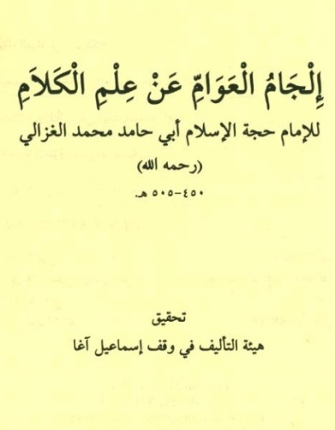
Fig. Al-Ghazali’s book Iljamul Awam aan ilmil Kalaam.

Buhahylyha Bingezla
Abu ali Yahya Ibn Jazla, Latinized as Buhahylyha Bingezla, was an 11th-century Arab physician of Iraq and author of Tacvini Aegritvdinvm et Morborum ferme omnium Corporis humani: cum curis eorundem, an influential treatise on regimen.
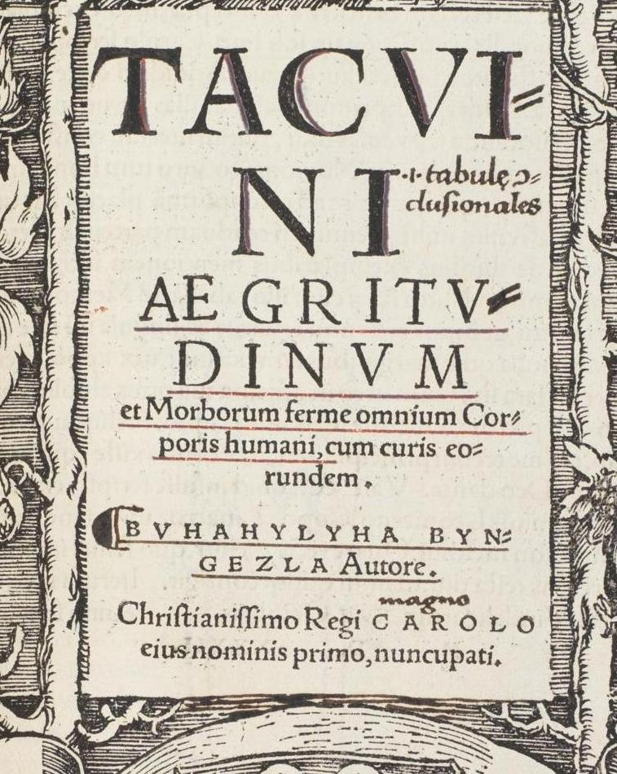
Fig. Tacvini Aegritvdinvm et Morborum ferme omnium Corporis humani: cum curis eorundem
The Tacuin was translated into Latin in 1280 CE by the Sicilian Jewish physician Faraj ben Salim and the Latin version was published in 1532. A German translation was published at Strasbourg in 1533 by Hans Schotte.
Ibn Jazla’s other work, Al-Minhaj fil-Adwiah Al-Murakkabah (Methodology of Compound Drugs). It was translated into Latin by Jambolinus under the caption Cibis et medicines simplicibus.
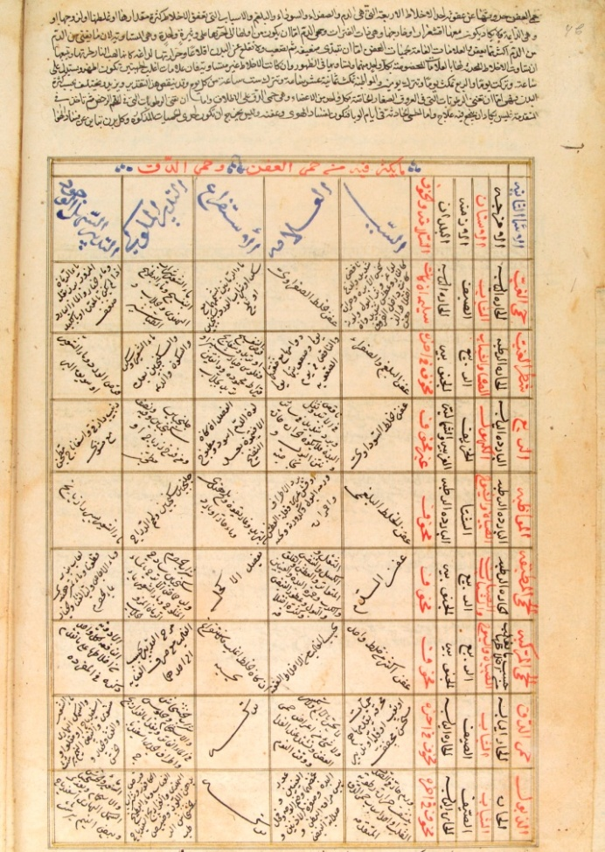
Fig. Table in which various maladies and their treatments are summarized within interlinear and intercolumnar rules and with commentaries in the upper and lower margins.

His Taqwim al-Abdan fi Dadbir al-Insan (Dispositio corporum de constitutione hominis, Tacuin agritudinum), as the name implies: tables in which diseases are arranged like the stars in astronomical tables, was translated into Latin.
Ibn Jazla was born of Christian Nestorian parents at Baghdad. He converted to Islam in 1074CE. A convert to Islam, he wrote a book under the caption ‘Risalah fi raddi ala Nasraniyyah’ in praise of Islam.
He died in 1100 CE.

Baruch ben Malka
Baruch ben Malka was a philosopher, Bible-commentator, physician and physicist of Jewish descent from Baghdad. He lived during c. 1080 –1165 CE. Baruch was born in Balad on the Tigris in Iraq. As a renowned physician, he served at the courts of the caliphs of Baghdad and the Seljuk sultans.
Baruch was Jewish and he dictated a long philosophical commentary on Ecclesiastes (a book of the Bible) to his pupil Isaac ben Abraham ben Ezra. It was written in Arabic using Hebrew aleph bet. Isaac wrote a poem in his honour as introduction to this work.
He wrote a philosophical commentary on the Kohelet entitled Kitab al-Mu'tabar (the title may be translated as The Book of What Has Been Established by Personal Reflection). Kitab al-Muʿtabar consists in the main of critical remarks jotted down by him over the years while reading philosophical text, and published at the insistence of his friends, in the form of a philosophical work. The work "presented a serious philosophical alternative to, and criticism of, Ibn Sina". He also developed concepts which resemble several modern theories in physics. He wrote the treatise "On the Reason Why the Stars Are Visible at Night and Hidden in Daytime".

Motion:
According to Alistair Cameron Crombie, Baruch proposed an explanation of the acceleration of falling bodies by the accumulation of successive increments of power with successive increments of velocity. According to Shlomo Pines, Baruch's theory of motion was the oldest negation of Aristotle's fundamental dynamic law [namely, that a constant force produces a uniform motion], [and is thus an] anticipation in a vague fashion of the fundamental law of classical mechanics [namely, that a force applied continuously produces acceleration].
Baruch's theory of motion distinguished between velocity and acceleration and showed that force is proportional to acceleration rather than velocity.
Baruch also modified Ibn Sina's theory of projectile motion, and stated that the mover imparts a violent inclination (mayl qasri) on the moved and that this diminishes as the moving object distances itself from the mover.
Baruch also suggested that motion is relative, writing that "there is motion only if the relative positions of the bodies in question change." He also stated that "each type of body has a characteristic velocity that reaches its maximum when its motion encounters no resistance."
Space and time: Baruch criticized Aristotle's concept of time as "the measure of motion" and instead redefines the concept with his own definition of time as "the measure of being", thus distinguishing between space and time, and reclassifying time as a metaphysical concept rather than a physical one. Y. Tzvi Langermann writes: Dissatisfied with the regnant approach, which treated time as an accident of the cosmos, al-Baghdadi drew the conclusion that time is an entity whose conception (ma'qul al-zaman) is a priori and almost as general as that of being, encompassing the sensible and the non-sensible, that which moves and that which is at rest. Our idea of time results not from abstraction, stripping accidents from perceived objects, but from a mental representation based on an innate idea. Baruch stops short of offering a precise definition of time, stating only that 'were it to be said that time is the measure of being (miqdar al-wujud), that would be better than saying [as Aristotle does] that it is the measure of motion'. His reclassification of time as a subject for metaphysics rather than for physics represents a major conceptual shift, not a mere formalistic correction. It also breaks the traditional linkage between time and space. Concerning space, al-Baghdadi held unconventional views as well, but he did not remove its investigation from the domain of physics.
Baruch also regarded space as three-dimensional and infinite.
A few prescriptions for remedies remain in manuscript and are as yet unstudied.
He converted from Judaism to Islam later in his life and chose the name Hibatullah and nickname Abu'l-Barakat. Baruch's thought had a deep influence on philosophers like Fakhruddin Razi, but none on Jewish thought. His works were not translated into Hebrew, and he is seldom cited in Jewish philosophy, probably because of his conversion to Islam. Baruch famed as Awhad al-Zaman (Unique One of his Time).

Avempace
Avempace was a famous Spanish Arab physicist and botanist. He was the first to theorize the concept of a reaction force for every force exerted. Avempace is the Latinate form of Ibn Bajja. Avempace was born in Zaragoza, Spain, around 1085 and died in Fes in 1138.
Though many of his works have not survived, his theories in astronomy and physics were preserved by Maimonides and Averroes respectively, His works impacted contemporary medieval thought, and influenced later astronomers and physicists including Galileo Galilei. Avempace wrote one of the first commentaries on Aristotle. While his work on projectile motion was never translated from Arabic to Latin, his views became well known to European scientists. Avempace's theories on projectile motion are found in the text known as ‘Text 71’.
Physics
Avempace starts with a kinematic definition of motion and construes it as a force. According to Avempace, regarding freely falling objects, what is moved the a heavy body falls, is the heavy body and what moves it downward is its 'gravity' or its 'form' or 'nature'.
Text 71 of Averroes' commentary on Aristotle's Physics contains a discussion on Avempace's theory of motion, as well as the following quotation from the seventh book of Avempace's lost work on physics: "And this resistance which is between the plenum and the body which is moved in it, is that between which, and the potency of the void, Aristotle made the proportion in his fourth book; and what

is believed to be his opinion, is not so. For the proportion of water to air in density is not as the proportion of the motion of the stone in water to its motion in air; but the proportion of the cohesive power of water to that of air is as the proportion of the retardation occurring to the moved body by reason of the medium in which it is moved, namely water, to the retardation occurring to it when it is moved in air."
"For, if what some people have believed were true, then the natural motion would be violent; therefore, if there were no resistance present, how could there be any motion? For it would necessarily be instantaneous. What then shall be said concerning the circular motion? There is no resistance there, because there is no cleavage of a medium involved; the place of the circle is always the same, so that it does not leave one place and enter another; it is therefore necessary that the circular motion should be instantaneous. Yet we observe in it the greatest slowness, as in the case of the fixed stars, and also the greatest speed, as in the case of the diurnal rotation. And this is caused only by the difference in perfection between the mover and the moved. When therefore the mover is of greater perfection, that which is moved by it will be more rapid; and when the mover is of lesser perfection, it will be nearer (in perfection) to that which is moved, and the motion will be slower."
What follows is also found in Text 71: “This resistance offered to the moving body by the medium does not occur in the way Aristotle has established in the fourth book when he discussed the void. The velocity of a body is not inversely proportional to the density of the medium, but it is the retardation the motion is subject to by virtue of the medium, which is proportional to the density. If what Aristotle said was true, natural motion in a supposed void would not meet any resistance and it would not take time but be instantaneous. Also, the motion of the heavenly spheres, which do not traverse a medium, would occur instantaneously. We see these motions occurring with different finite velocities: the motion of the fixed stars is very slow; the daily motion is very fast. These differences in velocity are due to the fact that the movers of the spheres differ in nobility and the more noble a mover, the faster is the motion of the sphere moved by it.”
In relation to the example of the stone falling through the mediums air and water, Avempace also brings up an example of dust particles to explain his ideas on natural movements. Dust particles are suspended in the air and naturally fall slowly. Despite having enough power to go down, it is still insufficient to displace the air underneath it.
Ernest A. Moody offered four main reasons in favor of the view that Avempace was at least a major thinker within the paradigm of the Theory of an 'impressed force'. The following points are cited from his argument:
1. "For Avempace. V=P-M, so that when M = 0, V=P. This opposes Aristotle's (supposed use of) V=P/M."
2. "Internal coherence with this "law of motion" requires, Moody believes, also a defense of the theory of an impressed force - as we find for exampled in Philopponus himself."
3. "Avempace's appeal to an 'impressed force' was also reflected in the fact that 'if we use modern terms, it might be said that the force of gravity, for Avempace, is not determined essentially as a relation between the masses of different bodies, but is conceived as an absolute indwelling power of self-motion animating the body like a soul."
Despite diverging from Aristotle's theory of motion, Avempace largely agrees with Aristotle's ideas on projectile motion. The central theory of the mover and the moved can be seen not only in his work in physics, but also in his work in Philosophy.
Ibn Bajjah proposed that for every force there is always a reaction force. While he did not specify that these forces be equal, it is considered an early version of the third law of motion which states that for every action there is an equal and opposite reaction.
Avempace was a critic of Ptolemy and he worked on creating a new theory of velocity to replace the one theorized by Aristotle. Thomas Aquinas and John Duns Scotus supported the theories Avempace created. Galileo went on and adopted Avempace's formula and talked about "that the velocity of a given object is the difference of the motive power of that object and the resistance of the medium of motion" in the Pisan dialogue.
Botany: Avempace’s work titled Kitab al-nabat (The Book of Plants) is a commentary influenced by the work De Plantis. In this commentary, Avempace discusses the morphology of various plants and attempts to classify them based on their similarities. He also writes about the reproductive nature of plants and their supposed genders based on his observations of palm and fig trees. Kitab al-nabat was written in Arabic and has most recently been translated into Spanish.
Avempace's book Kitab al-Tajribatayn ‘ala Adwiyah Ibn Wafid (Book of Experiences on Drugs of Ibn Wafid) is an attempt to classify plants from a pharmacological perspective. It is based the work of Ibn al-Wafid, a physician and Avempace's predecessor.

Adelard of Bath
Adelard of Bath was an Anglo-Saxon scholar monk, known for his work in astronomy and mathematics. He championed Arab learning and was the most Arabist of all scientists. Adelard of Bath brought in some fundamental elements into English and European intellectual life. He lived during c.1080 – c.1152CE. He was born in Bath, studied at Tours (France) and taught at Laon (France). He wrote Regule abaci, a treatise on the abacus.
After leaving Laon he spent seven years in study and travel in Cicilia and Syria. In 1114, an earthquake took place in Syria and Anatolia. At that time Adelard had been at Mamistra (modern Misis) on the way to Antioch. Cochrane highlights some very interesting points on how Adelard witnessed the Turks fixing bridges damaged by the earthquake and how their techniques were soon after to be seen in England.
By 1126 he was back in Europe. He translated from Arabic into Latin the astronomical tables of Algorithmi, revised by Maslama of Madrid.
Sarton informs that Adelard also wrote a treatise on falconry, the earliest Latin treatise of its kind. Just like Petrus Alphonsi, Adelard became associated with the court of Henry I.
Adelard's masterpiece is Quaestiones naturals, a collection of Natural Questions. It is the result of his seven years of travel amongst the Muslims in the Levant. The Quaestiones Naturals is in 76 chapters, each dealing with a scientific question, to explain the new knowledge which he had acquired from `his Arabs.' Quaestiones Naturales is in the form of a dialogue between the author, who has just returned from his journeys and is still full of the new impressions of Muslim science thus gained and his fictional nephew, who has had a scholastic education in France.When Adelard left Laon, he advised his `nephew' and his other pupils to remain there and learn all they could of philosophy as it was taught in northern France. He would travel and study with the `Arabs' and on his return they would compare notes. Adelard could no longer endure the prejudice against modern science which in his time was synonymous with Muslim scholarship, especially after he had spent seven years in study and travel.
Adelard declared that from his Muslim teachers he had learned to put reason above authority in the matter of natural knowledge since in fact the Ancients, who now possessed the authority, had gained it only by using their own reason. He says, "From the Arab masters I have learned one thing, led by reason, while you are caught by the image of authority, and led by another halter. For what is an authority to be called, but a halter? As the brute beasts, indeed, are led anywhere by the halter, and have no idea by what they are led or why, but only follow the rope that holds them, so the authority of writers leads not a few of you into danger, tied and bound by brutish credulity."

Al-Idrisi
Muhammad al-Idrisi was an Arab Muslim geographer, cartographer and Egyptologist who lived in Sicily. Latinate form of his name Dreses is rarely used. He lived during 1100 – 1165CE.
Al-Idrisi was born in Ceuta then belonging to the Moroccan Almoravids. He spent much of his early life travelling through North Africa and Spain and has acquired detailed information on both regions. He visited Anatolia when he was barely 16. He studied in Cordoba. His travels took him to many parts of Europe including Portugal, the Pyrenees, the French Atlantic coast, Hungary and York in England (then known as Jórvík). Because of conflict and instability in Spain, Al-Idrisi went to Sicily, where the Normans had overthrown Arabs.
Al-Idrisi incorporated the knowledge of Africa, the Indian Ocean and the Far East gathered by Muslim merchants and explorers and recorded on maps with the information brought by the Norman voyagers to create the most accurate map of the world in pre-modern times, which served as a concrete illustration of his Kitab nuzhat al-mushtaq (Latin: Opus Geographicum, Enhlish: Book of pleasant journeys into Far-Off Places)

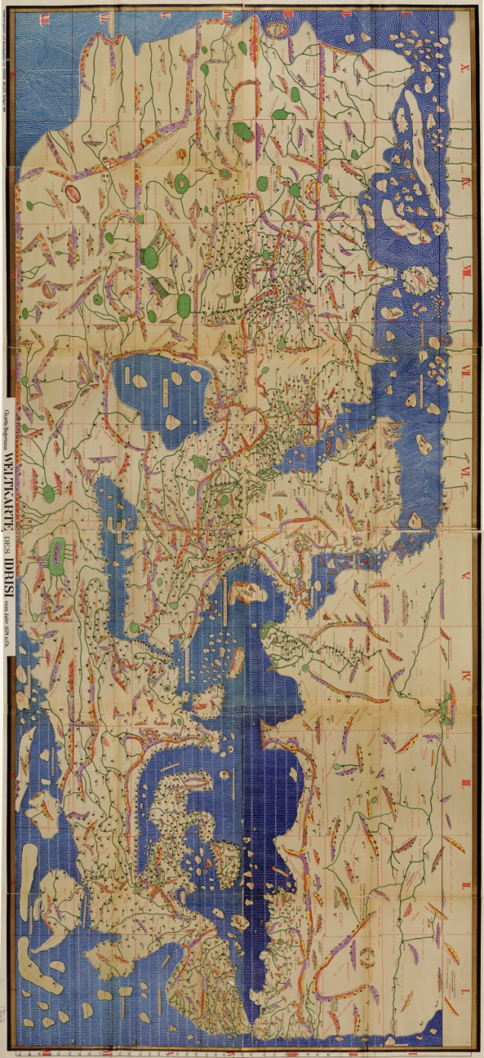

Fig. Tabula Rogeriana: Modern consolidation.
Al-Idrisi made the Tabula Rogeriana (Kitab Rujar) in 1154 for Roger II, Norman Count of Sicily, after a stay of eighteen years at his court, where he worked on the commentaries and illustrations of the map. The map, with legends written in Arabic, while showing the Eurasian continent in its entirety, only shows the northern part of the African continent and lacks details of Africa and Southeast Asia.
For Roger it was inscribed on a massive disc of solid silver, two metres in diameter. The silver disc is lost, but the paper copy survives. According to the French National Library, "Ten copies of the Kitab Rujar or Tabula Rogeriana exist worldwide today.
S.P. Scot wrote in 1904: The compilation of Edrisi marks an era in the history of science. Not only is its historical information most interesting and valuable, but its descriptions of many parts of the earth are still authoritative. For three centuries geographers copied his maps without alteration. The relative position of the lakes which form the Nile, as delineated in his work, does not differ greatly from that established by Baker and (Henry Morton) Stanley more than seven hundred years afterwards, and their number is the same. The mechanical genius of the author was not inferior to his erudition. The celestial and terrestrial planisphere of silver which he constructed for his royal patron was nearly six feet in diameter, and weighed four hundred and fifty pounds; upon the one side the zodiac and the constellations, upon the other-divided for convenience into segments-the bodies of land and water, with the respective situations of the various countries, were engraved.

Description of islands in the North Sea:
He mentioned Irlandah-al-Kabirah (Great Ireland). According to him, "from the extremity of Iceland to that of Great Ireland the sailing time was one day." Ashe mentioned, Although historians note that both al-Idrisi and the Norse tend to understate distances, the only location this reference is thought to have possibly pointed to, must likely have been in Greenland.

Description of Chinese trade: Al-Idrisi mentioned that the glassware of the city of Hangzhou and silk of Quanzhou. In his records of Chinese trade, al-Idrisi also wrote about Silla Dynasty of Korea and was one of the first Arabs to write about Korea. Al-Idrisi's references to Silla led other Arab merchants to seek Silla and its trade.

Nuzhat al-Mushtaq: As well as the maps, al-Idrisi produced a compendium of geographical information with the title Kitab nuzhat al-mushtaq fi'khtiraq al-'afaq, translated as the book of pleasant journeys into faraway lands. It has been preserved which contain maps.
In the introduction, al-Idrisi mentions two sources for geographical coordinates: Claudius Ptolemy and ‘an astronomer’ that must be Ishaq ibn al-Hasan al-Zayyat; and states that he has cross-checked oral reports from different informers to see if geographical coordinates were consistent.

Al-Idrisi’s Britain:
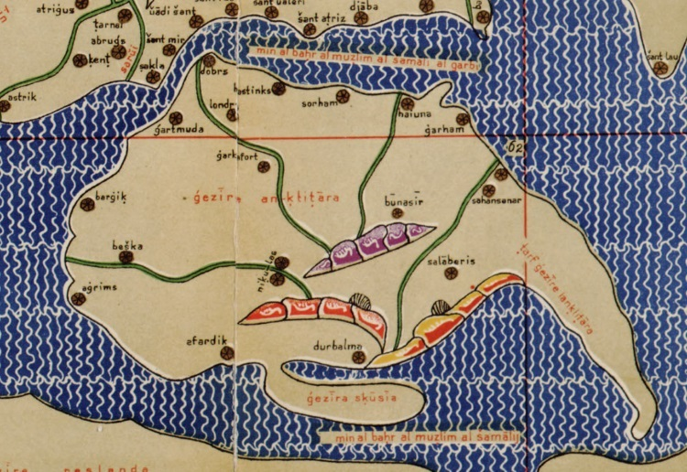
Fig. Britain according to Nuzhat al-mushtaq, oriented with north at the bottom

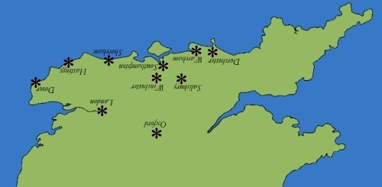

Fig. Places in southern England mentioned in Nuzhat al-mushtaq; oriented with north at the bottom (image: Dr Caitlin R. Green)
By comparing we observe some deviations in shape and scale.

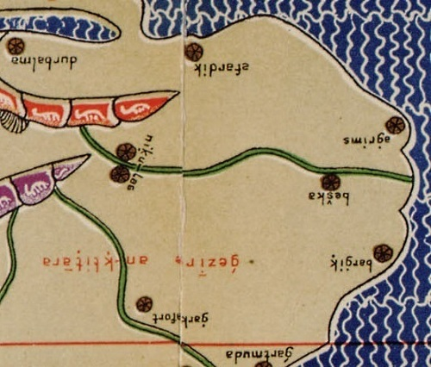

eastern England according to al-Idrisi's Nuzhat al-mushtaq

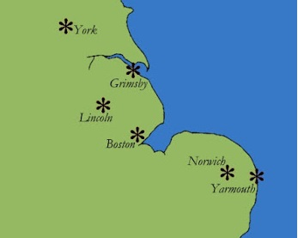

Map of places in eastern England between the Thames and the Tees that are mentioned in al-Idrisi's Nuzhat al-mushtaq (image: Dr Caitlin R. Green).

Publication and translation
An abridged version of the Arabic text was published in Rome in 1592 with title: De geographia universali or Kitāb Nuzhat al-mushtaq fī dhikr al-amsar wa-al-aqtar wa-al-buldan wa-al-juzur wa-al-mada’ in wa-al-afaq which in English would be Recreation of the desirer in the account of cities, regions, countries, islands, towns, and distant lands. This was first translation from the original Arabic was into Latin. A complete translation of the Arabic text into French by Pierre Jaubert middle of the 19th century was published. More recently sections of the text have been translated for particular regions. Beginning in 1970 an edition of the complete Arabic text was published.

Andalusian-American contact: Nuzhat al-Mushtaq, is often cited by proponents of pre-Columbian Andalusian-Americas contact theories. In this text, al-Idrisi wrote the following on the Atlantic Ocean: The Commander of the Muslims Ali ibn Yusuf ibn Tashfin sent his admiral Ahmad ibn Umar a.k.a. Raqsh al-Auzz to attack a certain island in the Atlantic, but he died before doing that. [...] Beyond this ocean of fogs it is not known what exists there. Nobody has the sure knowledge of it, because it is very difficult to traverse it. Its atmosphere is foggy, its waves are very strong, its dangers are perilous, its beasts are terrible, and its winds are full of tempests. There are many islands, some of which are inhabited, others are submerged. No navigator traverses them but bypasses them remaining near their coast. [...] And it was from the town of Lisbon that the adventurers set out known under the name of Mughamarin

[Adventurers], penetrated the ocean of fogs and wanted to know what it contained and where it ended. [...] After sailing for twelve more days they perceived an island that seemed to be inhabited, and there were cultivated fields. They sailed that way to see what it contained. But soon barques encircled them and made them prisoners, and transported them to a miserable hamlet situated on the coast. There they landed. The navigators saw there people with red skin; there was not much hair on their body, the hair of their head was straight, and they were of high stature. Their women were of an extraordinary beauty. Among the villagers, one spoke Arabic and asked them where they came from. Then the king of the village ordered them to bring them back to the continent where they were surprised to be welcomed by Berbers.
The most probable interpretation is that the Mugharrarin reached the Sargasso Sea, a part of the ocean covered by seaweed, which is very close to Bermuda yet one thousand miles away from the American mainland. Then while coming back, they may have landed either on the Azores, or on Madeira or even on the westernmost Canary Island, El Hierro (because of the sheep). Last, the story with the inhabited island might have occurred either on Tenerife or on Gran Canaria, where the Mugharrarin presumably met members of the Guanche tribe. This would explain why some of them could speak Arabic (some sporadic contacts had been maintained between the Canary Islands and Morocco) and why they were quickly deported to Morocco where they were welcomed by Berbers. Yet, the story reported by Idrisi is an indisputable account of a certain knowledge of the Atlantic Ocean by Andalusians and Moroccans.
Furthermore, al-Idrisi writes an account of eight Mugharrarin all from the same family who set sail from Lisbon (Achbona) in the first half of that century and navigated in the seaweed rich seas beyond the Azores.
Idrisi describes an island of cormorants with which has been tentatively identified as Corvo, Cape Verde but on weak grounds.

Fig: Al-Idrisi's world map from Ali ibn Hasan al-Hufi al-Qasimi's 1456 copy. The original text dates to 1154. Note that south is at the top of the map.

Abul-Faraj Ibnul-Jawzi
Abul-Faraj Ibnul-Jawzi was an Arab Muslim jurisconsult, preacher, orator, heresiographer, traditionist, historian, judge, hagiographer and philologist from Baghdad. He lived during c.1116 – 16June 1201CE.
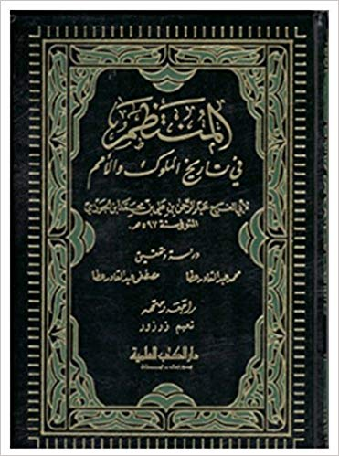  History Book: Almuntazam fi tarikhil muluk wal umam | 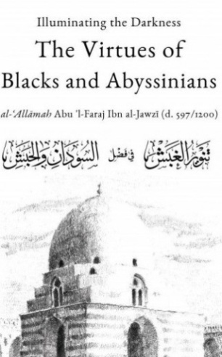  Illuminating the Darkness: The Virtues of Blacks and Abyssinians
Ibnul-Jawzi’s “Almuntazam fi tarikhil mulk wal umam” is a historical book in which he addressed the general history from the beginning of creation to the year 574AH/1179CE. The book is in eighteen parts.
The first and second part lists the general history since the beginning of creation and biography of the Prophet Muhammad (pbuh).

Illuminating the Darkness: The Virtues of Blacks and Abyssinians: Ibn Jawzi said, “I came across a group of eminent Ethiopian who were disheartened due to the darkness of their skin colour. I thus clarified to them that the matter upon which consideration is placed is good deeds rather than one’s appearance, and I wrote this book for them to mention the virtue of many from amongst the Ethiopian and black people.”
God is neither inside nor outside the Universe: In As-Sifat, Ibn Jawzi states that God neither exists inside the world nor outside of it. To him, "being inside or outside are concomitant of things located in space" i.e. what is outside or inside must be in a place, and, according to him, this is not applicable to God. He writes: Both [being in a place and outside a place] along with movement, rest, and other accidents are constitutive of bodies ....... The divine essence does not admit of any created entity [e.g. place] within it or inhering in it.
His “Devil’s Deception”, “Talqihu fuhum ahlil athar”, “Wafa bi ahwalil Mustafa” (Biography of he Prophet) and “Zadul Masir” (An Exegesis of the Holy Quran) are popular among Muslims. In fact, he was the most prolific writer among Muslims.

Al-Samawal
Al-Samawal was an ethnic Jewish mathematician. He lived during c. 1130–c. 1180. He was born in Baghdad. His father was a Jewish Rabbi, who emigrated from Fez. Al-Samawal's mother, Anna Isaac Levi, had moved from Basra.
His most famous treatise ‘Al-Bahir fil-Jabr’, meaning ‘The brilliant in algebra’, was written when he was only nineteen years old. It is a work of great importance both for the original ideas which it contains and also for the information that it records concerning works by al-Karaji which are now lost.
Al-Samawal developed an understanding of negative numbers. He also used zero (0) in his calculations writing:-
If we subtract a positive number from an empty power, the same negative number remains.
By this al-Samawal meant, in modern notation,
0 - a = -a.
He continued:
... if we subtract the negative number from an empty power, the same positive number remains.
Again in modern notation this is 0 - (-a) = a.
Multiplication of negative numbers was also completely understood by Al-Samawal. He wrote:-
... the product of a negative number by a positive number is negative, and by a negative number is positive.
In Al-Bahir fil-Jabr, Al-Samawal describes the theory of quadratic equations; but he gave geometric solutions to these equations despite algebraic methods having been fully described by al-Khwarizmi, al-Karaji and others. Al-Samawal also described the solution of indeterminate equations such as finding x so that a x^{n} is a square, and finding x so that ax^{n} + bx^{n-1} is a square. Also in this book is al-Samawal's description of the binomial theorem where the coefficients are given by the Pascal triangle. The method is attributed by al-Samawal to al-Karaji and provides the only surviving account of this remarkable work.
The sequences ∑ n2 and ∑ n3 had been studied by al-Samawal. He demonstrates an argument for n = 1, then prove the case n = 2 based on his result for n = 1, then prove the case n = 3 based on his result for n = 2, and carry on to around n = 5 before remarking that one can continue the process indefinitely. Although this is not induction proper, it is a major step towards understanding inductive proofs. We should also comment that he was not the first to use this form of recursive reasoning, since al-Karaji had used similar methods. The result is
1² + 2² + 3² + ... + n² = n(n + 1)(2n + 1)/6
After writing the Al-Bahir fil-Jabr, Al-Samawal travelled in many countries including Iraq, the Levant, Kohistan (a mountainous area in Afghanistan) and Azerbaijan. We know from his own writings that he was in Maragheh in Azerbaijan on 8 November 1163, for on that date al-Samawal made a commitment to the faith of Islam. This decision was not taken without a great deal of thought by al-Samawal. He had put much effort into testing the validity of the claims made by the major religions and he reports that on 8 November 1163 he decided that Islam was the most satisfactory.
Al-Samawal's father, being Jewish, would have found his son's conversion to Islam a painful experience and Al-Samawal, not wishing to hurt his father, delayed his conversion for four years. After this time Al-Samawal wrote to his father setting out his reasons for changing his religion from the Jewish faith to Islam. At this time Al-Samawal was in Aleppo and his father set out at once to see him on receiving the letter. However, Al-Samawal's father died on the journey before seeing his son. He wrote a work ‘Decisive refutation of the Christians and Jewsish’ which has survived.

Fakhruddin Razi
Fakhruddin Razi was a Sunni Muslim theologian and philosopher from Khorasan. He was born in 1149 CE (544 AH) in Rey in Iran and died in 1209 in Herat (in Afghanistan).
He wrote on medicine, physics, astronomy, literature, history and law. He first studied with his father, and later at Merv and Maragheh, where he was one of the pupils of Majd al-Din al-Jili, who in turn had been a disciple of al-Ghazali. He devoted himself to a wide range of studies and is said to have expended a large fortune on experiments in alchemy. He taught at Rey and Ghazni, and became head of a college at Herat.
He wrote Sharh Kulliyyat al-Qanun fi al-Tibb which is a commentary on Avienna’s Canon of Medicine.
Two of his works titled Mabahith al-mashriqiyya fī ilm al-ilahiyyat wal-tabiiyyat (Eastern Studies in Metaphysics and Physics) and al-Matalib al-Aliya (The Higher Issues) are usually regarded as his most important philosophical works.
Matalib al-Aliya: Al-Razi, in dealing with his conception of physics and the physical world in his Matalib al-Aliya, criticizes the idea of the geocentric model within the universe and "explores the notion of the existence of a multiverse in the context of his commentary" on the Quranic verse, "All praise belongs to God, Lord of the Worlds." He raises the question of whether the term ‘worlds’ in this verse refers to "multiple worlds within this single universe or cosmos, or to many other universes or a multiverse beyond this known universe."
Al-Razi states: It is established by evidence that there exists beyond the world a void without a terminal limit (khala' la nihayata laha), and it is established as well by evidence that God Most High has power over all contingent beings (al-mumkinat). Therefore He the Most High has the power (qadir) to create a thousand thousand worlds (alfa alfi 'awalim) beyond this world such that each one of those worlds be bigger and more massive than this world as well as having the like of what this world has of the throne (al-arsh), the chair (al-kursiyy), the skies and the earth, and the sun and the moon. The arguments of the philosophers for establishing that the world is one are weak, flimsy arguments founded upon feeble premises.
Al-Razi rejected the Aristotelian and Avicennian notions of a single universe revolving around a single world. He describes their main arguments against the existence of multiple worlds or universes, pointing out their weaknesses and refuting them. He discussed more on the issue of the void – the empty spaces between stars and constellations in the universe, that contain few or no stars – in greater detail in volume 5 of the Matalib. He argued that there exists an infinite outer space beyond the known world, and that God has the power to fill the vacuum with an infinite number of universes.

Fibonacci
Fibonacci was one of the greatest mathematicians of the medieval world. Fibonacci introduced the Hindu-Arabic number system in Europe, which ultimately allowed science and mathematics to flourish.
Biographical details of Fibonacci are rather sketchy. He lived during c.1170–c.1245CE. Fibonacci’s father was a public official concerned with taxation of trade between Pisa and North Africa. Bonacci spent a lot of time in the Arab port city of Bugia (now in Algeria). His work in taxation of trade led him to believe the future would be bright for people who understood numbers thoroughly.
He had his son schooled in mathematics in Bugia. The young Fibonacci was fascinated when he learned that Arab mathematicians did not use the Roman system of numbers: I, II, III, IV, V, etc, used in Europe. Ancient Greek mathematics had been brilliant in geometry, but it was far from fully developed due to clumsy number system, where numbers were represented by letters of the alphabet. To see the awkwardness of this system, think about calculating 17 × 19; it’s easy to do using modern numbers. Imagine, though, trying to multiply Q × S (the 17th and 19th letters of the alphabet). Suddenly what’s easy becomes awkward.
In the Roman system 17 × 19 would be XVII × XIX. The clumsy notation and the lack of the place value concept of ones, tens, hundreds, thousands, etc, made life difficult for Roman mathematicians.
In addition to their unwieldy numbers, Ancient Greeks and Romans also lacked the number zero; this made mathematics awkward, and would have made the development of modern mathematics impossible.
Fibonacci immersed himself in the new number system he learned in Bugia, realizing it was a huge improvement on Roman numerals. Fibonacci later traveled to Egypt, Greece, Sicily, France and Syria, learning more mathematics.
Fibonacci’s Book of Calculation: Fibonacci believed the Indian number system had huge advantages over the Roman system and believed the people of Europe should adopt it. In 1202 he published Liber Abaci – the Book of Calculation – which began the spread of the modern number system in Europe. Fibonacci updated the book and published a new edition in 1228.
Near the beginning of the Book of Calculation he wrote: “I received an excellent education in the methods of the nine Indian numbers; the knowledge of these methods pleased me more than anything else… Therefore strictly embracing the Indian method, and adding some of my own ideas, and more still from Euclid’s geometry, I assembled them in this book as understandably as I could.”
Book of Calculation, 1228: His Book of Calculation showed how calculations in commerce, finance, and pure mathematics could be carried out with the new number system.
How Important was Fibonacci’s Book?
Fibonacci’s book was vital in planting a seed in European minds. Popularizing the new numbers was a long process; widespread adoption began only after the twin events of:
• Gutenberg’s invention of the printing press in 1440
• the Ottoman Conquest of Constantinople in 1453
Fibonacci’s Book of Calculation was also important for European commerce and finance. In Arab lands the new number system had been used only by mathematicians and scientists. Fibonacci saw the superiority of the new system for businesses and devoted several chapters of his book to show calculations of profit, loss, and currency conversions. In fact, the book’s immediate impact on the commercial world was much greater than on the scientific world.
Some of the topics Fibonacci considered in his book were: the new numbers; addition; subtraction; multiplication and division; fractions; rules for money; accounting; quadratic and cube roots; quadratic equations; binomials; proportion; rules of algebra; checking calculations by casting out nines; progressions; and applied algebra.
The algebra in the Book of Calculation was principally influenced by work published by the mathematicians Algorithmi from Persia; Abu-Kamil from Egypt; and Al-Karaji from Baghdad.

Fibonacci Sequence: Fibonacci also famously considered the rabbit problem, which gave rise to the Fibonacci Sequence.
In his 1202 book Liber Abaci, Fibonacci introduced the sequence to Western European mathematics, although the sequence had been described earlier in Indian mathematics.

The Rabbit Problem: A man places a pair of rabbits into a garden surrounded by a wall. How many pairs of rabbits can be produced in a year if every month each pair produces a new pair which from the second month on becomes productive?
The Solution: The month-by-month solution to the problem became known as the Fibonacci Sequence. It involves adding the preceding two terms to one another to generate the next term:
1, 1, 2, 3, 5, 8, 13, 21, 34, 55, …

This remarkable sequence occurs repeatedly in mathematics and also in the natural world, where, for example, the scales of pine cones run in spirals arranged in ratios determined by the Fibonacci Sequence.

In mathematics, the Fibonacci numbers, commonly denoted F_{n} form a sequence, called the Fibonacci sequence, such that each number is the sum of the two preceding ones, starting from 0 and 1.
That is, F₀ = 0 , F₁ = 1 , and F_{n} = F_{n−1} + F_{n − 2} ,
for n > 1.
One has F₂ = 1. In some books, and particularly in old ones, F₀, the "0" is omitted, and the Fibonacci sequence starts with F₁ = F₂ = 1. The beginning of the sequence is thus:
( 0 , ) 1 , 1 , 2 , 3 , 5 , 8 , 13 , 21 , 34 , 55 , 89 , 144 , …

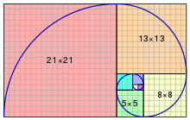
The Fibonacci spiral: an approximation of the golden spiral created by drawing circular arcs connecting the opposite corners of squares in the Fibonacci tiling; this one uses squares of sizes 1, 1, 2, 3, 5, 8, 13 and 21.

Fibonacci numbers are strongly related to the golden ratio. Even in art the Fibonacci Sequence is prominent. If you divide one term in the sequence by the previous term, the result gets closer and closer to the golden ratio – loved by artists and architects – as the terms get larger.
Binet's formula expresses the nth Fibonacci number in terms of n and the golden ratio, and implies that the ratio of two consecutive Fibonacci numbers tends to the golden ratio as n increases.
Applications of Fibonacci numbers include computer algorithms such as the Fibonacci search technique and the Fibonacci heap data structure, and graphs called Fibonacci cubes used for interconnecting parallel and distributed systems.
They also appear in biological settings, such as branching in trees, the arrangement of leaves on a stem, the fruit sprouts of a pineapple,
the flowering of an artichoke, an uncurling fern and the arrangement of a pine cone's bracts.
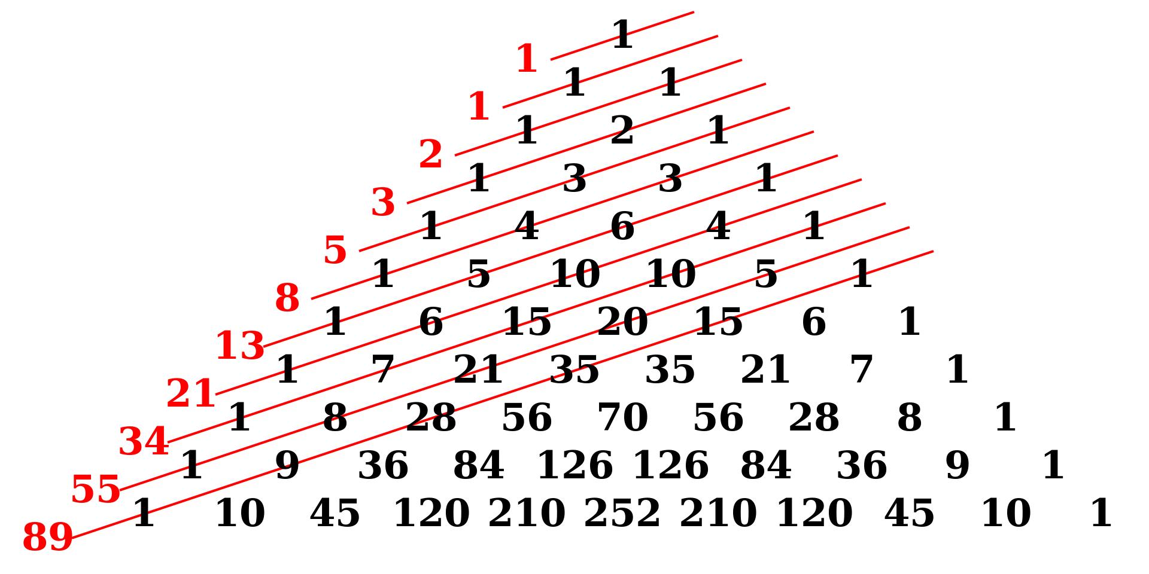
The Fibonacci numbers are the sums of the "shallow" diagonals (shown in red) of Pascal's triangle.

Completing the Basic Notation of Modern Arithmetic
After Fibonacci had introduced modern numbers to the West, a number of symbols still had to be introduced to transform arithmetic into its modern notation. These were:
• The plus (+) and minus (-) signs introduced by Johannes Widmann in 1489.
• The equals sign (=) introduced by Robert Recorde in 1557.
• The multiplication sign (x) introduced by William Oughtred in 1631.
• The division sign (÷) introduced by Johann Rahn in 1659 in his book Teutsche Algebra.
Fibonacci’s most famous work is his Liber Abaci (Book of Calculation). The main purpose of this book was to encourage everyone to abandon Roman numerals and use the Indian system of numbers; it was a general book of mathematics. He also wrote other books, some of which were solely for pure mathematicians. He wrote:
In 1223: Practica Geometriae (Practical Geometry) – a mixture of pure mathematics, theorems, proofs, and practical applications of geometry, such as using similar triangles to calculate the heights of tall objects.
Before 1225: Epistola and Magistrum Theodorum (A Letter to Master Theodore) – a letter to Frederick II’s philosopher Theodorus Physicus solving three problems in mathematics.
In 1225: Flos (Flower) – solutions to problems in algebra. As his fame spread to Frederick II, the Holy Roman emperor, whose own mathematicians were unable to solve a number of problems, so he challenged Fibonacci. Fibonacci published his solutions to the challenges in his 1225 book Flos (Flower).
In 1225: Liber Quadratorum (The Book of Squares) – A highly mathematical number theory book dealing with solutions to Diophantine equations – in this work we see just how accomplished a mathematician Fibonacci truly was.
Fibonacci’s achievements were recognized by his home city of Pisa, which granted him a salary for his work.

Ibnul Awwam
Ibnul Awwam was a Spanish Arab Muslim agriculturist and botanist who flourished in southern Spain in the later 12th century. The appellation ‘Al-Ishbili’ of his name translates as "the Sevillean". His dates of birth and death are not known. He was a large landowner whose interests lay exclusively with agricultural matters. He did lots of hands-on growing and experimenting with a wide range of crops himself. He was well-read in the agricultural writings of his predecessors.

He wrote a lengthy handbook on agriculture entitled in Arabic Kitab al-Filaha (English: Book on Agriculture), which is the most comprehensive treatment of the subject in medieval Arabic, and one of the most important medieval works on the subject in any language. An edition was published in 1802 with the Arabic text placed alongside a translation into Spanish, and in 1864 it was published in French. The edition in French is about 1350 pages. In fact his book is mostly compiled from the writings of other authors. He cites information from 112 different prior authors. His citations of prior authors have been analyzed with the following summary results: about 1900 direct and indirect citations altogether, of which 615 are to Greek authors (the great majority to the Geoponica of Cassianus Bassus), 585 are to Middle Eastern Arabic authors (the great majority to the Book of Nabataean Agriculture attributed to Ibn Wahshiyya) and 690 are to Spanish Arab authors.

Ibnul Awwam's book is divided into thirty-four chapters. The first thirty deal with crops and the last four deal with livestock. The first four chapters in the book deal successively with different types of soils, fertilizers, irrigation, and planning a garden layout. Then there are five chapters on growing fruit trees, including grafting, pruning, growing from cuttings, etc., and dozens of different fruit trees are treated individually. Later chapters deal with ploughing, the choice of seeds, the seasons and their tasks, grain farming, leguminous plants, small allotments, aromatic plants and industrial plants. Again, many plants are treated individually on how to cultivate them. One chapter is devoted to methods of preserving and storing foods after harvest, a topic which comes up intermittently elsewhere. The symptoms of many diseases of trees and vines are indicated, as are methods of cure. The chapters on livestock include discussion of the diseases and injuries to horses and cattle.

Abul-Izz Al-Jazari
Al-Jazari was an Arab Muslim mechanical engineer who has been hailed as the ‘father of robotics’ due to his invention of crankshaft, segmental gears and early robots. He lived during 1136-1206CE. He was from Cizre (Jazirat ibn Umar) in Anatolia. He served as chief engineer (Raisul-Amal) at Hasankeyf, capital of the Artuqid State.
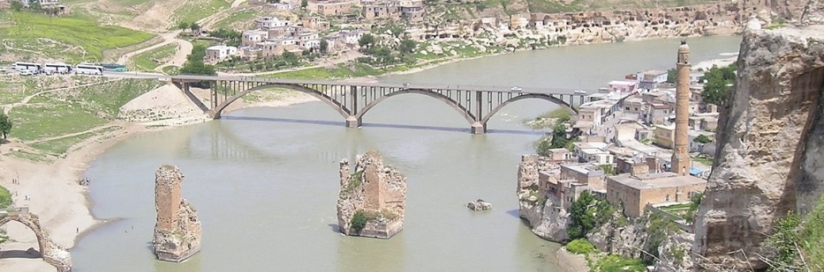
Photo: Parts of Hasankeyf, an ancient capital

From the Oxford manuscript copy of al-Jazari's treatise we learn that al-Jazari finished writing his book on 4 Jumada the Second, 602 H/ 16 January 1206. The oldest extant copy (preserved in Topkapi Sarayi Libray, Ahmet III collection, MS 3472) was completed by Muhammad ibn Yusuf ibn Uthman al-Haskafi at the end of Shaban 602 H/10 April 1206. From al-Haskafi's colophon we learn that al-Jazari was not living at this date. From these indications and other data, it may be concluded that he died in the year 602 H/1206, just few months after he had completed his work.
His Magnum Opus book of mechanics ‘Al-Jami bayn al-ilm wal-amal al-nafi fi sinaat al-hiyal’ (A Compendium on the Theory and Useful Practice of the Mechanical Arts) is a ground breaking work in the history of mechanical engineering. The published Arabic text enumerates fifteen manuscripts of al-Jazari's book in world libraries with one only probably in private hands. The main manuscript for finalizing printed text was MS Ahmet III 3472 in the Topkapi Sarayi Librarary, Istanbul. This is the closest copy to the time when al-Jazari completed his writing in 602 H/1206.
The English translation published by Donald R. Hill in 1974 carries the title Book of Knowledge of Mechanical Devices. This translation was based mainly on MS Graves 27 of the Bodleian Library in Oxford, where the Arabic title is Kitab fi marifat al-hiyal al-handasiyya. The book describes in detail fifty devices, which are grouped into six categories:
1) ten water and candle clocks;
2) ten vessels and figures suited for drinking sessions;
3) ten pitchers and basins for phlebotomy and washing before prayers;
4) ten fountains that change their shape alternately, and machines for the perpetual flute;
5) five water raising machines;
6) five miscellaneous devices.
Al-Jazari's book deals with a whole range of devices and machines, with a multiplicity of purposes. His book provides detailed instructions for all of his inventions and illustrate them using miniature paintings, to make it possible for a reader to reconstruct his inventions. This is why several of his inventions were reproduced. The monumental water clock was reproduced in 1976 in Dubai, and the huge "Elephant clock" that stands 8 meters high at the Ibn Battuta shopping mall in Dubai. And FSTC scholars in Manchester recreated 3D-model animations of some machines of al-Jazari, such as the reciprocating pump with a water wheel as the drive source. The recreated machines and the animated models proved to be real machines, working perfectly well.
Each device or shakl is described in simple Arabic that is easy to understand, and each is accompanied by a general drawing. There are fifty of these and are numbered by the letters of the Arabic alphabet from one to fifty. For the complicated devices al-Jazari gave detailed drawings for the components of a device or for subassemblies so that the operation could be understood. The edited version of his book based on the surviving manuscripts, contains a total of 174 drawings. An alphabet letter marks each part in a device. The text explains the construction of the device with the aid of the letters so that the reader can understand the device by reading the text and referring to the illustrations.
Historian Lynn White writes: "Segmental gears first clearly appear in al-Jazari, in the West they emerge in Giovanni de Dondi's astronomical clock finished in 1364, and only with the great Sienese engineer Francesco di Giorgio (1501) did they enter the general vocabulary of European machine design" (A segmental gear is a piece for receiving or communicating reciprocating motion from or to a cogwheel, consisting of a sector of a circular gear, or ring, having cogs on the periphery, or face.)
Donald R. Hill wrote in ‘Studies in Medieval Islamic Technology’, "It is impossible to over-emphasize the importance of al-Jazari's work in the history of engineering. Until modern times there is no other document from any cultural area that provides a comparable wealth of instructions for the design, manufacture and assembly of machines … Al-Jazari did not only assimilate the techniques of his non-Arab and Arab predecessors, he was also creative. He added several mechanical and hydraulic devices. The impact of these inventions can be seen in the later designing of steam engines and internal combustion engines, paving the way for automatic control and other modern machinery. The impact of al-Jazari's inventions is still felt in modern contemporary mechanical engineering"
George Sarton says: "this treatise is the most elaborate of its kind and may be considered the climax of this line of Moslem achievement.
Donald R. Hill commented that "until modern times there is no other document, from any cultural area, that provides a comparable wealth of instructions for the design, manufacture and assembly of machines.”
Al-Jazari's double acting piston pump is unique. It is remarkable for three reasons:
- it incorporates an effective means of converting rotary into reciprocating motion through the crankshaft mechanism;
- it makes use of the double-acting principle; and
- it is the first pump known to have had true suction pipes.
Al-Jazari described a combination lock. There are now in world museums three combination locks that were made in the same period of al-Jazari. Although they are simpler than the lock of al-Jazari, they follow the same principle. Two were made around 597 H/1200 CE by Muhammad b. Hamid and are located in Copenhagen and Boston. The third is in Maastricht, Holland. The first combination lock in Europe was described by Buttersworth in 1846 and the wheels of this lock are strikingly similar to the discs of al-Jazari.
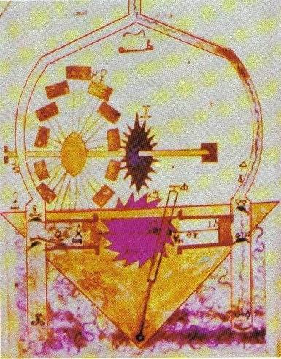
Figure: The reciprocating pump from al-Jazari's manuscript, Topkapi Palace Museum Library, Ahmet III 3472
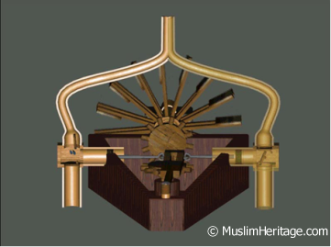
Figure: 3D-model recreated by FSTC of the reciprocating pump with a water wheel as the drive source.

The elephant clock: One of the most significant inventions of al-Jazari was the famous elephant clock. The various elements of the clock are in the housing on top of the elephant. The various elements that compose this clock move and make a sound every half hour. The timing mechanism is based on a water-filled bucket hidden inside the elephant. In the bucket is a deep bowl floating in the water, but with a small hole in the centre. The bowl takes half an hour to fill through this hole. In the process of sinking, the bowl pulls a string attached to a see-saw mechanism in the tower on top of the elephant. This releases a ball that drops into the mouth of a serpent, causing the serpent to tip forward. At the same time, a system of strings causes a figure in the tower to raise either the left or right hand and the mahout (elephant driver at the front) to hit a drum. This indicates a half or full hour. Next the snake tips back again and the sunken bowl is raised out of the water. The cycle then repeats .This was the first clock in which an automaton reacted after certain intervals of time. The elephant clock of al-Jazari was the first mechanism to employ a flow regulator, which was used to determine the time when the clock strikes at hourly intervals. The hourly intervals were determined with the use of a small opening in a submersible float, which was calibrated to give the required rates of flow under different water rates.
This appears to be the earliest example of a closed-loop system in a mechanism. The clock functioned as long as there were metal balls in its magazine.
All illustrations in al-Jazari's book are in color, and among the fifty main drawings are miniatures that are of great artistic merit. This resulted in the disappearance of some of these paintings from the manuscripts and they found their way to the international museums of art or to private collections.

Anselm Turmeda
Anselm Turmeda, later known as Abdullah Tarjuman, was a Majorcan Arabist, philosopher, administrator, writer. Turmeda represents the only example of a medieval writer who wrote in a Latin language and in Arabic, that reached great success in both literatures. He was born in c.1355 in Palma de Mallorca. The native language is Catalan. Turmeda entered the Franciscan Order and studied theology, and physics in Lleida/Lerida (in Catalonia) and Bologna. He wrote several books.
Llibre de bons amonestaments (1398): It consists of 428 poems giving moral advice arranged in three rhyming stanzas followed by a rhyme-free one. The work was very popular throughout the Catalan speaking territories up until the XIX Century.
Cobles de la divisió del Regne de Mallorques (1398): He also wrote Cobles de la divisió del Regne de Mallorques, an allegorical 123 verse poem; and a series of prophecies (1404-1407), in which he prophecized about politics and religion.
Llibre de tres (1405-1407): The compilation of proverbs.
Disputa de l'ase (1418): Disputa de l’Ase is written Catalan, no part survived in its original language. Current Catalan editions are available based on a medieval French translation. The Inquisition put it on the Index of prohibited books in 1583, contributing to its disappearance. Both for political and religious reasons, it did not square with the orthodoxy of Spain in the 16th century. Disputa de l'ase, his most celebrated work, is a satirical narrative of great expressive agility. ‘Dispute of a Donkey’ has a human-animal interaction as its central motif. In this story, Anselm as himself debates with a donkey in order to determine who is superior - man or animal. Both spar with each other over as many as eighteen issues, with Anselm mobilizing all the resources of his intelligence and scholarship to put forward reasons for the nobility of humans, only to be rebutted and refuted patiently, logically and resourcefully by the donkey,
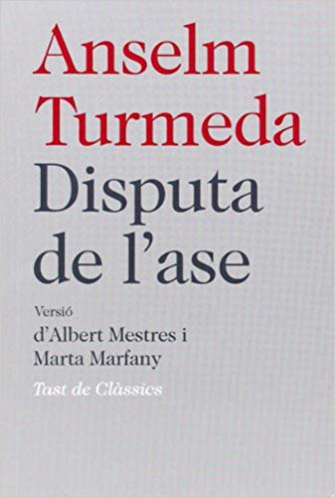
Over as many as eighteen arguments, the donkey is able to prove that animals are in no way inferior to humans, when judged from the perspective of appearance, habits, traits, abilities and activities. Both physically and otherwise, animals have it in them to give humans a run for their money. When one follows every pair of the eighteen arguments closely, one discovers that the narrator presents a defence of man’s abilities in a succinct, matter-of-fact manner, whereas the donkey’s discourse given as a reply is deliberately made much more elaborate and painstaking, is couched in examples and ameliorated with rhetoric. The reader cannot but feel a sense of exhilaration as the donkey refutes every suggestion of Anselm in a dignified and logical manner, making the scholar look like a novice of sorts on more than one occasion. At last Anselm delivers a final blow in his nineteenth argument - Christ assumed a human form. The mention of Christ ultimately tilts the scales hopelessly against them and brings about a judgment.
Utilization of the example of sending of Prophets as humans on Earth as a plea for human superiority is not new to theological exercises. But he is innovative in the way in which he shapes the arguments for animals against humans, although his Renaissance grounding would have expected the opposite.
Turmeda’s adroit support for animals in the text makes us convince that more than being a tract on humanism, it is also an early Renaissance commentary on animals’ rights. The animal world has always been very closely connected with human civilization, providing food, products, a potent work-force and entertainment in a variety of ways. It is only in recent times that mechanization, vegetarianism and an increased awareness of animals’ rights have reduced the dependence on animals to a large extent; otherwise, from the beginning of civilization almost, animals have been an inseparable and invariable part of human life, be it during peace or war; on the field or in the house; on mountains or in the plains; with the rich and with the poor. For his part, man too has responded to animals in a variety of ways, though not all responses have been encouraging. While on the one hand humans have over-utilized animals without any regard to their welfare and have caused their deaths simply for pleasure, on the other they have venerated them in literature or apotheosized them in literature and culture.
Cruel, anti-animal pastimes as bear-baiting, bull-baiting, cock-fighting, fishing, fowling, hawking, or hunting must be prohibited.
Although in Turmeda’s story sending of Prophets as humans ultimately leads to the defeat of animals in the debate on superiority, the very fact can interestingly be produced in support of animals. If humans are so superior then one area in which they should evince their superiority lies in being compassionate towards animals, which they hardly do. Cruelty towards animals was neither a sign of superiority. Further, Jesus had been sent as a shepherd - a person whose primary responsibility is to look after animals. It is with shepherds and their flock that the ideal form of life called pastoralism is associated; therefore if humans realized that superiority, then they are also called for responsibility and compassion.
He left for Bologna and he lived there in the church with an aged priest. Turmeda describes his life in Bologna, conversion to Islam, the life of Tunisian sultans, and a series of arguments against adherents to Trinity in his book Tuhfatul arib fi radd ala ahlis-salib (The Gift to the Intelligent for Refuting the Arguments of the People of Cross) written in 1420 in Arabic.
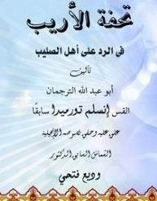
The Gift to the Intelligent for Refuting the Arguments of the People of Cross

He narrated: I became very close to him (the priest) by serving and assisting him with his duties until I became one of his most trusted assistants, so that he trusted me with the keys of his domicile in the church and of his food and drink stores. He kept for himself only the key of a small room where he used to sleep. I think, and Allah knows best, that he kept his treasure chest in there.
I was a student and servant for a period of ten years. Then he fell ill and failed to attend the meetings of priests. During his absence the priests discussed some religious matters, till they came to what was said by the Almighty Allah through His Prophet Jesus in the Gospel: “After him a Prophet called Paraclete will come.” They argued a great deal about this Prophet and as to who he was among the prophets. I went to my priest, and as usual he asked about what was discussed in the meeting that day. I mentioned to him the different opinions of the priests about the name Paraclete, and how they finished the meeting without clarifying its meaning.
He asked me: “What was your answer?” I gave him my opinion, which was taken from my interpretation of a well-known exegesis. He said, “But the truth is different from all of that. This is because the interpretation of that noble name is known only to a small number of well versed scholars. And we possess only a little knowledge.”
I fell down and kissed his feet, saying: “Sir, you know that I travelled and came to you from a distant country, I have served you now for more than ten years; and have attained knowledge beyond estimation, so please favour me and tell me the truth about this name.”
The priest then wept and said: “My Son, By God, you are very much dear to me for serving me and devoting yourself to my care. Know the truth about this name, and there is a great benefit, but there is also a great danger. And I fear that when you know this truth, and the Christians discover that, you will be killed immediately.”
I said: “By God, By the Gospel and He who was sent with it, I shall never speak any word about what you will tell me, I shall keep it as a secret in my heart.”
He said: Know, my son, that Paraclete is the name of their Prophet, Muhammad to whom was revealed the fourth book as mentioned by Daniel. His way is the clear way which is mentioned in the Gospel.” I said: “Then sir, what do you say about the religion of these Christians?” He said: “My son, if these Christians remained on the original religion of Jesus, then they would have been on God’s true religion; because the religion of Jesus and all the other prophets is the true religion of God. But they changed it and became unbelievers.”
I asked him: “Then, sir, what is the salvation from this?” He said: “Oh my son, embracing Islam.”
I asked him: “Will the one who embraces Islam be saved?”
He answered: “Yes, in this world and the Hereafter.” I said: “The prudent chooses for himself; sir, if you know the merit of Islam, then what keeps you from it?”
He answered: “My son, The Almighty God did not expose me to the truth of Islam and the prophet of Islam until after I have become old and my body weakened. Yes, there is no excuse for us in this, on the contrary, the proof of Allah has been established against us. If God had guided me to this when I was your age I would have left everything and adopted the religion of truth. Love of this world is the essence of every sin, and look how I am esteemed, glorified and honoured by the Christians, and how I am living in affluence and comfort! In my case, if I show a slight inclination towards Islam they would kill me immediately. Suppose that I was saved from them and succeeded in escaping to the Muslims they would say, do not count your Islam as a favour upon us, rather you have benefited yourself only by entering the religion of truth, the religion that will save you from the punishment of Allah! So I would live among them as a poor old man of more than ninety years, without knowing their language, and they would not know my real status and I would die among them starving. I am, and all praise is due to Allah on the religion of Christ and on that which he came with, and Allah knows that from me.”
So I asked him: “Do you advise me to go to the country of the Muslims and adopt their religion?” He said to me: “If you are wise and hope to save yourself, then race to that which will achieve this life and the hereafter. But my son, none is present with us concerning this matter, it is between you and me only. Exert yourself and keep it a secret. If it is disclosed and the people know about it they will kill you immediately. I will be of no benefit to you against them. Neither will it be of any use to you if you tell them what you heard from me concerning Islam, or that I encouraged you to be a Muslim, because I shall deny it. They will trust my testimony against you but will not trust yours against me. So, do not tell a word, whatever happens.”
He bade him farewell and went to Majorca where he stayed with his parents for six months. Then he traveled to Sicily and remained there five months, waiting for a ship bound for the land of the Muslims. Finally a ship arrived bound for Tunis.
He narrates: When I got off the ship (at Tunis), Christian scholars who heard of my arrival came to greet me and take me to their dwelling place. Some local merchants also offered their hospitality and I stayed with them for four months in ease and comfort.
After that I asked them if there was a translator in the Sultan’s Palace. The Sultan was Abul Abbas Ahmad II (r. 1370-1394). They said there was a virtuous man, the Sultan’s Physician and one of his closest advisors. His name was Dr. Yusuf. I was pleased to hear this, and asked where he lived. They took me there and I met him separately. I told him about my story and the reason of my coming there; which was to embrace Islam. He was immensely pleased because this matter would be completed by his help. We rode to the Sultan’s Palace. He met the Sultan and told him about my story and asked his permission for me to meet him. The Sultan accepted and I presented myself before him.
The Sultan asked about my age. I told him that I was thirty-five years old. He then asked about my learning. He said, “Your arrival is the arrival of goodness. Be a Muslim with blessings of Allah.” I then said to the physician, “Tell the honorable Sultan that it always happens that when anyone changes his religion his people defame him and speak evil of him. So, I wish if he kindly sends to bring the Christian priests and merchants of this city to ask them about me and hear what they have to say. Then by the will of Allah, I shall accept Islam.”
He said to me through the translator, “You have asked what Abdullah Bin Salam asked from the Prophet when he (Abdullah) came to announce his Islam. He then sent for the priests and some Christian merchants and let me sit in an adjoining room unseen by them. When they came he asked them, “What do you say about this new priest who just arrived by ship?”
They said: “He is a great scholar in our religion. Our bishops say he is the most learned and no one is superior to him in our religious knowledge.” After hearing what the Christian said, the Sultan sent for me, and presented myself before them. I declared the two testimonies, that there is no one worthy of Worship except Allah, and that Muhammad is His Messenger, and when the Christians heard this they crossed themselves and said: “Nothing incited him to do that except his desire to marry, as priests in our religion can not marry”. Then they left him in distress and grief. The Sultan appointed for me a quarter of a dinar everyday from the treasury and let me marry the daughter of Muhammad Al-Saffar.
He died in Tunis after 1423 CE.

Ibn Shatir
Ali ibn Ibrahim known as Ibn Shatir was a Syrian Arab astronomer, mathematician and engineer. He lived during 1304–1375CE.

He worked as muwaqqit (prayer timekeeper) in the Umayyad Mosque in Damascus and constructed a sundial for its minaret in 1371/72. The idea of using hours of equal time length throughout the year was the innovation of Ibn Shatir in 1371. Ibn Shatir was aware that "using a gnomon that is parallel to the Earth's axis will produce sundials whose hour lines indicate equal hours on any day of the year." His sundial is the oldest polar-axis sundial still in existence. The concept later appeared in European sundials from at least 1446.
Ibn Shatir also invented a timekeeping device called ‘sanduq al‐yawaqit’ (jewel box), which incorporates both a universal sundial and a magnetic compass. He invented it for the purpose of finding the times of prayers. Other notable instruments invented by him include a reversed astrolabe and an astrolabic clock.
Ibn Shatir’s most important astronomical treatise was ‘Kitab nihayat al-sul fi tashih al-usul’ (The Final Quest Concerning the Rectification of Principles). In it he reformed the Ptolemaic models of the Sun, Moon and planets in a way that was mathematically identical to what Copernicus did in the 16th century. He incorporated in his model Muayyaduddin Urdi’s lemma and introduced the Tusi-couple so that the need for an equant might be eliminated.
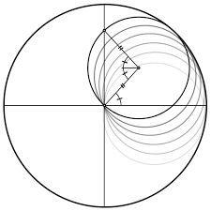
Fig. A Tusi couple.
The Tusi couple is a mathematical device in which a small circle rotates inside a larger circle twice the diameter of the smaller circle. Rotations of the circles cause a point on the circumference of the smaller circle to oscillate back and forth in linear motion along a diameter of the larger circle. The couple was first proposed by Nasiruddin Tusi in 1247 as a solution for the latitudinal motion of the inferior planets.
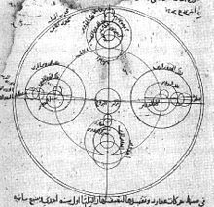
1. Ibn Shatir's model for the appearances of Mercury, 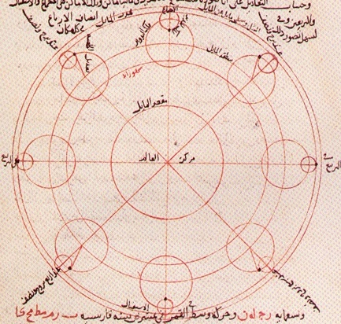
2. Ibn Shatir's lunar model
Unlike previous astronomers before him, Ibn Shatir did not adhere to Aristotelian cosmology, rather he produced a model that was more consistent with empirical observations. He eliminated the epicycle in the Ptolemaic solar model and all the eccentrics, epicycles and equant in the Ptolemaic lunar model. His model was thus in better agreement with empirical observations than any previous model. According to George Saliba, his work marked a turning point in astronomy, which may be considered a "Scientific Revolution before the Renaissance".
Ibn Shatir observed that the distance to the Moon did not change as drastically as required by Ptolemy's lunar model. So he produced a new lunar model that replaced Ptolemy's crank mechanism with a double epicycle model that reduced the computed range of distances of the Moon from the Earth.
Ibn Shatir's model for the appearances of Mercury shows the multiplication of epicycles in a Ptolemaic enterprise.

Possible influence on Nicolaus Copernicus
Although Ibn Shatir's system was geocentric, the mathematical details of his system were identical to those in Copernicus's De revolutionibus. Furthermore, the exact replacement of the equant by two epicycles used by Copernicus in the Commentariolus paralleled the work of Ibn Shatir one century earlier. Ibn Shatir's lunar and Mercury models are also identical to those of Copernicus. Saliba and Linton stated that Copernicus must have had access to some yet to be identified work on the ideas of ibn Shatir. It is unknown whether Copernicus read ibn Shatir.

Al-Qalasadi
Al-Qalasadi was a Muslim who was brought up in Baza which is north-east of Granada city. It must have been a difficult period in which to live in Baza, with a steady, yet intermittent, encroachment of Castile towards the city. Al-Qalasadi began his education in Baza, studying law, the Quran and the science of fixed shares in an estate. He moved south, away from the war zone, to Granada where he continued his studies, in particular philosophy, science and Muslim law.
Al-Qalasadi chose to remain in the Muslim land and he left Granada and travelled widely. In particular he spent much time in the North Africa. He spent some time in Tlemcen (now in Algeria) where he studied under teachers who taught him arithmetic and its applications. Form there al-Qalasadi went to Egypt where again he studied with some of the leading scholars. Eventually al-Qalasadi reached Mecca, the purpose of hajj, and returned to Granada.
Things were in a bad way when al-Qalasadi returned to Granada. The last remaining parts of the Muslim state were under severe attack from the Christians of Aragon and Castile. However, al-Qalasadi taught and wrote some of his major works during this period but eventually the advancing Christian armies made life impossible for him. Al-Qalasadi was soon forced to join the Andalusian hordes of refugees that were spreading over the Maghrib.

The defeat of the whole Muslim state in Granada finally took place until 1492, six years after al-Qalasadi's death in North Africa, when the city of Granada fell to the Christian Castile.
In ‘Las ciencias de los antiguos en al-Andalus’ (Madrid, 1992) by J Samsó, al-Qalasadi is described as a specialist in the apportioning of inheritances who took the first steps toward the introduction of algebraic symbolism. His contributions to algebraic symbolism were in using short Arabic words, or just their initial letters, as mathematical symbols. In particular he used
wa meaning "and" for plus (+)
illa meaning "less" for minus (-)
fi meaning "times" for multiplication (×)
ala meaning "over" for ÷
j from jadah meaning "root"
sh from shay meaning "thing" (x, the unknown)
m from mal for squared (x²)
k form kab for cube (x³⁾
l from yadilu for equality (=)
Al-Qalasadi died in 1486 CE in Tunisia.

Orban
Orban (in Turkish: Urban) was an iron founder and engineer from Brassó (Brașov), Transylvania, in the Kingdom of Hungary (now in Romania). Orban was of Hungarian ethnicity. He became adroit in constructing large cannons. In 1452 he offered his services to the Byzantines, but Constantine XI could not afford his high salary nor did he possess the materials necessary for it.
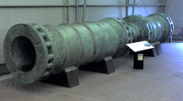
Fig. The Dardanelles Gun, cast in 1464 and based on the Orban bombard; British Royal Armouries collection
Orban then left Constantinople and approached the Ottoman sultan Mehmed II, who was preparing to besiege the city.
Claiming that his weapon could blast 'the walls of Babylon itself', Orban was given abundant funds and materials by the sultan. Orban managed to build the giant size gun within three months in 1453 CE at Adrianople, from which it was dragged by sixty oxen to Constantinople. In the meantime, Orban also produced other smaller cannons for the Turks. In 1453CE Orban, along with an entire crew, was probably killed during the siege when one of his superguns exploded, which was not an unusual occurrence during that time. But the Ottomans conquered Constantinople. So credit must be shared with Orban.
Pietru Caxaro
Pietru Caxaro was a Maltese philosopher and poet. He is Malta's first known philosopher, fragments of whose works are extant. He lived during circa 1400 – 1485CE. Peter Caxaro was born in Mdina in Malta. His father's name was Leo, and his mother's Zuna. The family was of Jewish descent and had been forced to convert to Christianity.
His contribution skillfully stands as a mature reflection of the social and cultural revival of Malta.
Caxaro's first studies were undertaken in Malta. Later, he went to Palermo, Sicily, to pursue further. There, Caxaro completed his studies and became a notary in 1438. He was appointed judge at the courts of Gozo for the years 1440-1441. In 1441, he also sat as judge in the courts of Malta, and the similarly in 1475. He was judge at the civil courts in 1460-1461, 1470–1471 and 1481–1482, and judge at the ecclesiastical courts in 1473 and 1480-1481. He possessed considerable property at the northern side of Malta, and was the owner of six slaves.
In 1480, Caxaro took an active and bold part in an issue which involved the bishop of Malta, who was suspected of corruption. Caxaro was vehement against such corruption, and vigorous in his demand for an immediate remedy. In June 1480, as an act of retaliation, the bishop excommunicated him, an action which was considered immensely serious in those days. Nevertheless, Caxaro was unyielding in his opposition and demands. Consequently, the bishop interdicted him. However, Caxaro was nonetheless undaunted. The issue lingered on until the first half of the following year, when the bishop had to accede to Caxaro's and the Town Council's demands. Accordingly, the excommunication and the interdict were removed. Caxaro's determination and resolve in the matter were highly praised.
His ‘Il-Kantilena’ is the oldest literary text in the Maltese language. It dates no later than 1485, the death of its author, and probably from the 1470s, but was not found until 1966 by Prof. Godfrey Wettinger and Fr. M. Fsadni (OP).
He introduced Latin script. Although written in Maltese, it was a very early Maltese that had not yet been influenced much by Italian or English. This text contains many Arabic morphemes. The only Romance words are vintura ‘luck’ and et ‘and’. In general, early Maltese texts contain very little non-Semitic vocabulary.
Caxaro's philosophy
Caxaro's philosophy, entirely reflect the peculiar force, functions and needs of the Maltese people whose mental constitution and mode of expression were readily set.
Caxaro's composition, following the line of Plato's own professional preferences, is shrouded in a linguistic and conceptual veil so as to incite us to an active surmise. Its very narrative construction prompts our latent curiosity to probe the hidden meaning under the apparently shallow surface.
As opposed to Aristotelico-Scholastic form, which is almost always intrinsically rigid and lineated, even if more immediate and direct, Caxaro's philosophy is given under the disguise of a narration which has a reality of its own.
While Caxaro himself synthetically states his concepts, especially as regards the unpleasantness of illusion, he prefers to express himself under “deceptive” clothing. The objective nature of his philosophy is thus skilfully guarded behind a screen through which a mere sensuous perception fails to penetrate.

The recognition of the Maltese language
The recognition of the Maltese language by using it with masterly skill while positively valuing highly the language of the people as opposed to the Latin and Sicilian languages was a bold endeavor of Caxaro. Not only is it a mere choice of language but, it is the adherence to a set mentality peculiar to a geographic territory.
It also shows the worth given to a local culture and heritage, considering it capable of standing on its own two feet on an equal par with that of other neighbouring countries. The use of the Maltese language is not a call for independent rule but an affirmation of a native identity characteristic of a people.

The sphere of reality
The concreteness of Caxaro's reflections stands out loud and clear against any theoretical speculation. The arid, scholastic, professional terminology and mental structure is completely done away with. The practical existential perspective to life and reality is preferred. This may be considered typically Maltese in nature or at least Mediterranean where an acute common sense is noticeable in everyday dealings.
Caxaro's inclination towards action rather than speculation, subordinating (though not eliminating) the latter to the former reveals his inclination towards the platonic school and away from Aristotelico-Scholastic categories of thought.

Allegory vs. Parable
Correspondences exist in the Cantilena between the various symbolisms which Caxaro harmoniously employs. In truth, he does not simply portray an image for the mere artificial imitation of its external form but moreover dwells on the wealthy analogous qualities of the theory of symbols so widely used in the medieval period.
The use of allegory in Caxaro's Cantilena, in accordance with mediaeval usage, adheres to a subject under the semblance of narrative suggesting similar characteristics. Caxaro may not be referring to one single case but to a life-situation in general. The use of an allegory technically functions as a stimulation to further reflection; an openness to the mystery and riddle of life.

Truth vs. Appearance
This is an important theme in the Cantilena, maybe carrying the greatest consequence for the whole composition. “Fen tumayt insib il gebel sib tafal morchi” (“Where I hoped to find rock I found soft clay”, v. 13{19}) gives us the hint.
This may well be the key to the composition's enigma. We have here a juxtaposition of an apparent truth (a pseudo-truth) and the truth itself. This is a metaphysical problem. It marks human's encounter with a reality which is in itself concealed and garbed with the immediate consciousness and evidence of the sensible. Caxaro eventually contrasts the phenomenal to the noumenical reality, that is, the object of the senses, to which he was attracted in the first place, and the object of the intellect, which he discovered posteriorly. Caxaro's emphasis, however, and this is his proper characteristic in this sphere, is less on the intuitive function of humans and more on experiential undergoing. The senses are the media with which the real is arrived at.
The theme is an echo of Plato's most fundamental problematic. Plato opposes appearance to the truth (reality), to which he identifies life. To the former he identifies existence. Appearance stops at the level of things which are not of any prime importance save as a vehicle of thought. A general superficiality in life at large is a result of constant and persisting shallowness in all aspects of humans’ being. The ability, on the other hand, to go to the heart of things, to the truth of reality, to life itself, would make this appearance ineffective.
The precise date of his death is still not known. Caxaro drew up his will On August 12, 1485. It is not known where he was initially buried. However, later, as he had it willed, his remains were laid to rest in one of the newly built chapels of the church of St. Dominic at Rabat, Malta.

Martin Behaim
Behaim was born in Nuremberg on 6 October 1459. His father was a senator of Nuremberg. Behaim, as a member of a prominent and prosperous family, received a good education at one of the best schools in the city. When his father died in 1474, Martin's uncle Leonhard sent him at the age of 15 to Mechelen, Flanders to gain experience as a textile merchant. There he joined the business. In 1477 they visited Antwerp. In 1484 Behaim moved to Lisbon. Behaim was looking for trading opportunities. He quickly found favor as a counselor in the court of King Joao II. Around 1485 he participated in a trading voyage to Guinea.
Following his marriage in 1486, he resided on island of Faial in the Azores, where his father-in-law was leader of the Flemish community. In 1490, Behaim returned to Nuremburg. He managed to convince leading members of the city council to finance the construction of his famous terrestrial globe under his direction. Leading members of the city council financed the construction of a terrestrial globe. Thus the oldest extant globe was constructed by a team of artisans and craftsmen under the direction of Behaim from 1490–1492. It is constructed of a laminated linen ball in two halves, reinforced with wood and overlaid with a map painted by Georg Glockendon. The globe is about 21 inches (51 cm) in diameter and was fashioned from a type of papier-mache and coated with gypsum. The ball was supported on a wooden tripod and secured by a pair of iron hoops. Glockendon's map drawings were painted onto parchment strips and pasted into position around the sphere. The globe contains more than 2,000 place names, 100 pictorial illustrations (plus 48 banners and 15 coats of arms) and more than 50 long legends. Many of the notations deal with fabulous monsters of foreign countries and their inhabitants, plants and animals. Many notes also deal with trade, explorations, and famous travelers like Marco Polo.
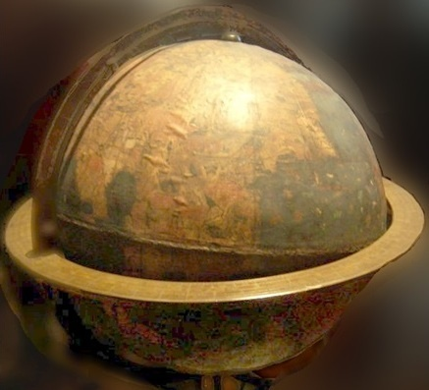
Erdapfel produced by Martin Behaim.

The completed globe came to be called Erdapfel (earth apple) by the townspeople. The Erdapfel in German literaly means earth apple. It was originally housed in Nuremberg's city hall. In the 17th century the Behaim family took possession of the globe. It was inexpertly restored in 1823 and again in 1847, resulting in the corruption of many place-names and labels. The German National Museum in Nuremberg later took possession of the globe. The antiquity of this globe on the eve of the discovery of the Americas, makes the oldest globe. It also represents an encyclopedia of Europe's knowledge of the known world in 1492. Columbus returned to Spain no sooner than March 1493.
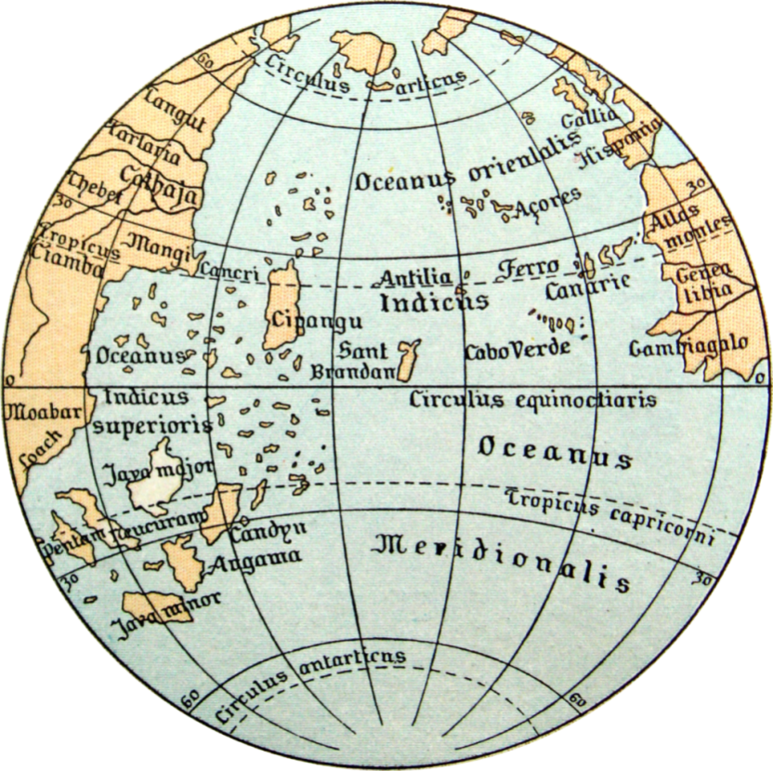
Oceanic area described on the Martin Behaim globe.

Görz mentions that the world map depicted on the Behaim globe is based primarily on the geography of Ptolemy. It also combines geographical information from other sources, including Marco Polo, John Mandeville and Diogo Gomes. Görz also noted that it lacked
more current Portuguese geographic data which should have been available to Behaim and it contained numerous errors that did not reflect contemporary geographical understanding.
Cipangu (Japan) in the map is oversized and well south of its true position; The Americas are not included, but a land mass called Saint Brendan's Island is shown between Europe and Asia.
He returned to Faial in 1493 by way of Flanders and Lisbon, and he remained there until 1506.
Behaim died in Lisbon on 29 July 1507 while visiting the city for business.
Unsubstantiated claims: Numerous assertions have been made regarding Behaim's accomplishments, some made by himself and others by his early biographers. Since the twentieth century, historians have taken a more critical look at these claims and have concluded that many of them are unsubstantiated by any documentary evidence, and in some cases flatly contradicted by existing documentation. Historian Johann Wagenseil claimed in 1682 that Behaim had discovered America before Columbus. Beazley mentions that there is no evidence that Behaim ever sailed west on a voyage of discovery and neither Behaim nor Columbus ever referenced such a meeting.
Behaim’s globe represents an encyclopedia of Europe's knowledge of the known world in 1492.
Bibliography
A. Mark Smith, From Sight to Light: The Passage from Ancient to Modern Optics, University of Chicago Press, 2015.
A. Mark Smith, Alhacen's Theory of Visual Perception (First Three Books of Alhacen's de Aspectibus), American Philosophical Society, 2001.
Abel B. Franco, "Avempace, Projectile Motion, and Impetus Theory", Journal of the History of Ideas, University of Pennsylvania Press, October 2003.
Abul-Faraj Ibnul Jawzi, Muntazam fi Tarikh al-Muluk wal Umam, Dar Al-Kotob Al-ilmiyah, Beirut, 2014.
Alessandro Bausani, "Cosmology and Religion in Islam", Scientia/Rivista di Scienza. 1973
Ali Moussa, "Mathematical Methods in Abu al-Wafa's Almagest and the Qibla Determinations", Arabic Sciences and Philosophy, 2011.
Bai Shouyi et al., A History of Chinese Muslims, 2003.
Bashmakova, Izabella Grigor’evna; Galina S. Smirnova, The beginnings and evolution of algebra, Cambridge University Press, 2000.
Carl B. Boyer, A History of Mathematics (Second ed.), John Wiley & Sons Inc., 1991.
Charles Raymond Beazley, "Behaim, Martin", Encyclopedia Britannica (11th ed.), Cambridge University Press, 1911.
Cyril Elgood, A Medical History of Persia and the Eastern Caliphate (1st ed.), Cambridge University Press, 2010.
David A. King, Astronomy in the Service of Islam, Aldershot, U.K. Variorum, 1993.
David Waines, Food Culture and Health in Pre-Modern Muslim Societies, Brill Academic Publishers, 2010.
David Pingree, "ABD-AL-ḤAMID B. VASE", Encyclopaedia Iranica, Vol. I, 1982.
Donald R. Hill, Studies in Medieval Islamic Technology, 1 edition, Routledge, 1998.
Douglas McCormick, Columbus’s Geographical Miscalculations, IEEE Spectrum, 2012.
Edward Granville Browne, Islamic Medicine, Goodword Books Pvt. Ltd., 2001.
Ernst G. Ravenstein, “Martin Behaim, His Life and His Globe”, George Philip & Son Ltd, 1908.
Ernst von Meyer, A History of Chemistry From Earliest Times to the Present Day, Macmillan, 1906.
Ernest A. Moody, "Galileo and Avempace: The Dynamics of the Leaning Tower Experiment", Journal of the History of Ideas, University of Pennsylvania Press, April 1951.
Estreicher, Stefan K, Wine: From Neolithic Times to the 21st Century, Algora Publishing, 2006.
F. J. Ragep, P. Ragep Sally; Steven John Livesey, Tradition, transmission, transformation: proceedings of two conferences on pre-modern science held at the University of Oklahoma, Brill, 1996.
Frank N. Egerton, "History of Ecological Sciences, Part 43: Plant Physiology, 1800s", Bulletin of the Ecological Society of America, 2012.
George Saliba, A History of Arabic Astronomy: Planetary Theories During the Golden Age of Islam, New York Univ. Press, 1994.
Guenther Görz, "Behaim, Martin", The Biographical Encyclopedia of Astronomers. New York, Springer, 2007.
Geoffrey Ashe, The Quest for America, Pall Mall Press; 1971.
George Sarton, Introduction to the History of Science, 3 vols., Baltimore, Williams and Wilkins, 1948.
G L Huxley, Biography in Dictionary of Scientific Biography, New York, 1990.
Gerli, E. Michael, Routledge Revivals: Medieval Iberia: An Encyclopedia, Routledge, 2017.
Ghazanfar and Islahi, "Economic Thought of Al-Ghazali" Islamic Economics Research Series, King Abdulaziz University, 1997.
Hasan Hasan, How the decline of Muslim scientific thought still haunts, the National (2012-02-09), UAE.
Helaine Selin, Encyclopaedia of the history of science, technology, and medicine in non-western cultures, Springer Science+Business Media, 1997.
Helaine Selin, Mathematics Across Cultures: The History of Non-Western Mathematics.
Hugh Chisholm, ed., "Albategnius", Encyclopædia Britannica (11th ed.), Cambridge University Press, 1911.
Jamil Ali (trans.), The Determination of the Coordinates of Cities: Al‐Bīrunī's Tahdīd al‐Amākin, American University of Beirut, 1967.
Jacques Sesiano, An introduction to the history of algebra: solving equations from Mesopotamian times to the Renaissance, AMS Bookstore, 2009-07-09.
John Marenbon, The Oxford Handbook of Medieval Philosophy, Oxford University Press, 14 June 2012.
Josép Puig Montada, "Ibn Bâjja [Avempace]", The Stanford Encyclopedia of Philosophy, 2018.
Jorge J. E.Gracia, "Philosophy in the Middle Ages: An Introduction", A Companion to Philosophy in the Middle Ages, Blackwell Publishing Ltd, 2007.
Kurt Bernardo Wolf, Geometric Optics on Phase Space, Springer, 2004.
Karl W. Butzer, "The Islamic Traditions of Agroecology: Crosscultural Experience, Ideas and Innovations", Cultural Geographies (Journal), volume 1, 1994.
L. Cochrane: Adelard of Bath, British Museum Press, 1994.
Martin Levey, "Abu Kamil Shuja ibn Aslam ibn Muhammad ibn Shujaʿ", Dictionary of Scientific Biography, New York, Charles Scribner's Sons., 1970.
Mohammad Kamiar, Brilliant Biruni: A Life Story of Abu Rayhan Mohammad Ibn Ahmad, Lanham, Maryland, Scarecrow Press, 2009
Mario Livio, The Golden Ratio. New York: Broadway, 2003
MJL Young, Religion, Learning and Science in the 'Abbasid Period, Cambridge University Press, 2006.
Michael E. Marmura, The Incoherence of the Philosophers (translated), 2nd ed, Provo Utah, 2000.
Muhammad A. Khalid, Medieval Islamic Philosophical Writings, Cambridge, UK, 2005.
Merlin Swartz, A Medieval Critique of Anthropomorphism, Leiden: Brill Publishers, 2001.
R Rashed, The development of Arabic mathematics: between arithmetic and algebra, London, 1994.
Sally Ganchy, Islam and Science, Medicine, and Technology, New York, Rosen Pub., 2008.
T L Heath, A History of Greek Mathematics, 2 Vols., Oxford, 1921.
W. Hartner, "ABU KAMIL SHUDJA", Encyclopaedia of Islam (2nd ed.), Brill Academic Publishers, 1960.

The battle was between the Abbasids along with their ally the Tibetan Empire against the Chinese Tang dynasty.
Bai Shouyi et al., A History of Chinese Muslims, 2003.
David A. King, Astronomy in the Service of Islam, 1993.
UNESCO website mentions: “Founded in the 9th century and home to the oldest university in the world, Fez reached its height in the 13th–14th centuries under the Marinids, when it replaced Marrakesh as the capital of the kingdom.”
Carl Boyer, A History of Mathematics (Second ed.), p. 193.
T L Heath, A History of Greek Mathematics, 1921.
T L Heath, A History of Greek Mathematics, 1921.
G L Huxley, Biography in Dictionary of Scientific Biography (New York 1970-1990).
Abul Faraj ibnul Jawzi, AlMuntazam fi tarikh mulk wa umam
Several Latin translations were published. Its first full translation into English was by Francis Adams in 1834.
Von Meyer, 1906.
Pingree 1982, p. 111.
Boyer, Carl B. (1991), A History of Mathematics (Second ed), p. 234.
The book was twice translated into Latin by both Gerard of Cremona and Robert of Chester in the 12th century
Alidade derived from the Arabic word al-adadah (meaning ‘the ruler’).
Helaine Selin, Mathematics Across Cultures: The History of Non-Western Mathematics, 2000.
Livio, Mario, 2003, pp. 89–90, 92, 96.
Helaine Selin, 2000.
Bashmakova, Izabella Grigorʹevna; Galina S. Smirnova (2000-01-15), p.52.
Encyclopaedia of the history of science, technology, and medicine in non-western cultures. Springer. pp. 4–5.
Hartner, W. (1960).
Hartner, W. (1960).
Ragep, F. J.; Sally P. Ragep; Steven John Livesey, Tradition, transmission, transformation: proceedings of two conferences on pre-modern science held at the University of Oklahoma. Brill,1996, p. 48..
Livio, Mario, The Golden Ratio. New York: Broadway, 2003, pp. 89–90, 92, 96.
Hartner, W. (1960).
Sesiano, Jacques (2009-07-09). An introduction to the history of algebra: solving equations from Mesopotamian times to the Renaissance.
It gained more attention after historian Franz Woepcke linked it with an anonymous Latin work, Liber augmenti et diminutionis.
Levey, Martin. "Abū Kāmil Shujāʿ ibn Aslam ibn Muhammad ibn Shuja”, Dictionary of Scientific Biography, 1. New York: Charles Scribner's Sons. 1970, pp. 30–32.
George Sarton, Introduction to the History of Science.
EG Browne 2001 Islamic Medicine, p. 44.
Elgood, Cyril (2010). A Medical History of Persia and The Eastern Caliphate, p. 202–203.
Sally Ganchy, Islam and Science, Medicine, and Technology. New York, 2008.
Elgood, Cyril (2010). p. 202–203.
It was translated more than a dozen times into Latin and other European languages.
It was translated into Latin in 1279 by Faraj ben Salim, a Jewish physician, and after which it had a considerable influence in Europe.
David Waines (2010), p. 225.
Marenbon, John (14 June 2012). The Oxford Handbook of Medieval Philosophy. pp. 69–70.
Hadith scholar Abu Hatim Muhammad ibn Idris al-Razi (811–890) is different person.
Marenbon, John (14 June 2012), The Oxford Handbook of Medieval Philosophy, pp. 69–70.
Kamiar, Mohammad, Brilliant Biruni: A Life Story of Abu Rayhan Mohammad Ibn Ahmad, 2009
“Trigonometry". Encyclopædia Britannica.
Chisholm, Hugh, ed., "Albategnius" Encyclopædia Britannica. 1 (11th ed.). 1911, p. 491.
Moussa, Ali, "Mathematical Methods in Abu al-Wafaʾ's Almagest and the Qibla Determinations", Arabic Sciences and Philosophy, 2011.
Stefan K Estreicher, 2006, p. 46.
E. Michael Gerli, 2017, p. 12.
Smith, A. Mark (2015). From Sight to Light: The Passage from Ancient to Modern Optics, p. 178.
Kurt Bernardo Wolf, Geometric Optics on Phase Space, p. 9, Springer, 2004
Claudius Ptolemy (c.100–c.170CE) compiled a mathematical and astronomical treatise which had been translated into Arabic under the same caption Almagest.
Codex Masudicus, Al-Biruni quoted in Bausani, Alessandro (1973). "Cosmology and Religion in Islam". Scientia/Rivista di Scienza. 108.
MJL Young, 2006.
Jaakko Hämeen-Anttila Ideology, Nabataean Agriculture.
S.H. Nasr in A History of Muslim Philosophy (1966), volume II, p. 1323
This is a Chinese name; the family name is Bi.
The Toledo Tables were translated into Latin in the Twelfth century.
The Incoherence of the Philosophers. Translated by Michael E. Marmura. 2000, pp. 116-7.
Muhammad Khalid (2005), p.162.
Hasan Hasan, How the decline of Muslim scientific thought still haunts, the National (2012-02-09), UAE.
Ghazanfar and Islahi, "Economic Thought of Al-Ghazali", Islamic Economics Research Series, 1997.
Ernest A. Moody (April 1951). "Galileo and Avempace: The Dynamics of the Leaning Tower Experiment (I)", p. 163-193
Franco, Abel B. (October 2003). "Avempace, Projectile Motion, and Impetus Theory". Journal of the History of Ideas. 64 (4): 521–546.
Montada, Josép Puig, 2018, "Ibn Bâjja [Avempace]". The Stanford Encyclopedia of Philosophy. Retrieved 2018-11-14.
Franco, Abel B. (October 2003). "Avempace, Projectile Motion, and Impetus Theory". Journal of the History of Ideas. 64 (4): 521–546.
Franco, Abel B.. "Avempace, Projectile Motion, and Impetus Theory". Journal of the History of Ideas, Vol. 64(4): 543.
Gracia, Jorge J. E. (2007-11-26), "Philosophy in the Middle Ages: An Introduction", A Companion to Philosophy in the Middle Ages, Blackwell Publishing Ltd, 2007, pp. 1–11.
Egerton, Frank N. (2012). "History of Ecological Sciences, Part 43: Plant Physiology, 1800s". Bulletin of the Ecological Society of America. 93 (3): 197–219.
L. Cochrane: Adelard of Bath, British Museum press, 1994.
Roger I (born Normandy, France c. 1040 - d. Mileto, Italy 1101) was a Norman nobleman who became the first Count of Sicily from 1071 to 1101. He practiced general toleration towards Arabs and Greeks. His private physician was a Muslim named Abu al-Salt, and his cartographer was al-Idrisi.
Ashe, The Quest for America, 1971, p. 48.
Merlin Swartz (2001), A Medieval Critique of Anthropomorphism, p. 159.
R Rashed, The development of Arabic mathematics: between arithmetic and algebra (London, 1994).
Karl W. Butzer, (1994), "The Islamic Traditions of Agroecology: Crosscultural Experience, Ideas and Innovations", volume 1, pages 7-50 (including pages 28-29 and 39-40)
D.R. Hill, Studies in Medieval Islamic Technology, 1998, II, pp. 231-232
G. Sarton, Introduction to the History of Science, p. 510.
D.R. Hill, Studies in Medieval Islamic Technology, 1998, II, pp. 231.
George Saliba, A History of Arabic Astronomy: Planetary Theories During the Golden Age of Islam, 1994, pp. 233–234 & 240)
Görz, 2007.
Görz, 2007.
Ravenstein, 1908.
Görz, 2007.
Beazley, 1911

